**Industrial Internship Report on**

**”** Self-Regulating Traffic Management System**”**

**Prepared by**

**Payal Ravindra Ashtikar**

|  |
| --- |
| *Executive Summary* |
| This report provides details of the Industrial Internship provided by upskill Campus and The IoT Academy in collaboration with Industrial Partner UniConverge Technologies Pvt Ltd (UCT).  This internship was focused on a project/problem statement provided by UCT. We had to finish the project including the report in 6 weeks’ time.   * My project was Reduce everyday congestion, markedly, by smoothening traffic flow and prioritizing traffic in response to demand in real time. * Reduce pollution throughout the city: stop-start driving is inefficient and polluting. * Enable a much more effective response to traffic incidents so as to prevent accidents and gridlocks.   Enable Inbound Flow Control.  This internship gave me a very good opportunity to get exposure to Industrial problems and design/implement solution for that. It was an overall great experience to have this internship. |

**TABLE OF CONTENTS**

1 Preface 3

2 Introduction 4

2.1 About UniConverge Technologies Pvt Ltd 4

2.2 About upskill Campus 8

2.3 Objective 9

2.4 Reference 9

2.5 Glossary 10

3 Problem Statement 11

4 Existing and Proposed solution 12

5 Proposed Design/ Model 13

5.1 High Level Diagram (if applicable) 13

5.2 Low Level Diagram (if applicable) 13

5.3 Interfaces (if applicable) 13

6 Performance Test 14

6.1 Test Plan/ Test Cases 14

6.2 Test Procedure 14

6.3 Performance Outcome 14

7 My learnings 15

8 Future work scope 16

# Preface

During the six week of my internship,I’ve learnt the cloud models,data uplodation, creating things, policy, and attaching them to certificates. I focused on exploring various cloud platforms and their IoT capabilities. This week’s primary areas of study included ThingSpeak Cloud, AWS IoT Core, and data uploadation to IBM Bluemix. Below is a detailed account of the activities and learnings from this week.

Week 5 of the cloud internship has been a period of significant learning and development. The focus was on enhancing both technical and soft skills, understanding the nuances of cloud technology, and preparing for future career opportunities.

Brief about Your project/problem statement.

UniConverge Technologies (often referred to as UCG) is a technology company that provides a variety of services and opportunities in the field of technology solutions. It may offer opportunities across multiple sectors, particularly in IT services, telecommunications, and business solutions. Here are some of the key opportunities typically provided by a company like UniConverge Technologies:

**Job Roles**: UniConverge Technologies may offer career opportunities across various roles such as software development, system architecture, IT support, data analytics, project management, and business development.

* **Internships and Training**: The company could offer internships, apprentice programs, and training for students and fresh graduates. This helps individuals gain practical experience in the tech field.
* **Skill Development**: UniConverge may provide professional development programs, training sessions, and certifications in advanced technologies like cloud computing, AI, machine learning, and data science.

**Custom Software Development**: They may offer opportunities for businesses to develop custom software solutions tailored to their needs, including applications, ERP systems, and web development.

* **Digital Transformation**: UniConverge Technologies likely assists organizations with their digital transformation journeys, helping to optimize their business processes through advanced technological solutions.
* **Cloud Computing Services**: The company may provide cloud infrastructure and services to help businesses transition to scalable and cost-effective cloud platforms.
* **Cybersecurity Solutions**: Providing robust security solutions to protect organizations from cyber threats and data breaches.

These are some of the opportunities that a company like UniConverge Technologies could provide to individuals, businesses, and organizations. The exact nature of opportunities would depend on the company’s current offerings, industry focus, and strategic goals.

How Program was planned

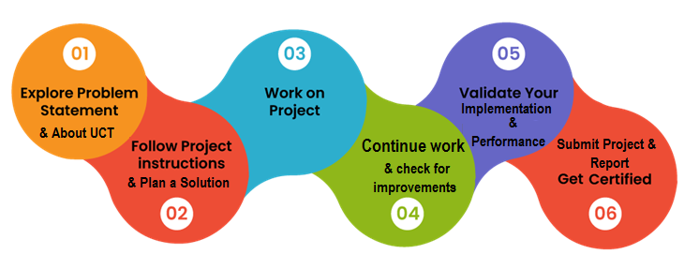

Your Learnings and overall experience.

Thank to all (with names), who have helped you directly or indirectly.

Your message to your juniors and peers.

# Introduction

## About UniConverge Technologies Pvt Ltd

A company established in 2013 and working in Digital Transformation domain and providing Industrial solutions with prime focus on sustainability and RoI.

For developing its products and solutions it is leveraging various**Cutting Edge Technologies e.g. Internet of Things (IoT), Cyber Security, Cloud computing (AWS, Azure), Machine Learning, Communication Technologies (4G/5G/LoRaWAN), Java Full Stack, Python, Front end**etc.

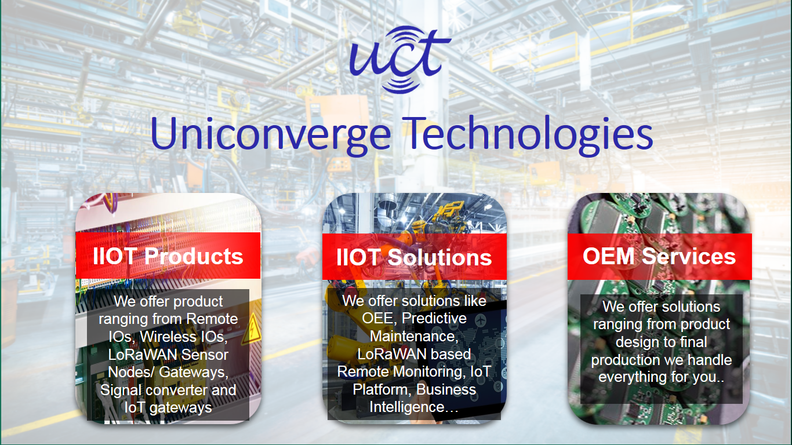

1. UCT IoT Platform **(****)**

**UCT Insight** is an IOT platform designed for quick deployment of IOT applications on the same time providing valuable “insight” for your process/business. It has been built in Java for backend and ReactJS for Front end. It has support for MySQL and various NoSql Databases.

* It enables device connectivity via industry standard IoT protocols - MQTT, CoAP, HTTP, Modbus TCP, OPC UA
* It supports both cloud and on-premises deployments.

It has features to  
• Build Your own dashboard  
• Analytics and Reporting  
• Alert and Notification  
• Integration with third party application(Power BI, SAP, ERP)  
• Rule Engine

 

1. **Smart Factory Platform (****)**

Factory watch is a platform for smart factory needs.

It provides Users/ Factory

* with a scalable solution for their Production and asset monitoring
* OEE and predictive maintenance solution scaling up to digital twin for your assets.
* to unleased the true potential of the data that their machines are generating and helps to identify the KPIs and also improve them.
* A modular architecture that allows users to choose the service that they what to start and then can scale to more complex solutions as per their demands.

Its unique SaaS model helps users to save time, cost and money.

 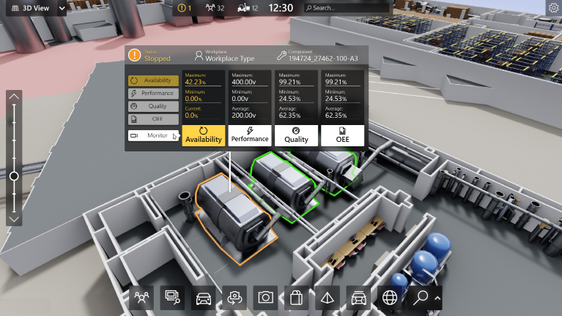

1. 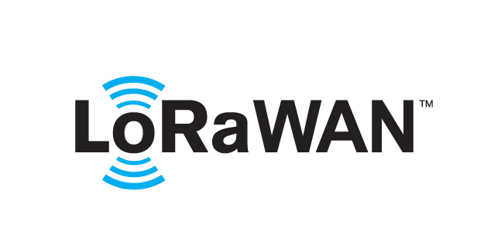 based Solution

UCT is one of the early adopters of LoRAWAN teschnology and providing solution in Agritech, Smart cities, Industrial Monitoring, Smart Street Light, Smart Water/ Gas/ Electricity metering solutions etc.

1. Predictive Maintenance

UCT is providing Industrial Machine health monitoring and Predictive maintenance solution leveraging Embedded system, Industrial IoT and Machine Learning Technologies by finding Remaining useful life time of various Machines used in production process.



## About upskill Campus (USC)

upskill Campus along with The IoT Academy and in association with Uniconverge technologies has facilitated the smooth execution of the complete internship process.

USC is a career development platform that delivers **personalized executive coaching** in a more affordable, scalable and measurable way.



Seeing need of upskilling in self paced manner along-with additional support services e.g. Internship, projects, interaction with Industry experts, Career growth Services

<https://www.upskillcampus.com/>

upSkill Campus aiming to upskill 1 million learners in next 5 year

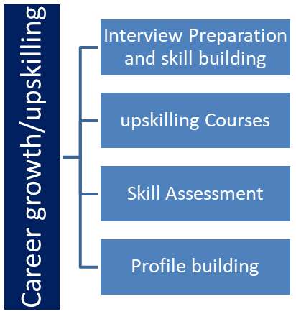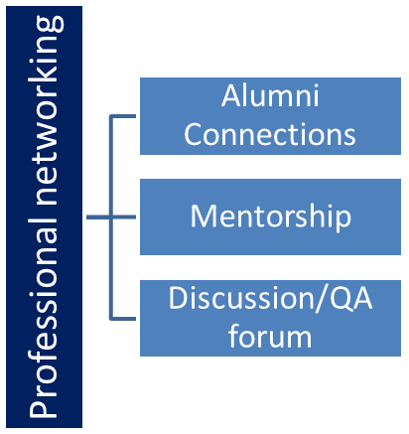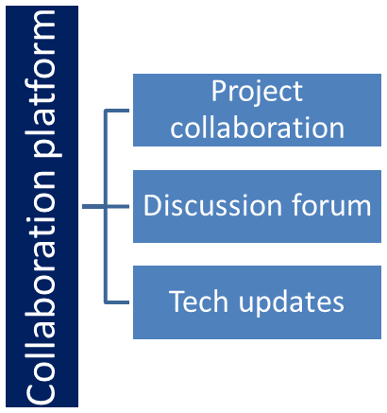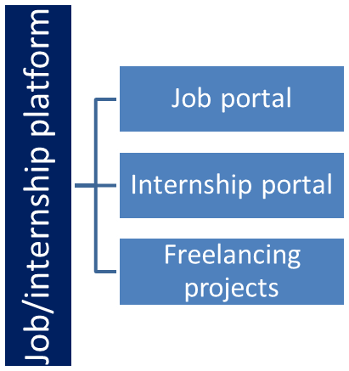

## The IoT Academy

The IoT academy is EdTech Division of UCT that is running long executive certification programs in collaboration with EICT Academy, IITK, IITR and IITG in multiple domains.

## Objectives of this Internship program

The objective for this internship program was to

 ☛ get practical experience of working in the industry.

 ☛ to solve real world problems.

 ☛ to have improved job prospects.

 ☛ to have Improved understanding of our field and its applications.

 ☛ to have Personal growth like better communication and problem solving.

# Problem Statement

Traffic simulation models are useful for both transportation planning and to transportation design and operations. Lane type, signal timing and other traffic related questions are investigated to improve local system effectiveness and efficiency. Simulation in transportation is important because it can study models that are way too complicated for analytical or numerical treatment, can be used for experimental studies, can study detailed relations that might be lost in analytical or numerical treatment and can produce attractive visual demonstrations of present and future scenarios.

# Existing and Proposed solution

**Why Traffic Management System?**

* Reduce everyday congestion, markedly, by smoothening traffic flow and prioritizing traffic in response to demand in real time.
* Reduce pollution throughout the city: stop-start driving is inefficient and polluting.
* Enable a much more effective response to traffic incidents so as to prevent accidents and gridlocks.

Normal analytical techniques make use of extensive mathematical models which require assumptions and restrictions to be placed on the model. This can result in an avoidable inaccuracy in the output data. Simulations avoid placing restrictions on the system and also take random processes into account; in fact, in some cases simulation is the only practical modeling technique applicable. Analysts can study the relationships between components in detail and can simulate the projected consequences of multiple design options before having to implement the outcome in the real-world. It is possible to easily compare alternative designs so as to select the optimal system. The actual process of developing the simulation can itself provide valuable insights into the inner workings of the network which can in turn be used at a later stage.

## Code submission (Github link)

## Report submission (Github link) : first make placeholder, copy the link.

# My learnings

During the sixth week of my internship, I had the opportunity to deepen my understanding of various aspects of cloud technologies, including different cloud models, data uploadation processes, and policies related to cloud platforms. I spent time creating and configuring elements within cloud platforms and linking them to certificates for enhanced security and authenticity. A significant focus was placed on **exploring different cloud platforms** and understanding their Internet of Things (IoT) capabilities.

### Key Areas of Learning:

1. **Cloud Models**: I gained a deeper understanding of the various cloud deployment models, including public, private, and hybrid clouds. Each model offers distinct advantages in terms of scalability, cost, and security, and I was able to comprehend how to select the appropriate model based on specific business needs.
2. **Data Uploadation**: I learned the critical process of uploading data to cloud platforms, a task that is crucial for managing data flow between devices and cloud systems. This involved working with real-time data feeds and understanding how to handle them in a cloud environment.
3. **Cloud Platforms and IoT Integration**: A significant part of my learning was around IoT capabilities in cloud platforms. I explored **ThingSpeak Cloud**, **AWS IoT Core**, and **IBM Bluemix** in depth. ThingSpeak Cloud, for example, offers an easy interface for IoT projects, and I learned how to use it for collecting and visualizing sensor data. Similarly, AWS IoT Core was a key focus for its advanced tools in device management, messaging, and data processing in IoT ecosystems. I also practiced uploading data to **IBM Bluemix**, a powerful platform for building and deploying cloud-based applications, focusing on its compatibility with IoT devices.
4. **Policies and Security**: A significant portion of the week was spent learning about cloud security policies, including best practices for ensuring data protection and managing access. I understood the importance of **attaching certificates** to ensure secure communication between devices and the cloud, especially in IoT applications, where security is a top priority.

Week 5 was particularly important in terms of both technical and **soft skills development**. On the technical side, I continued to explore various tools and methods within the cloud ecosystem. On the soft skills front, I worked on **communication** and **teamwork**, which are essential for effectively collaborating in a professional tech environment. Understanding cloud technologies is important, but being able to communicate your findings and work effectively within a team setting is just as crucial for a successful career in tech.

As the internship continues, I am focused on enhancing my **problem-solving skills** and preparing for more advanced tasks related to cloud computing and IoT technologies. This week has provided a solid foundation, and I am eager to continue building upon it to better understand how cloud systems integrate with real-world applications. The knowledge gained in Week 5 will help me in future career opportunities, particularly in roles related to cloud engineering, IoT development, and cybersecurity.

This week has been an enriching learning experience, with a perfect blend of theoretical knowledge and practical exposure, helping me prepare for a successful career in cloud technologies and IoT.

# Future work scope

The **future scope of traffic management systems in cloud computing** is incredibly promising, as cloud technologies continue to evolve and offer new ways to address urban mobility, reduce congestion, and enhance the overall efficiency of transportation systems. By leveraging cloud computing, traffic management systems can become more intelligent, scalable, and real-time, which is vital as cities grow and the need for smart infrastructure increases. Here are several key areas where cloud computing can significantly transform traffic management in the future:

### 1. ****Real-Time Traffic Data Processing****

* **Cloud-based Traffic Analytics**: Cloud platforms can process large volumes of traffic data generated by sensors, cameras, GPS devices, and IoT-enabled vehicles. This real-time data can be analyzed using **Big Data** technologies to optimize traffic flow, predict congestion, and suggest alternative routes. Cloud computing provides the scalability needed to handle massive amounts of real-time traffic data and deliver insights quickly.
* **Predictive Analytics**: With machine learning algorithms running in the cloud, traffic systems can predict traffic patterns, incidents, and congestion before they occur. Predictive models can analyze historical traffic data to forecast busy periods, accidents, or road closures, allowing authorities to proactively manage traffic and reduce disruptions.

### 2. ****Internet of Things (IoT) Integration****

* **IoT Devices in Traffic Management**: Traffic management systems will integrate more IoT devices, such as sensors, cameras, smart traffic lights, and connected vehicles, to collect and share real-time data. Cloud computing enables these devices to work seamlessly together by providing a centralized platform for data storage, processing, and analysis. The cloud can process data from **smart traffic lights**, **parking sensors**, and **vehicle-to-infrastructure (V2I)** communication systems to optimize traffic flow.
* **Smart Traffic Signals**: Cloud-based traffic management systems can dynamically adjust traffic signals based on real-time traffic conditions. For example, traffic lights can change their timing to prioritize lanes with higher traffic volumes or adjust signal patterns during accidents or emergencies.

### 3. ****Scalability and Flexibility****

* **On-demand Resources**: Cloud computing offers **scalability**, which is crucial as cities grow and traffic demands increase. Traditional on-premise systems may struggle to handle the scale, but cloud infrastructure can scale up or down as needed to accommodate growing data traffic. This allows municipalities to manage the resources efficiently and cost-effectively.
* **Edge Computing and Cloud Integration**: As the number of IoT devices in traffic management increases, **edge computing** can play a key role in processing data locally (at the device level), while the cloud can handle larger datasets, analysis, and long-term storage. This hybrid model allows for both fast decision-making and deeper analytics, ensuring optimal traffic management.

### 4. ****Autonomous Vehicles and Traffic Management****

* **Autonomous Vehicle Integration**: Cloud computing will be central to the success of autonomous vehicles (AVs) in the future. AVs require constant communication with traffic management systems to optimize routes and adapt to changing road conditions. The cloud will provide the platform for AVs to exchange data with smart traffic infrastructure, enabling real-time updates and coordination. This can help reduce traffic congestion, improve road safety, and enhance vehicle efficiency.
* **Vehicle-to-Everything (V2X) Communication**: Cloud computing will support the V2X ecosystem, where vehicles communicate with infrastructure, other vehicles, and traffic management systems. Cloud-based traffic systems can process V2X data in real time, enabling smoother and safer traffic flow for autonomous and connected vehicles.

### 5. ****Smart Cities and Urban Mobility****

* **Smart City Integration**: Traffic management will be a key component of the broader **smart city** ecosystem. Cloud computing enables the integration of traffic management systems with other urban systems, such as public transportation, energy management, and waste management. For example, a smart city could have cloud-enabled traffic management that coordinates with public transportation schedules, adjusts traffic lights to prioritize buses, or provides real-time updates to commuters about traffic