**Real-Time Detection of Object Missing and New Object Placement**

**Objective:**

The objective of this project is to build a real-time video analytics pipeline capable of:

* Missing Object Detection — Detect when an object that was previously present disappears from the scene.
* New Object Placement Detection — Detect when a new object appears in the scene.

The system must be optimized for both detection accuracy and inference speed (FPS) to enable real-time performance.

**Approach:**

We built the pipeline using the following components:

* Object Detection Model: YOLOv8 Small (yolov8s.pt) for better detection.
* Object Tracking Model: DeepSORT Realtime Tracker for maintaining object identities across frames.
* Missing/New Detection Logic:
  + Each frame, we track active object IDs.
  + If an ID disappears, it is marked as missing.
  + If a new ID appears, it is marked as new.

**Architecture Overview:**

| **Stage** | **Description** |
| --- | --- |
| Frame Capture | Capture frames from webcam using OpenCV. |
| Detection | Run YOLOv8 object detection per frame. |
| Tracking | Associate detected objects across frames using DeepSORT. |
| Status Check | Compare current frame IDs to previous frame IDs to detect missing or new objects. |
| Annotation | Display bounding boxes, IDs, detection status, and FPS on the frame. |
| FPS Monitoring | Calculate per-frame FPS and average FPS at the end of the run. |

**Performance:**

Average FPS Achieved: 8.23 FPS

* FPS was monitored frame-by-frame and final average was computed after execution ended.
* The FPS is comparatively low because the model runs entirely on **CPU** without GPU acceleration.

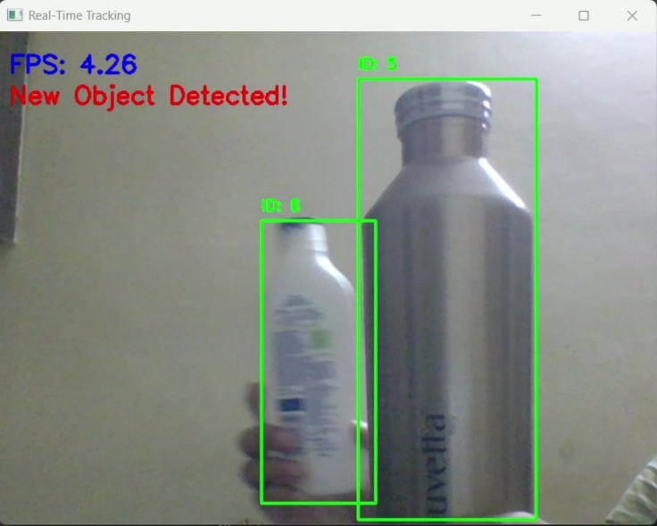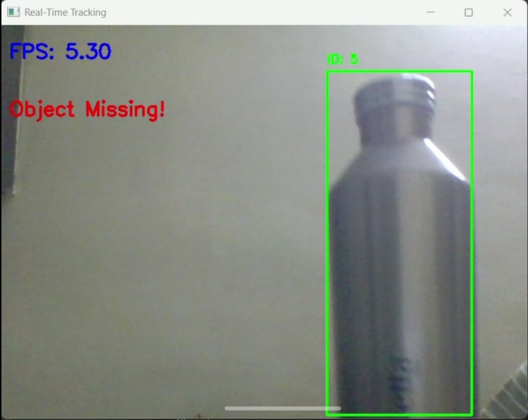**Sample Outputs:**

