**DBMS: Task 4**

1] How many employees working in each department?

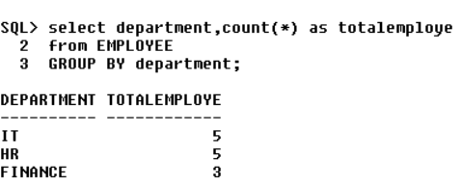

2] Find the total salary given to all employees department wise

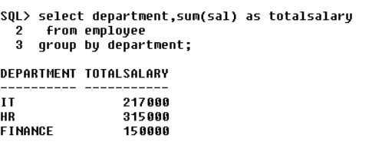

3] Display total no of employees lives per city

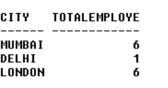4] Display count of male and female employees working for each department

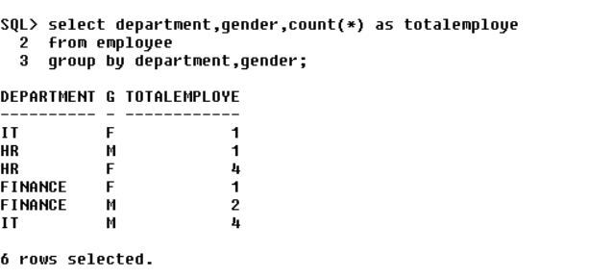5] Find the total salaries and the total number of employees by City, and by gender

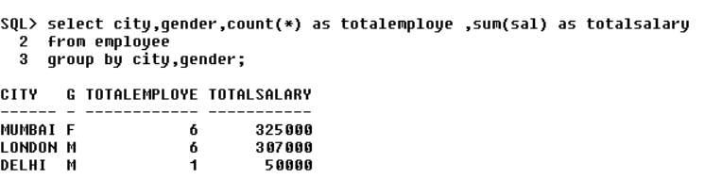

6] Display average salary given for every department

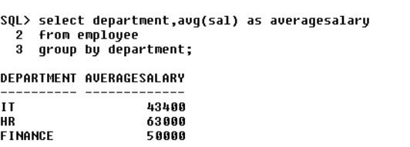

7] Total salary given to all employees who are working in London

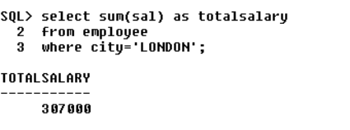

8] Retrieve the total salary of all the Male employees who are working in London

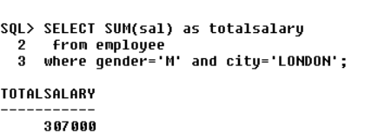

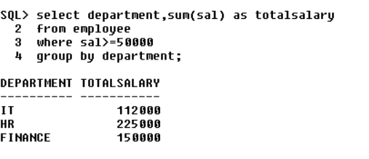9] Display department names who are giving salary more than 150000

10] Show department names who strength is more than 3

