1. Grade Checker
#Took score as input and kept in variable 'Grade'
Grade=int(input("Enter your marks\n"))

#Printing grades as per defined conditions in Assignment using if else:
if Grade>90:
print("A")
elif Grade>=80:
print("B")
elif Grade>70:
print("C")
elif Grade>=60:
print("D")
elif Grade<60:
print("F")

Output:
@Payal1899 ➜ /workspaces/Devops-Learning/Python (Assignment) $ python3 Grade_Checker.py
Enter your marks
87
B
@Payal1899 ➜ /workspaces/Devops-Learning/Python (Assignment) $ python3 Grade_Checker.py
Enter your marks
92
A
@Payal1899 ➜ /workspaces/Devops-Learning/Python (Assignment) $ python3 Grade_Checker.py
Enter your marks
60
D

2. Student Grades

#Creating dictionary
Dict={}
YN='Y'
while YN!='N':
YN=input("Do you want to add new Student and grades? Y/N\n")
if YN=='Y':
#Input for student name
Name = input("Enter name of student: ")
#Input for student grade
grade = int(input("Enter Grades: "))
#Adding input to dictionary
Dict[Name]=grade
else:
#Input for student name
Name = input("Enter name of student who's grades to be modified: ")
if Name in Dict:
#Input for student grade
grade = int(input("Enter Grades: "))
#Modifying student grade in dictionary
Dict[Name]=grade
else:
print("Enterred student is not available")
YN=input("Do you want to perform anymore updates? Y/N\n")

#Printing content of decitionary
print(Dict)

Output:
@Payal1899 ➜ /workspaces/Devops-Learning/Python (Assignment) $ python3 Student_grades.py
Do you want to add new Student and grades? Y/N
Y
Enter name of student: Punam
Enter Grades: 87
Do you want to perform anymore updates? Y/N
Y
Do you want to add new Student and grades? Y/N
N
Enter name of student who's grades to be modified: Punam
Enter Grades: 89
Do you want to perform anymore updates? Y/N
N
{'Punam': 89}

3.Write to a File
#create new file with write mode
with open("example.txt", "w+") as file1:
#writes into file example.txt
file1.write("Hello, world!")
file1.seek(0) #movin cursor back to initial position
#inside with block so no need to open the file again as we have opened file in write+read mode
Read=file1.read() #reads the file
#print content of the file
print(Read)
Output:

@Payal1899 ➜ /workspaces/Devops-Learning/Python (Assignment) $ python3 Fileoperations.py
Hello, world!

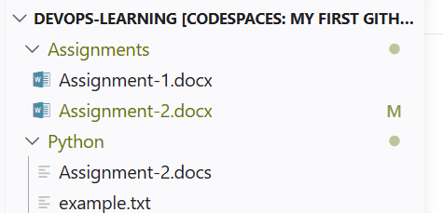

4.Read from a File
#open file example.txt in read mode
file1=open("example.txt", "r")
#read and print the content of the file
print(file1.read())
#close the file
file1.close()
Output:
@Payal1899 ➜ /workspaces/Devops-Learning/Python (Assignment) $ python3 Fileoperations.py
Hello, world!

Repo link: https://github.com/Payal1899/Devops-Learning/blob/Assignment/Assignments/Assignment-2.docx

