Download / clone git repository

Steps:

Go to folder where “src folder” is located open cmd and run command > npm install

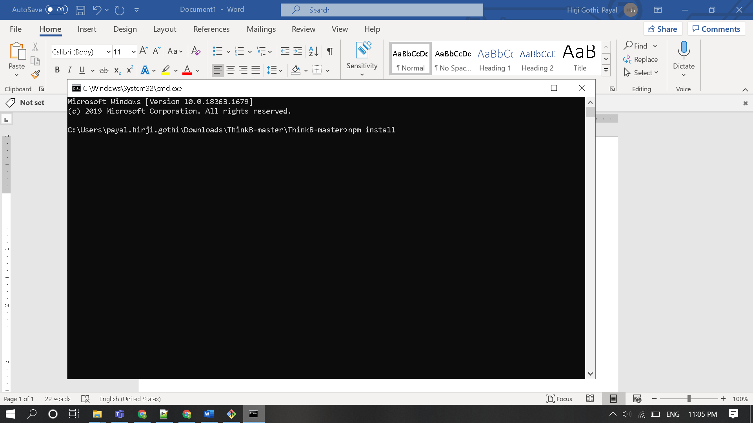

2.Run App > after npm install

Run ng serve

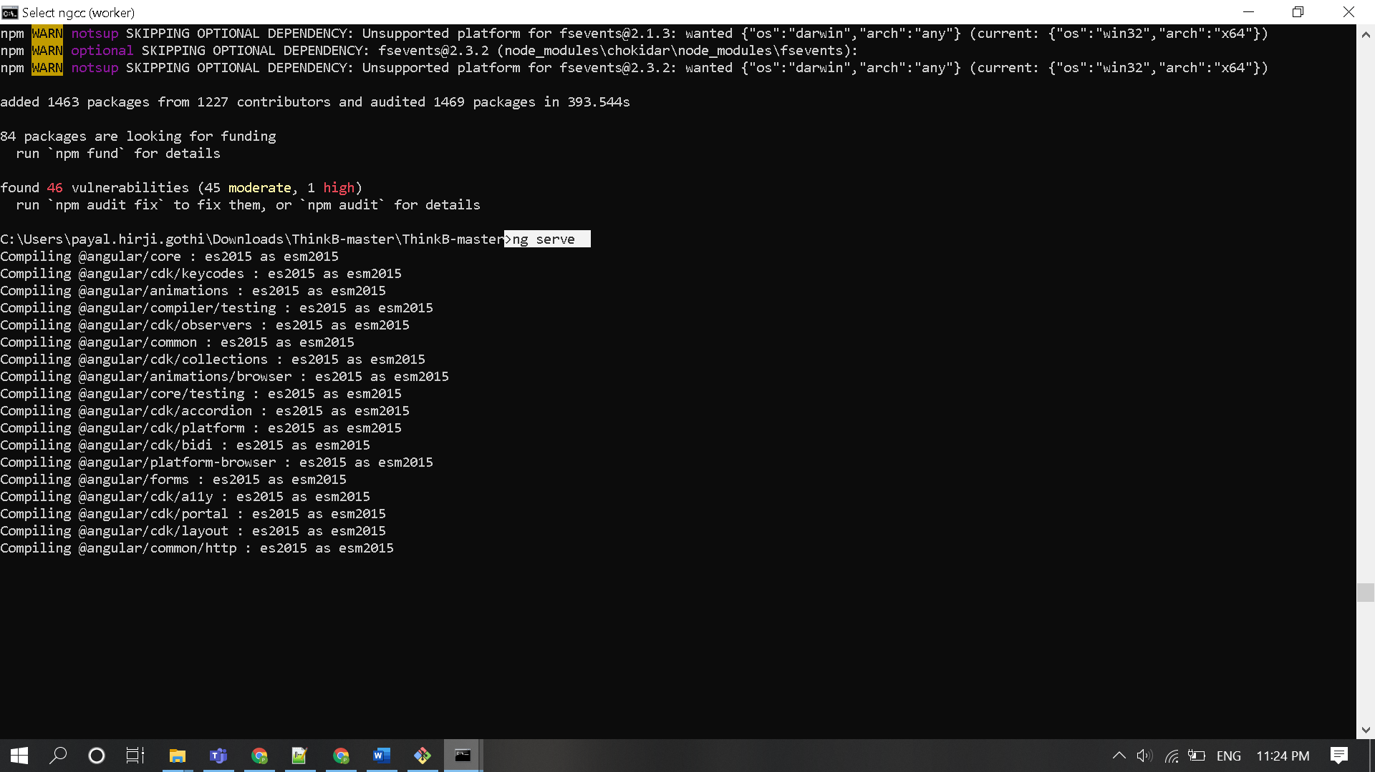

3. Running api

Requirement Python installed

Go to src\app folder open cmd run command > python inventory.py 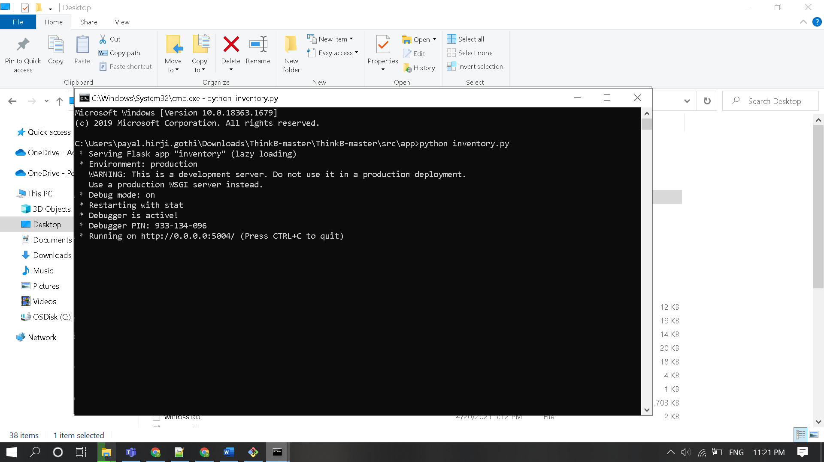

4. Run Application: http://localhost:4200

