Name: Payal Sharma

Date: 27/01/2014

Assignment 1: Lab Work

1. Image showing connection to Server:

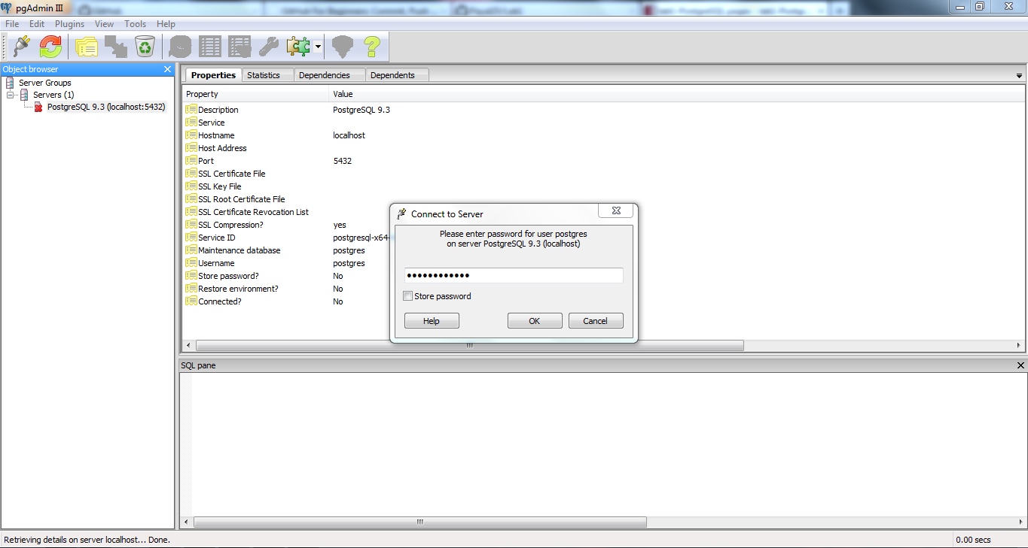

1. Image to show to the database and the query editor:

