Name: Payal Sharma

Date: 02/04/2014

Assignment 2: Lab Work

#Q1

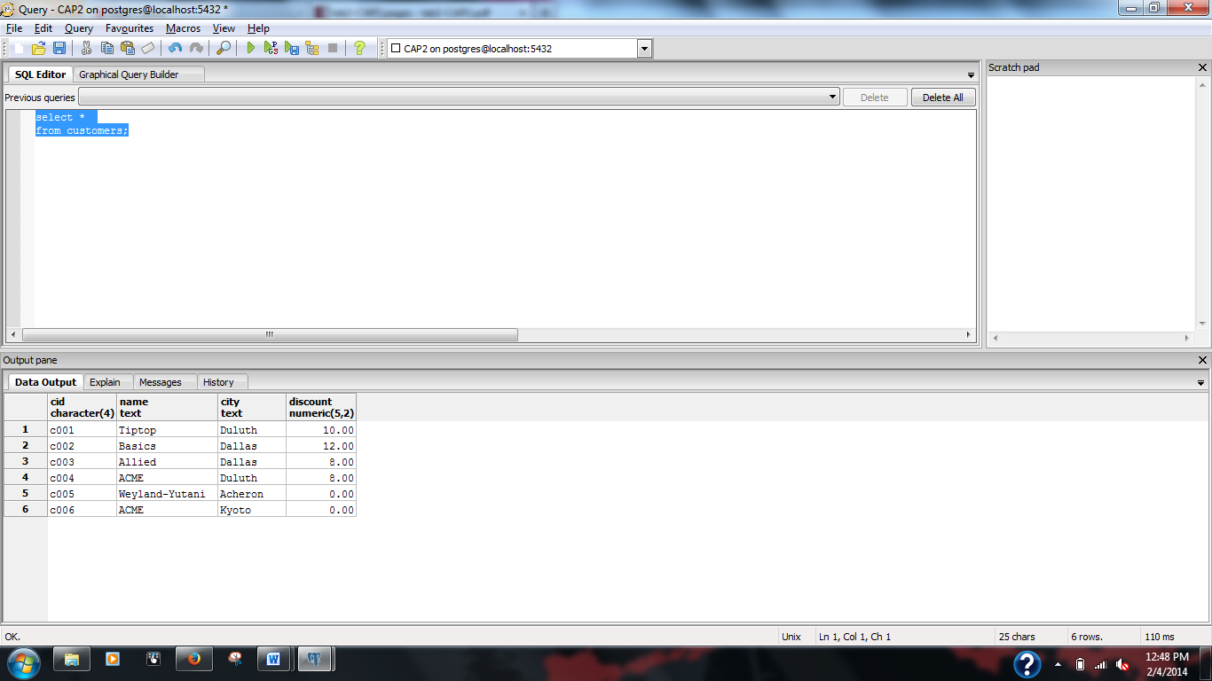

#Q2

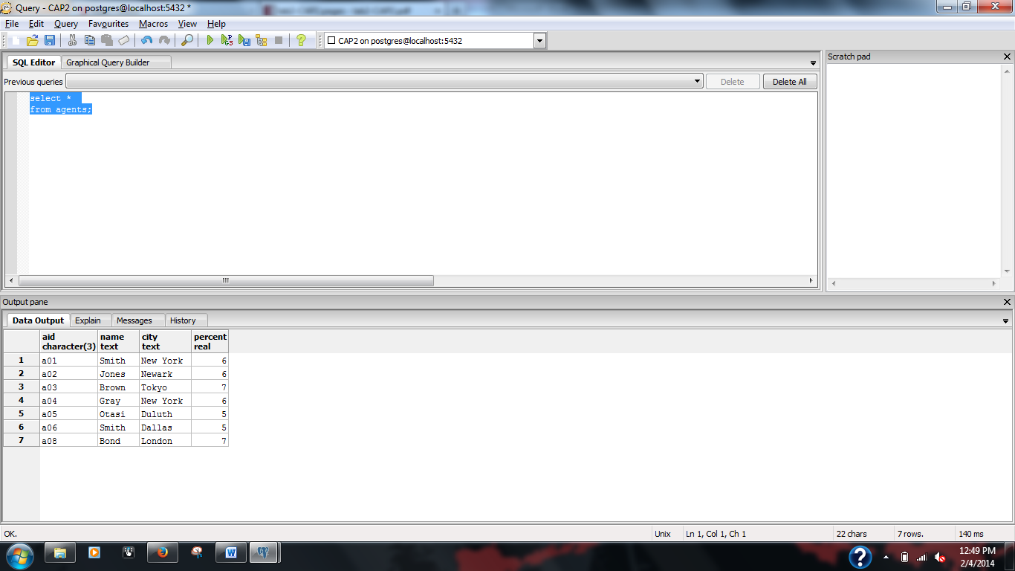

#Q3

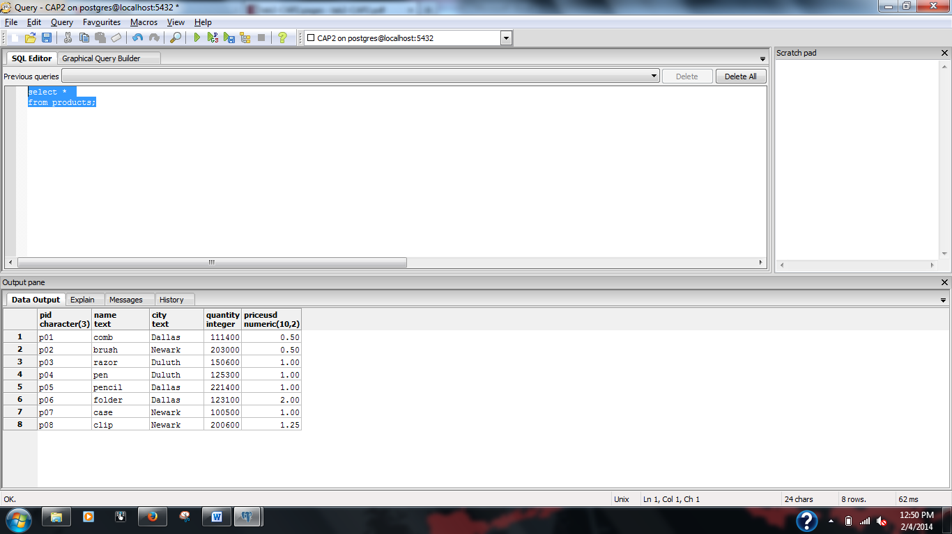

#Q4

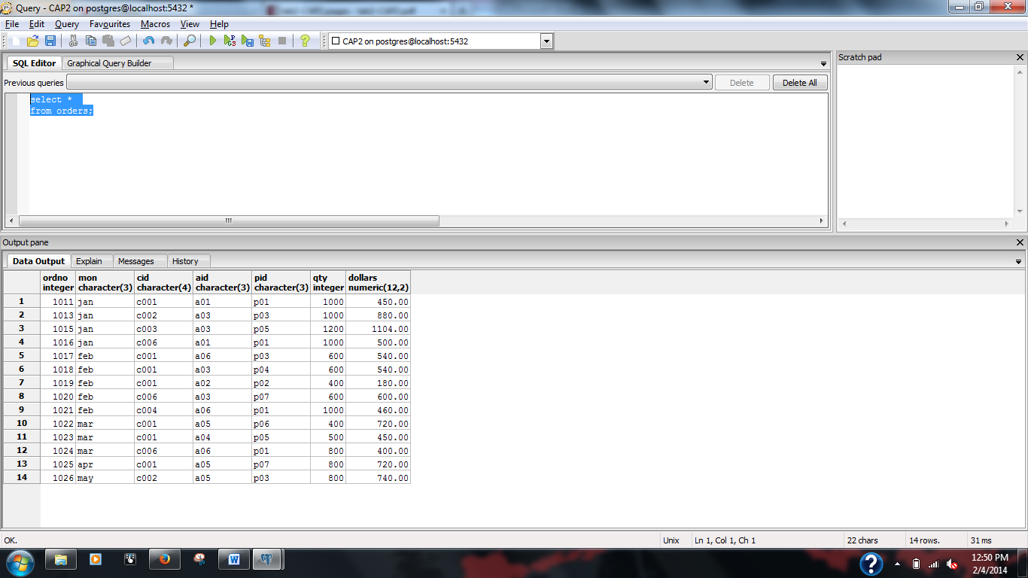

I have compared the data of all four tables. It is same.