SCHOOL OF INFORMATION TECHNOLOGY

Assignment Code | SF1
Assignment Type | Project
Assignment Type | Individual Assignment
Total Marks | 300

Module Name | Web Interactive Design
Module Code | WI12

Assignment Title: | Web Interactive Design for WI12_Assignment_SF1
Student's Name: | Payal.S.Morar
Date of Submission: | 13 October 2023
Qualification: | BSc in Web Design and Web Development
Year: | 1

.DESCRIPTION

For this assignment, students are required to gather information, then design, and produce a 30-second motion Infographic based on how the Fintech Industry in Africa will look in the year 2030. In doing so, students will adhere to specific requirements to solve real-world problems using industry-related App development principles/standards. Such as using the Adobe Application Suite to design and create infographics.
Table of Contents

Task 1 – Gathering Information 3
1.1. Gathering Infographics 3
1.1.1. Infographic 1 3
1.1.2. Infographic 2 4
1.1.3. Infographic 3 5
1.1.4. Infographic 4 6
1.1.5. Infographic 5 7
1.2. Fintech Information Gathering 8
1.2.1. Research 8
1.2.2. Storyline 12
1.2.3. Information Data 12
1.2.4. Design Thoughts 13
1.2.5. Graphs 13
1.3. Explaining Fintech Industry 14
1.3.1. Definition 14
1.3.2. Key Concepts 14
1.3.3. Opportunities 15
1.3.4. Challenges 16
1.4. Key Objectives 17
References 18

Task 1 – Gathering Information

Gathering Infographics

Infographic 1

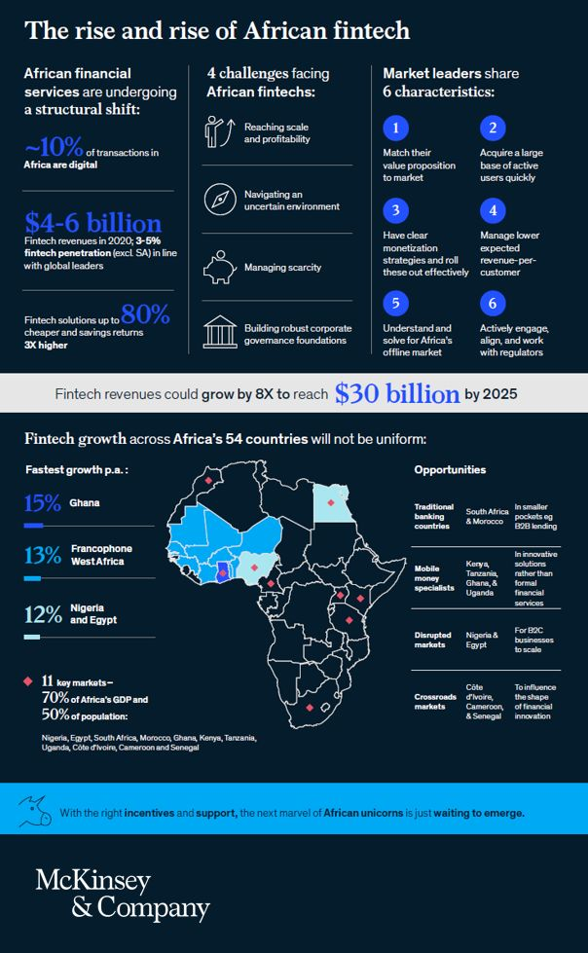
Figure 1: (Reem El Sherif, Reem El Sherif, Phd posted on linkedin 2022)
Title: The Rise and Rise of African Fintech
Description:
The infographic shows that African fintech is emerging as a hotbed for investment, with average deal sizes growing and the proportion of fintech funding in Africa increasing over the past year, bringing jobs and growth to African economies.
How to make the infographic interactive:
Create clickable icons that will demonstrate the emerging as a hotbed for investment. Make the map of Africa point out the highlighted areas.

Infographic 2

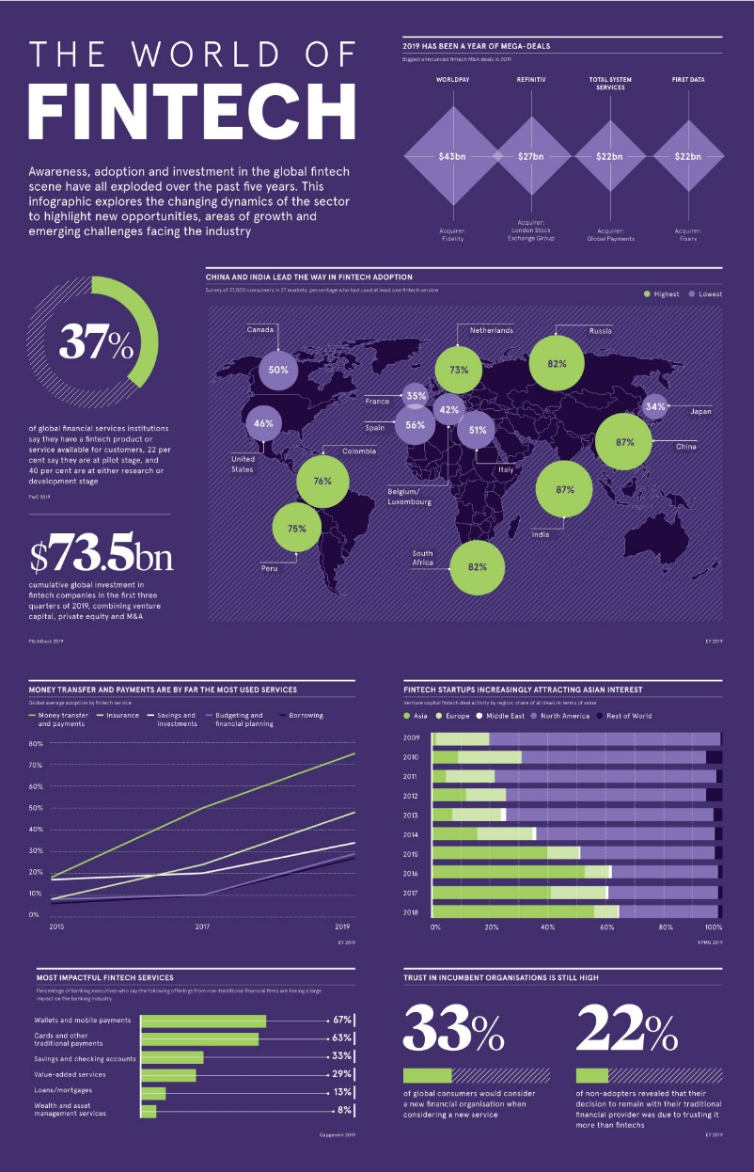
Figure 2: (Ghosh & Khan Graphics & Design Alejandra Dander, Visualizing the current landscape of the fintech industry 2020)
Title: The World of Fintech
Description:
The infographic from Raconteur highlights the global growth of the fintech industry, the services with the most staying power, and major M&A developments of the past year as traditional institutions scramble to deal with this digital disruption.

How to make the infographic interactive:
Interactive charts displaying success stories of fintech-driven startups, with clickable profiles.

Infographic 3

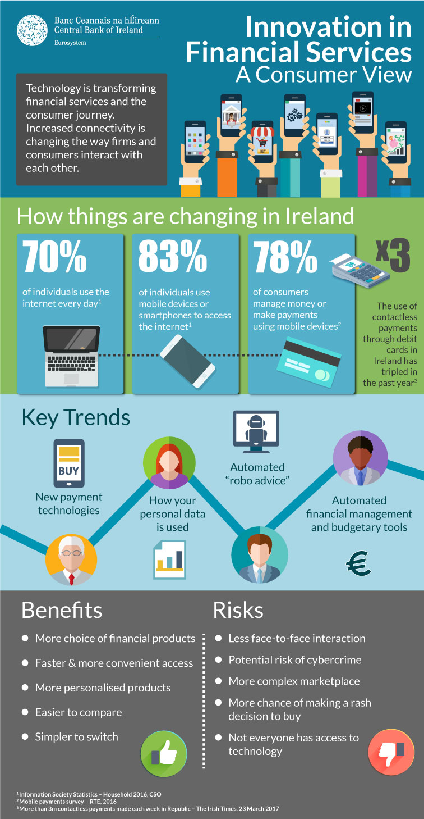
Figure 3: (What is 'Fintech' and how is it changing financial products?)
Title: Innovation in Financial Services – A Consumer View
Description:
Infographic that explains what is fintech and how is it changing financial products.
How to make the infographic interactive:
Timeline animation showcasing key trends of financial services. Clickable bullet points that explain the benefits and risks in more detail.

Infographic 4

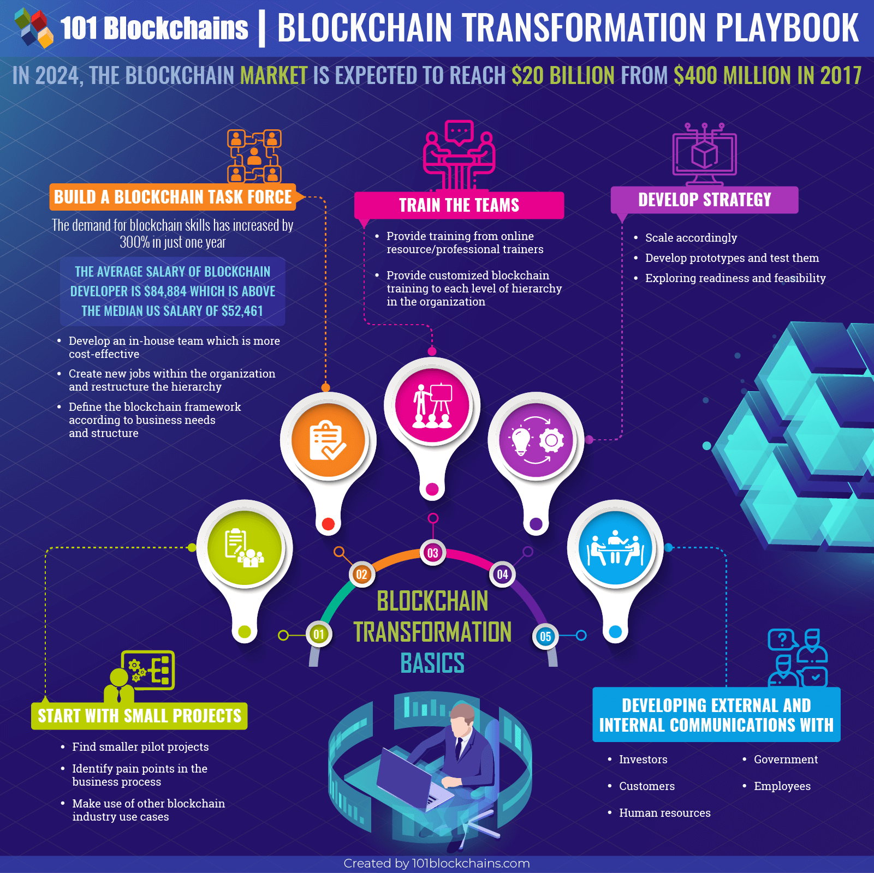
Figure 4: (Best blockchain infographics collection 2021)
Title: Blockchain Transformation Playbook
Description:
Infographic shows you a step-by-step process of the blockchain transformation. Basically, you can see that there are five steps for a successful blockchain transformation.
How to make the infographic interactive:
Clickable icons that expand to show detailed explanations when navigated through the dotted lines.

Infographic 5

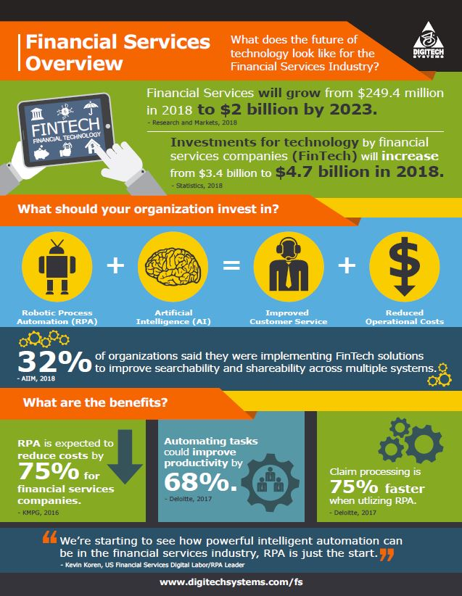
Figure 5: (Financial Services infographic 2018)
Title: Financial Services Overview
Description:
Infographic that shows what the Future of Technology Look Like for the Financial Services Industry.
How to make the infographic interactive:
Clickable icons that expand to show detailed explanations and progress towards each goal. Make the numbers standout.

Fintech Information Gathering

Research

Main Idea: How the Fintech Industry in Africa will look like in the year 2030?
- Africa will have a fintech market worth $65 billion. The market size will grow from its present $5 billion level by a factor of thirteen. (Fintech in Africa: The end of the beginning, 2022)
- Mobile money will be the main factor in growth. In Africa, mobile money is already the most used method of payment, and this pattern is anticipated to last. (Fintech in Africa: The end of the beginning, 2022)
- The importance of financial inclusion will increase. Millions of Africans are either underbanked or unbanked, and fintech startups are attempting to change that. (Fintech in Africa: The end of the beginning, 2022)
- A significant part of the growth of Africa's digital economy will be played by fintech. In addition to helping individuals more easily access necessary financial services, fintech companies will help to develop new businesses and jobs. (Fintech in Africa: The end of the beginning, 2022)
- Africa will develop as a centre for fintech innovation worldwide. The continent is home to several top-notch colleges and a young, tech-savvy populace. (Fintech in Africa: The end of the beginning, 2022)
Statistical information:
- From 2021 through 2030, the African fintech sector is anticipated to expand at a compound annual growth rate (CAGR) of 32 percent, according to a report by the Boston Consulting Group and QED Investors. (Fintech in Africa: The end of the beginning, 2022)
- In Africa, mobile money is the most widely used method of payment. Africa is predicted to have 1 billion mobile money accounts by 2030, up from an estimated 600 million in 2021. (Fintech in Africa: The end of the beginning, 2022)
- In Africa, there are 1.2 billion individuals who lack access to banking, according to the UN. A lot of progress has been made recently by fintech companies in their efforts to provide financial services to these folks. (Fintech in Africa: The end of the beginning, 2022)
- By 2030, the African Development Bank predicts that the continent's digital economy would be worth $1 trillion. An important part of the development of this digital economy is being played by fintech companies. (Fintech in Africa: The end of the beginning, 2022)

The fintech Industries in Africa are expected to incorporate these key areas in 2030:
Payments:
- Mobile payments are already a market leader in Africa, and this development is anticipated to continue. Blockchain technology will be used by fintech companies to create fresh, creative methods for improving payment systems' efficiency and security.(Botta et al., The Future of Payments in Africa, 2022)
- They will also investigate how biometrics, including fingerprint and facial recognition, can facilitate payments. Using smart contracts to automate payments and lower the risk of fraud may fall under this category.(Botta et al., The Future of Payments in Africa, 2022)
- The development of mobile payment solutions that are usable by residents in rural areas will also be a priority for fintech companies. This can entail creating solutions for low-bandwidth networks or deploying solar-powered mobile payment devices.(Botta et al., The Future of Payments in Africa, 2022)
  - The value of mobile payments in Africa is expected to reach $1 trillion by 2030. (Botta et al., The Future of Payments in Africa, 2022)
  - The number of mobile money users in Africa is expected to reach 500 million by 2030. (Botta et al., The Future of Payments in Africa, 2022)
Banking as a Service (BaaS):
- Businesses can provide banking services through BaaS without needing to establish their own banks. This practice is becoming more popular in Africa as it gives small businesses access to banking services that would otherwise be inaccessible. They give them a range of financial services, including the ability to open new accounts, borrow money, and make mobile payments. Small businesses will benefit from easier access to the financial services they require to expand.(celner, Bank of 2030: The Future of Banking)
- BaaS providers will collaborate with a broader range of companies, including non-profit organizations, retailers, and microfinance institutions. This will facilitate granting more individuals in Africa access to banking services.(celner, Bank of 2030: The Future of Banking)
- BaaS suppliers will also create more complex solutions to address the unique requirements of organizations. This might involve offering cash flow management options, loans, or insurance coverage.(celner, Bank of 2030: The Future of Banking)
  - The number of BaaS providers in Africa is expected to grow from 50 to 200 by 2030. (celner, Bank of 2030: The Future of Banking)
  - The value of the BaaS market in Africa is expected to reach $10 billion by 2030. (celner, Bank of 2030: The Future of Banking)

Insurtech:
- The term "insurtech" refers to the application of technology to the insurance sector. This involves utilizing data analytics to make underwriting choices and mobile apps to streamline the purchase and management of insurance policies for clients.. (Balasubramanian et al., Insurance 2030-the impact of AI on the future of Insurance, 2021)
- Data analytics will be used by insurtech companies to create more precise and individualized underwriting choices. Additionally, they will use mobile apps to simplify the process for customers to obtain quotations, make payments, file claims, and purchase and manage insurance plans.(Balasubramanian et al., Insurance 2030-the impact of AI on the future of Insurance, 2021)
  - The value of the insurtech market in Africa is expected to reach $5 billion by 2030. (Balasubramanian et al., Insurance 2030-the impact of AI on the future of Insurance, 2021)
Cybersecurity:
- Businesses in Africa are highly concerned about cybersecurity since they are frequently the subject of cyberattacks. Fintech businesses will need to create fresh strategies to safeguard client data and stop cyberattacks.(Middle East and Africa cyber security 2023-2030, 2022)
- In order to safeguard client data from hackers, fintech organizations will make investments in cybersecurity measures. Additionally, they will inform clients about the dangers of cybersecurity and how to safeguard themselves. This could involve using encryption, firewalls, and intrusion detection systems. (Middle East and Africa cyber security 2023-2030, 2022)
- Additionally, fintech businesses will inform clients about the dangers of cyberattacks and how to guard against them. This can entail giving advice on how to make secure passwords, stay away from phishing schemes, and keep informed of the most recent risks.
  - The number of cyberattacks in Africa is expected to increase by 50% in 2030. (Middle East and Africa cyber security 2023-2030, 2022)
  - The cost of cyberattacks in Africa is expected to reach $10 billion by 2030. (Middle East and Africa cyber security 2023-2030, 2022)

Blockchain:
- A distributed ledger technology called blockchain can be used to record transactions securely and openly.
- The creation of safe data ecosystems that can be used to tag and track nearly any kind of goods is supported by blockchain technology. The retail sector will be significantly affected by this, giving brands more leverage to fend off the trade in counterfeit goods. These advancements may be especially crucial for reducing the trade in conflict diamonds in Africa. (THE DIGITAL TRANSFORMATION STRATEGY FOR AFRICA 2020-2030)
- Blockchain technology will be used by fintech companies to create applications for a range of markets, including payments, trade finance, and supply chain management. In order to track payments, transactions, and assets in a more safe and transparent manner, blockchain technology may be used.(THE DIGITAL TRANSFORMATION STRATEGY FOR AFRICA 2020-2030)
- The use of blockchain to develop new financial products and services will be investigated by fintech firms. This can entail establishing a decentralized exchange utilizing blockchain technology or issuing tokens that denote ownership of assets. (THE DIGITAL TRANSFORMATION STRATEGY FOR AFRICA 2020-2030)
  - The number of blockchain startups in Africa is expected to grow from 50 to 200 by 2030. (THE DIGITAL TRANSFORMATION STRATEGY FOR AFRICA 2020-2030)

Storyline
Title – Beyond Payments – The Expanding Fintech Landscape in Africa by 2030.

The storyline begins by setting the stage for the fintech industry in Africa in the year 2030. Africa is experiencing a fintech revolution, with innovative solutions transforming the financial landscape. This infographic is a glimpse of the key aspects that will shape this dynamic industry.

Information Data

Objective Chart:
Africa's fintech revenue is set to surge at a 32% CAGR until 2030, as per BCG and QED Investors' analysis. (Gilbert, Collaborate - innovate - transform – monetize, 2023)

Computer Screen:

Payments: Africa expects $1 trillion in mobile payments and 500 million mobile money users by 2030. Fintech companies will explore biometrics (fingerprint and facial recognition) for payments and employ smart contracts to automate payments and reduce fraud risks. (Fintech in Africa: The end of the beginning, 2022)

Insurtech: Insurtech’s use data analytics for personalized underwriting and mobile apps for simplified customer interactions, including quotes, payments, claims, and plan management. (Fintech in Africa: The end of the beginning, 2022)

Blockchain: Fintech’s in Africa are adopting blockchain for safer and transparent payments, with an expected growth in blockchain startups from 50 to 200 by 2030. (Fintech in Africa: The end of the beginning, 2022)

Cybersecurity: Cybersecurity measures safeguarded data and transactions. Banking as a Service: BaaS is on the rise in Africa, enabling small businesses to access vital financial services and custom solutions like loans and insurance. (Fintech in Africa: The end of the beginning, 2022)

Panda Mascot:
The friendly Panda mascot embodies the approachability and warmth of African fintech services, making finance more accessible to all. The Panda leans on a credit card, symbolizing the convenience and ease of use that fintech provides.

Design Thoughts

Colour Scheme:
Vibrant Orange Office Background: The choice of an inviting, vibrant orange office background signifies energy, optimism, and innovation. It immediately captures the viewer's attention and sets a positive tone for the infographic.
Vibrant Green Accents: Green accents are used throughout the infographic to symbolize growth, prosperity, and sustainability. They complement the dominant orange background and highlight key information and milestones. (Kramer, Color meanings and the art of using color symbolism - 99designs, 2022)

Panda Mascot:
The Panda mascot serves as a friendly, approachable, and relatable figure. Its presence adds a touch of charm and humanizes the fintech industry, making it more relatable to the audience.

Computer Screen:
Placing the key focus areas (Payments, Insurtech, Blockchain, Cybersecurity, and Banking as a Service) on a computer screen allows for a visually appealing and organized presentation of detailed information.

Balance of Information:
The infographic balances visual elements with concise textual information. It avoids overwhelming the viewer with excessive details, making the content easily digestible.

Font Choices:
Choosing a clean, modern font ensures readability and professionalism. The font colour and style are selected to match the overall aesthetic and colour scheme. (DigitalSynopsis.com, What different types of fonts mean and how to use them, 2023)

Graphs

Milestones: Important milestones and achievements are marked on the graph, emphasizing the industry's steady ascent.

Bar Graph: A dynamic bar graph demonstrates the impressive growth of the African fintech industry from 2020 to 2030. It showcases key metrics such as investment, user adoption, revenue, and cybersecurity measures implemented.

Explaining Fintech Industry

Definition

Fintech Industry also known as financial technology is based on a broad term that encompasses the use of technology to deliver and enhance financial services. It stands for the point where technology and finance converge, when diverse facets of the financial sector are addressed using cutting-edge solutions and technological instruments. Fintech is transforming how financial services are accessible, provided, and managed while also providing advantages including improved efficiency, accessibility, and convenience. The technologies that support the various fintech industry business models differ greatly. They consist of robotic processing automation, AI, machine learning, and blockchain technology, among other big data applications (RPA). (Fintech Financial Technology, 2022)

Key Concepts

The main purpose of fintech is to assist corporations, business owners, and individuals in managing their financial operations, procedures, and lives more effectively. It is made up of specialized software and algorithms utilized by laptops and mobile devices. (Fintech Financial Technology, 2022)
Each use case is distinct, but the overall goal of disaggregating the financial services industry which has historically benefited from extensive regulation and is what unites them all. (Fintech Financial Technology, 2022)
Three primary purposes are served by traditional financial service providers, mostly banks and credit unions:
- They keep cash on hand, including deposits and a range of investment options.
- They provide loans, both secured (such as mortgages) and unsecured (like student lines of credit).
- They move money through international money transfers and routine, straightforward payments through global networks like SWIFT (Society for Worldwide Interbank Financial Telecommunications).
The creation and application of cryptocurrencies like Bitcoin is also a part of fintech. The traditional international banking sector, with its multitrillion-dollar market capitalization, continues to be where the big money is, even though the fintech sector may garner the majority of headlines. (Fintech Financial Technology, 2022)

Opportunities

Enhanced Accessibility: Fintech solutions make financial services more accessible to individuals and businesses, especially in underserved or remote areas where traditional banking infrastructure may be lacking. (Podgaiskaya, Top challenges and opportunities for Fintech in 2023 2023)

Cost Savings: Automation and digitization in fintech lead to cost savings for financial institutions and ultimately for consumers, as it reduces the need for physical branches and paperwork. (Podgaiskaya, Top challenges and opportunities for Fintech in 2023 2023)

Financial Inclusion: Fintech has the potential to bring millions of unbanked or underbanked individuals into the formal financial system, offering them a range of services they didn't have access to before. (Podgaiskaya, Top challenges and opportunities for Fintech in 2023 2023)

Innovation: Fintech fosters continuous innovation, leading to the development of new financial products and services that cater to evolving customer needs. (Podgaiskaya, Top challenges and opportunities for Fintech in 2023 2023)

Efficiency: Through automation and AI-driven processes, fintech enhances the efficiency of financial operations, reducing processing times and errors. (Podgaiskaya, Top challenges and opportunities for Fintech in 2023 2023)

Investment Opportunities: The fintech sector itself presents investment opportunities, as startups and established companies seek funding to develop and scale their innovative solutions. (Podgaiskaya, Top challenges and opportunities for Fintech in 2023 2023)

Challenges

Cybersecurity Concerns: As fintech relies heavily on technology, it is susceptible to cybersecurity threats. Protecting sensitive financial data is a constant challenge. (Podgaiskaya, Top challenges and opportunities for Fintech in 2023 2023)

Data Privacy: The collection and use of customer data in fintech services raise privacy concerns. Companies must adhere to strict data protection regulations. (Podgaiskaya, Top challenges and opportunities for Fintech in 2023 2023)

Competition: The fintech industry is highly competitive, with numerous startups and established players vying for market share. This competition can make it challenging for new entrants. (Podgaiskaya, Top challenges and opportunities for Fintech in 2023 2023)

Financial Literacy: Some fintech solutions may be complex for users who are not financially literate. Ensuring that customers understand and use these services effectively is crucial. (Podgaiskaya, Top challenges and opportunities for Fintech in 2023 2023)

Market Volatility: Cryptocurrencies and blockchain technologies, although promising, are known for their price volatility. This can pose risks to investors and users. (Podgaiskaya, Top challenges and opportunities for Fintech in 2023 2023)

Key Objectives

Promoting financial inclusion, innovation, and economic development while maintaining consumer safety and protection will be the primary goals of the fintech sector in Africa in 2030. All people in Africa should therefore have access to fundamental financial services like payments, credit, and savings. To develop an inclusive and sustainable financial ecosystem, cooperation between governments, fintech businesses, traditional financial institutions, and various stakeholders is required. (Gilbert, Collaborate - innovate - transform – monetize, 2023)
According to a new analysis from Boston Consulting Group (BCG) and QED Investors, Africa will experience the highest rise in fintech revenue, with a compound annual growth rate (CAGR) of 32% from now until 2030. (Gilbert, Collaborate - innovate - transform - monetize 2023)
The African Union (AU) has established a variety of goals to accomplish this goal, including:
- 50% more bank accounts would be opened
- A 25% cost reduction for financial services
- Double the amount of people using mobile payment systems
- Increasing the reach of microfinance organizations by 50%
(THE DIGITAL TRANSFORMATION STRATEGY FOR AFRICA 2020-2030)
The AU is also attempting to improve the regulatory climate for fintech businesses. This entails creating a uniform set of rules for fintech businesses throughout Africa and offering funding to fintech entrepreneurs. (THE DIGITAL TRANSFORMATION STRATEGY FOR AFRICA 2020-2030)
For Africa, achieving universal financial inclusion would provide a lot of advantages, such as:
- Accelerated economic expansion
- Decreased poverty
- Higher level of financial literacy
- Increased credit availability
- Increased financial security
The quest to attain widespread financial inclusion in Africa involves the fintech sector heavily. Innovative solutions are being created by fintech companies to make it simpler and more affordable for customers to access financial services. (THE DIGITAL TRANSFORMATION STRATEGY FOR AFRICA 2020-2030)

References

Balasubramanian, R., Libarikian, A. and McElhaney, D. (2021) Insurance 2030-the impact of AI on the future of Insurance, McKinsey & Company. Available at: https://www.mckinsey.com/industries/financial-services/our-insights/insurance-2030-the-impact-of-ai-on-the-future-of-insurance (Accessed: 27 August 2023).
Best blockchain infographics collection (2021) 101 Blockchains. Available at: https://101blockchains.com/blockchain-infographics/ (Accessed: 27 August 2023).
Botta, A. et al. (2022) The Future of Payments in Africa, McKinsey & Company. Available at: https://www.mckinsey.com/industries/financial-services/our-insights/the-future-of-payments-in-africa (Accessed: 27 August 2023).
Celner, Anna (no date) Bank of 2030: The Future of Banking, Deloitte. Available at: https://www.deloitte.com/global/en/Industries/financial-services/perspectives/bank-of-2030-the-future-of-banking.html (Accessed: 27 August 2023).
CFI Team (2022) Fintech (Financial Technology), Corporate Finance Institute. Available at: https://corporatefinanceinstitute.com/resources/wealth-management/fintech-financial-technology/?campaignid=20123236318&adgroupid=&adid=&gclid=CjwKCAjwxaanBhBQEiwA84TVXHYbSeETOfHUXCyS66lfjapXvQ2pwn3BlN8V8F7BEybItYF5GN1uLBoCWd4QAvD_BwE (Accessed: 27 August 2023).
Financial Services infographic (2018) Digitech Systems, LLC. Available at: https://www.digitechsystems.com/financial-services-infographic/ (Accessed: 27 August 2023).
Fintech in Africa: The end of the beginning (2022) McKinsey & Company. Available at: https://www.mckinsey.com/industries/financial-services/our-insights/fintech-in-africa-the-end-of-the-beginning (Accessed: 27 August 2023).
Ghosh, I. and Khan Graphics & Design Alejandra Dander, R. (2020) Visualizing the current landscape of the fintech industry, Visual Capitalist. Available at: https://www.visualcapitalist.com/current-fintech-industry/ (Accessed: 27 August 2023).
Gilbert, P. (2023) Collaborate - innovate - transform - monetize, Connecting Africa. Available at: https://www.connectingafrica.com/author.asp (Accessed: 27 August 2023).
Middle East and Africa cyber security market size, share & covid-19 impact analysis, by security type (Network Security, cloud application security, end-point security, Secure Web Gateway, Application Security, and others (internet security)), by Enterprise Size (Small & medium-sized enterprises and large enterprises), by industry (BFSI, IT and Telecommunications, retail, healthcare, government, manufacturing, travel and transportation, energy and utilities, and others), and Regional Forecast, 2023-2030 (2022) Middle East and Africa Cyber Security Market Report [2030]. Available at: https://www.fortunebusinessinsights.com/middle-east-and-africa-cyber-security-market-107432 (Accessed: 27 August 2023).
Moloko, M.G. et al. (2023) Africa’s fintech boom: Fastest-growing region, Ventureburn. Available at: https://ventureburn.com/2023/07/africas-fintech-boom-fastest-growing-region/#:~:text=Meanwhile%2C%20Africa’s%20fintech%20market%2C%20led,(CAGR)%20of%2032%25. (Accessed: 27 August 2023).
Patat, P. (no date) Why Africa has the future of payments, LinkedIn. Available at: https://www.linkedin.com/pulse/why-africa-has-future-payments-philippe-patat (Accessed: 27 August 2023).
Podgaiskaya, E. (2023) Top challenges and opportunities for Fintech in 2023, Velmie. Available at: https://www.velmie.com/post/fintech-companies-challenges-and-opportunities-in-2023 (Accessed: 11 October 2023).
Reem El Sherif, P. (2022) Reem El Sherif, Phd posted on linkedin, Reem El Sherif, PhD posted on LinkedIn. Available at: https://www.linkedin.com/posts/reem-el-sherif_africa-mckinseyafrica-fintech-activity-6976427419511500800-9ymb/?originalSubdomain=za (Accessed: 27 August 2023).
THE DIGITAL TRANSFORMATION STRATEGY FOR AFRICA (2020) Google. Available at: https://chrome.google.com/webstore/detail/adobe-acrobat-pdf-edit-co/efaidnbmnnnibpcajpcglclefindmkaj?hl=en-GB (Accessed: 27 August 2023).
Tomboc, K. (no date) How to make animated infographics: Creative tips and ideas, Learn Hub. Available at: https://learn.g2.com/animated-infographics (Accessed: 27 August 2023).
What is ‘Fintech’ and how is it changing financial products? (no date) Central Bank of Ireland. Available at: https://www.centralbank.ie/consumer-hub/explainers/what-is-fintech-and-how-is-it-changing-financial-products (Accessed: 27 August 2023).

