SCHOOL OF INFORMATION TECHNOLOGY

Assignment Code | SF1
Assignment Type | Project
Assignment Type | Individual Assignment
Total Marks | 300

Module Name | Web Interactive Design
Module Code | WI12

Assignment Title: | Web Interactive Design for WI12_Assignment_SF1
Student's Name: | Payal.S.Morar
Date of Submission: | 13 October 2023
Qualification: | BSc in Web Design and Web Development
Year: | 1

.DESCRIPTION

For this assignment, students are required to gather information, then design, and produce a 30-second motion Infographic based on how the Fintech Industry in Africa will look in the year 2030. In doing so, students will adhere to specific requirements to solve real-world problems using industry-related App development principles/standards. Such as using the Adobe Application Suite to design and create infographics.
Table of Contents

Task 3 – Design 3
3.1. Illustrations 3
3.2. Final Illustration 7
3.3. Designing Motion Infographics 9
3.4. Sound Editing 10
1. Different Sounds Per SWOT 10
2. Background Music 11
3. Use of Sound Effects 11
4. Sound Editing 12
References 13

Task 3 – Design

Illustrations

Cultural Relevance: Mascots are a fun and approachable method to appeal to a wide range of people. The usage of mascots like the beaver and panda can overcome language borders and resonate with a wide spectrum of people in Africa, where there is a wealth of cultural diversity.
Animal Symbolism: The beaver is frequently connected with laborious labour, inventiveness, and construction, all of which are crucial attributes in fintech and reflect the sector's inventive and tenacious spirit. The panda is a symbol of warmth and approachability, traits that can promote customer loyalty and trust.
Industry Representation: The computer screen highlighting significant fintech industry sectors highlights the significance and relevance of these industries in Africa. It conveys that the fintech sector is a dynamic, all-encompassing industry. (Fintech images - free download on Freepik 2021)
Technology Integration: The computer screen emphasizes the importance of innovation and technology, both of which are crucial for the expansion of fintech in Africa. It illustrates how the region's financial services are driven by technology. (Fintech images - free download on Freepik 2021)
Security Emphasis: The computer screen's reference to cybersecurity highlights the significance of data security and protection in the fintech industry. In Africa, where worries about data security and privacy are of utmost importance, this is vital. (Fintech images - free download on Freepik 2021)
Growth in African Fintech A view into the future is provided by the graph showing the fintech market in Africa in 2030. It illustrates the sector's potential for expansion and growth, showing the hope and opportunity in African fintech.
Local Representation: By including African symbols or locations in the office background or on the chart, the image can be made to be more pertinent to the local context, supporting the notion that the fintech industry in Africa is prospering and meets regional demands and aspirations.

Final Illustration

In the illustration, A charming panda mascot leaning casually on a credit card. The credit card serves as the central focal point of the composition. The credit card displays the title of your fintech motion infographic, which is written in bold and modern typography, capturing the attention of the viewers. The credit card could have a reflective surface, giving it a polished and contemporary look.
The panda mascot, standing upright and friendly, adds a touch of character and relatability to the scene. The computer screen is placed on the table next to the panda, displaying five key areas of the fintech industry:
- Blockchain: A graphical representation of blockchain technology with interconnected blocks and data flows.
- Banking as a Service: An image representing a bank building transformed into a service platform with arrows connecting various banking services.
- Cybersecurity: A padlock and shield symbolizing the robust security measures in the fintech industry.
- Payments: Icons of various payment methods, such as credit cards, mobile payment apps, and digital wallets.
- Insurtech: A combination of an insurance symbol and innovative technology elements, demonstrating the insurtech sector.

The office background is modern and sophisticated, with clean lines and a window that allows a glimpse of the city skyline. The office is bathed in soft, natural light, creating an inviting and conducive workspace. There's a stylish desk with the computer on it, indicating a professional environment.
In the background, there is a futuristic chart that predicts what the fintech industry in Africa will look like in the year 2030. This chart is a visual representation of data and trends, showing growth and evolution in the fintech sector.

Designing Motion Infographics

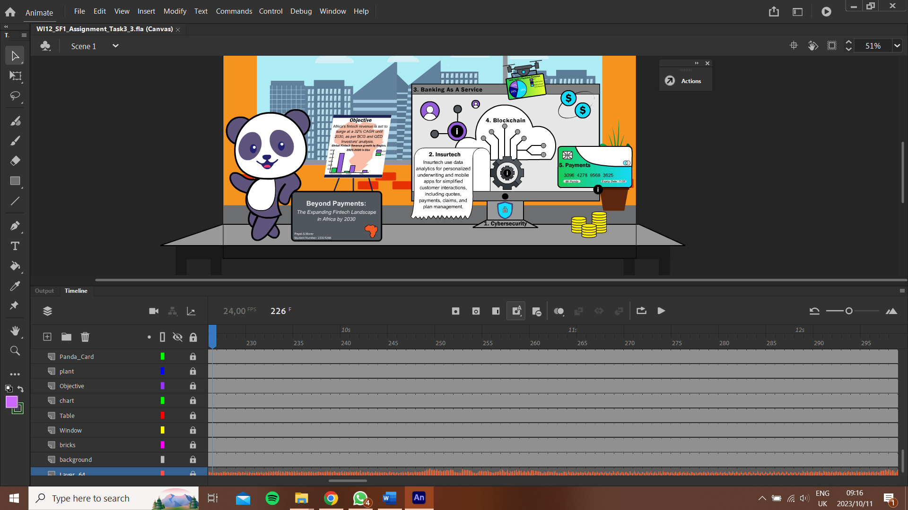
Figure 1: Adobe Animate - Designing Motion Infographics

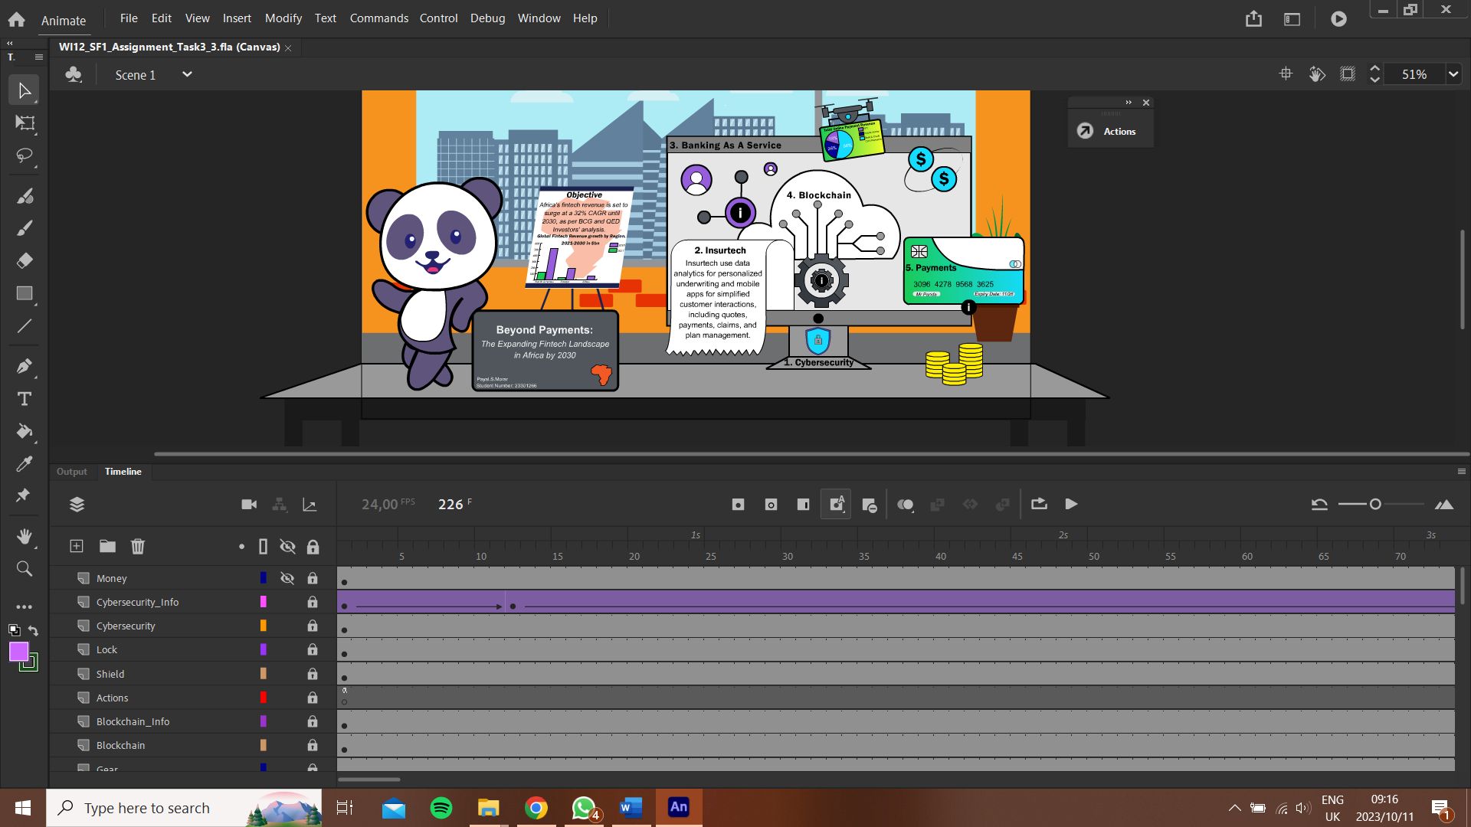
Figure 2: Adobe Animate - Designing Motion Infographics

Sound Editing

Different Sounds Per SWOT

Strengths:
- Professionalism and Elegance: The piano sound conveys a sense of sophistication and professionalism, which is often associated with the finance and fintech industry. (Blog: Fintech - A SWOT analysis)
- Emotional Appeal: The piano's melodious and emotive qualities can evoke a range of emotions, from trust and confidence to calmness and reliability. (Blog: Fintech - A SWOT analysis)
- Versatility: Piano music is versatile and can adapt to various tones and moods, making it suitable for different sections of the infographic. (Blog: Fintech - A SWOT analysis)
Weaknesses:
- Overused: Piano music is a popular choice for various media projects, and its frequent use can lead to a sense of unoriginality or cliché if not carefully executed. (Blog: Fintech - A SWOT analysis)
- Limited Range: While the piano is versatile, it may not convey the same level of excitement or dynamism as other musical choices. For fintech, where innovation and technology are key, this could be a drawback. (Blog: Fintech - A SWOT analysis)

Opportunities:
- Audience Connection: The piano sound can foster a strong connection with the audience, especially if the music resonates with the target demographic. (Blog: Fintech - A SWOT analysis)
- Narrative Enhancement: The piano sound can be used to complement the narrative, emphasizing key messages, milestones, or transitions in the fintech story. (Blog: Fintech - A SWOT analysis)

Threats:
- Mismatch with Visuals: If the piano sound doesn't align with the visuals and overall tone of the infographic, it can create a discordant experience for the viewer. (Blog: Fintech - A SWOT analysis)
- Competitive Disadvantage: If competitors use more innovative or captivating audio elements, relying solely on piano music may put your motion infographic at a disadvantage. (Blog: Fintech - A SWOT analysis)

Background Music

Professionalism and Elegance: The piano sound can bring an air of professionalism and sophistication to the fintech setting. It aligns well with the financial industry's image of trustworthiness and reliability. (Olóndriz, The Best Background Music for Banks and Financial Insitutions 2023)
Emotional Resonance: Piano music is known for its emotional depth and versatility. It can help convey a sense of trust, confidence, and calmness, which is desirable in fintech to reassure clients and investors. (Olóndriz, The Best Background Music for Banks and Financial Insitutions 2023)
Visual Harmony: The elegant and timeless quality of piano music can harmonize well with the visuals of an office, a panda mascot, and a computer. It can make the infographic feel coherent and well-put-together. (Olóndriz, The Best Background Music for Banks and Financial Insitutions 2023)

Use of Sound Effects

Reverb/Echo: Adding a touch of reverb or echo to the piano sound can create a sense of space, making the music feel more immersive. It can work well in conveying an open and professional atmosphere for your fintech motion infographic. (Olóndriz, The Best Background Music for Banks and Financial Insitutions 2023)
Fade In: Apply a slight fade-in effect serves as a subtle background to narration or visuals. This can maintain a sense of professionalism and elegance without overwhelming the main content. (Olóndriz, The Best Background Music for Banks and Financial Insitutions 2023)
Fade Out: Use of fade-out effect to gently conclude a section or the entire infographic. This can provide a sense of closure and signal the end of a specific topic. (Olóndriz, The Best Background Music for Banks and Financial Insitutions 2023)

Sound Editing
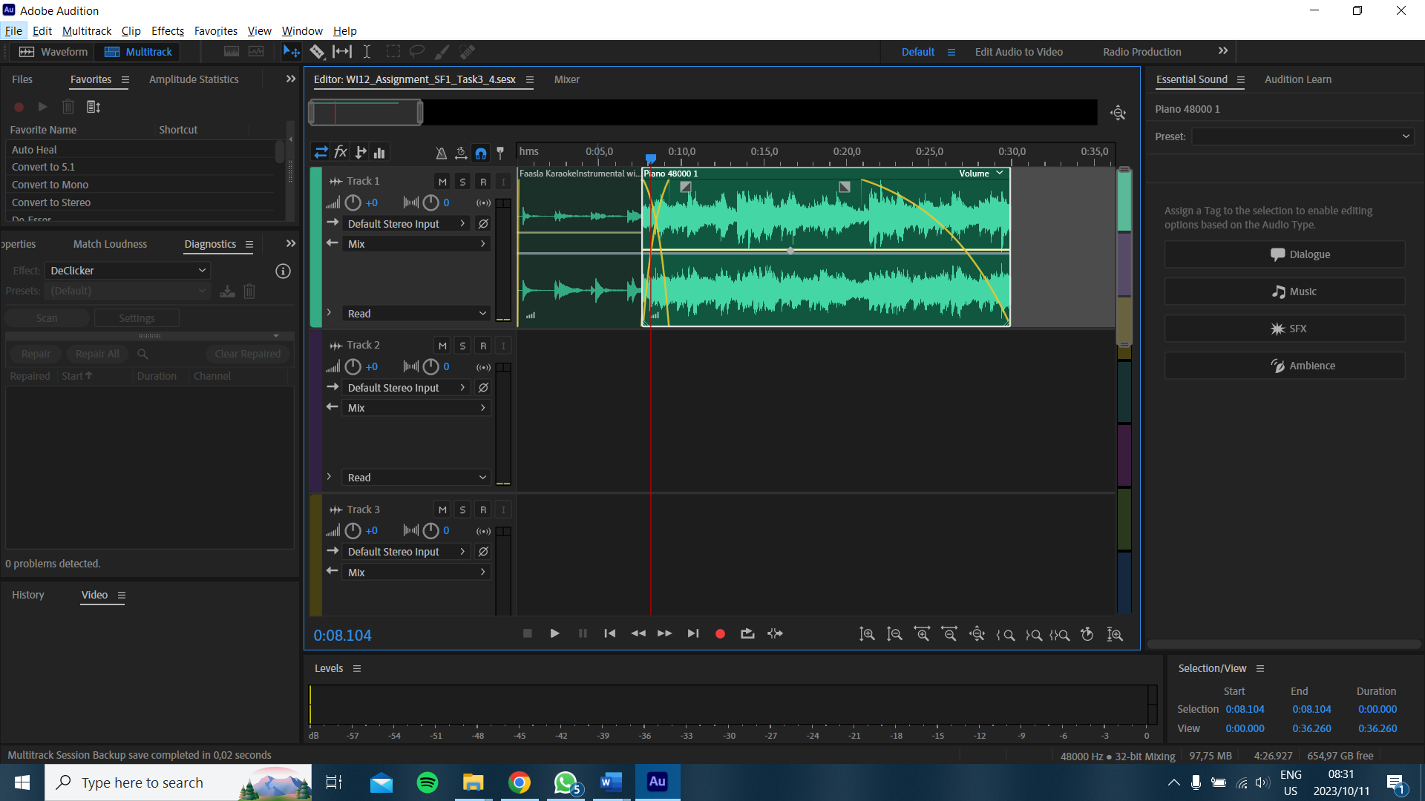
Figure 3: Adobe Audition Sound Editing

References

(No date a) Audio recording and editing software | adobe audition. Available at: https://www.adobe.com/products/audition.html (Accessed: 11 October 2023).
(No date) Daddy_s_Music - Pixabay. Available at: https://pixabay.com/users/daddy_s_music-22836301/ (Accessed: 11 October 2023).
Adobe Creative Cloud: Sign in (no date) Adobe Creative Cloud | Sign in. Available at: https://creativecloud.adobe.com/cc/learn/premiere-pro/web/edit-music-dynamic-link-remix?playlist=%2Fccx%2Fv1%2Fcollection%2Fproduct%2Faudition%2Fsegment%2Fdesigner%2Fexplevel%2Fbeginner%2Fapplaunch%2Forientation%2Fcollection.ccx.js%3Fref&locale=en (Accessed: 11 October 2023).
Blog: Fintech - A SWOT analysis (no date) Commonwealth. Available at: https://thecommonwealth.org/news/blog-fintech-swot-analysis (Accessed: 11 October 2023).
Fintech images - free download on Freepik (2021) Freepik. Available at: https://www.freepik.com/free-photos-vectors/fintech (Accessed: 11 October 2023).
Olóndriz, P. (2023) The Best Background Music for Banks and Financial Insitutions, Legis Music. Available at: https://legismusic.com/background-music-banks-financial-institutions/ (Accessed: 11 October 2023).

