SCHOOL OF INFORMATION TECHNOLOGY

Assignment Code | SF1
Assignment Type | Project
Assignment Type | Individual Assignment
Total Marks | 300

Module Name | Web Interactive Design
Module Code | WI12

Assignment Title: | Web Interactive Design for WI12_Assignment_SF1
Student's Name: | Payal.S.Morar
Student Number: | 23301266
Date of Submission: | 13 October 2023
Qualification: | BSc in Web Design and Web Development
Year: | 1
Monitor Day 1: | 24 August 2023
Monitor Day 2: | 11 September 2023
Monitor Day 3: | 25 September 2023
Monitor Day 4: | 2 October 2023

.DESCRIPTION

For this assignment, students are required to gather information, then design, and produce a 30-second motion Infographic based on how the Fintech Industry in Africa will look in the year 2030. In doing so, students will adhere to specific requirements to solve real-world problems using industry-related App development principles/standards. Such as using the Adobe Application Suite to design and create infographics.
Table of Contents

Task 1 – Gathering Information 4
1.1. Gathering Infographics 4
1.1.1. Infographic 1 4
1.1.2. Infographic 2 5
1.1.3. Infographic 3 6
1.1.4. Infographic 4 7
1.1.5. Infographic 5 8
1.2. Fintech Information Gathering 9
1.2.1. Research 9
1.2.2. Storyline 13
1.2.3. Information Data 13
1.2.4. Design Thoughts 14
1.2.5. Graphs 14
1.3. Explaining Fintech Industry 15
1.3.1. Definition 15
1.3.2. Key Concepts 15
1.3.3. Opportunities 16
1.3.4. Challenges 17
1.4. Key Objectives 18
Task 2 – Planning 19
2.1. Evaluating Requirements 19
Functional Requirements: 19
Non-Functional Requirements: 20
2.2. Time Management 21
2.2.1. Setting Priorities 22
2.2.2. Daily or Weekly Goals 22
2.2.3. Potential Challenges 22
2.2.4. Planed Consultations 23
2.2.5. Planning Tools 23
2.3. Typography and Colour 24
Typography 24
Colours 25
2.4. Five Scamp Ideas 26
2.4.1. Scamp Idea 1 26
2.4.2. Scamp Idea 2 26
2.4.3. Scamp Idea 3 26
2.4.4. Scamp Idea 4 26
2.4.5. Scamp Idea 5 26
2.5. Final Three Scamps 30
2.5.1. Final Scamp 1 30
2.5.2. Final Scamp 2 30
2.5.3. Final Scamp 3 30
Task 3 – Design 35
3.1. Illustrations 35
3.2. Final Illustration 39
3.3. Designing Motion Infographics 41
3.4. Sound Editing 42
1. Different Sounds Per SWOT 42
2. Background Music 43
3. Use of Sound Effects 43
4. Sound Editing 44
Task 4 – Rationale 45
Project Overview and Audience Considerations 45
Data Gathering and Credibility 45
Visual Design and Colour Choices 45
Narrative Flow and Information Presentation 46
Design Alterations for Clarity 46
Technical Challenges and Solutions 46
Interactivity and File Submission 46
Conclusion 47
References 48

Task 1 – Gathering Information

Gathering Infographics

Infographic 1

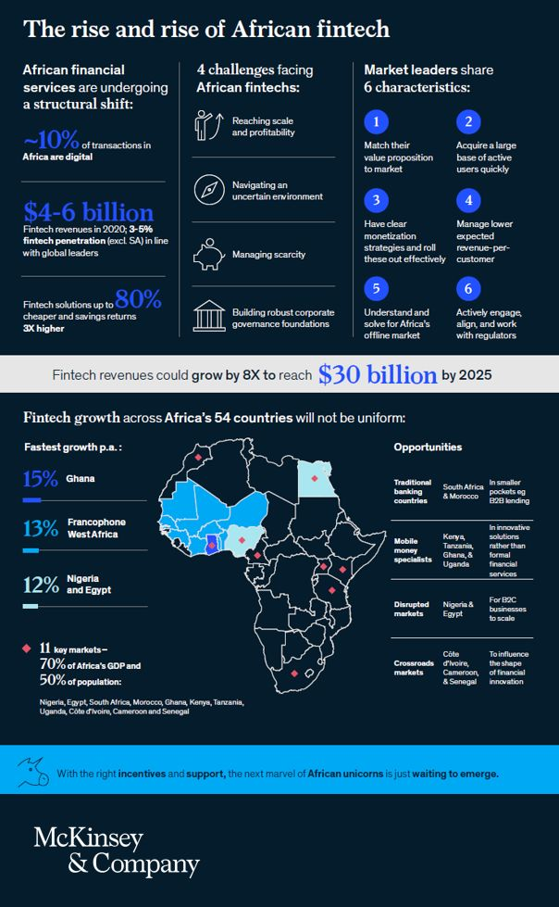
Figure 1: (Reem El Sherif, Reem El Sherif, Phd posted on linkedin 2022)
Title: The Rise and Rise of African Fintech
Description:
The infographic shows that African fintech is emerging as a hotbed for investment, with average deal sizes growing and the proportion of fintech funding in Africa increasing over the past year, bringing jobs and growth to African economies.
How to make the infographic interactive:
Create clickable icons that will demonstrate the emerging as a hotbed for investment. Make the map of Africa point out the highlighted areas.

Infographic 2

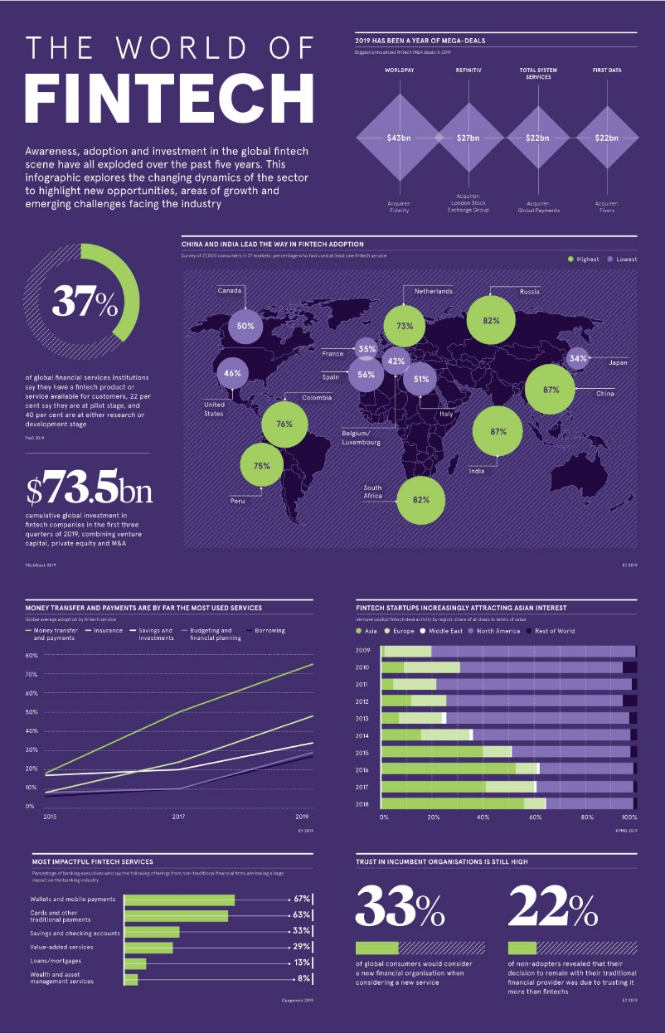
Figure 2: (Ghosh & Khan Graphics & Design Alejandra Dander, Visualizing the current landscape of the fintech industry 2020)
Title: The World of Fintech
Description:
The infographic from Raconteur highlights the global growth of the fintech industry, the services with the most staying power, and major M&A developments of the past year as traditional institutions scramble to deal with this digital disruption.

How to make the infographic interactive:
Interactive charts displaying success stories of fintech-driven startups, with clickable profiles.

Infographic 3

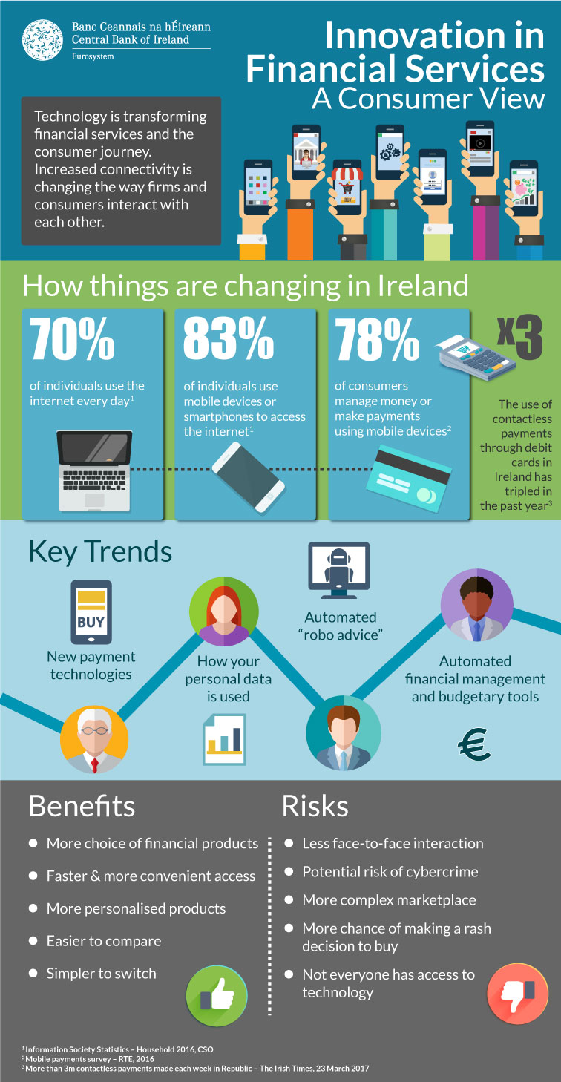
Figure 3: (What is 'Fintech' and how is it changing financial products?)
Title: Innovation in Financial Services – A Consumer View
Description:
Infographic that explains what is fintech and how is it changing financial products.
How to make the infographic interactive:
Timeline animation showcasing key trends of financial services. Clickable bullet points that explain the benefits and risks in more detail.

Infographic 4

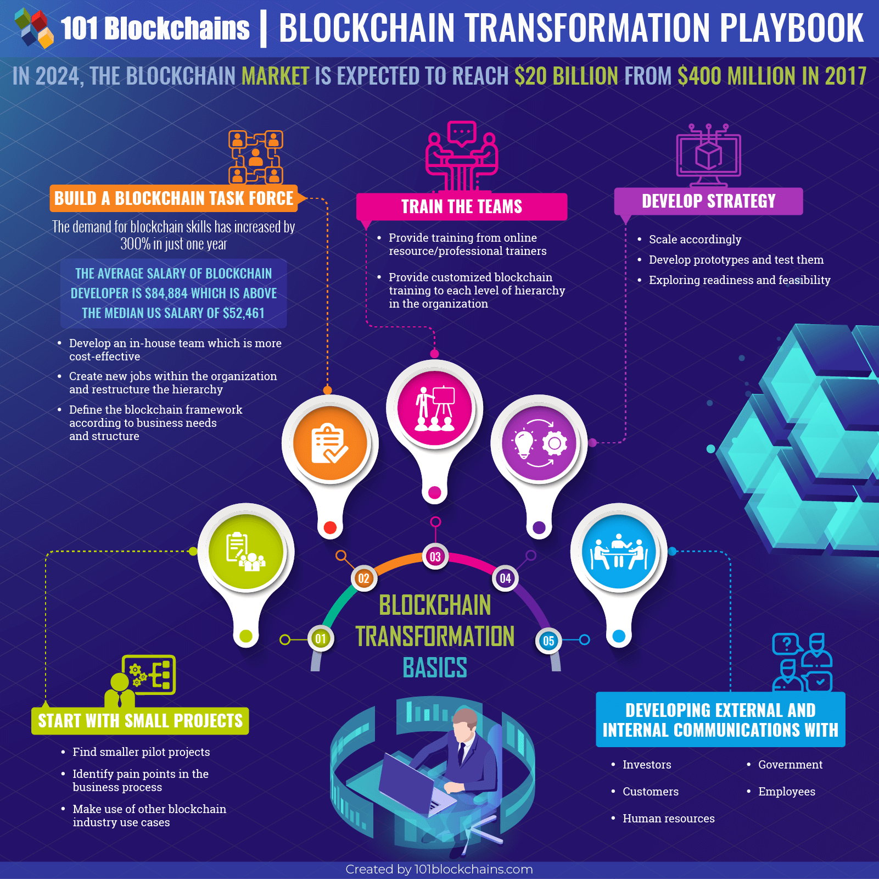
Figure 4: (Best blockchain infographics collection 2021)
Title: Blockchain Transformation Playbook
Description:
Infographic shows you a step-by-step process of the blockchain transformation. Basically, you can see that there are five steps for a successful blockchain transformation.
How to make the infographic interactive:
Clickable icons that expand to show detailed explanations when navigated through the dotted lines.

Infographic 5

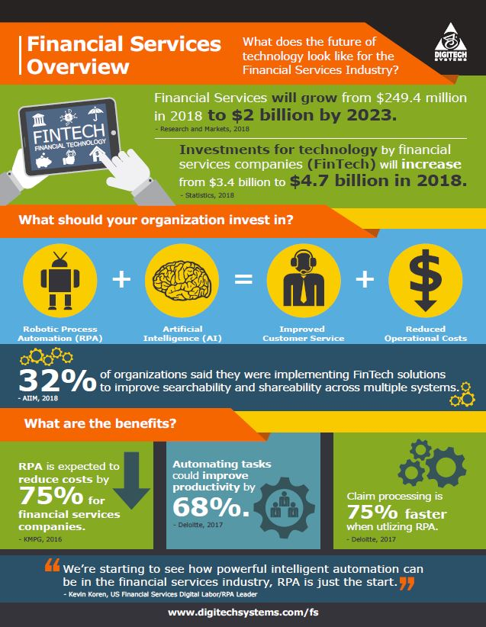
Figure 5: (Financial Services infographic 2018)
Title: Financial Services Overview
Description:
Infographic that shows what the Future of Technology Look Like for the Financial Services Industry.
How to make the infographic interactive:
Clickable icons that expand to show detailed explanations and progress towards each goal. Make the numbers standout.

Fintech Information Gathering

Research

Main Idea: How the Fintech Industry in Africa will look like in the year 2030?
- Africa will have a fintech market worth $65 billion. The market size will grow from its present $5 billion level by a factor of thirteen. (Fintech in Africa: The end of the beginning, 2022)
- Mobile money will be the main factor in growth. In Africa, mobile money is already the most used method of payment, and this pattern is anticipated to last. (Fintech in Africa: The end of the beginning, 2022)
- The importance of financial inclusion will increase. Millions of Africans are either underbanked or unbanked, and fintech startups are attempting to change that. (Fintech in Africa: The end of the beginning, 2022)
- A significant part of the growth of Africa's digital economy will be played by fintech. In addition to helping individuals more easily access necessary financial services, fintech companies will help to develop new businesses and jobs. (Fintech in Africa: The end of the beginning, 2022)
- Africa will develop as a centre for fintech innovation worldwide. The continent is home to several top-notch colleges and a young, tech-savvy populace. (Fintech in Africa: The end of the beginning, 2022)
Statistical information:
- From 2021 through 2030, the African fintech sector is anticipated to expand at a compound annual growth rate (CAGR) of 32 percent, according to a report by the Boston Consulting Group and QED Investors. (Fintech in Africa: The end of the beginning, 2022)
- In Africa, mobile money is the most widely used method of payment. Africa is predicted to have 1 billion mobile money accounts by 2030, up from an estimated 600 million in 2021. (Fintech in Africa: The end of the beginning, 2022)
- In Africa, there are 1.2 billion individuals who lack access to banking, according to the UN. A lot of progress has been made recently by fintech companies in their efforts to provide financial services to these folks. (Fintech in Africa: The end of the beginning, 2022)
- By 2030, the African Development Bank predicts that the continent's digital economy would be worth $1 trillion. An important part of the development of this digital economy is being played by fintech companies. (Fintech in Africa: The end of the beginning, 2022)

The fintech Industries in Africa are expected to incorporate these key areas in 2030:
Payments:
- Mobile payments are already a market leader in Africa, and this development is anticipated to continue. Blockchain technology will be used by fintech companies to create fresh, creative methods for improving payment systems' efficiency and security.(Botta et al., The Future of Payments in Africa, 2022)
- They will also investigate how biometrics, including fingerprint and facial recognition, can facilitate payments. Using smart contracts to automate payments and lower the risk of fraud may fall under this category.(Botta et al., The Future of Payments in Africa, 2022)
- The development of mobile payment solutions that are usable by residents in rural areas will also be a priority for fintech companies. This can entail creating solutions for low-bandwidth networks or deploying solar-powered mobile payment devices.(Botta et al., The Future of Payments in Africa, 2022)
  - The value of mobile payments in Africa is expected to reach $1 trillion by 2030. (Botta et al., The Future of Payments in Africa, 2022)
  - The number of mobile money users in Africa is expected to reach 500 million by 2030. (Botta et al., The Future of Payments in Africa, 2022)
Banking as a Service (BaaS):
- Businesses can provide banking services through BaaS without needing to establish their own banks. This practice is becoming more popular in Africa as it gives small businesses access to banking services that would otherwise be inaccessible. They give them a range of financial services, including the ability to open new accounts, borrow money, and make mobile payments. Small businesses will benefit from easier access to the financial services they require to expand.(celner, Bank of 2030: The Future of Banking)
- BaaS providers will collaborate with a broader range of companies, including non-profit organizations, retailers, and microfinance institutions. This will facilitate granting more individuals in Africa access to banking services.(celner, Bank of 2030: The Future of Banking)
- BaaS suppliers will also create more complex solutions to address the unique requirements of organizations. This might involve offering cash flow management options, loans, or insurance coverage.(celner, Bank of 2030: The Future of Banking)
  - The number of BaaS providers in Africa is expected to grow from 50 to 200 by 2030. (celner, Bank of 2030: The Future of Banking)
  - The value of the BaaS market in Africa is expected to reach $10 billion by 2030. (celner, Bank of 2030: The Future of Banking)

Insurtech:
- The term "insurtech" refers to the application of technology to the insurance sector. This involves utilizing data analytics to make underwriting choices and mobile apps to streamline the purchase and management of insurance policies for clients.. (Balasubramanian et al., Insurance 2030-the impact of AI on the future of Insurance, 2021)
- Data analytics will be used by insurtech companies to create more precise and individualized underwriting choices. Additionally, they will use mobile apps to simplify the process for customers to obtain quotations, make payments, file claims, and purchase and manage insurance plans.(Balasubramanian et al., Insurance 2030-the impact of AI on the future of Insurance, 2021)
  - The value of the insurtech market in Africa is expected to reach $5 billion by 2030. (Balasubramanian et al., Insurance 2030-the impact of AI on the future of Insurance, 2021)
Cybersecurity:
- Businesses in Africa are highly concerned about cybersecurity since they are frequently the subject of cyberattacks. Fintech businesses will need to create fresh strategies to safeguard client data and stop cyberattacks.(Middle East and Africa cyber security 2023-2030, 2022)
- In order to safeguard client data from hackers, fintech organizations will make investments in cybersecurity measures. Additionally, they will inform clients about the dangers of cybersecurity and how to safeguard themselves. This could involve using encryption, firewalls, and intrusion detection systems. (Middle East and Africa cyber security 2023-2030, 2022)
- Additionally, fintech businesses will inform clients about the dangers of cyberattacks and how to guard against them. This can entail giving advice on how to make secure passwords, stay away from phishing schemes, and keep informed of the most recent risks.
  - The number of cyberattacks in Africa is expected to increase by 50% in 2030. (Middle East and Africa cyber security 2023-2030, 2022)
  - The cost of cyberattacks in Africa is expected to reach $10 billion by 2030. (Middle East and Africa cyber security 2023-2030, 2022)

Blockchain:
- A distributed ledger technology called blockchain can be used to record transactions securely and openly.
- The creation of safe data ecosystems that can be used to tag and track nearly any kind of goods is supported by blockchain technology. The retail sector will be significantly affected by this, giving brands more leverage to fend off the trade in counterfeit goods. These advancements may be especially crucial for reducing the trade in conflict diamonds in Africa. (THE DIGITAL TRANSFORMATION STRATEGY FOR AFRICA 2020-2030)
- Blockchain technology will be used by fintech companies to create applications for a range of markets, including payments, trade finance, and supply chain management. In order to track payments, transactions, and assets in a more safe and transparent manner, blockchain technology may be used.(THE DIGITAL TRANSFORMATION STRATEGY FOR AFRICA 2020-2030)
- The use of blockchain to develop new financial products and services will be investigated by fintech firms. This can entail establishing a decentralized exchange utilizing blockchain technology or issuing tokens that denote ownership of assets. (THE DIGITAL TRANSFORMATION STRATEGY FOR AFRICA 2020-2030)
  - The number of blockchain startups in Africa is expected to grow from 50 to 200 by 2030. (THE DIGITAL TRANSFORMATION STRATEGY FOR AFRICA 2020-2030)

Storyline
Title – Beyond Payments – The Expanding Fintech Landscape in Africa by 2030.

The storyline begins by setting the stage for the fintech industry in Africa in the year 2030. Africa is experiencing a fintech revolution, with innovative solutions transforming the financial landscape. This infographic is a glimpse of the key aspects that will shape this dynamic industry.

Information Data

Objective Chart:
Africa's fintech revenue is set to surge at a 32% CAGR until 2030, as per BCG and QED Investors' analysis. (Gilbert, Collaborate - innovate - transform – monetize, 2023)

Computer Screen:

Payments: Africa expects $1 trillion in mobile payments and 500 million mobile money users by 2030. Fintech companies will explore biometrics (fingerprint and facial recognition) for payments and employ smart contracts to automate payments and reduce fraud risks. (Fintech in Africa: The end of the beginning, 2022)

Insurtech: Insurtech’s use data analytics for personalized underwriting and mobile apps for simplified customer interactions, including quotes, payments, claims, and plan management. (Fintech in Africa: The end of the beginning, 2022)

Blockchain: Fintech’s in Africa are adopting blockchain for safer and transparent payments, with an expected growth in blockchain startups from 50 to 200 by 2030. (Fintech in Africa: The end of the beginning, 2022)

Cybersecurity: Cybersecurity measures safeguarded data and transactions. Banking as a Service: BaaS is on the rise in Africa, enabling small businesses to access vital financial services and custom solutions like loans and insurance. (Fintech in Africa: The end of the beginning, 2022)

Panda Mascot:
The friendly Panda mascot embodies the approachability and warmth of African fintech services, making finance more accessible to all. The Panda leans on a credit card, symbolizing the convenience and ease of use that fintech provides.

Design Thoughts

Colour Scheme:
Vibrant Orange Office Background: The choice of an inviting, vibrant orange office background signifies energy, optimism, and innovation. It immediately captures the viewer's attention and sets a positive tone for the infographic.
Vibrant Green Accents: Green accents are used throughout the infographic to symbolize growth, prosperity, and sustainability. They complement the dominant orange background and highlight key information and milestones. (Kramer, Color meanings and the art of using color symbolism - 99designs, 2022)

Panda Mascot:
The Panda mascot serves as a friendly, approachable, and relatable figure. Its presence adds a touch of charm and humanizes the fintech industry, making it more relatable to the audience.

Computer Screen:
Placing the key focus areas (Payments, Insurtech, Blockchain, Cybersecurity, and Banking as a Service) on a computer screen allows for a visually appealing and organized presentation of detailed information.

Balance of Information:
The infographic balances visual elements with concise textual information. It avoids overwhelming the viewer with excessive details, making the content easily digestible.

Font Choices:
Choosing a clean, modern font ensures readability and professionalism. The font colour and style are selected to match the overall aesthetic and colour scheme. (DigitalSynopsis.com, What different types of fonts mean and how to use them, 2023)

Graphs

Milestones: Important milestones and achievements are marked on the graph, emphasizing the industry's steady ascent.

Bar Graph: A dynamic bar graph demonstrates the impressive growth of the African fintech industry from 2020 to 2030. It showcases key metrics such as investment, user adoption, revenue, and cybersecurity measures implemented.

Explaining Fintech Industry

Definition

Fintech Industry also known as financial technology is based on a broad term that encompasses the use of technology to deliver and enhance financial services. It stands for the point where technology and finance converge, when diverse facets of the financial sector are addressed using cutting-edge solutions and technological instruments. Fintech is transforming how financial services are accessible, provided, and managed while also providing advantages including improved efficiency, accessibility, and convenience. The technologies that support the various fintech industry business models differ greatly. They consist of robotic processing automation, AI, machine learning, and blockchain technology, among other big data applications (RPA). (Fintech Financial Technology, 2022)

Key Concepts

The main purpose of fintech is to assist corporations, business owners, and individuals in managing their financial operations, procedures, and lives more effectively. It is made up of specialized software and algorithms utilized by laptops and mobile devices. (Fintech Financial Technology, 2022)
Each use case is distinct, but the overall goal of disaggregating the financial services industry which has historically benefited from extensive regulation and is what unites them all. (Fintech Financial Technology, 2022)
Three primary purposes are served by traditional financial service providers, mostly banks and credit unions:
- They keep cash on hand, including deposits and a range of investment options.
- They provide loans, both secured (such as mortgages) and unsecured (like student lines of credit).
- They move money through international money transfers and routine, straightforward payments through global networks like SWIFT (Society for Worldwide Interbank Financial Telecommunications).
The creation and application of cryptocurrencies like Bitcoin is also a part of fintech. The traditional international banking sector, with its multitrillion-dollar market capitalization, continues to be where the big money is, even though the fintech sector may garner the majority of headlines. (Fintech Financial Technology, 2022)

Opportunities

Enhanced Accessibility: Fintech solutions make financial services more accessible to individuals and businesses, especially in underserved or remote areas where traditional banking infrastructure may be lacking. (Podgaiskaya, Top challenges and opportunities for Fintech in 2023 2023)

Cost Savings: Automation and digitization in fintech lead to cost savings for financial institutions and ultimately for consumers, as it reduces the need for physical branches and paperwork. (Podgaiskaya, Top challenges and opportunities for Fintech in 2023 2023)

Financial Inclusion: Fintech has the potential to bring millions of unbanked or underbanked individuals into the formal financial system, offering them a range of services they didn't have access to before. (Podgaiskaya, Top challenges and opportunities for Fintech in 2023 2023)

Innovation: Fintech fosters continuous innovation, leading to the development of new financial products and services that cater to evolving customer needs. (Podgaiskaya, Top challenges and opportunities for Fintech in 2023 2023)

Efficiency: Through automation and AI-driven processes, fintech enhances the efficiency of financial operations, reducing processing times and errors. (Podgaiskaya, Top challenges and opportunities for Fintech in 2023 2023)

Investment Opportunities: The fintech sector itself presents investment opportunities, as startups and established companies seek funding to develop and scale their innovative solutions. (Podgaiskaya, Top challenges and opportunities for Fintech in 2023 2023)

Challenges

Cybersecurity Concerns: As fintech relies heavily on technology, it is susceptible to cybersecurity threats. Protecting sensitive financial data is a constant challenge. (Podgaiskaya, Top challenges and opportunities for Fintech in 2023 2023)

Data Privacy: The collection and use of customer data in fintech services raise privacy concerns. Companies must adhere to strict data protection regulations. (Podgaiskaya, Top challenges and opportunities for Fintech in 2023 2023)

Competition: The fintech industry is highly competitive, with numerous startups and established players vying for market share. This competition can make it challenging for new entrants. (Podgaiskaya, Top challenges and opportunities for Fintech in 2023 2023)

Financial Literacy: Some fintech solutions may be complex for users who are not financially literate. Ensuring that customers understand and use these services effectively is crucial. (Podgaiskaya, Top challenges and opportunities for Fintech in 2023 2023)

Market Volatility: Cryptocurrencies and blockchain technologies, although promising, are known for their price volatility. This can pose risks to investors and users. (Podgaiskaya, Top challenges and opportunities for Fintech in 2023 2023)

Key Objectives

Promoting financial inclusion, innovation, and economic development while maintaining consumer safety and protection will be the primary goals of the fintech sector in Africa in 2030. All people in Africa should therefore have access to fundamental financial services like payments, credit, and savings. To develop an inclusive and sustainable financial ecosystem, cooperation between governments, fintech businesses, traditional financial institutions, and various stakeholders is required. (Gilbert, Collaborate - innovate - transform – monetize, 2023)
According to a new analysis from Boston Consulting Group (BCG) and QED Investors, Africa will experience the highest rise in fintech revenue, with a compound annual growth rate (CAGR) of 32% from now until 2030. (Gilbert, Collaborate - innovate - transform - monetize 2023)
The African Union (AU) has established a variety of goals to accomplish this goal, including:
- 50% more bank accounts would be opened
- A 25% cost reduction for financial services
- Double the amount of people using mobile payment systems
- Increasing the reach of microfinance organizations by 50%
(THE DIGITAL TRANSFORMATION STRATEGY FOR AFRICA 2020-2030)
The AU is also attempting to improve the regulatory climate for fintech businesses. This entails creating a uniform set of rules for fintech businesses throughout Africa and offering funding to fintech entrepreneurs. (THE DIGITAL TRANSFORMATION STRATEGY FOR AFRICA 2020-2030)
For Africa, achieving universal financial inclusion would provide a lot of advantages, such as:
- Accelerated economic expansion
- Decreased poverty
- Higher level of financial literacy
- Increased credit availability
- Increased financial security
The quest to attain widespread financial inclusion in Africa involves the fintech sector heavily. Innovative solutions are being created by fintech companies to make it simpler and more affordable for customers to access financial services. (THE DIGITAL TRANSFORMATION STRATEGY FOR AFRICA 2020-2030)

Task 2 – Planning

2.1. Evaluating Requirements

Functional Requirements:

- Content Clarity: The motion infographic should effectively convey the intended message through animations, text, and graphics. (Functional vs. non-functional requirements, 2023)

- Engagement: It should capture the audience's attention and maintain their interest throughout by using captivating animations and visuals. (Functional vs. non-functional requirements, 2023)

- Interactivity: Depending on the purpose, it might require interactive elements, such as clickable buttons or animations that respond to user input. (Functional vs. non-functional requirements, 2023)

- Storytelling: If applicable, the motion infographic should follow a logical and engaging narrative structure to guide the viewer through the information. (Functional vs. non-functional requirements, 2023)

- Data Presentation: If data is involved, it should be presented clearly and effectively using charts, graphs, and visualizations that are easy to understand. (Functional vs. non-functional requirements, 2023)

- Cross-Platform Compatibility: It should work seamlessly on various devices and platforms, including desktop, mobile, and tablets. (Functional vs. non-functional requirements, 2023)

Non-Functional Requirements:
- Performance: The motion infographic should load quickly and run smoothly to prevent lag or buffering issues, ensuring a pleasant user experience. (Functional vs. non-functional requirements, 2023)

- Scalability: It should be designed in a way that allows for easy updates and scalability, especially if new data or information needs to be added. (Functional vs. non-functional requirements, 2023)

- Load Balancing: If it's hosted on a server, ensure it's capable of handling a large number of concurrent users without crashing or slowing down. (Functional vs. non-functional requirements, 2023)

- Backup and Recovery: Implement regular backups and have a recovery plan in place to prevent data loss in case of technical issues. (Functional vs. non-functional requirements, 2023)

- Compliance: Ensure that the motion infographic complies with legal and copyright requirements, including permissions for using certain content or data sources. (Functional vs. non-functional requirements, 2023)

2.2. Time Management
Time Frame
Item | Tasks to be Completed | Week 1  21 – 25 Aug |  |  |  |  | Week 2  28 Aug – 1 Sept |  |  |  |  | Week 3  4 – 8 Sept |  |  |  |  | Week 4  11 -15 Sept |  |  |  |  | Week 5  18 – 22 Sept |  |  |  |  | Week 6  25 – 29 Sept |  |  |  |  | Week 7  2 – 6 Oct |  |  |  |  | Week 8  9 – 13 Oct
Research | Gather 5 ideas of infographic
 | Gather information about topic
 | Explain understanding of topic
 | Key objective outlined
Planning | Evaluate Requirements
 | Gain resources
 | Set Time Schedule
 | Font and colour choice
 | 5 scamps
 | 3 final scamps
Design | Create illustrations
 | Style graphs
 | Create characters
 | Choose final illustrations and characters
Develop | Create a 30-second motion graphics
 | Edit sound
 | Add sound to infographic
Review | Write Rationale for the final product
 | Edit the motion graphics
 | Final checks of project
Launch | Submit final product

2.2.1. Setting Priorities

Research: Start with gathering ideas and information about the infographic. This forms the foundation of your project.
Planning: Once you have sufficient information, move on to planning, which involves evaluating requirements, gathering resources, setting a time schedule, and making font and colour choices.
Design: Create illustrations, style graphs, and develop characters. This step is crucial for the visual appeal of your infographic.
Develop: Work on creating the 30-second motion graphics and add sound.
Review: After completing the motion graphics, write a rationale for your final product and perform any necessary edits.
Launch: Finally, submit your finished product.

2.2.2. Daily or Weekly Goals

Week 1: Focus on research, gathering ideas, and information about the topic.
Week 2: Dive into planning, evaluating requirements, and gathering resources.
Week 3: Continue planning by setting a detailed time schedule and making font and colour choices.
Week 4: Begin the design phase, creating illustrations and styling graphs.
Week 5: Complete the design phase by creating characters and selecting final illustrations.
Week 6: Shift to development, creating the 30-second motion graphics and adding sound.
Week 7: Review and finalize your project, including writing a rationale and making any necessary edits before submission.

2.2.3. Potential Challenges

Designing illustrations and characters could be time-consuming.
Technical issues with motion graphics development.
Revisions and edits may be necessary during the review phase.
Meeting submission deadlines may be challenging.

2.2.4. Planed Consultations

During Design: Got feedback from peers and mentors on my design choices.
During Development: Test the motion graphics with a small audience for feedback.
During Review: Have someone review my rationale for clarity and coherence.

2.2.5. Planning Tools

Calendar: Use a digital or physical calendar to schedule tasks and deadlines.
Design Software: Employ graphic design software such as Adobe Creative Cloud for creating illustrations and motion graphics.

2.3. Typography and Colour

Typography
- Proxima Nova: Proxima Nova is a modern and highly legible font, making it an excellent choice for conveying information clearly in infographics. (DigitalSynopsis.com, What different types of fonts mean and how to use them, 2023)

- Helvetica: Helvetica's clean and timeless design ensures a professional and visually pleasing appearance, ideal for enhancing the aesthetics of your infographic. (DigitalSynopsis.com, What different types of fonts mean and how to use them, 2023)

- Arial: Arial is a widely recognized and easy-to-read font, ensuring that your infographic's content remains accessible and user-friendly. (DigitalSynopsis.com, What different types of fonts mean and how to use them, 2023)

- Montserrat: Montserrat offers a touch of elegance and versatility, allowing you to add a stylish and contemporary flair to your infographic's typography. (DigitalSynopsis.com, What different types of fonts mean and how to use them, 2023)

Colours
- #000000 (Black):
Meaning: Black can be used to convey a sense of sophistication and professionalism in fintech. It often represents security and reliability, which are crucial aspects of financial technology. It can also symbolize mystery, authority, and timelessness. In design, black is commonly used for text and as a background to create contrast with other colours. (Kramer, Color meanings and the art of using color symbolism - 99designs, 2022)
- #343A40 (Dark Gray):
Meaning: Dark Gray is a neutral and conservative colour that represents balance, stability, and professionalism. In the fintech industry, it can represent the solid foundation and reliability of financial services and technologies. It suggests a sense of seriousness and trust that is important in the financial sector. (Kramer, Color meanings and the art of using color symbolism - 99designs, 2022)
- #030395 (Deep Blue):
Meaning: Deep blue is a rich and intense shade of blue. Deep blue is a colour often associated with trust and reliability, which are essential qualities in fintech. It can also symbolize security and the feeling of safety that customers expect when dealing with their financial transactions and data. (Kramer, Color meanings and the art of using color symbolism - 99designs, 2022)
- #1ACB55 (Vibrant Green):
Meaning: Vibrant green is a lively and energetic colour associated with growth, health, and renewal. It often symbolizes nature, vitality, and positivity. In a tech context, it can represent innovation and environmental consciousness. Vibrant green can represent growth, innovation, and financial well-being. It suggests that fintech solutions can help customers achieve their financial goals and improve their financial health. (Kramer, Color meanings and the art of using color symbolism - 99designs, 2022)

- #965EDA (Lavender Purple):
Meaning: Lavender purple is a soft and soothing shade of purple. Purple is associated with creativity, spirituality, and imagination. Lavender purple, with its calming and soothing qualities, can be used to convey a sense of trust and confidence in fintech services. It may suggest that using fintech solutions can help ease financial stress and provide a sense of tranquillity in managing finances. (Kramer, Color meanings and the art of using color symbolism - 99designs, 2022)

2.4. Five Scamp Ideas

2.4.1. Scamp Idea 1
Title – The Fintech Revolution: Africa 2030
Description – This scamp design focuses on the fintech revolution that is set to transform Africa by 2030. It highlights the innovative solutions and technological advancements that will shape the financial landscape of the continent, promising increased financial inclusion and economic growth.

2.4.2. Scamp Idea 2
Title – Financial Technology Forecast: Africa 2030
Description – In this scamp design, we delve into the future of financial technology in Africa, offering insights into the trends and developments that are expected to unfold by 2030. It provides a forward-looking perspective on how fintech will revolutionize financial services across the continent.

2.4.3. Scamp Idea 3
Title – Fintech’s Future in Africa: A Glimpse into 2030
Description – "Fintech’s Future in Africa: A Glimpse into 2030" invites viewers to explore the potential of fintech in Africa. This scamp design offers a sneak peek into the opportunities and challenges that lie ahead, showcasing the role of technology in reshaping Africa's financial landscape.

2.4.4. Scamp Idea 4
Title – Beyond Payments: The Expanding Landscape in Africa by 2030
Description – This scamp design goes beyond payments to depict the broader transformation occurring in Africa's financial sector by 2030. It illustrates how fintech is diversifying its offerings, from payments to investments, insurance, and more, reflecting the evolving needs of African consumers and businesses.

2.4.5. Scamp Idea 5
Title – Financial Technology (Fintech) Forecast in Africa: Vision 2030
Description – "Financial Technology (Fintech) Forecast in Africa: Vision 2030" provides a forward-looking perspective on the fintech landscape in Africa. This scamp design offers a glimpse into the future of financial technology, envisioning a continent where digital innovation empowers economic growth and financial inclusion for all.

2.5. Final Three Scamps

2.5.1. Final Scamp 1
Title - Place the title at the top of the infographic in a bold and large font.
Description - Position the description below the title in a smaller font size but still easily readable.
Visual Elements - Incorporate images or icons representing the opportunities and challenges of fintech in Africa. Use images of innovative fintech companies or products that are shaping Africa's financial landscape.
Key Points - Organize key points or facts in bullet points or numbered lists, placing them below the visual elements.
Timeline - Create a simple timeline on the bottom or along the sides of the infographic to indicate the progression from the current state to the envisioned 2030 fintech landscape.

2.5.2. Final Scamp 2
Title - Place the title prominently at the top.
Description - Position the description below the title.
Visual Elements - Include icons or images representing each of these services within their respective sections. Use images of innovative fintech companies or products that are shaping Africa's financial landscape.
Key Points: Organize key points or highlights in boxes or sections near the relevant visual elements.

2.5.3. Final Scamp 3
Title - Place the title at the top, using a font that stands out.
Description - Position the description below the title.
Visual Elements - Feature a futuristic African cityscape in the background to symbolize the technological transformation. Use arrows or paths to guide viewers through different elements of the fintech future, such as improved financial services, blockchain.
Key Points - Include key insights or predictions in speech bubbles or callout boxes throughout the infographic.
Timeline - Create a timeline that moves from the present to 2030, highlighting key milestones along the way.

Task 3 – Design

Illustrations

Cultural Relevance: Mascots are a fun and approachable method to appeal to a wide range of people. The usage of mascots like the beaver and panda can overcome language borders and resonate with a wide spectrum of people in Africa, where there is a wealth of cultural diversity.
Animal Symbolism: The beaver is frequently connected with laborious labour, inventiveness, and construction, all of which are crucial attributes in fintech and reflect the sector's inventive and tenacious spirit. The panda is a symbol of warmth and approachability, traits that can promote customer loyalty and trust.
Industry Representation: The computer screen highlighting significant fintech industry sectors highlights the significance and relevance of these industries in Africa. It conveys that the fintech sector is a dynamic, all-encompassing industry. (Fintech images - free download on Freepik 2021)
Technology Integration: The computer screen emphasizes the importance of innovation and technology, both of which are crucial for the expansion of fintech in Africa. It illustrates how the region's financial services are driven by technology. (Fintech images - free download on Freepik 2021)
Security Emphasis: The computer screen's reference to cybersecurity highlights the significance of data security and protection in the fintech industry. In Africa, where worries about data security and privacy are of utmost importance, this is vital. (Fintech images - free download on Freepik 2021)
Growth in African Fintech A view into the future is provided by the graph showing the fintech market in Africa in 2030. It illustrates the sector's potential for expansion and growth, showing the hope and opportunity in African fintech.
Local Representation: By including African symbols or locations in the office background or on the chart, the image can be made to be more pertinent to the local context, supporting the notion that the fintech industry in Africa is prospering and meets regional demands and aspirations.

Final Illustration

In the illustration, A charming panda mascot leaning casually on a credit card. The credit card serves as the central focal point of the composition. The credit card displays the title of your fintech motion infographic, which is written in bold and modern typography, capturing the attention of the viewers. The credit card could have a reflective surface, giving it a polished and contemporary look.
The panda mascot, standing upright and friendly, adds a touch of character and relatability to the scene. The computer screen is placed on the table next to the panda, displaying five key areas of the fintech industry:
- Blockchain: A graphical representation of blockchain technology with interconnected blocks and data flows.
- Banking as a Service: An image representing a bank building transformed into a service platform with arrows connecting various banking services.
- Cybersecurity: A padlock and shield symbolizing the robust security measures in the fintech industry.
- Payments: Icons of various payment methods, such as credit cards, mobile payment apps, and digital wallets.
- Insurtech: A combination of an insurance symbol and innovative technology elements, demonstrating the insurtech sector.

The office background is modern and sophisticated, with clean lines and a window that allows a glimpse of the city skyline. The office is bathed in soft, natural light, creating an inviting and conducive workspace. There's a stylish desk with the computer on it, indicating a professional environment.
In the background, there is a futuristic chart that predicts what the fintech industry in Africa will look like in the year 2030. This chart is a visual representation of data and trends, showing growth and evolution in the fintech sector.

Designing Motion Infographics

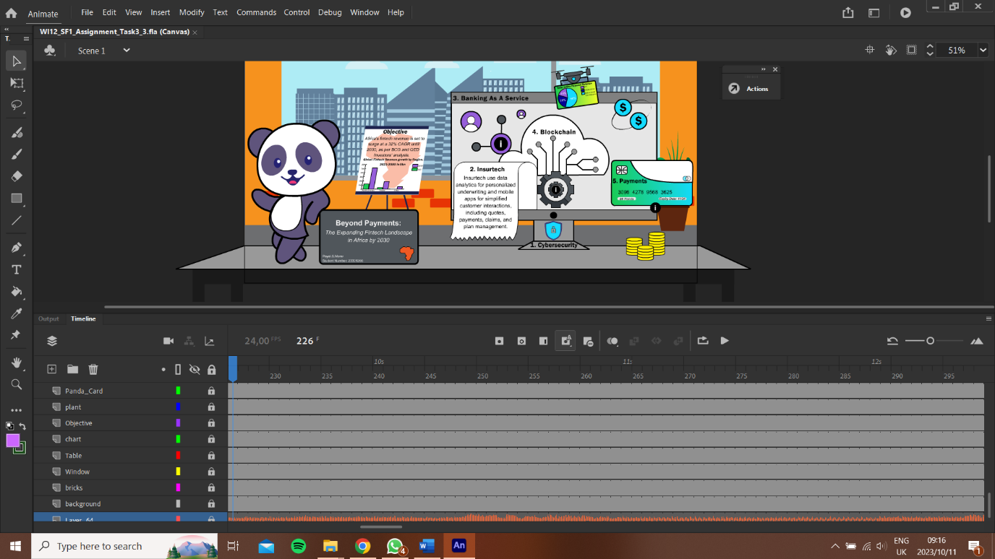
Figure 1: Adobe Animate - Designing Motion Infographics

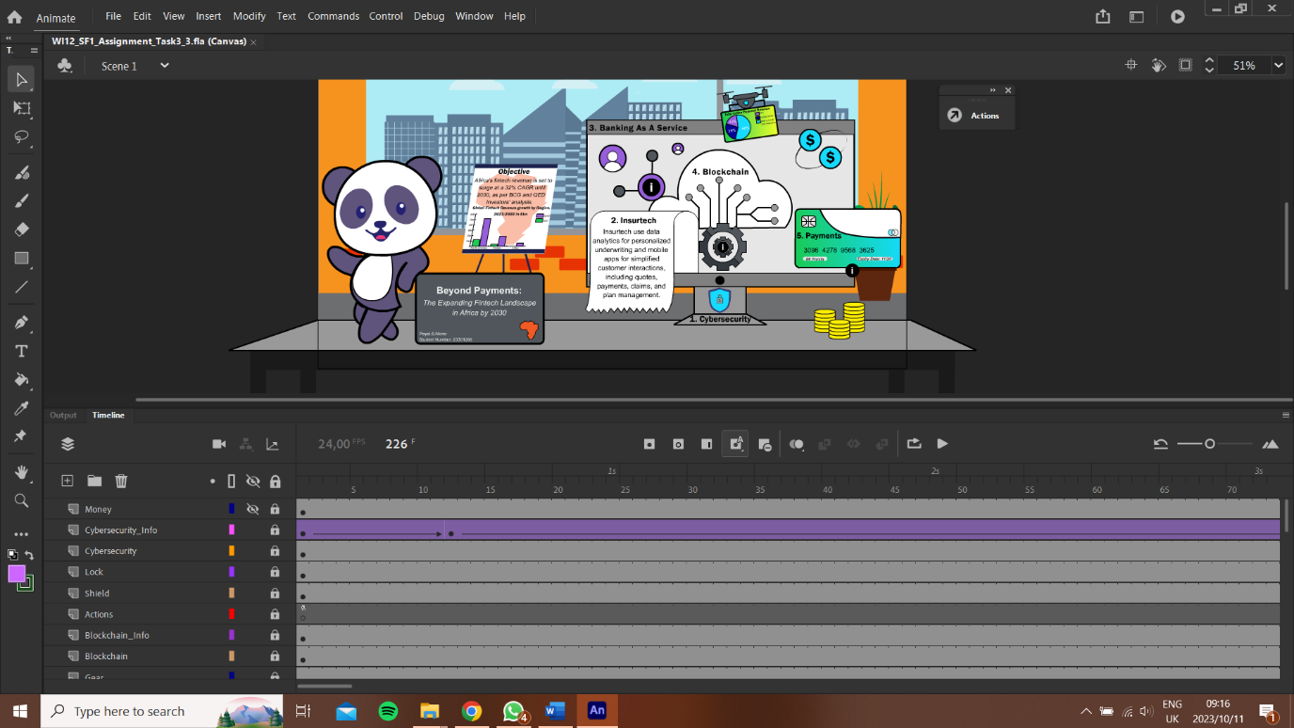
Figure 2: Adobe Animate - Designing Motion Infographics

Sound Editing

Different Sounds Per SWOT

Strengths:
- Professionalism and Elegance: The piano sound conveys a sense of sophistication and professionalism, which is often associated with the finance and fintech industry. (Blog: Fintech - A SWOT analysis)
- Emotional Appeal: The piano's melodious and emotive qualities can evoke a range of emotions, from trust and confidence to calmness and reliability. (Blog: Fintech - A SWOT analysis)
- Versatility: Piano music is versatile and can adapt to various tones and moods, making it suitable for different sections of the infographic. (Blog: Fintech - A SWOT analysis)
Weaknesses:
- Overused: Piano music is a popular choice for various media projects, and its frequent use can lead to a sense of unoriginality or cliché if not carefully executed. (Blog: Fintech - A SWOT analysis)
- Limited Range: While the piano is versatile, it may not convey the same level of excitement or dynamism as other musical choices. For fintech, where innovation and technology are key, this could be a drawback. (Blog: Fintech - A SWOT analysis)

Opportunities:
- Audience Connection: The piano sound can foster a strong connection with the audience, especially if the music resonates with the target demographic. (Blog: Fintech - A SWOT analysis)
- Narrative Enhancement: The piano sound can be used to complement the narrative, emphasizing key messages, milestones, or transitions in the fintech story. (Blog: Fintech - A SWOT analysis)

Threats:
- Mismatch with Visuals: If the piano sound doesn't align with the visuals and overall tone of the infographic, it can create a discordant experience for the viewer. (Blog: Fintech - A SWOT analysis)
- Competitive Disadvantage: If competitors use more innovative or captivating audio elements, relying solely on piano music may put your motion infographic at a disadvantage. (Blog: Fintech - A SWOT analysis)

Background Music

Professionalism and Elegance: The piano sound can bring an air of professionalism and sophistication to the fintech setting. It aligns well with the financial industry's image of trustworthiness and reliability. (Olóndriz, The Best Background Music for Banks and Financial Insitutions 2023)
Emotional Resonance: Piano music is known for its emotional depth and versatility. It can help convey a sense of trust, confidence, and calmness, which is desirable in fintech to reassure clients and investors. (Olóndriz, The Best Background Music for Banks and Financial Insitutions 2023)
Visual Harmony: The elegant and timeless quality of piano music can harmonize well with the visuals of an office, a panda mascot, and a computer. It can make the infographic feel coherent and well-put-together. (Olóndriz, The Best Background Music for Banks and Financial Insitutions 2023)

Use of Sound Effects

Reverb/Echo: Adding a touch of reverb or echo to the piano sound can create a sense of space, making the music feel more immersive. It can work well in conveying an open and professional atmosphere for your fintech motion infographic. (Olóndriz, The Best Background Music for Banks and Financial Insitutions 2023)
Fade In: Apply a slight fade-in effect serves as a subtle background to narration or visuals. This can maintain a sense of professionalism and elegance without overwhelming the main content. (Olóndriz, The Best Background Music for Banks and Financial Insitutions 2023)
Fade Out: Use of fade-out effect to gently conclude a section or the entire infographic. This can provide a sense of closure and signal the end of a specific topic. (Olóndriz, The Best Background Music for Banks and Financial Insitutions 2023)

Sound Editing
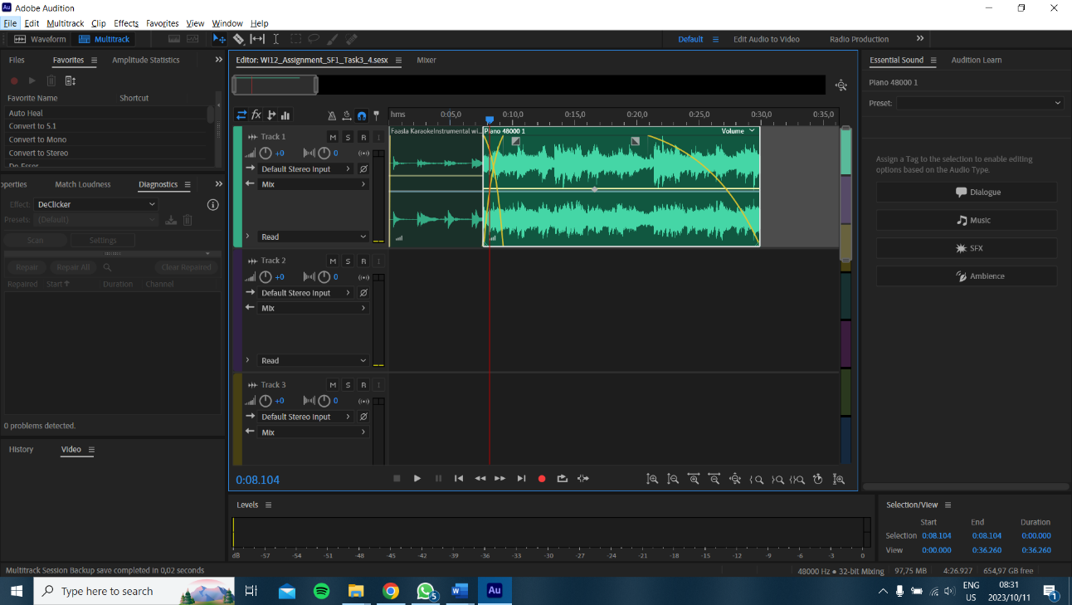
Figure 3: Adobe Audition Sound Editing

Task 4 – Rationale

This rationale aims to provide insight into the thought process behind creating an infographic on the projected state of the fintech industry in Africa in 2030. The infographic focuses on key areas such as cybersecurity, payments, blockchain, banking as a service, and insurtech, within the rapidly evolving African fintech landscape. Infographics are powerful tools for visual storytelling and simplifying complex information. In this report, I outlined the process I followed to plan and create an infographic.

Project Overview and Audience Considerations
The fintech industry in Africa is undergoing significant transformation due to technological advancements, demographic shifts, and increased access to financial services, primarily driven by population growth. To effectively communicate these insights, I chose to create an infographic, recognizing its power as a visual storytelling tool that simplifies complex information.
Consideration of the target audience's education level played a fundamental role in shaping the design and level of detail included in the infographic. This audience analysis informed my decisions and ensured that the information was accessible and engaging.

Data Gathering and Credibility
To ensure the accuracy and credibility of the content displayed on the infographic, I gathered data from reputable sources, including websites and government reports. This step was crucial in providing a reliable foundation for the infographic's content.

Visual Design and Colour Choices
The visual design of the infographic was carefully considered to enhance engagement and convey key messages effectively. I selected colours strategically:
- Black: Signifying sophistication and trust, crucial for fintech's focus on security and professionalism.
- Dark Gray: Representing stability and seriousness, reflecting the reliability of financial services.
- Blue: Symbolizing trust and security, aligning with fintech's emphasis on secure transactions.
- Vibrant Green: Conveying growth, innovation, and financial well-being, reflecting fintech's role in achieving financial goals.
- Lavender Purple: Suggesting trust, creativity, and tranquillity, emphasizing fintech's ability to ease financial stress.

Narrative Flow and Information Presentation
To ensure that the infographic conveyed its message effectively, I established a clear narrative flow, starting with an engaging headline. This narrative flow guided the reader through the information in a logical sequence. I prioritized simplicity and clarity, avoiding clutter and using concise text. Visual elements such as charts were employed to illustrate complex data points.

Design Alterations for Clarity
During the design phase, I recognized the importance of visual clarity. To achieve this, I made several design alterations:
- Simplification of Icons: I simplified complex icons and visuals to ensure easy comprehension, particularly for the target audience with varying education levels.
- Consistency: I maintained a consistent visual style throughout the infographic, ensuring that elements such as icons, fonts, and colour schemes remained uniform.
- Spacing and Balance: Adequate spacing was introduced to avoid visual clutter, and a balanced layout was maintained to ensure that the infographic was visually appealing.

Technical Challenges and Solutions
The creation process involved several technical tools: Adobe Illustrator for illustrations, Adobe Animate for animation, and Adobe Audition for sound editing.
Challenges included maintaining a consistent visual style and striking a balance between providing enough information and avoiding information overload. The timeline in Adobe Animate became complex, especially with many elements and layers. Managing and editing the timeline was challenging.
Overcoming the difficulties when creating this infographic involved finding a balance between clarity and information, simplifying complex content, and maintaining a consistent visual style. Adobe Animate's timeline complexity posed difficulties, careful organization and strategic layer management helped streamline the process, resulting in a cohesive and informative infographic.

Interactivity and File Submission
I submitted two files: the SWF and FLA files. The interactivity in the SWF file was not working as intended due to the lack of ActionScript, which was not covered in the module. To demonstrate that the interactivity functions when tested on the web, I included the FLA file, which contains the necessary interactivity required for the project.

Conclusion
The creation of this infographic on the fintech industry in Africa in 2030 has been a journey through the dynamic landscape of financial technology. Through precise research, thoughtful design choices, and a commitment to clarity and accuracy, I have distilled complex information into a visually engaging and informative representation. The outcome was an interactive and visually appealing infographic that effectively communicates the future of the fintech industry in Africa in the year 2030.

References
(No date a) Audio recording and editing software | adobe audition. Available at: https://www.adobe.com/products/audition.html (Accessed: 11 October 2023).
(No date) Daddy_s_Music - Pixabay. Available at: https://pixabay.com/users/daddy_s_music-22836301/ (Accessed: 11 October 2023).
Adobe Creative Cloud: Sign in (no date) Adobe Creative Cloud | Sign in. Available at: https://creativecloud.adobe.com/cc/learn/premiere-pro/web/edit-music-dynamic-link-remix?playlist=%2Fccx%2Fv1%2Fcollection%2Fproduct%2Faudition%2Fsegment%2Fdesigner%2Fexplevel%2Fbeginner%2Fapplaunch%2Forientation%2Fcollection.ccx.js%3Fref&locale=en (Accessed: 11 October 2023).
Balasubramanian, R., Libarikian, A. and McElhaney, D. (2021) Insurance 2030-the impact of AI on the future of Insurance, McKinsey & Company. Available at: https://www.mckinsey.com/industries/financial-services/our-insights/insurance-2030-the-impact-of-ai-on-the-future-of-insurance (Accessed: 27 August 2023).
Best blockchain infographics collection (2021) 101 Blockchains. Available at: https://101blockchains.com/blockchain-infographics/ (Accessed: 27 August 2023).
Blog: Fintech - A SWOT analysis (no date) Commonwealth. Available at: https://thecommonwealth.org/news/blog-fintech-swot-analysis (Accessed: 11 October 2023).
Botta, A. et al. (2022) The Future of Payments in Africa, McKinsey & Company. Available at: https://www.mckinsey.com/industries/financial-services/our-insights/the-future-of-payments-in-africa (Accessed: 27 August 2023).
Celner, Anna (no date) Bank of 2030: The Future of Banking, Deloitte. Available at: https://www.deloitte.com/global/en/Industries/financial-services/perspectives/bank-of-2030-the-future-of-banking.html (Accessed: 27 August 2023).
CFI Team (2022) Fintech (Financial Technology), Corporate Finance Institute. Available at: https://corporatefinanceinstitute.com/resources/wealth-management/fintech-financial-technology/?campaignid=20123236318&adgroupid=&adid=&gclid=CjwKCAjwxaanBhBQEiwA84TVXHYbSeETOfHUXCyS66lfjapXvQ2pwn3BlN8V8F7BEybItYF5GN1uLBoCWd4QAvD_BwE (Accessed: 27 August 2023).
DigitalSynopsis.com (2023) What different types of fonts mean and how to use them, Digital Synopsis. Available at: https://digitalsynopsis.com/design/font-psychology-emotions/#:~:text=Serif%20fonts%20portray%20tradition%2C%20sophistication,%2C%20classic%2C%20stylish%20and%20formal. (Accessed: 11 October 2023).
Farmer, K. (2021) Case study: Commonwealth secretariat fintech animations, Bold Content Video Production. Available at: https://boldcontentvideo.com/2021/03/23/case-study-commonwealth-secretariat-fintech-animations/ (Accessed: 13 September 2023).
Financial Services infographic (2018) Digitech Systems, LLC. Available at: https://www.digitechsystems.com/financial-services-infographic/ (Accessed: 27 August 2023).
Fintech images - free download on Freepik (2021) Freepik. Available at: https://www.freepik.com/free-photos-vectors/fintech (Accessed: 11 October 2023).
Fintech in Africa: The end of the beginning (2022) McKinsey & Company. Available at: https://www.mckinsey.com/industries/financial-services/our-insights/fintech-in-africa-the-end-of-the-beginning (Accessed: 27 August 2023).
Functional vs. non-functional requirements (2023) QRA. Available at: https://qracorp.com/guides_checklists/functional-vs-non-functional-requirements/?utm_campaign=Purchase%2BQVscribe%2BBasic%2BQ1_24_PM&utm_term=&utm_source=adwords&utm_medium=ppc&hsa_tgt=&hsa_ad=&hsa_grp=&hsa_src=x&hsa_cam=20466383654&hsa_mt=&hsa_net=adwords&hsa_acc=2231427534&hsa_kw=&hsa_ver=3&gclid=Cj0KCQjwj5mpBhDJARIsAOVjBdoXIaPJRRyyg3acpZE4tskNFFapPSVd2dQQMyFxF6-e3sZxUf5eb6IaAkK0EALw_wcB (Accessed: 11 October 2023).
Ghosh, I. and Khan Graphics & Design Alejandra Dander, R. (2020) Visualizing the current landscape of the fintech industry, Visual Capitalist. Available at: https://www.visualcapitalist.com/current-fintech-industry/ (Accessed: 27 August 2023).
Gilbert, P. (2023) Collaborate - innovate - transform - monetize, Connecting Africa. Available at: https://www.connectingafrica.com/author.asp (Accessed: 27 August 2023).
Kramer, L. (2022) Color meanings and the art of using color symbolism - 99designs, Color meanings and the art of using color symbolism. Available at: https://99designs.com/blog/tips/color-meanings/ (Accessed: 11 October 2023).
Middle East and Africa cyber security market size, share & covid-19 impact analysis, by security type (Network Security, cloud application security, end-point security, Secure Web Gateway, Application Security, and others (internet security)), by Enterprise Size (Small & medium-sized enterprises and large enterprises), by industry (BFSI, IT and Telecommunications, retail, healthcare, government, manufacturing, travel and transportation, energy and utilities, and others), and Regional Forecast, 2023-2030 (2022) Middle East and Africa Cyber Security Market Report [2030]. Available at: https://www.fortunebusinessinsights.com/middle-east-and-africa-cyber-security-market-107432 (Accessed: 27 August 2023).
Moloko, M.G. et al. (2023) Africa’s fintech boom: Fastest-growing region, Ventureburn. Available at: https://ventureburn.com/2023/07/africas-fintech-boom-fastest-growing-region/#:~:text=Meanwhile%2C%20Africa’s%20fintech%20market%2C%20led,(CAGR)%20of%2032%25. (Accessed: 27 August 2023).
Olóndriz, P. (2023) The Best Background Music for Banks and Financial Insitutions, Legis Music. Available at: https://legismusic.com/background-music-banks-financial-institutions/ (Accessed: 11 October 2023).
Patat, P. (no date) Why Africa has the future of payments, LinkedIn. Available at: https://www.linkedin.com/pulse/why-africa-has-future-payments-philippe-patat (Accessed: 27 August 2023).
Podgaiskaya, E. (2023) Top challenges and opportunities for Fintech in 2023, Velmie. Available at: https://www.velmie.com/post/fintech-companies-challenges-and-opportunities-in-2023 (Accessed: 11 October 2023).
Premium vector: Fintech Investment Financial Internet Technology fintech (2018) Freepik. Available at: https://www.freepik.com/premium-vector/fintech-investment-financial-internet-technology-fintech_1972315.htm (Accessed: 13 September 2023).
Reem El Sherif, P. (2022) Reem El Sherif, Phd posted on linkedin, Reem El Sherif, PhD posted on LinkedIn. Available at: https://www.linkedin.com/posts/reem-el-sherif_africa-mckinseyafrica-fintech-activity-6976427419511500800-9ymb/?originalSubdomain=za (Accessed: 27 August 2023).
THE DIGITAL TRANSFORMATION STRATEGY FOR AFRICA (2020) Google. Available at: https://chrome.google.com/webstore/detail/adobe-acrobat-pdf-edit-co/efaidnbmnnnibpcajpcglclefindmkaj?hl=en-GB (Accessed: 27 August 2023).
Tomboc, K. (no date) How to make animated infographics: Creative tips and ideas, Learn Hub. Available at: https://learn.g2.com/animated-infographics (Accessed: 27 August 2023).
What is ‘Fintech’ and how is it changing financial products? (no date) Central Bank of Ireland. Available at: https://www.centralbank.ie/consumer-hub/explainers/what-is-fintech-and-how-is-it-changing-financial-products (Accessed: 27 August 2023).
What is a contingency plan in project management? (no date) Versatile & Robust Project Management Software. Available at: https://www.wrike.com/project-management-guide/faq/what-is-contingency-plan-in-project-management/ (Accessed: 11 October 2023).

