**OUTPUTS OF PROJECT**

**1. Create main folder:**

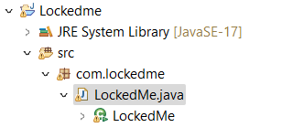

**2. Welcome screen:**

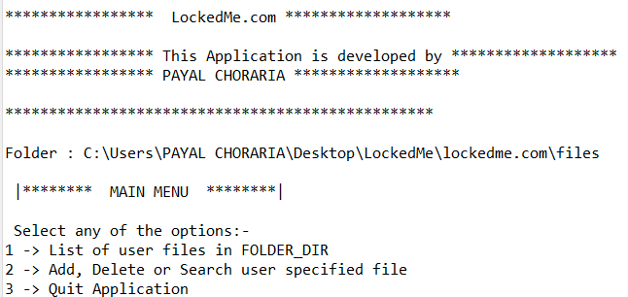

**3. Display main menu:**



**4. Flow chart of the program:**

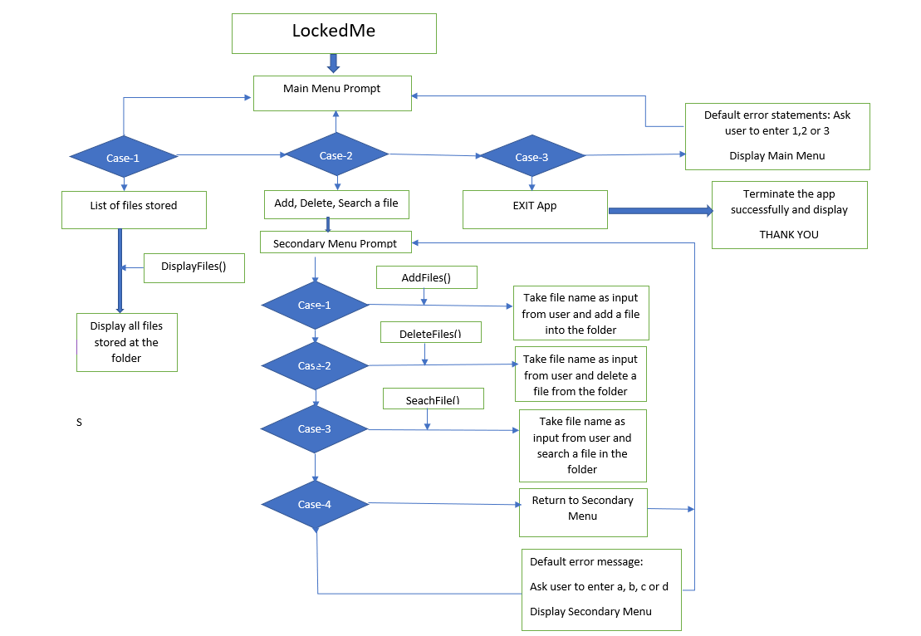

**5. List all files:**

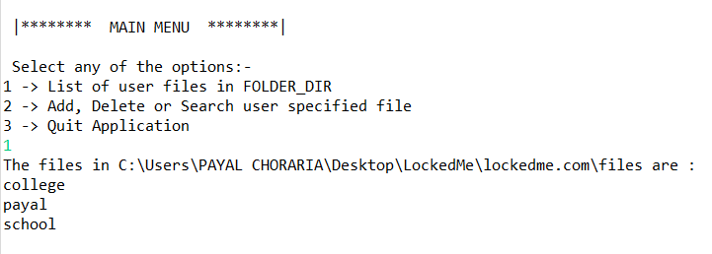

**6. Adding a file :**

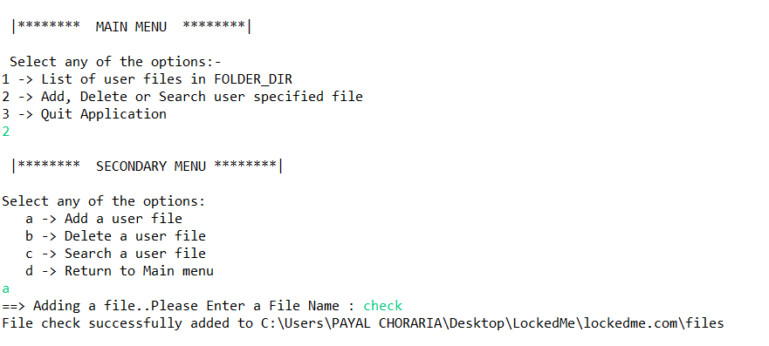

**7. Deleting a file:**

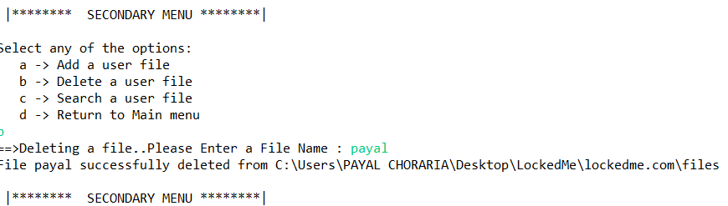

**8. Searching a file:**

**a. File Found:**

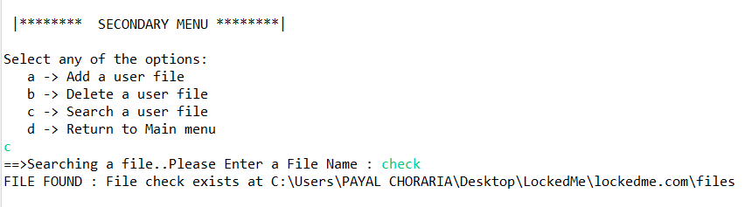

**B. File not found.**

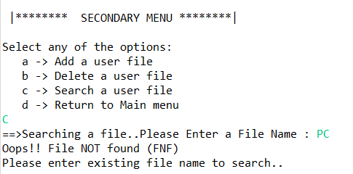

**10. Program to exit:**

**-+**

