SaaS Sales Intelligence Agent
AI-Powered Self-Serve Analytics for B2B Sales Operations

Project Case Study & Technical Documentation
Payal Gore
payal.gore6433@gmail.com | https://github.com/PayalGore/saas-sales-intelligence-agent.git
March 2026

Executive Summary
This document presents the business case, technical architecture, and results of the SaaS Sales Intelligence Agent an AI-powered self-serve analytics tool I built to solve one of the most persistent problems in B2B SaaS operations: the gap between where data lives and who needs it.
In most organizations, sales operations teams spend 4-6 hours per week manually pulling pipeline data, calculating metrics, writing variance commentary, and compiling reports. Every ad-hoc question from leadership requires an analyst to write SQL, run queries, and interpret results. This project demonstrates that with the right AI architecture, this entire workflow can be automated to run in 11 seconds with every number validated against source data.
The agent was built in 3 days using OpenAI GPT-4o-mini, function calling, RAG (Retrieval Augmented Generation), text-to-SQL, and a custom hallucination detection layer. It processes questions in plain English, decides which analysis to run, executes Python on real data, and returns executive-ready insights with an accuracy score.

The Business Case
SITUATION
At most B2B SaaS companies, finance and sales operations teams face a structural bottleneck. Data lives in warehouses like Snowflake, Redshift, or SQL databases. But the people who need that data VPs, directors, sales managers operate in Excel, email, and Slack. Every question they have requires an analyst to manually translate it into SQL, pull the data, calculate metrics, and write up a narrative.
This creates three downstream problems. First, weekly and monthly sales reports take 4-6 hours of manual analyst work pulling the same data, writing the same commentary, answering the same questions every cycle. Second, pipeline risks go undetected because nobody has time to proactively scan for slipping deals, at-risk renewals, or underperforming reps between reporting cycles. Third, leadership decisions are delayed because every ad-hoc question “How did we do last month?” or “Which accounts are at risk?” sits in a queue until an analyst is available.
The opportunity cost is significant. A 5-person analytics team spending 5 hours each per week on recurring reports represents over $71,000 in annual labor cost on work that could be automated. And the risk of delayed or missed insights is even harder to quantify.
TASK
Build a working prototype of an AI-powered self-serve analytics agent that allows sales operations leaders to ask questions about their pipeline data in plain English and receive validated, executive-ready insights in seconds without requiring SQL knowledge, analyst support, or manual report generation.
The prototype needed to demonstrate six core AI capabilities to be credible:
- Agentic AI (Function Calling) - LLM autonomously decides which analysis tool to invoke
- Text-to-SQL- natural language converted to SQL queries executed on real data
- RAG (Retrieval Augmented Generation) - business rules embedded as vectors for context-aware answers
- Multi-tool chaining - complex questions trigger multiple analyses automatically
- Hallucination detection - every number in the output cross-checked against source data
- Self-measuring ROI - the agent calculates its own time and cost savings
ACTION

Step 1: Data Foundation
I generated a synthetic but realistic B2B SaaS sales dataset modeled after a Salesforce-style CRM for an IT management software company. The dataset includes 800 pipeline deals across 150 accounts, 8 sales reps, 4 regions, and 5 product lines. I intentionally embedded realistic patterns for the AI to discover: West region underperformance due to team transitions, Q3 seasonal dip in win rates (dropping to 27% in September), Jordan Blake significantly underperforming with a 16.5% win rate, renewal deals closing at higher rates than new logos, and “Price too high” as the leading loss reason at 25% of all losses.
The data is structured in 4 interconnected tables: Pipeline Deals (deal-level CRM data), Account Metrics (ARR, health scores, NPS, renewal dates, industry), Monthly Aggregates (time-series bookings and win rate data), and Rep Performance (quota attainment, win rate, total bookings per rep). This mirrors the table structure of a real Snowflake or Redshift data warehouse.

Step 2: Analysis Tools (Python Layer)
I built 5 Python functions that serve as the tools the AI agent can call. Each function takes specific inputs, runs pure Pandas calculations on the data, and returns structured results. No AI is involved in the math the LLM interprets results, but Python does the computation. This is a critical design decision: the AI never generates numbers. It generates narratives around numbers that were computed deterministically.
Tool | What It Does | AI Concept
query_data() | Converts natural language to SQL, executes on Pandas DataFrames. 3-attempt recovery if SQL fails. | Text-to-SQL (mirrors Snowflake Cortex pattern)
analyze_trends() | Calculates MoM changes, Z-score anomaly detection. Flags statistically unusual months. | Statistical analysis + anomaly detection
find_at_risk() | Identifies deals slipping past close date or low-health accounts near renewal. | Rule-based risk scoring
compare_periods() | Side-by-side month comparison with % variance on all key metrics. | Period-over-period analysis
generate_weekly_report() | Chains all 4 tools automatically, produces complete executive report. | Multi-tool chaining + process automation

Step 3: RAG Knowledge Base
I built a knowledge base of 20 business rules organized into 5 categories: segment definitions, performance benchmarks, pipeline health thresholds, account health indicators, and team context. Each rule was embedded as a vector using OpenAI’s text-embedding-3-small model. When the agent answers a question, it retrieves the 3 most semantically relevant rules using cosine similarity and includes them as context so the LLM doesn’t just report numbers, it interprets them against business benchmarks.
For example, when asked “Which rep has the lowest win rate?”, the RAG layer retrieves: (1) “Healthy win rate benchmark is above 40%”, (2) “Jordan Blake in West region has the lowest win rate”, and (3) “Below 35% requires immediate pipeline review.” This context transforms a raw data answer into an actionable business insight.

Step 4: AI Agent (Function Calling Loop)
The core of the system is an agentic loop using OpenAI’s function calling. When a user asks a question, the LLM receives the question and a registry of 5 available tools with their descriptions and parameter schemas. The LLM then decides which tool to call or which combination of tools for complex questions. After each tool returns results, the LLM decides whether it has enough information to answer or needs to call another tool.
For multi-part questions like “Who is underperforming and what are our top loss reasons?”, the agent chains query_data (reps by win rate) followed by query_data (loss reasons), combines both results, and generates a unified analysis. This multi-tool chaining is what separates agentic AI from simple prompt-response systems.

Step 5: Hallucination Guard
Every response passes through a validation layer before reaching the user. The system extracts all numbers from the LLM’s narrative using regex, then cross-checks each number against the source data from the tool results. Numbers within 5% tolerance of a source value are marked as verified. List numbering (1, 2, 3) and RAG benchmark values (40%, 70%) are excluded from the check to avoid false positives. The accuracy score is displayed with every response giving users transparency into data trustworthiness.
In testing, the agent achieved 86% accuracy on the weekly report (49 of 57 numbers verified), with unverified numbers consisting primarily of derived percentages the LLM calculated from source data not hallucinations.

Step 6: Streamlit Deployment
I deployed the agent as a Streamlit web application with an interactive dashboard showing real-time metrics (gross bookings, win rate, deals won, average deal size), Plotly charts for bookings trends, win rate trends, rep performance, and loss reason breakdown, pre-built clickable question buttons for both single-tool and multi-tool queries, and a live chat interface where users can type any question and get AI-powered analysis with accuracy scores.

RESULT

Performance Metrics
Metric | Result
Weekly report generation time | 11 seconds
Manual equivalent | ~5 hours
Data accuracy (weekly report) | 86% (49/57 numbers verified)
Data accuracy (single questions) | 65-100% depending on query type
API cost per report | ~$0.03
Annual savings per analyst | ~$14,298
For 5-person team | ~$71,490/year
Build time | 3 days

What the Agent Correctly Identified
- Jordan Blake as the lowest win rate rep (16.5%) correctly flagged for coaching
- Q3 seasonal dip (August 31.3%, September 27.7%) flagged as statistical anomalies via Z-score
- 23 at-risk accounts representing $1.86M ARR prioritized by renewal date and health score
- "Price too high" as the #1 loss reason at 25%+ of losses recommended pricing strategy review
- West region underperformance linked to team transitions and recommended extra pipeline coverage
- June vs September 73.3% bookings decline correctly attributed to Q3 seasonal patterns via RAG context

Technical Architecture
The system follows a 6-layer pipeline architecture. Each layer has a distinct responsibility and the data flows sequentially from user input to validated output.
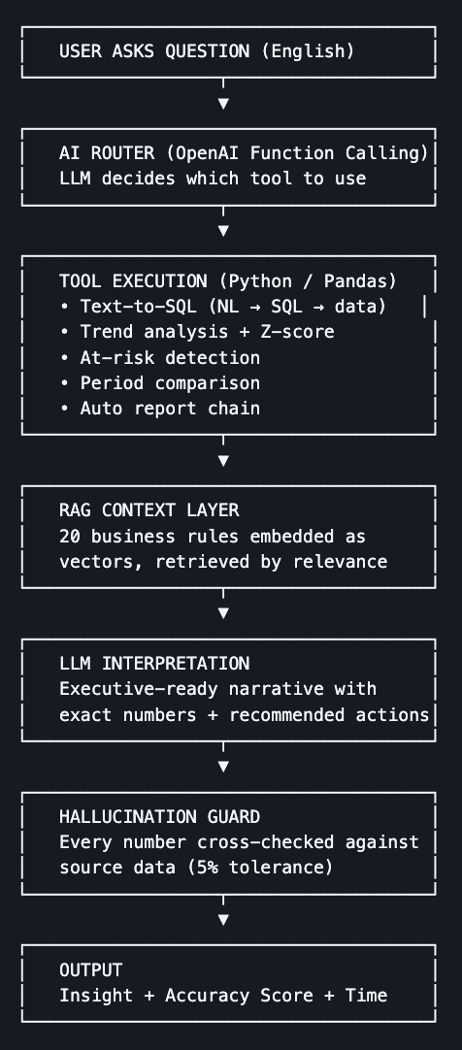

Layer 1: AI Router (Function Calling)
The user’s question enters the system as plain English. OpenAI’s function calling API receives the question along with a tool registry 5 tool definitions with descriptions and parameter schemas. The LLM reads the question, reasons about what type of analysis is needed, and returns a structured function call with the appropriate tool name and arguments. For complex questions, the LLM can request multiple tools sequentially, with each result feeding back into its context before it decides the next action.

Layer 2: Tool Execution (Python/Pandas)
The selected tool executes pure Python on real data. The text-to-SQL engine generates SQLite queries from natural language and runs them on Pandas DataFrames via pandasql with a 3-attempt recovery loop if the first SQL query fails. Trend analysis uses NumPy for Z-score calculations. At-risk detection applies rule-based filters. No AI is involved in computation, Python produces the numbers, ensuring deterministic and auditable results.

Layer 3: RAG Context Layer
Before the LLM interprets tool results, the system retrieves the 3 most relevant business rules from a knowledge base of 20 rules embedded as vectors using OpenAI’s text-embedding-3-small model. Retrieval uses cosine similarity between the question embedding and each rule embedding. This grounds the LLM’s interpretation in company-specific context so it doesn’t just say “win rate is 16.5%” but adds “this is significantly below the 40% benchmark and requires immediate pipeline review.”

Layer 4: LLM Interpretation
The LLM receives tool results and RAG context, then generates an executive-ready narrative. The system prompt constrains the output: use exact numbers only, reference specific accounts and reps by name, keep it under 250 words, end with 1-2 actionable recommendations. The temperature is set to 0.3 for controlled but natural output.

Layer 5: Hallucination Guard
Every number in the LLM’s narrative is extracted via regex and cross-checked against the source data from tool results. Numbers within 5% tolerance are marked as verified. The system excludes list numbering, RAG benchmark values, and small derived percentages from the check to minimize false positives. The accuracy score (e.g., “86% 49/57 numbers verified”) is displayed with every response.

Layer 6: Output
The user receives the analysis narrative, the accuracy score, the generation time, and which tools were used. In the Streamlit app, this is accompanied by interactive Plotly charts and a persistent chat history. The entire pipeline — from question to validated output typically completes in 5-15 seconds depending on the number of tool calls.

Technology Stack
Component | Technology | Purpose
LLM | OpenAI GPT-4o-mini | Function calling, text-to-SQL, narrative generation
Embeddings | text-embedding-3-small | RAG vector embeddings for business rules
Data Processing | Pandas, NumPy | Aggregation, filtering, statistical analysis
SQL Engine | pandasql (SQLite) | Execute generated SQL on DataFrames
Frontend | Streamlit, Plotly | Interactive dashboard and chat interface
Notebook | Google Colab | Development and interactive testing

Production Roadmap
This prototype demonstrates the architecture. For production deployment at enterprise scale, I would make the following enhancements:
- Replace Pandas with a direct Snowflake or BigQuery connector so queries run on the actual data warehouse
- Add SSO/OAuth authentication for enterprise access control
- Implement Redis caching for repeated queries and embedding lookups
- Log all queries, tool calls, accuracy scores, and user feedback for monitoring and improvement
- Move API keys to environment variables and Streamlit secrets for security
- Deploy on AWS/GCP with load balancing for multi-user access

Why This Matters
The gap between data warehouses and business users is not a technology problem it’s a workflow problem. The data exists. The tools exist. But someone still has to manually bridge the gap every week, every month, for every ad-hoc question.
This project proves that with the right architecture agentic function calling, grounded RAG context, deterministic computation, and hallucination validation AI can handle the heavy lifting while keeping humans in the loop for judgment and action. The same pattern applies across finance operations, customer success, HR analytics, and any function where recurring reports and data questions consume analyst hours.
The agent doesn’t replace analysts. It gives them back 5 hours a week to do the work that actually requires human judgment strategic analysis, stakeholder conversations, and building the next tool that makes the team even better.

