Mini Case Report: Investigating an Underperforming Solar Site (EO Analytics)
Time-series analytics mini case • 1-week sample • 5‑minute actuals vs hourly expected

Executive summary
Problem: Given actual site production and an expected (forecast) baseline, identify underperformance, distinguish likely operational derate/outage from data gaps, and quantify impact (lost MWh).
Bottom line: Daily performance is normal on 6 of 7 days. A single high-severity event occurs on 2026‑01‑04, where production drops far below expected during peak daylight hours. The confirmed underperformance window is 11:25–14:45 (205 minutes) with estimated lost energy ≈ 87.45 MWh and an average Actual/Expected ratio ≈ 0.203 during the window.

Data used
- Actual generation (MW): 5‑minute resolution, 1 week (2016 rows).
- Expected generation (MW): hourly resolution, 1 week (168 rows), resampled to 5‑minute intervals via time interpolation to align with actuals.
- Important note: 0 MW values overnight are normal for solar. Performance KPIs are evaluated primarily during daylight (expected > 0) to avoid nighttime bias.

Method overview
- Align timestamps and resample expected to 5‑minute frequency.
- Compute gap and performance ratio at 5‑minute resolution.
- Create a daylight-only view (expected > 0.5 MW) for fair comparisons.
- Summarize daily energy (MWh/day) and daily performance ratio (Actual/Expected).
- Apply practical, ops-style outage/derate rules and require persistence (≥30 minutes) to confirm an event.
- Estimate impact (lost MWh) within confirmed windows.

Key definitions
- gap_mw = expected_mw − actual_mw
- gap_mw_pos = max(gap_mw, 0) (counts only underproduction, ignores overperformance)
- ratio = actual_mw / expected_mw (defined only when expected_mw > 0)
- lost_mwh (over a window) = Σ gap_mw_pos × (5/60)

Results: daily view (triage)
Daily aggregation uses daylight-only data to avoid nighttime zeros. The 0.85 ratio line is used as a simple triage threshold to highlight candidate days for drilldown (customizable by ops/finance).

Figure 1. Daily expected vs actual energy (MWh/day).
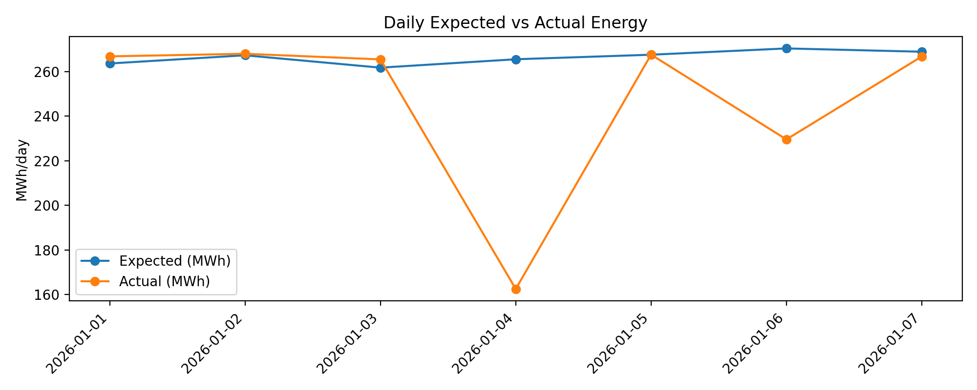
Figure 2. Daily performance ratio (Actual/Expected).
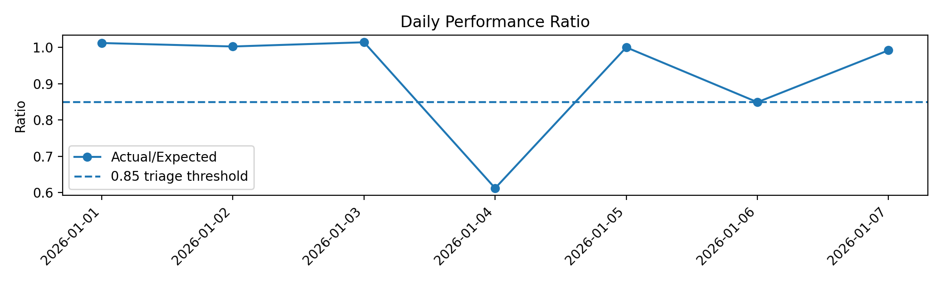

Table 1. Daily summary (daylight-only).
Date | Expected (MWh) | Actual (MWh) | Ratio
2026-01-01 | 263.63 | 266.82 | 1.012
2026-01-02 | 267.31 | 267.99 | 1.003
2026-01-03 | 261.77 | 265.47 | 1.014
2026-01-04 | 265.53 | 162.56 | 0.612
2026-01-05 | 267.56 | 267.61 | 1.000
2026-01-06 | 270.38 | 229.59 | 0.849
2026-01-07 | 268.91 | 266.76 | 0.992

Results: 5-minute drilldown + event confirmation
Ops-style rule (configurable): flag an interval as outage/derate-like when:
• Time is midday (10:00–15:00)
• Expected is high (expected_mw ≥ 25 MW)
• Actual is either near zero (≤ 2 MW) OR drops below 25% of expected
• Confirm only if the condition persists for ≥ 30 minutes (6 consecutive 5‑minute points)

Figure 3. 5‑minute drilldown for the underperformance day (2026‑01‑04). Confirmed points are highlighted.
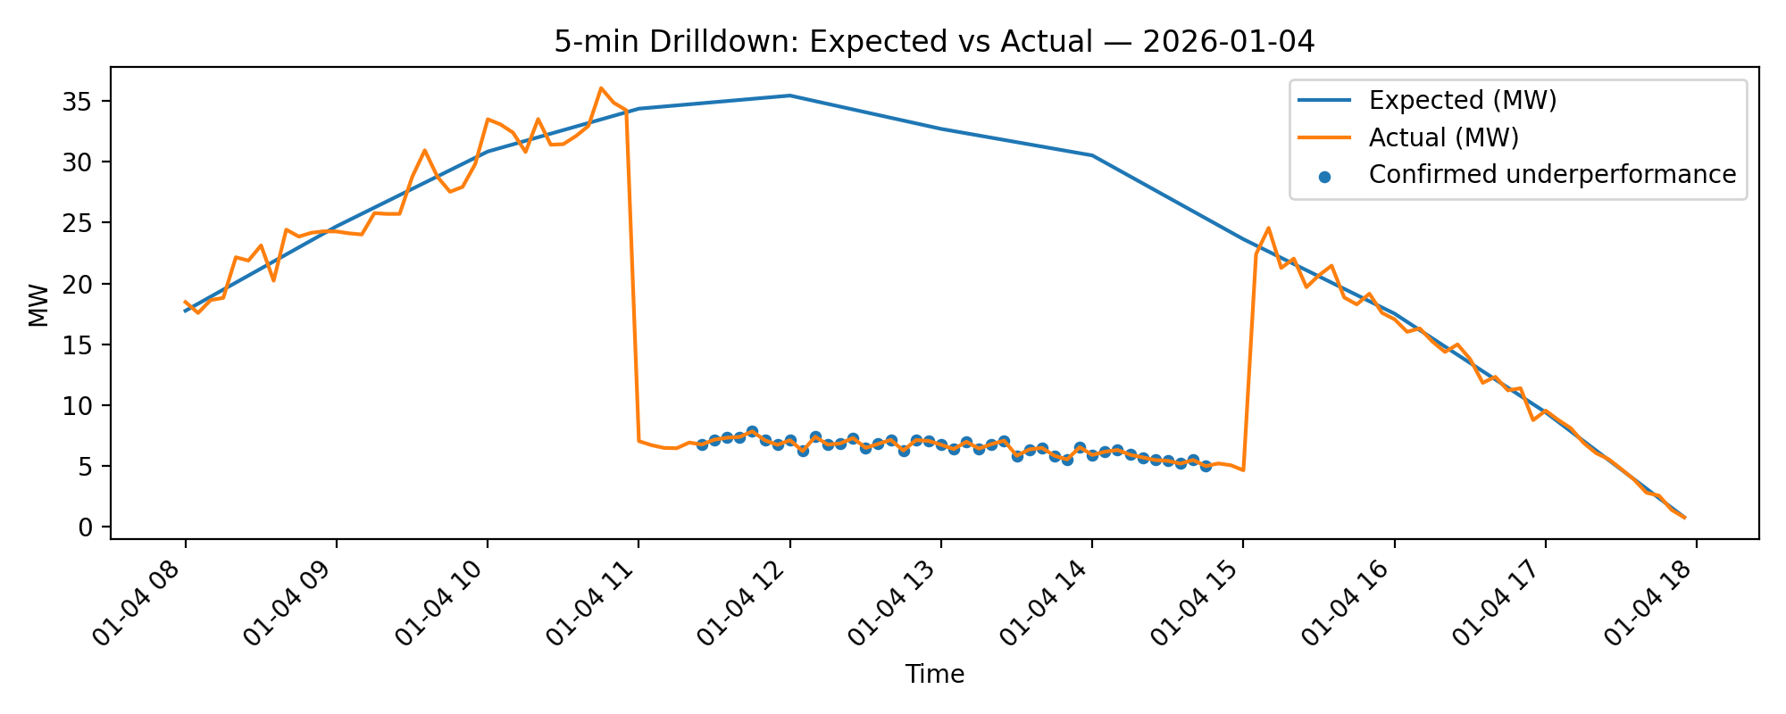

Table 2. Confirmed underperformance event(s) (daylight-only).
Event date | Start | End | Duration (min) | Lost energy (MWh)
2026-01-04 | 11:25 | 14:45 | 205 | 87.45
Within the confirmed window, the average Actual/Expected ratio is 0.203, indicating a severe derate/outage-like drop rather than minor forecast error.

Monitoring & troubleshooting checks (pipeline health)
These checks help separate data quality issues from operational performance and are useful for automated monitoring runs.
Check | Value
data_source | real_csv
earliest_timestamp | 2026-01-01 00:00:00
latest_timestamp | 2026-01-07 23:55:00
expected_freq_minutes | 5
rows_total | 2016
pct_missing_actual | 0.006448
pct_missing_expected | 0.000000
min_rows_per_day | 288
max_rows_per_day | 288
pct_confirmed_points_daylight | 0.040959
Interpretation highlights:
• pct_missing_actual ≈ 0.64% indicates a small amount of missing actual telemetry; missingness alone does not explain the 2026‑01‑04 midday drop.
• pct_confirmed_points_daylight ≈ 4.10% reflects that confirmed underperformance is concentrated in a short window rather than spread across the week.
• Rows/day = 288 suggests the expected 5‑minute cadence (12×24) is present across days (good pipeline regularity).

SQL equivalent (Snowflake-style)
Below is an equivalent pattern for implementing the same outage confirmation logic in a warehouse table (e.g., fact_site_power_5min).
-- fact_site_power_5min(site_id, ts, actual_mw, expected_mw)
WITH base AS (
SELECT
site_id,
ts,
actual_mw,
expected_mw,
GREATEST(expected_mw - actual_mw, 0) AS gap_mw
FROM fact_site_power_5min
),
flags AS (
SELECT
*,
IFF(DATE_PART('hour', ts) BETWEEN 10 AND 15
AND expected_mw >= 25
AND (actual_mw <= 2 OR actual_mw <= 0.25 * expected_mw), 1, 0) AS flag_outage_like,
SUM(IFF(DATE_PART('hour', ts) BETWEEN 10 AND 15
AND expected_mw >= 25
AND (actual_mw <= 2 OR actual_mw <= 0.25 * expected_mw), 1, 0))
OVER (PARTITION BY site_id ORDER BY ts ROWS BETWEEN 5 PRECEDING AND CURRENT ROW) AS outage_like_30m
FROM base
)
SELECT
site_id, ts, actual_mw, expected_mw, gap_mw,
IFF(outage_like_30m = 6, 1, 0) AS flag_outage_confirmed
FROM flags
ORDER BY site_id, ts;

Recommended next steps
- Operational validation:
- Cross-check site SCADA/inverter status and alarms for 2026‑01‑04 11:25–14:45.
- Verify whether curtailment was active (grid event), or whether a component-level derate occurred.
- Data validation:
- Inspect telemetry completeness around the event (packet loss / comms drop).
- Validate expected baseline source (forecast vs clear-sky model) and recalibrate thresholds by season/site.
- Productization:
- Persist the derived features (gap, ratio, flags) as a warehouse fact table and schedule daily monitoring jobs with alerting thresholds.

