**Indira Gandhi Delhi Technical University for Women**

**(Established by Govt. of Delhi vide Act 09 of 2012)**

**Kashmere Gate, Delhi - 110006**



**Practical File**

**For**

**OBJECT ORIENTED PROGRAMMING USING JAVA (BAI-102)**

***Submitted to: Submitted By:***

Ms. Shweta Singhal Name: Payal

Enrolment No.: 09301172022

Semester: 2nd Semester

|  |  |  |
| --- | --- | --- |
| Sno. | Experiment | Date |
| 1. | Experiment 1: Basic questions | 29/03/23 |
| 2. | Experiment 2: Pattern and loop | 05/04/23 |
| 3. | Experiment 3: Switch statement | 19/04/23 |
| 4. | Experiment 4: Calendar and matrix | 26/04/23 |
| 5. | Experiment 5: Constructor | 03/05/23 |
| 6. | Experiment 6: Inheritance | 24/05/23 |
| 7. | Experiment 7: Overriding | 31/05/23 |
| 8. | Experiment 8: File Handling | 07/06/23 |
| 9. | Experiment 9: Exception Handling | 14/06/23 |

INDEX

Experiment -1

**Question 1** WAP to print whether a given number is even or odd?

package exp1;

import java.util.*;

public class exp1_1 {

    public static void main(String[] args) {

        Scanner sc = new Scanner(System.in);

        System.out.print("enter number: ");

        int a = sc.nextInt();

        if (a % 2 == 0) {

            System.out.println("Even number");

        } else {

            System.out.println("Odd number");

        }

        sc.close();

    }

}

Output:

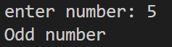 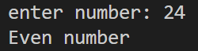

**Question 2** WAP to swap two numbers without taking a 3rd variable

package exp1;

import java.util.*;

public class exp1_2 {

    public static void main(String[] args) {

        Scanner sc = new Scanner(System.in);

        System.out.print("enter first number: ");

        int a = sc.nextInt();

        System.out.print("enter second number: ");

        int b = sc.nextInt();

        a = a + b;

        b = a - b;

        a = a - b;

        System.out.print("enter first no. becomes: ");

        System.out.println(a);

        System.out.print("enter second no. becomes: ");

        System.out.println(b);

        sc.close();

    }

}

Output:

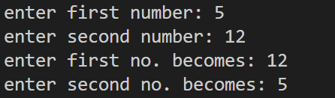

**Question 3** WAP to find maximum of 3 numbers

package exp1;

import java.util.*;

public class exp1_3 {

    public static void main(String[] args) {

        Scanner sc = new Scanner(System.in);

        System.out.print("enter first number a: ");

        int a = sc.nextInt();

        System.out.print("enter second number b: ");

        int b = sc.nextInt();

        System.out.print("enter third number c: ");

        int c = sc.nextInt();

        if (a>b && a>c){

            System.out.println("a is maximum");

        }else if(b>a && b>c){

            System.out.println("b is maximum");

        }else{

            System.out.println("c is maximum");

        }

        sc.close();

    }

}

Output:

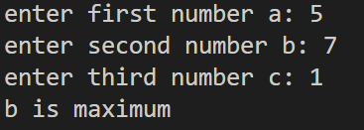

**Question 4** WAP to print the grade of a student as per given marks

‘A’ for marks>80

‘B’ marks between 70-80

‘C’ marks between 60-70

‘D’ marks between 50-60

‘F’ for marks less than 50

package exp1;

import java.util.*;

public class exp1_4 {

    public static void main(String[] args) {

        Scanner sc = new Scanner(System.in);

        System.out.print("enter marks: ");

        int n = sc.nextInt();

        if(n>80){

            System.out.println("A");

        }else if(n<=80 && n>=70){

            System.out.println("B");

        }else if(n<=70 && n>=60 ){

            System.out.println("C");

        }else if(n<=60 && n>=50 ){

            System.out.println("D");

        }else{

            System.out.println("F");

        }

        sc.close();

    }

}

Output:

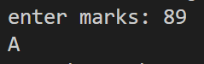

**Question 5** WAP to find the roots of a quadratic equation

package exp1;

public class exp1_5 {

    public static void main(String[] args) {

        // x^2 - 5x - 6 = 0

        int coeffx2 = 1;

        int coeffx = -5;

        int constant = -6;

        double d = (coeffx*coeffx-4*(coeffx2*constant));

        double rootd = Math.sqrt(d);

        double root1 = (-coeffx+rootd)/(2*coeffx2);

        double root2 = (-coeffx-rootd)/(2*coeffx2);

        System.out.println("The first root is : "+root1);

        System.out.println("The second root is : "+root2);

    }

}

Output:

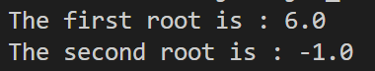

Experiment - 2

**Question 1** Write programmes to print the following patterns?

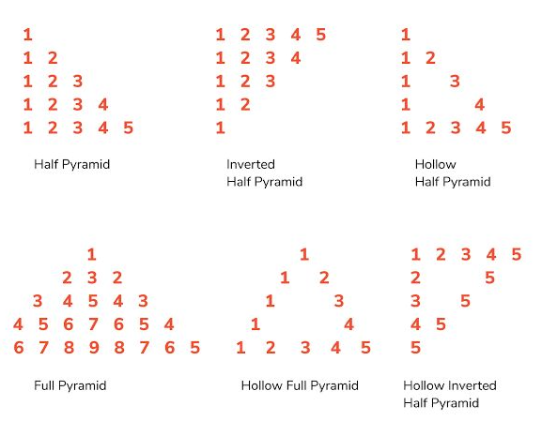

package exp2;

public class exp2_1 {

    public static void main(String[] args) {

        System.out.println("----------a-Half Pyramid---------");

        for (int i=1;i<=5;i++){

            for (int j=1;j<=i;j++){

                System.out.print(j+" ");

            }System.out.println();

        }

        System.out.println("----------b-Inverted Half Pyramid---------");

        int n=5;

        for(int i=1;i<=n;i++){

            for(int j=1;j<=n-i+1;j++){

                System.out.print(j+" ");

            }System.out.println();

        }

        System.out.println("----------c-Hollow Half Pyramid---------");

        for (int i=1;i<=5;i++){

            for (int j=1;j<=i;j++){

                if (j==1 || j==i){

                    System.out.print(j+" ");

                }else if(i==5){

                    System.out.print(j+" ");

                }else{

                    System.out.print("  ");

                }

            }System.out.println();

        }

        System.out.println("---------d-Full Pyramid----------");

        for(int i=1; i<=5; i++){

            for(int j=1; j<=5-i; j++){

                System.out.print(' ');

            }

            int x= i;

            for(int k =1; k<=i;k++){

                System.out.print(x);

                x++;

            }

            x = x-2;

            for(int l = 1; l<i ; l++){

                System.out.print(x);;

                x--;

            }

            System.out.println();

        }

        System.out.println("---------e-Hollow Full Pyramid----------");

        for(int i=1;i<=5;i++){

            for(int j=1;j<=5-i;j++){

                System.out.print("  ");

            }

            int l=1;

            for(int k=1; k<=(2*i-1);k++){

                if (k==1 && i!=5){

                    System.out.print("1 ");

                }else if(k==(2*i-1)){

                    System.out.print(i+" ");

                }else if(i==5 && k%2==1){

                    System.out.print(l+" ");

                    l++;

                }else{

                    System.out.print("  ");

                }

            }

            System.out.println();

        }

        System.out.println("---------f-Hollow Inverted half Pyramid----------");

        int m=5;

        for(int i=1;i<=m;i++){

            for(int j=1;j<=m-i+1;j++){

                if (i==1){

                    System.out.print(j+" ");

                }else if(j==1){

                    System.out.print(i+" ");

                }else if(j==m-i+1){

                    System.out.print(m+" ");

                }else{

                    System.out.print("  ");

                }

            }System.out.println();

        }

    }

}

Output:

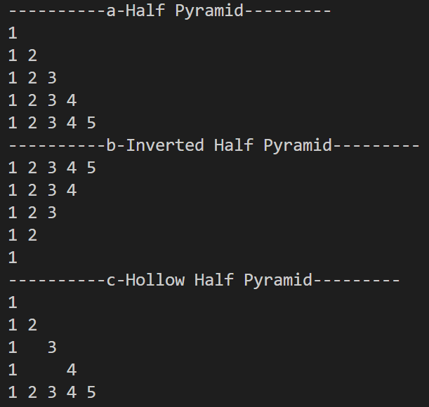

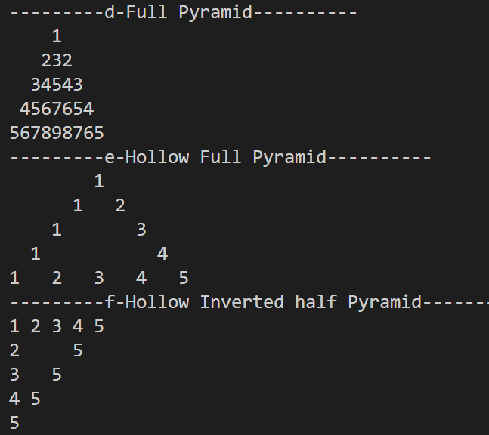

**Question 2** Print (a+(b*c))/(b-c) taking a, b, c as input

package exp2;

import java.util.*;

public class exp2_2 {

    public static void main(String[] args) {

        Scanner sc = new Scanner(System.in);

        float a = sc.nextFloat();

        float b = sc.nextFloat();

        float c = sc.nextFloat();

        float ans = (a-(b*c))/(b-c);

        System.out.println("The answer is : "+ans);

        sc.close();

    }

}

Output:

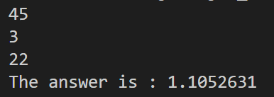

**Question 3** Convert rupees, taken as input, to paise

package exp2;

import java.util.*;

public class exp2_3 {

    public static void main(String[] args) {

        Scanner sc = new Scanner(System.in);

        System.out.print("Enter amount in rupees : ");

        int rupees = sc.nextInt();

        int paisa = rupees * 100;

        System.out.println("The amount in paisa is : "+paisa);

        sc.close();

    }

}

Output:

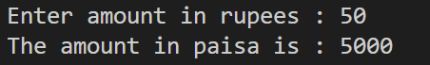

Experiment - 3

**Question 1** WAP to make a calculator.

import java.util.*;

public class exp3_1 {

    public static void main(String[] args) {

        Scanner sc = new Scanner(System.in);

        System.out.print("enter first number: ");

        int a = sc.nextInt();

        System.out.print("enter second number: ");

        int b = sc.nextInt();

        System.out.print("enter operator: ");

        char op = sc.next().charAt(0);

        if (op=='+'){

            System.out.println(a+b);

        }else if(op=='-'){

            System.out.println(a-b);

        }else if(op=='*'){

            System.out.println(a*b);

        }else if(op=='/'){

            System.out.println(a/b);

        }else if(op=='%'){

            System.out.println(a%b);

        }

        sc.close();

    }

}

Output:

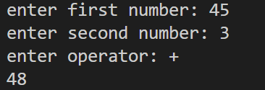

**Question 2** WAP to make a calculator using switch.

import java.util.*;

public class exp3_2 {

    public static void main(String[] args) {

        Scanner sc = new Scanner(System.in);

        System.out.print("enter first number: ");

        int a = sc.nextInt();

        System.out.print("enter second number: ");

        int b = sc.nextInt();

        System.out.print("enter operator: ");

        char op = sc.next().charAt(0);

        switch(op){

            case '+':System.out.println(a+b); break;

            case '-':System.out.println(a-b); break;

            case '*':System.out.println(a*b); break;

            case '/':System.out.println(a/b); break;

            case '%':System.out.println(a+b); break;

        }

        sc.close();

    }

}

Output:

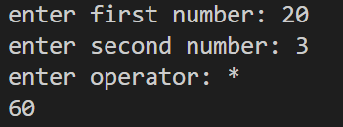

**Question 3** WAP to Convert temperature in Celsius to Fahrenheit.

import java.util.*;

public class exp3_3 {

    public static void main(String[] args) {

        Scanner sc = new Scanner(System.in);

        System.out.print("Enter temperature in degree Celsius: ");

        double a = sc.nextFloat();

        double b = ((9.0/5.0)*a)+32.0;

        System.out.print("Temperature in degree Fahrenheit is: ");

        System.out.println(b);

        sc.close();

    }

}

Output:

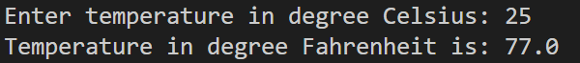

**Question 4** WAP to check if a number is positive, negative or zero.

import java.util.*;

public class exp3_4 {

    public static void main(String[] args) {

        Scanner sc = new Scanner(System.in);

        System.out.print("Enter number: ");

        float a = sc.nextFloat();

        if (a>0){

            System.out.println("Positive number");

        }else if(a<0){

            System.out.println("Negative number");

        }else{

            System.out.println("Zero");

        }

        sc.close();

    }

}

Output:

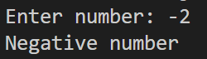

**Question 5** WAP to find weather a year is a leap year or not.

import java.util.*;

public class exp3_5 {

    public static void main(String[] args) {

        Scanner sc = new Scanner(System.in);

        System.out.print("Enter year : ");

        int year = sc.nextInt();

        if (year % 4 ==0){

            if(year%100!=0){

                System.out.println("leap year");

            }else if(year%400==0){

                System.out.println("leap year");

            }else{

                System.out.println("not a leap year");

            }

        }else{

            System.out.println("not a leap year");

        }

        sc.close();

    }

}

Output:

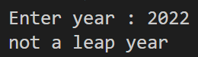

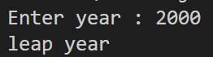

**Question 6** WAP to find if a character is a vowel or a consonant.

import java.util.*;

public class exp3_6 {

    public static void main(String[] args) {

        Scanner sc = new Scanner(System.in);

        System.out.print("Enter a character");

        String s = sc.next();

        s=s.toLowerCase();

        switch(s)

        {

            case "a": case "e": case "i": case "o": case "u":

            System.out.println("vowel"); break;

            default:System.out.println("consonant");break;

        }

        sc.close();

    }

}

Output:

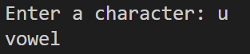

**Question 7** WAP to find the month name and number of days in the months by taking input as month number.

import java.util.*;

public class exp3_7 {

    public static void main(String[] args) {

        Scanner sc = new Scanner(System.in);

        System.out.print("Enter month number : ");

        int n = sc.nextInt();

        switch(n){

            case 1 : System.out.println("January\n31 days"); break;

            case 2 : System.out.println("February\n28 or 29 days"); break;

            case 3 : System.out.println("March\n31 days"); break;

            case 4 : System.out.println("April\n30 days"); break;

            case 5 : System.out.println("May\n31 days"); break;

            case 6 : System.out.println("June\n30 days"); break;

            case 7 : System.out.println("July\n31 days"); break;

            case 8 : System.out.println("August\n31 days"); break;

            case 9 : System.out.println("September\n30 days"); break;

            case 10 : System.out.println("October\n31 days"); break;

            case 11: System.out.println("November\n30 days"); break;

            case 12: System.out.println("December\n31 days"); break;

        }

        sc.close();

    }

}

Output:

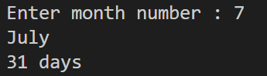

Experiment 4

**Question 1** Create a calendar, enter a date to get its previous date, next date and days.

package exp4;

import java.util.*;

public class exp4_1 {

    public static void main(String[] args) {

        Scanner sc = new Scanner(System.in);

        System.out.print(("Enter dd: "));

        int dd = sc.nextInt();

        System.out.print("Enter mm: ");

        int mm = sc.nextInt();

        System.out.print("Enter yyyy: ");

        int yyyy = sc.nextInt();

        int nextdd = dd+1;

        int prevdd = dd-1;

        int nextmm = mm;

        int prevmm = mm;

        int nextyyyy = yyyy;

        int prevyyyy = yyyy;

        switch(mm){

            case 1: switch(dd){

                case 01: prevdd =31; prevmm=12; prevyyyy = yyyy-1; break;

                case 31: nextdd = 01; nextmm = mm+1; break;

            }break;

            case 2: switch(dd){

                case 01: prevdd =31; prevmm=mm-1; break;

                case 28: if(yyyy %4 !=0){

                    nextdd = 01; nextmm = mm+1;

                }break;

                case 29: nextdd = 01; nextmm=mm+1; break;

            }break;

            case 3: switch(dd){

                case 1: if (yyyy%4 == 0){

                    prevdd = 29 ; prevmm = mm-1;

                }else{

                    prevdd = 28 ; prevmm = mm-1;

                }break;

                case 31: nextdd = 1; nextmm = mm+1; break;

            }break;

            case 4: switch(dd){

                case 1: prevdd = 31; prevmm= mm-1; break;

                case 30: nextdd = 1; nextmm= mm+1; break;

            }break;

            case 5: switch(dd){

                case 1: prevdd = 30; prevmm= mm-1; break;

                case 31: nextdd = 1; nextmm= mm+1; break;

            }break;

            case 6: switch(dd){

                case 1: prevdd = 31; prevmm= mm-1; break;

                case 30: nextdd = 1; nextmm= mm+1; break;

            }break;

            case 7: switch(dd){

                case 1: prevdd = 31; prevmm= mm-1; break;

                case 30: nextdd = 1; nextmm= mm+1; break;

            }break;

            case 8: switch(dd){

                case 1: prevdd = 30; prevmm= mm-1; break;

                case 31: nextdd = 1; nextmm= mm+1; break;

            }break;

            case 9: switch(dd){

                case 1: prevdd = 31; prevmm= mm-1; break;

                case 30: nextdd = 1; nextmm= mm+1; break;

            }break;

            case 10: switch(dd){

                case 1: prevdd = 30; prevmm= mm-1; break;

                case 31: nextdd = 1; nextmm= mm+1; break;

            }break;

            case 11: switch(dd){

                case 1: prevdd = 31; prevmm= mm-1; break;

                case 30: nextdd = 1; nextmm= mm+1; break;

            }break;

            case 12: switch(dd){

                case 1: prevdd = 30; prevmm= mm-1; break;

                case 31: nextdd = 1; nextmm= mm+1; nextyyyy = yyyy+1 ; break;

            }break;

        }

        System.out.println("Next Date : "+ nextdd +"/"+nextmm+"/"+nextyyyy);

        System.out.println("Previous Date : "+prevdd+"/"+prevmm+"/"+prevyyyy);

        sc.close();

    }

}

Output:

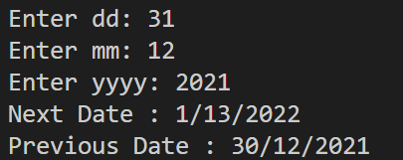

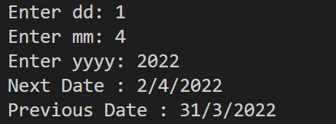

**Question 2** Use 2D array to print matrix, perform addition and multiplication on it with another matrix.

package exp4;

import java.util.*;

public class exp4_2 {

    public static void main(String[] args) {

        Scanner sc = new Scanner(System.in);

        System.out.print("Enter no. of row of first matrix: ");

        int m1 = sc.nextInt();

        System.out.print("Enter no. of column of first matrix: ");

        int n1 = sc.nextInt();

        System.out.print("Enter no. of row of second matrix: ");

        int m2 = sc.nextInt();

        System.out.print("Enter no. of column of second matrix: ");

        int n2 = sc.nextInt();

        int a[][] = new int[m1][n1];    // first matrix A

        int b[][] = new int[m2][n2];    // second matrix B

        int c[][] = new int[m1][n2];    // matrix after adding A and B

        int d[][] = new int[m2][n2];    // matrix after multiplying A and B

        System.out.println("enter the elements of the first matrix: ");

        for(int i=0; i<m1; i++){

            for(int j=0; j<n1; j++){

                a[i][j] = sc.nextInt();

            }

        }

        System.out.println("enter the elements of the second matrix: ");

        for(int i=0; i<m2; i++){

            for(int j=0; j<n2; j++){

                b[i][j] = sc.nextInt();

            }

        }

        System.out.println("\nThe first matrix is: ");

            for(int i=0; i<m1; i++){

                for(int j=0; j<n2; j++){

                    System.out.print(a[i][j]+ " ");

                }

                System.out.println();

            }

        System.out.println();

        System.out.println("The second matrix is: ");

            for(int i=0; i<m1; i++){

                for(int j=0; j<n2; j++){

                    System.out.print(b[i][j]+ " ");

                }

                System.out.println();

            }

        System.out.println();

        if(n1!=n2 && m1!=m2){

            System.out.println("matrix addition not possible");

        } else {

            for(int i=0; i<m1; i++){

                for(int j=0; j<n1; j++){

                    d[i][j]= a[i][j] + b[i][j];

                }

            }

            System.out.println("The resultant matrix by matrix addition: ");

            for(int i=0; i<m1; i++){

                for(int j=0; j<n1; j++){

                    System.out.print(d[i][j]+ " ");

                }

                System.out.println();

            }

        }

        System.out.println();

        if(n1!=m2){

            System.out.println("matrix multiplication not possible");

        } else {

            for(int i=0; i<m1; i++){

                for(int j=0; j<n2; j++){

                    for(int k=0; k<n1; k++){

                        c[i][j] += a[i][k]*b[k][j];

                    }

                }

            }

            System.out.println("The resultant matrix by matrix multiplication: ");

            for(int i=0; i<m1; i++){

                for(int j=0; j<n2; j++){

                    System.out.print(c[i][j]+ " ");

                }

                System.out.println();

            }

        }

        sc.close();

    }

}

Output:

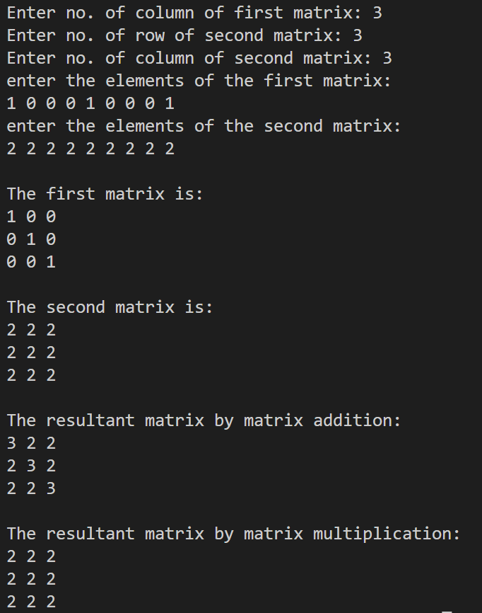

Experiment 5

**Question 1** Create a class triangle having colour, type, side (1,2,3). Depending on the type of triangle, call constructor and calculate and print area.

package exp5;

import java.lang.Math;

import java.util.Scanner;

class triangle {

    String color; String type;

    double side1, side2 , side3;

    double area;

    triangle(){

        color="White";

        type="None";

        side1=0.0;

        side2=0.0;

        side3=0.0;

    }

    triangle(double a){

        side1 = a;

        side2 = a;

        side3 = a;

        type = "Equilateral";

    }

    triangle(double a, double b){

        side1 = a;

        side2 = a;

        side3 = b;

        type = "Isosceles";

    }

    triangle(double a , double b , double c){

        side1 = a;

        side2 = b;

        side3 = c;

        type = "Scalene";

    }

    void calcArea(){

        double s = (side1+side2+side3)/2;

        area = Math.sqrt(s*(s-side1)*(s-side2)*(s-side3));

    }

    void printDetails(){

        System.out.println("Type of traingle :"+type);

        System.out.println("Area of the triangle is :"+ area);

        System.out.println("Color of triangle :"+color);

    }

}

class exp5_1 {

    public static void main(String[] args) {

        Scanner sc = new Scanner(System.in);

        System.out.print("side 1 : ");

        double a = sc.nextInt();

        System.out.print("side 2 : ");

        double b = sc.nextInt();

        System.out.print("side 3 : ");

        double c = sc.nextInt();

        if(a+b>c && b+c>a && a+c>b) {

            if(a==b && a==c && b==c){

                triangle t1 = new triangle(a);

                t1.color = "Purple";

                t1.calcArea();

                t1.printDetails();

            }else if(a==b && a!=c){

                triangle t2 = new triangle(a,c);

                t2.color = "Red";

                t2.calcArea();

                t2.printDetails();

            }else if(a==c && a!=b){

                triangle t2 = new triangle(a,b);

                t2.color = "Red";

                t2.calcArea();

                t2.printDetails();

            }else if(b==c && b!=a){

                triangle t2 = new triangle(b,a);

                t2.color = "Red";

                t2.calcArea();

                t2.printDetails();

            }else{

                triangle t3 = new triangle(a,b,c);

                t3.color = "Blue";

                t3.calcArea();

                t3.printDetails();

            }

        }else{

            System.out.println("Triangle not possible ");

        }

        sc.close();

    }

}

Output:

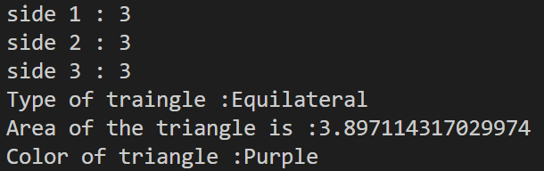 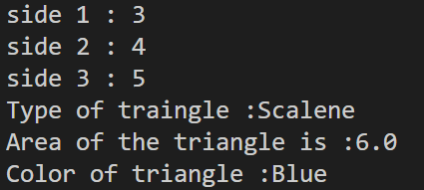 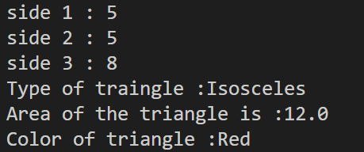

**Question 2** Write a program to create a class Account having account no, name, balance, rate of interest type (current or savings). Write the code for possible operations:

(1) create account (2) check balance (3) update balance (4) withdraw (5) deposit (6) exit

package exp5;

import java.util.Scanner;

class account {

    static int acc_no = 0;

    String name;

    double balance;

    double rate;

    String type;

    Scanner sc = new Scanner(System.in);

    account(){

        System.out.println(".........WELCOME TO OUR BANK.........");

    }

    void create() {

        System.out.println("Creating a bank account ");

        this.balance = 0.0;

        account.acc_no++;

        System.out.println("Account Number: "+account.acc_no);

        System.out.print("Enter Name : ");

        name = sc.nextLine();

        System.out.print("Enter Rate of interest : ");

        rate = sc.nextDouble();

        sc.nextLine();

        System.out.print("Enter Type(current/saving) : ");

        type = sc.nextLine();

        System.out.println("Account created successfully...");

    }

    void check() {

        System.out.println("Current Balance : "+balance);

    }

    void deposit() {

        System.out.println("Enter amount to be deposited : ");

        int z = sc.nextInt();

        balance = balance+z;

        System.out.println("Current Balance: "+balance);

    }

    void update() {

        if(type.equalsIgnoreCase("current")){

            balance = balance + (rate * balance) /2;

        }else if (type.equalsIgnoreCase("saving")){

            balance = balance + balance*rate;

        }

        System.out.println("Updated Balance after interest : "+balance);

    }

    void withdraw() {

        System.out.println("Enter amount to be withdrawn : ");

        int z = sc.nextInt();

        balance = balance-z;

        System.out.println("Current Balance : "+balance);

    }

}

class exp5_2b {

    public static void main(String[] args) {

        Scanner s = new Scanner(System.in);

        boolean choice = true;

        while(choice){

            account a1 = new account();

            a1.create();

            a1.check();

            a1.deposit();

            a1.update();

            a1.withdraw();

            System.out.print("Do you want to continue (y/n) : ");

            String c = s.nextLine();

            if (c.equalsIgnoreCase("n")){

                choice = false;

                System.out.println("......... THANK YOU ! .........");

            }

        }

        s.close();

    }

}

Output:

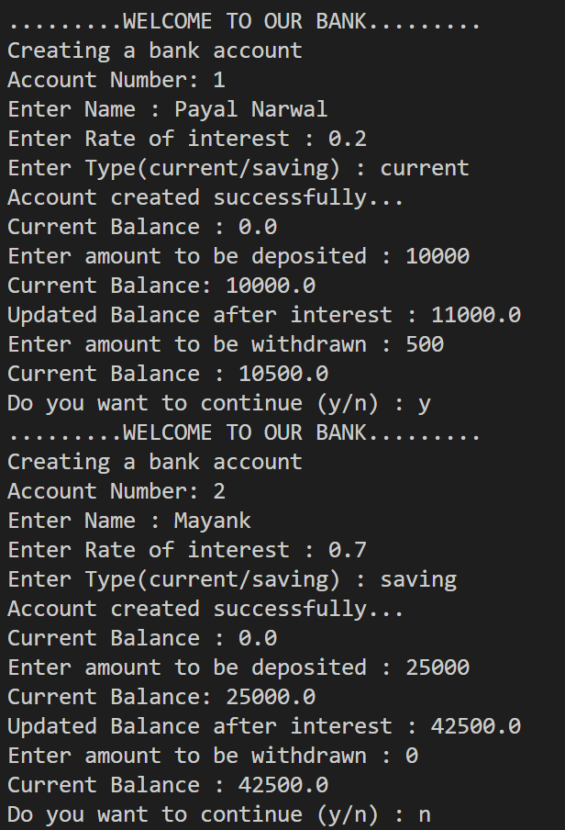

Experiment 6

**Question 1** Create base class distance, give private parameter d1. Create constructors for add, subtract and print. Two derived classes dinch (convert d1 to inches) dmiles (convert d1 to miles), give them same constructors. Use override to add, subtract and print.

package exp6;

import java.util.Scanner;

class Distance{

    double d;

    Distance() {

        d = 0;

    }

    Distance(double d) {

        this.d = d;

    }

    Distance add (Distance other){

        Distance result = new Distance();

        result.d = this.d + other.d;

        return result;

    }

    Distance sub (Distance other){

        Distance result = new Distance();

        if(this.d > other.d){

            result.d = this.d - other.d;

        }else{

            result.d = other.d - this.d;

        }

        return result;

    }

    void printDistance(){

        System.out.println(this.d+" meters");

    }

}

class dInches extends Distance{

    dInches(){

        this.d = 0;

    }

    dInches(double d){

        this.d = ((d)*(2.54))/100;

    }

    dInches add (dInches other){

        dInches result = new dInches();

        result.d = this.d + other.d;

        return result;

    }

    dInches sub (dInches other){

        dInches result = new dInches();

        if(this.d > other.d){

            result.d = this.d - other.d;

        }else{

            result.d = other.d - this.d;

        }

        return result;

    }

    void printDistance(){

        System.out.println("Result : "+this.d+" inches");

    }

}

class dMiles extends Distance{

    dMiles(){

        this.d = 0;

    }

    dMiles(double d){

        this.d = d* 0.000621;

    }

    dMiles add (dMiles other){

        dMiles result = new dMiles();

        result.d = this.d + other.d;

        return result;

    }

    dMiles sub (dMiles other){

        dMiles result = new dMiles();

        if(this.d > other.d){

            result.d = this.d - other.d;

        }else{

            result.d = other.d - this.d;

        }

        return result;

    }

    void printDistance(){

        System.out.println("Result : "+this.d+" miles");

    }

}

public class exp6_1b {

    public static void main(String[] args) {

        Scanner sc = new Scanner(System.in);

        System.out.print("Enter distance d1 : ");

        double a = sc.nextDouble();

        System.out.print("Enter distance d2 : ");

        double b = sc.nextDouble();

        Distance d1 = new Distance(a);

        Distance d2 = new Distance(b);

        Distance d3 = d1.add(d2);

        System.out.print("The resultant distance after adding : ");

        d3.printDistance();

        Distance d4 = d1.sub(d2);

        System.out.print("The resultant distance after subtracting : ");

        d4.printDistance();

        dInches dI_1 = new dInches(a);

        System.out.print("The distance d1 in Inches : ");

        dI_1.printDistance();

        dInches dI_2 = new dInches(b);

        System.out.print("The distance d2 in Inches : ");

        dI_2.printDistance();

        dMiles dM_1 = new dMiles(a);

        System.out.print("The distance d1 in Miles : ");

        dM_1.printDistance();

        dMiles dM_2 = new dMiles(b);

        System.out.print("The distance d2 in Miles : ");

        dM_2.printDistance();

        sc.close();

    }

}

Output:

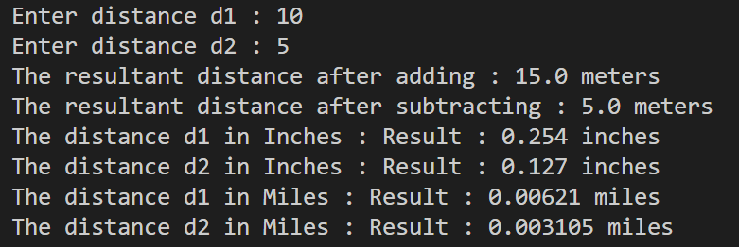

**Question 2** Create an employee class with private members name address age gender taken as input, use constructor to initialize values to the variable, display all. Derive employee class into full time employee, with members salary and designation (display all) and part time employee with members work hour and rate per hour from which pay can be calculated (work hour * rate per hour), display pay.

import java.util.Scanner;

class Employee {

    private String name;

    private String address;

    private int age;

    private String gender;

    Employee(String n, String a, int age, String g) {

        this.name = n;

        this.address = a;

        this.age = age;

        this.gender = g;

    }

    void displayDetails() {

        System.out.println("Name: " + name);

        System.out.println("Address: " + address);

        System.out.println("Age: " + age);

        System.out.println("Gender: " + gender);

    }

}

class FullTimeEmployee extends Employee {

    private double salary;

    private String designation;

    FullTimeEmployee(String n, String a, int age, String g, double s, String d) {

        super(n, a, age, g);

        this.salary = s;

        this.designation = d;

    }

    void displayDetails() {

        super.displayDetails();

        System.out.println("Salary: " + salary);

        System.out.println("Designation: " + designation);

    }

}

class PartTimeEmployee extends Employee {

    private int workHours;

    private double ratePerHour;

    PartTimeEmployee(String n, String a, int age, String g, int wh, double rph) {

        super(n, a, age, g);

        this.workHours = wh;

        this.ratePerHour = rph;

    }

    void calculatePay() {

        double pay = workHours * ratePerHour;

        System.out.println("Pay: " + pay + " rupees");

    }

}

public class exp6_2 {

    public static void main(String[] args) {

        Scanner sc = new Scanner(System.in);

        System.out.println("----employee----");

        System.out.print("Enter employee name: ");

        String name = sc.nextLine();

        System.out.print("Enter employee address: ");

        String address = sc.nextLine();

        System.out.print("Enter employee age: ");

        int age = sc.nextInt();

        sc.nextLine();

        System.out.print("Enter employee gender: ");

        String gender = sc.nextLine();

        Employee emp1= new Employee(name, address, age, gender);

        System.out.println("Employee Details:");

        emp1.displayDetails();

        System.out.println();

        System.out.println("----full-time employee---- ");

        System.out.print("Enter full-time employee salary: ");

        double salary = sc.nextDouble();

        sc.nextLine();

        System.out.print("Enter full-time employee designation: ");

        String designation = sc.nextLine();

        FullTimeEmployee emp2 = new FullTimeEmployee("Abcd", "xxxx", 24, "m", salary, designation);

        System.out.println("Full-Time Employee Details:");

        emp2.displayDetails();

        System.out.println();

        System.out.println("----part-time employee----");

        System.out.print("Enter part-time employee work hours: ");

        int workHours = sc.nextInt();

        System.out.print("Enter part-time employee rate per hour: ");

        double ratePerHour = sc.nextDouble();

        PartTimeEmployee emp3 = new PartTimeEmployee("Bcde", "yyyy", 18, "m", workHours, ratePerHour);

        System.out.println("Part-Time Employee Details:");

        emp3.displayDetails();

        emp3.calculatePay();

        sc.close();

    }

}

Output:

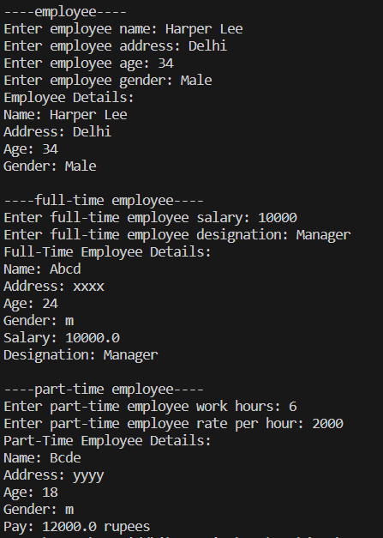

Experiment 7

**Question 1** Define a class MotorVehicle having members model name, model number and price having method display() to display number and price. Find another class Car that inherits MotorVehicle and have Distance rate, display() to display car name, number and price and discount() method to compute discount. Create the classes with suitable constructor and test for 2 objects.

class MotorVehicle{

    String modelName ;

    int modelNo;

    double modelPrice;

    public MotorVehicle() {

    }

    public MotorVehicle(String modelName, int modelNo, double modelPrice) {

        this.modelName = modelName;

        this.modelNo = modelNo;

        this.modelPrice = modelPrice;

    }

    void display(){

        System.out.println("modelName : "+modelName);

        System.out.println("modelNo : "+modelNo);

        System.out.println("modelPrice : "+modelPrice);

    }

}

class Car extends MotorVehicle{

    double disRate = 2.2;

    Car(){

        super();

    }

    Car(String modelName, int modelNo, double modelPrice) {

        super(modelName, modelNo, modelPrice);

    }

    void display(){

        System.out.println("modelName : "+ super.modelName);

        System.out.println("modelNo : "+ super.modelNo);

        System.out.println("model price before discount :"+ super.modelPrice);

        discount();

        System.out.println("model price after discount :"+ modelPrice);

    }

    void discount(){

        super.modelPrice -= super.modelPrice * disRate * 0.01;

    }

}

public class Q1_motorVehicle {

    public static void main(String[] args) {

        MotorVehicle m1 = new MotorVehicle();

        m1 = new Car();

        m1.modelName = "AirRacer-Pro";

        m1.modelNo = 1;

        m1.modelPrice = 1000000;

        m1.display();

        Car m2 = new Car("AirRacer",2,100000);

        m2.disRate = 5;

        m2.display();

    }

}

Output:

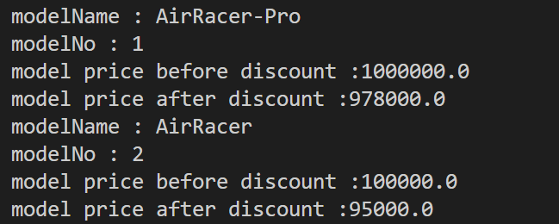

**Question 2** An Educational institution wishes to maintain a database of its employees. The database is divided into a number of classes whose hierarchical relationships are shown in the figure below. The figure also shows the minimum information required for each class. Specify all the classes and define methods to create the database and retrieve individual information as and when required. Implement this application by creating multiple classes and storing them in different files. Also write a driver Class (called College) and illustrate the execution of this application.

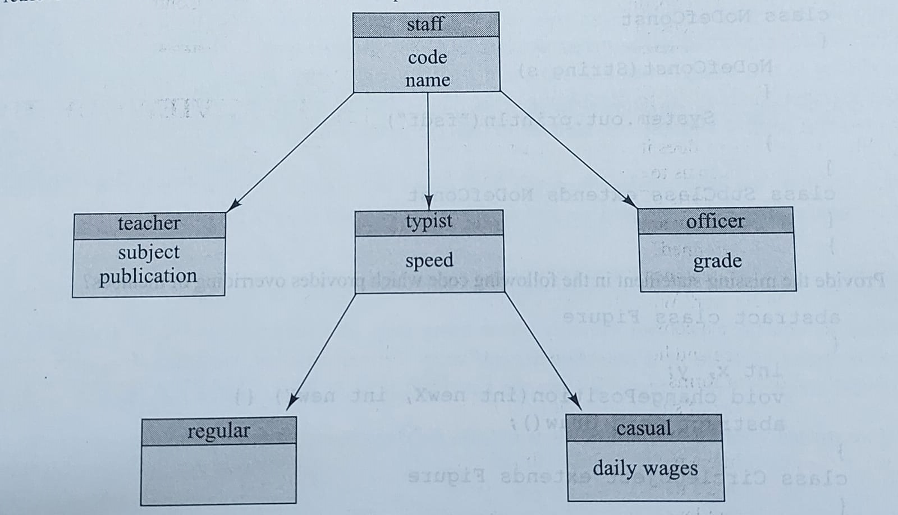

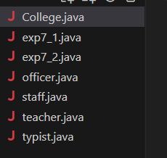

College file (Driver code):

public class College {

    public static void main(String[] args) {

        System.out.println("for staff member 1");

        teacher s1 = new teacher();

        s1.readDetails();

        s1.printDetails();

        System.out.println();

        System.out.println("for staff member 2");

        officer s2 = new officer();

        s2.readDetails();

        s2.printDetails();

        System.out.println();

        System.out.println("for staff member 3");

        regular s3 = new regular();

        s3.readDetails();

        s3.printDetails();

        System.out.println();

    }

}

Staff file:

import java.util.Scanner;

public class staff {

    String code;

    String name;

    Scanner sc = new Scanner(System.in);

    void readDetails(){

        System.out.print("Enter the code:");

        this.code = sc.nextLine();

        System.out.print("Enter the name:");

        this.name = sc.nextLine();

    }

    void printDetails(){

        System.out.println("A Staff member");

        System.out.println("code: "+ this.code);

        System.out.println("name: "+ this.name);

    }

}

Teacher file:

class teacher extends staff{

    String subject;

    String publication;

    void readDetails(){

        System.out.print("Enter the code:");

        super.code = sc.nextLine();

        System.out.print("Enter the name:");

        super.name = sc.nextLine();

        System.out.print("Enter the subject:");

        this.subject = sc.nextLine();

        System.out.print("Enter the publication:");

        this.publication = sc.nextLine();

    }

    void printDetails(){

        System.out.println("A Teacher");

        System.out.println("code: "+ super.code);

        System.out.println("name: "+ super.name);

        System.out.println("subject: "+ this.subject);

        System.out.println("publication: "+ this.publication);

    }

}

Officer file:

class officer extends staff{

    String grade;

    void readDetails(){

        System.out.print("Enter the code:");

        super.code = sc.nextLine();

        System.out.print("Enter the name:");

        super.name = sc.nextLine();

        System.out.print("Enter the grade:");

        this.grade = sc.nextLine();

    }

    void printDetails(){

        System.out.println("An Officer");

        System.out.println("code: "+ super.code);

        System.out.println("name: "+ super.name);

        System.out.println("grade: "+ this.grade);

    }

}

Typist file (also includes child classes casual and regular):

class typist extends staff{

    double speed;

    void readDetails(){

        System.out.print("Enter the code:");

        super.code = sc.nextLine();

        System.out.print("Enter the name:");

        super.name = sc.nextLine();

        System.out.print("Enter the speed:");

        this.speed = sc.nextDouble();

    }

    void printDetails(){

        System.out.println("A Typist");

        System.out.println("code: "+ super.code);

        System.out.println("name: "+ super.name);

        System.out.println("speed: "+ this.speed);

    }

}

class regular extends typist{

    void readDetails(){

        System.out.print("Enter the code:");

        super.code = sc.nextLine();

        System.out.print("Enter the name:");

        super.name = sc.nextLine();

    }

    void printDetails(){

        System.out.println("A Regular Typist");

        System.out.println("code: "+ super.code);

        System.out.println("name: "+ super.name);

    }

}

class casual extends typist{

    double daily_wages;

    void readDetails(){

        System.out.print("Enter the code:");

        super.code = sc.nextLine();

        System.out.print("Enter the name:");

        super.name = sc.nextLine();

        System.out.print("Enter the daily wages:");

        this.daily_wages = sc.nextDouble();

        sc.close();

    }

    void printDetails(){

        System.out.println("A Casual Typist");

        System.out.println("code: "+ super.code);

        System.out.println("name: "+ super.name);

    }

}

Output:

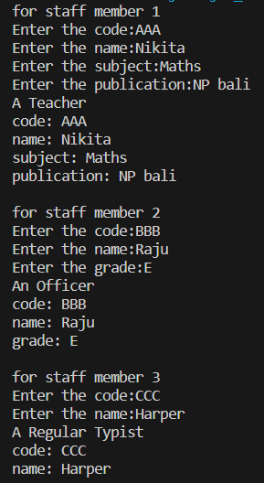

Experiment 8

**Question 1** Write a program to copy the contents of one file to another.

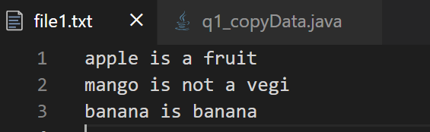

package exp8;

import java.io.*;

public class q1_copyData {

    public static void main(String[] args) throws IOException {

        File f1 = new File("C:\\Users\\PAYAL\\Desktop\\java_assignments\\exp8\\file1.txt");

        FileInputStream fis = new FileInputStream(f1);

        byte b1[] = new byte[fis.available()];

        int n1 = fis.read(b1);

        System.out.println("The number of charters read from file 1 : "+n1);

        String s = new String(b1);

        System.out.println("File Contents : ");

        System.out.println(s);

        fis.close();

        File f2 = new File("C:\\Users\\PAYAL\\Desktop\\java_assignments\\exp8\\file2.txt");

        FileOutputStream fos = new FileOutputStream(f2);

        fos.write(b1);

        fos.close();

    }

}

Output:

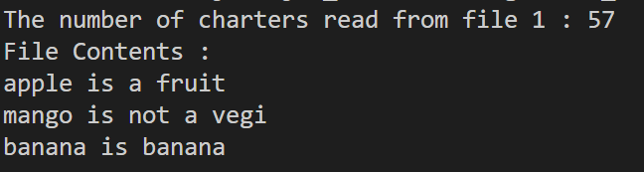

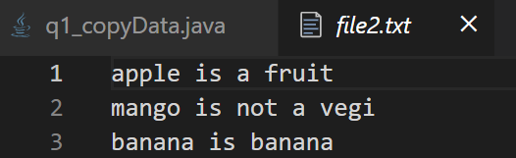

**Question 2** Write a program to count and delete the blank spaces from a file.

package exp8;

import java.io.*;

public class q2_blankSpaces {

    public static void main(String[] args) throws IOException {

        File f1 = new File("C:\\Users\\PAYAL\\Desktop\\java_assignments\\exp8\\file1.txt");

        FileInputStream fis = new FileInputStream(f1);

        byte b1[] = new byte[fis.available()];

        int n1 = fis.read(b1);

        System.out.println("The number of charters read from file 1 : "+n1);

        String s1 = new String(b1);

        byte b2[] = new byte[n1];

        int count = 0;

        String s2 = "";

        for (int i = 0, j = 0; i < n1; i++) {

            if(s1.charAt(i)==' '){

                count++;

            }else{

                b2[j]=(byte)s1.charAt(i);

                j++;

                s2 = s2+ s1.charAt(i);

            }

        }

        System.out.println("The number of spaces are: "+count);

        System.out.println("--------Original content :-------");

        System.out.println(s1);

        System.out.println("---------Content after removing spaces :--------");

        System.out.println(s2);

        fis.close();

        File f2 = new File("C:\\Users\\PAYAL\\Desktop\\java_assignments\\exp8\\file3.txt");

        FileOutputStream fos = new FileOutputStream(f2);

        fos.write(b2);

        fos.close();

    }

}

Output:

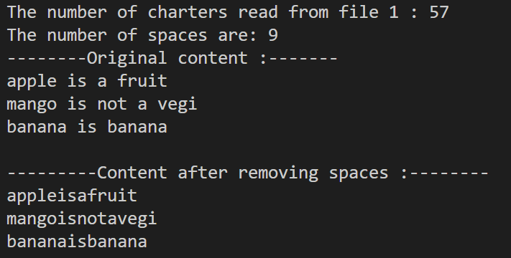 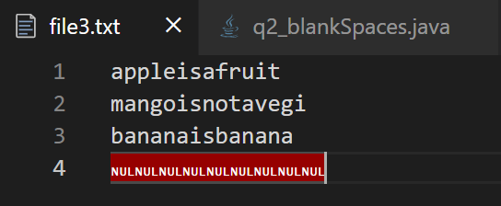

**Question 3** Count the number of vowels in a file.

package exp8;

import java.io.*;

public class q3_countVowels {

    public static void main(String[] args) throws IOException {

        File f1 = new File("C:\\Users\\PAYAL\\Desktop\\java_assignments\\exp8\\file1.txt");

        FileInputStream fis = new FileInputStream(f1);

        byte b1[] = new byte[fis.available()];

        int n1 = fis.read(b1);

        System.out.println("Total number of characters read from file 1 : "+n1);

        String s = new String(b1);

        System.out.println("File Contents : ");

        System.out.println(s);

        int count =0;

        for (int i = 0; i < n1; i++) {

            if(s.charAt(i)=='a'||s.charAt(i)=='e'||s.charAt(i)=='i'||s.charAt(i)=='o'||s.charAt(i)=='u'){

                count++;

            }

        }

        System.out.println("The number of vowels in the file are : "+count);

        fis.close();

    }

}

Output:

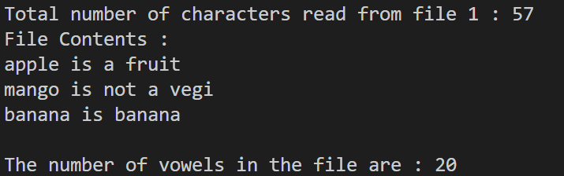

**Question 4** Write a program to concatenate 2 files and copy into the 3rd file.

package exp8;

import java.io.*;

public class q4_conactenate {

    public static void main(String[] args) throws IOException {

        File f1 = new File("C:\\Users\\PAYAL\\Desktop\\java_assignments\\exp8\\file1.txt");

        FileInputStream fis1 = new FileInputStream(f1);

        byte b1[] = new byte[fis1.available()];

        int n1 = fis1.read(b1);

        System.out.println("The number of characters read from file 1 : " + n1);

        String s1 = new String(b1);

        System.out.println(s1);

        fis1.close();

        File f2 = new File("C:\\Users\\PAYAL\\Desktop\\java_assignments\\exp8\\file2.txt");

        FileInputStream fis2 = new FileInputStream(f2);

        byte b2[] = new byte[fis2.available()];

        int n2 = fis2.read(b2);

        System.out.println("The number of characters read from file 2 : " + n2);

        String s2 = new String(b2);

        System.out.println(s2);

        fis2.close();

        int l = s1.length() + s2.length();

        String s3 = s1+s2;

        System.out.println("Total characters read are : "+l);

        byte b3[] = new byte[l];

        for (int i = 0; i < s3.length(); i++) {

            b3[i] = (byte) s3.charAt(i);

        }

        File f3 = new File("C:\\Users\\PAYAL\\Desktop\\java_assignments\\exp8\\file3.txt");

        FileOutputStream fos = new FileOutputStream(f3);

        fos.write(b3);

        fos.close();

    }

}

Output:

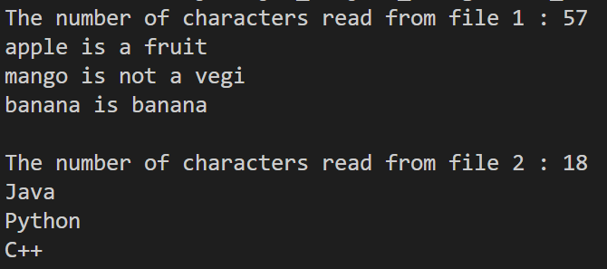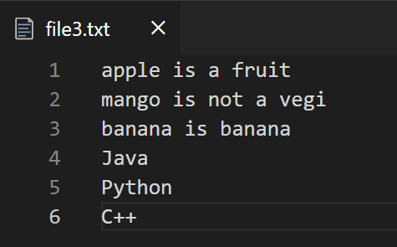

**Question 5** Write a program to replace all the vowels with a blank space in the file.

package exp8;

import java.io.*;

public class q5_replaceVowels {

    public static void main(String[] args) throws IOException {

        File f1 = new File("C:\\Users\\PAYAL\\Desktop\\java_assignments\\exp8\\file1.txt");

        FileInputStream fis = new FileInputStream(f1);

        byte b1[] = new byte[fis.available()];

        int n1 = fis.read(b1);

        System.out.println("Total number of characters read from file 1 : "+n1);

        String s = new String(b1);

        System.out.println("File Contents : ");

        System.out.println(s);

        int count =0;

        String s2 ="";

        for (int i = 0; i < n1; i++) {

            if(s.charAt(i)=='a'||s.charAt(i)=='e'||s.charAt(i)=='i'||s.charAt(i)=='o'

||s.charAt(i)=='u'||

            s.charAt(i)=='A'||s.charAt(i)=='E'||s.charAt(i)=='I'||s.charAt(i)=='O'

||s.charAt(i)=='U'){

                count++;

                s2 = s2+" ";

            }else{

                s2 = s2+ s.charAt(i);

            }

        }

        System.out.println("The number of vowels in the file are : "+count);

        System.out.println("File Contents after removing spaces : ");

        System.out.println(s2);

        fis.close();

    }

}

Output:

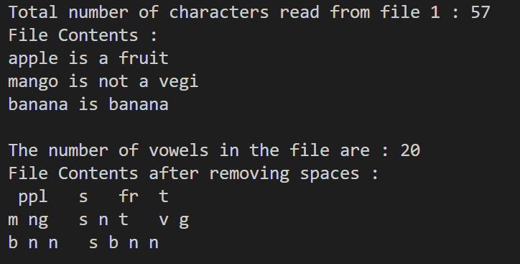

Experiment 9

**Question 1** Write a program to create a file to save employee details such as name, designation, salary, department. Write a file as an object and read and print on the screen.

package exp9;

import java.io.*;

class emp implements Serializable{

    String name;

    String designation;

    int salary;

    String department;

    emp(String name, String designation, int salary, String department) {

        this.name = name;

        this.designation = designation;

        this.salary = salary;

        this.department = department;

    }

    void getDetails(){

        System.out.println("Name : "+this.name);

        System.out.println("Designation : "+this.designation);

        System.out.println("Salary : "+this.salary);

        System.out.println("Department : "+this.department);

    }

}

class exp9_1{

    public static void main(String[] args) throws IOException, ClassNotFoundException {

        emp e1 = new emp("Payal","Data analyst",234500,"IT");

        FileOutputStream fos = new FileOutputStream("file1.dat");

        ObjectOutputStream oos = new ObjectOutputStream(fos);

        oos.writeObject(e1);

        oos.close();

        FileInputStream fis = new FileInputStream("file1.dat");

        ObjectInputStream ois = new ObjectInputStream(fis);

        emp e2 = new emp("","",0,"");

        e2 = (emp)ois.readObject();

        ois.close();

        System.out.println("The details of employee 1: ");

        e1.getDetails();

        System.out.println("The read details of employee 1: ");

        e2.getDetails();

    }

}

Output:

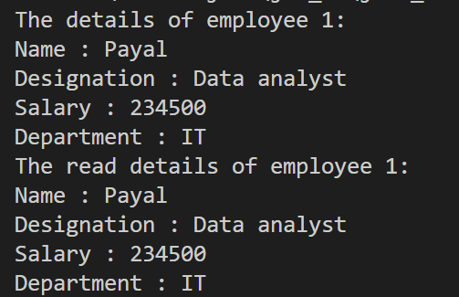 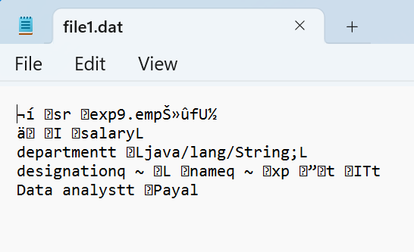

**Question 2** Write a program that reads 2 integers and runs a loop for calculating ‘a’ to the power ‘b’. You must check if ‘b’ equals zero then throw an arithmetic exception ‘a/b’. Catch the exception and run till correct input is provided. Write ‘hi’ and ‘bye’ for every block of code.

package exp9;

import java.util.*;

class exp9_2 {

    public static void main(String[] args) {

        System.out.println("Hi, main");

        double a;

        double b;

        int temp = 0;

        Scanner sc = new Scanner(System.in);

        while (temp == 0) {

            System.out.println("Hi, while");

            System.out.print("Enter a : ");

            a = sc.nextDouble();

            System.out.print("Enter b : ");

            b = sc.nextDouble();

            temp = 1;

            try {

                System.out.println("Hi, try");

                int d = (int)a/(int)b;

                System.out.println("Bye, try");

                System.out.println("a/b is : "+ d);

            } catch (ArithmeticException e) {

                System.out.println("Hi, catch");

                System.out.println("Exception occurred");

                System.out.println("re enter value");

                temp = 0;

                System.out.println("Bye, catch");

            }

            System.out.println("a to the power b is :"+Math.pow(a, b));

            System.out.println("Bye, while");

        }

        sc.close();

        System.out.println("Bye, main");

    }

}

Output:

