**High Level Design :**

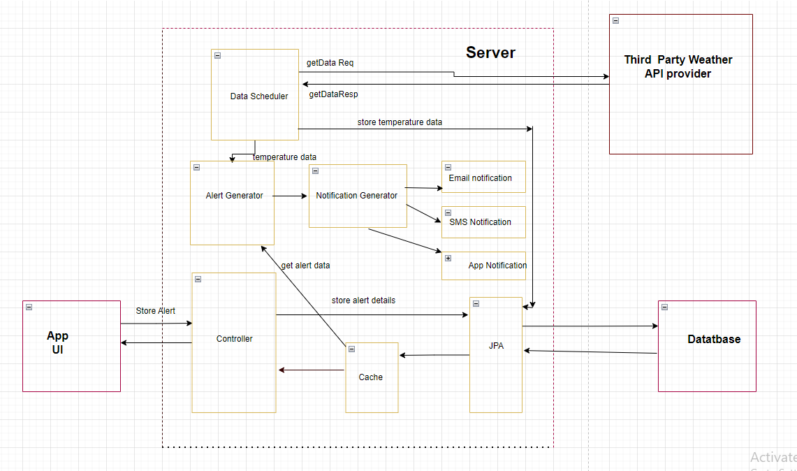

**Low Level Design :**

Following tech stack is used :

|  |  |
| --- | --- |
| Component | |
| Database server : | MySQL Server 8.0.32 |
| UI technology : | JSP |
| Backend : | Springboot 2.7.2 |
| Unit test : | Junit |
| Logging : | Slf4J |
| Web server : | Tomcat |
| Database visual tool : | MySQL Workbench |
| Weather API provider : | https://weatherapi-com.p.rapidapi.com |

Database design :

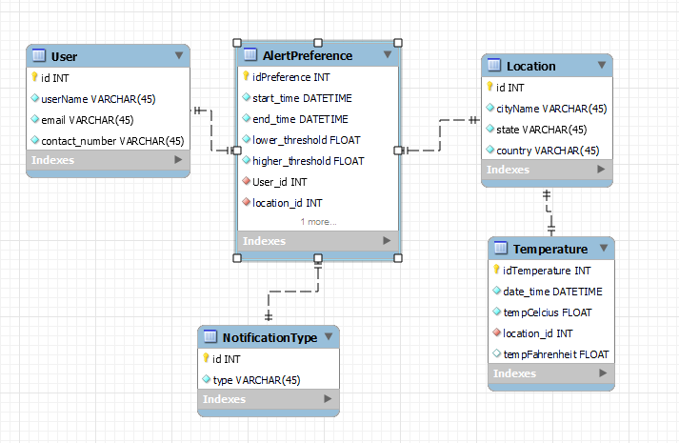

**UI design:**

1. Home page :

URL : http://localhost:8080/home

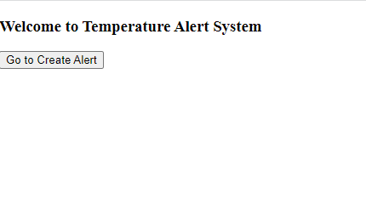

1. Add Alert form :

URL : http://localhost:8080/showForm

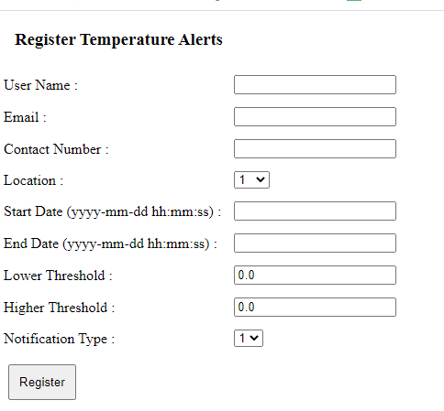

1. Alert added screen :

URL : http://localhost:8080/register

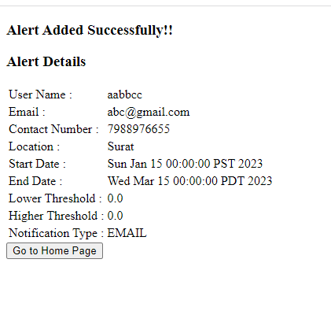  
API design :

1. Create alert

|  |  |
| --- | --- |
| Method | POST |
| URL | http://localhost:8080/alert/create |
| Headers | Content-Type : application/json |
| Body | {  "startTime": "2023-01-28 23:09:52",  "endTime": "2023-03-28 23:09:52",  "lowerThreshold": 10.5,  "higherThreshold": 35,  "user": {  "userName": "user2",  "email": "user2@gmail.com",  "contactNumber": "9988776654"  },  "location": {  "id": 1,  "cityName": "Pune",  "state": "Maharashtra",  "country": "India"  },  "notificationType" : {  "id" : 2,  "type" : "email"  },  "active" : true  } |

1. Get All Location

|  |  |
| --- | --- |
| Method | GET |
| URL | http://localhost:8080/location/getAll |
| Headers |  |
| Body | NA |

1. Get All NotificationType

|  |  |
| --- | --- |
| Method | GET |
| URL | http://localhost:8080/notificationType/getAll |
| Headers |  |
| Body | NA |

**Data Schedular:**

* This component fetches current temperature data every 10 mins from third party api :

<https://weatherapi-com.p.rapidapi.com/current.json?q=Pune>

* Second data for temperature to calculate mean is generated with internal code, as another free api couldn’t be subscribed.
* Mean of both is used as temperature
* This temperature is used for alert generation

**Notification Generator :**

User can opt for any of the 3, or all of the 3 notification types:

1. Email
2. SMS
3. App Notification

*Currently notifications are generated over console only

Assumptions:

1. Current UI is only for guest user with access only to register form
2. Current notifications are generated only for console
3. There is no need to store violations as these are generated real time and notifications are emitted immediately.
4. Current system supports only temperature in Celcius
5. Admin /developer should prefill location and notification type data into database (insert query file provided in zip)

Future Scope:

1. User registration and login session
2. Store and retrieve alert violations and notifications