Kafka Local Setup

1) Install kafka from <https://kafka.apache.org/downloads> and extract it.

(this comes with ZooKeeper and Kafka server both)

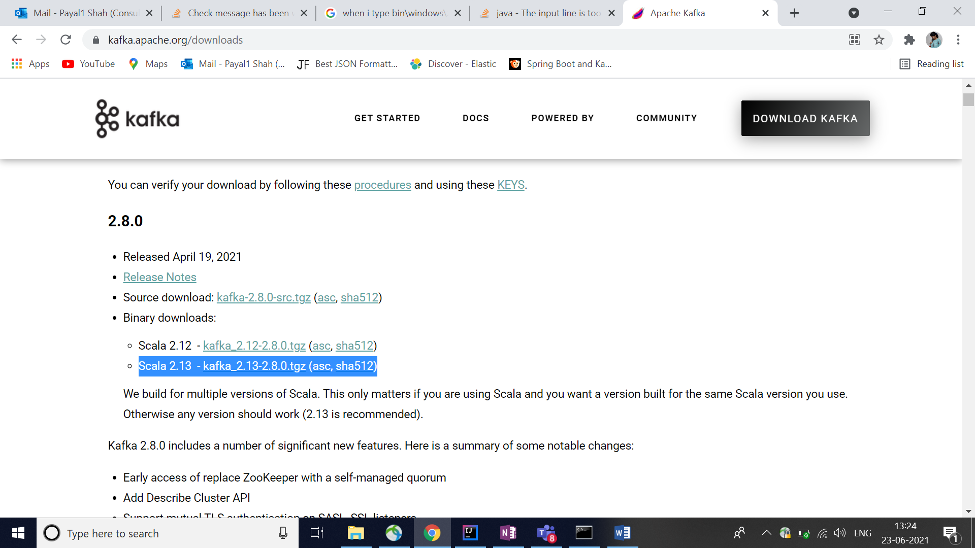

2) Goto config folder (in my case : C:\kafka_2.13-2.8.0\kafka_2.13-2.8.0\config)

1) open zookeeper.properties

Replace dataDir=C:/tmp/zookeeper to dataDir=C:/temp/zookeeper

2) open server.properties

Replace log.dirs=C:/tmp/kafka-logs to C:/temp/kafka-logs

(make sure that you have smaller path to access kafka folder,in case it is big enough gives error on command prompt while starting the server.

The input line is too long.the synatax of the command is incorrect.

3) open cmd and goto kafka folder and execute the following commands

bin\windows\zookeeper-server-start.bat config\zookeeper.properties

bin\windows\kafka-server-start.bat config\server.properties

4)if you get the following error check classpath of kafka

Echo %CLASSPATH%

Set classpath=;

Set it to empty

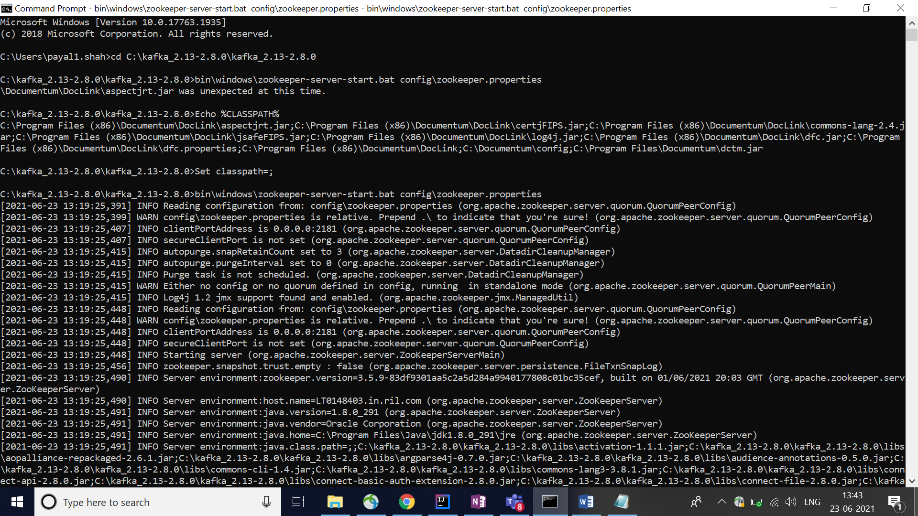

5) start zookeeper server check logs ,if you get this then zookeeper server is started on port 2181.

[2021-06-23 13:19:25,565] INFO binding to port 0.0.0.0/0.0.0.0:2181 (org.apache.zookeeper.server.NIOServerCnxnFactory)

6)start kafka server and check in the logs if you get this then kafka server is started.

[2021-06-23 13:49:25,635] INFO [ZooKeeperClient Kafka server] Connected. (kafka.zookeeper.ZooKeeperClient)