Credit Card Fraud Detection
Author: Payal Thombare
Dataset: Credit Card Fraud Detection (Kaggle, mlg-ulb)

Abstract
This project develops and evaluates a machine learning system to detect fraudulent credit card transactions in a highly imbalanced dataset of 284,807 anonymized European transactions, of which only 492 (0.17%) are fraudulent. Four modelling approaches were implemented and compared under a leakage-safe evaluation protocol: class-weighted Logistic Regression, class-weighted Random Forest, Hist Gradient Boosting, and SMOTE-augmented Logistic Regression. Models were compared using precision, recall, F1-score, ROC-AUC, and PR-AUC rather than accuracy, which is uninformative under this level of imbalance. The Random Forest model achieved the strongest validation PR-AUC (0.771) and was selected as the final model. A classification threshold was then chosen using an explicit, documented business cost function rather than the default 0.5 cutoff, yielding a threshold of 0.25. On a held-out test set never used for model selection or tuning, the final system achieved 0.626 precision, 0.811 recall, an F1-score of 0.706, and a PR-AUC of 0.822, correctly identifying 77 of 95 fraudulent transactions. The project further includes cross-validation stability analysis, probability calibration, permutation-based feature importance, a time-based stability check, and a packaged, deployable model artifact with a documented inference function.

Introduction
Credit card fraud causes substantial financial losses to consumers, merchants, and financial institutions every year. Automated, machine-learning-based fraud detection systems are now standard in the payments industry, screening transactions in real time and flagging suspicious activity for review or automatic decline. Building such a system is technically distinctive from typical classification tasks for two reasons: the target class of interest occurs extremely rarely (a severe class-imbalance problem), and the practical cost of different types of errors is highly asymmetric — a missed fraud and a false alarm are not equally bad. This project works through the complete lifecycle of building such a system: understanding and exploring the data, preparing it without introducing data leakage, training and fairly comparing several models suited to imbalanced data, choosing an evaluation-appropriate decision threshold, validating the chosen model more rigorously, and packaging it for deployment.

Problem Statement
Given an anonymized record of a credit card transaction, predict whether it is fraudulent (Class = 1) or genuine (Class = 0). The central challenge is that fraudulent transactions make up only 0.17% of the dataset, so a naive model that always predicts "genuine" would achieve 99.83% accuracy while catching zero fraud. An effective solution must therefore explicitly account for class imbalance during training, be evaluated with imbalance-aware metrics, and select a decision threshold based on the real-world asymmetry between the cost of a missed fraud and the cost of a false alarm.

Objectives
- Explore and understand the structure, distribution, and limitations of the dataset.
- Prepare the data for modelling without introducing data leakage (leakage-safe scaling, splitting, and oversampling).
- Train and fairly compare multiple approaches to imbalanced classification.
- Evaluate models using metrics appropriate for severe class imbalance (precision, recall, F1, ROC-AUC, PR-AUC), not accuracy.
- Select a classification threshold using an explicit, business-cost-driven objective rather than the arbitrary 0.5 default.
- Validate the chosen model further via cross-validation, calibration, and feature-importance analysis.
- Package the model for deployment with a reusable, input-validated prediction function.

Dataset Description
The dataset (Kaggle: "Credit Card Fraud Detection", mlg-ulb) contains 284,807 transactions made by European cardholders over two days in September 2013. It has 31 columns:
- Time — seconds elapsed between each transaction and the first transaction in the dataset.
- V1 through V28 — principal components obtained via PCA on the original (confidential) features, provided in anonymized, already-decorrelated form.
- Amount — the transaction amount, in the original currency unit.
- Class — the target label (0 = genuine, 1 = fraud).
The dataset contains no missing values but does contain 1,081 exact duplicate rows, which are removed prior to modelling. Only 492 of the 284,807 transactions (0.173%) are fraudulent, making this an extreme class-imbalance problem. Because V1-V28 are anonymized PCA components, no business interpretation of individual features is possible — only their statistical relationship with the target can be assessed.

Literature / Background Context
Credit card fraud detection is a well-studied application of imbalanced classification. Two broad families of techniques are commonly used to address class imbalance: algorithm-level approaches, which adjust the learning algorithm itself (e.g., class-weighting, cost-sensitive learning), and data-level approaches, which rebalance the training data (e.g., random oversampling, under sampling, or synthetic oversampling). This project uses the Synthetic Minority Oversampling Technique (SMOTE), introduced by Chawla, Bowyer, Hall, and Kegelmeyer (2002), which generates synthetic minority-class examples by interpolating between real minority examples and their nearest minority neighbours, rather than duplicating existing rows outright. Ensemble tree methods (Random Forest, gradient boosting) are widely reported in the literature as strong performers on this type of tabular, PCA-anonymized fraud dataset, which this project's own results corroborate.

Methodology
The project follows an eight-phase pipeline: (1) data understanding, (2) exploratory data analysis, (3) leakage-safe preprocessing, (4) training four imbalance-aware models, (5) comparative evaluation on a validation set, (6) cost-based threshold optimization, (7) advanced validation (cross-validation, calibration, feature importance, time-stability), and (8) model packaging for deployment. A stratified 60% / 20% / 20% split into training, validation, and test sets was used throughout, preserving the 0.17% fraud rate in every split. All threshold and model-selection decisions were made using the validation set only; the test set was scored exactly once, at the end, to obtain an unbiased final estimate of performance.

Exploratory Data Analysis
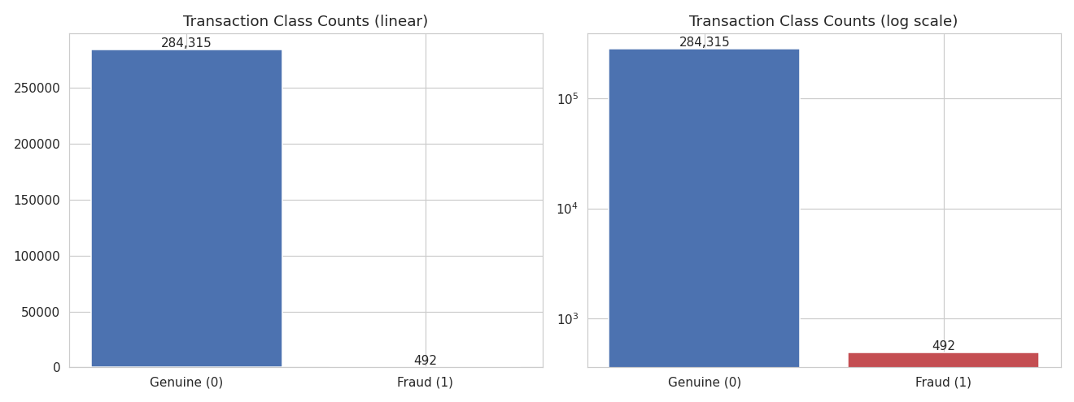
Key exploratory findings, illustrated below:
Figure 1. Class distribution — fraud (0.17%) is invisible on a linear scale, illustrating the imbalance problem.
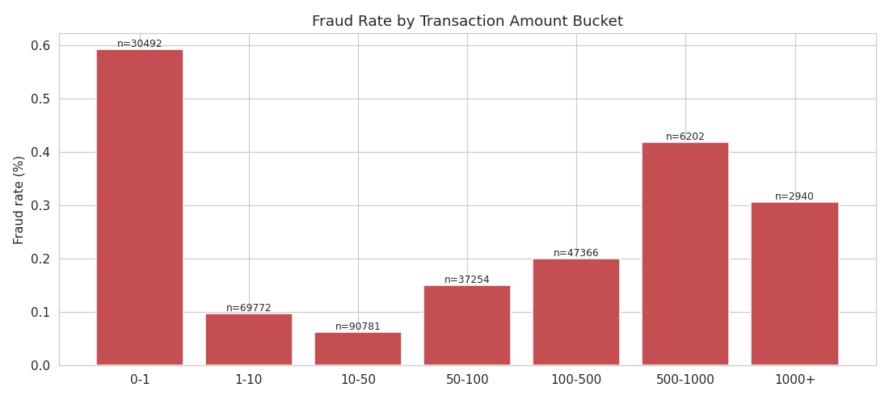

Figure 2. Fraud rate (not count) by transaction amount bucket — the smallest transactions ($0-1) show the highest fraud rate, consistent with "card testing" behavior.
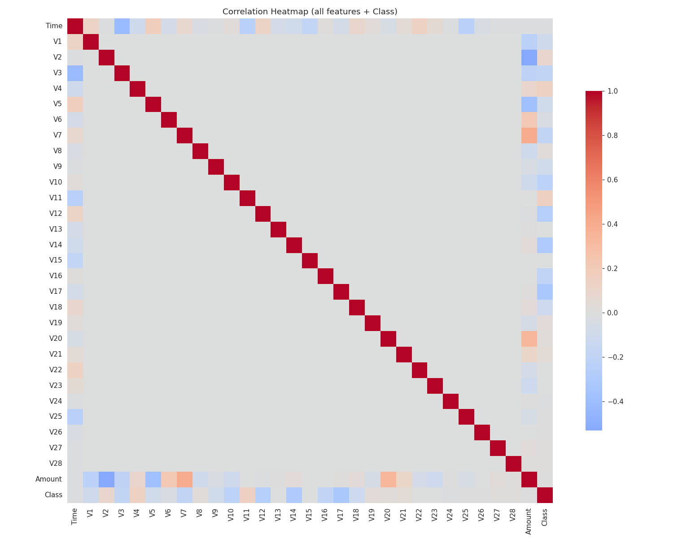
Figure 3. Correlation heatmap of all features and the target. V17, V14, and V12 show the strongest linear correlation with fraud.
Additional analysis (full detail in the accompanying notebook) showed that genuine transactions dip in frequency overnight while fraud is proportionally more common during those same low-traffic hours, and that several PCA components (V17, V14, V12, V10) show visibly separated distributions between genuine and fraudulent transactions — an early signal of which features would later prove most predictive.

Data Preprocessing
Preprocessing decisions were made specifically to avoid data leakage:
- The 1,081 duplicate rows were removed before splitting, so no identical row could appear in both training and test data.
- A stratified split was used (rather than a plain random split) to preserve the 0.17% fraud rate in every subset, given how few fraud examples exist in total (492).
- Only Time and Amount were scaled (via StandardScaler), since V1-V28 are already PCA components on a comparable scale. The scaler was fit on the training data only, then applied to validation and test data.
- SMOTE oversampling, where used, was fit and applied strictly to the training split, never to validation or test data.
A genuine time-based validation split (training on earlier calendar time, testing on later) was considered but judged inappropriate for this specific dataset, since it spans only 48 hours — too short a window to capture meaningful temporal drift. A stratified random split was used instead, with a lightweight time-stability check performed separately in Phase 7 as a partial substitute.

Model Development
Four models were trained on the training split and evaluated on the validation split:
- Logistic Regression (class_weight="balanced") — a fast, interpretable linear baseline that reweights the loss function inversely to class frequency.
- Random Forest (class_weight="balanced_subsample") — an ensemble of decision trees, each trained on a rebalanced bootstrap sample, capable of capturing non-linear feature interactions.
- HistGradientBoosting (sample-weighted) — scikit-learns histogram-based gradient boosting, upweighting fraud examples via sample weights.
- SMOTE + Logistic Regression — synthetic fraud examples generated only from training data, used to train a plain Logistic Regression on a rebalanced training set.
Because the imbalanced-learn package was unavailable in the development environment, SMOTE was implemented manually using NumPy and scikit-learns Nearest Neighbour’s, following the original Chawla et al. (2002) algorithm. This is a behaviourally equivalent, drop-in substitute for in learns SMOTE class.

Evaluation Metrics
Accuracy was deliberately excluded as a selection criterion: with a 99.83% majority class, accuracy is dominated by trivially correct predictions on genuine transactions and says nothing about fraud-catching ability. Instead, models were compared on:
- Precision — of transactions flagged as fraud, what fraction truly were fraud.
- Recall — of actual fraud cases, what fraction were caught.
- F1-score — the harmonic mean of precision and recall.
- ROC-AUC — ranking quality across all thresholds, using the false-positive rate.
- PR-AUC (Average Precision) — ranking quality focused on the rare positive class; the most trustworthy single metric under this level of imbalance, and the metric used for model selection.

Results

Validation set — model comparison (threshold = 0.5)
Model | Precision | Recall | F1 | ROC-AUC | PR-AUC
Random Forest (balanced) | 0.886 | 0.745 | 0.809 | 0.945 | 0.771
HistGradientBoosting | 0.503 | 0.787 | 0.614 | 0.951 | 0.703
Logistic Regression (balanced) | 0.059 | 0.851 | 0.110 | 0.971 | 0.692
SMOTE + Logistic Regression | 0.055 | 0.851 | 0.104 | 0.972 | 0.692

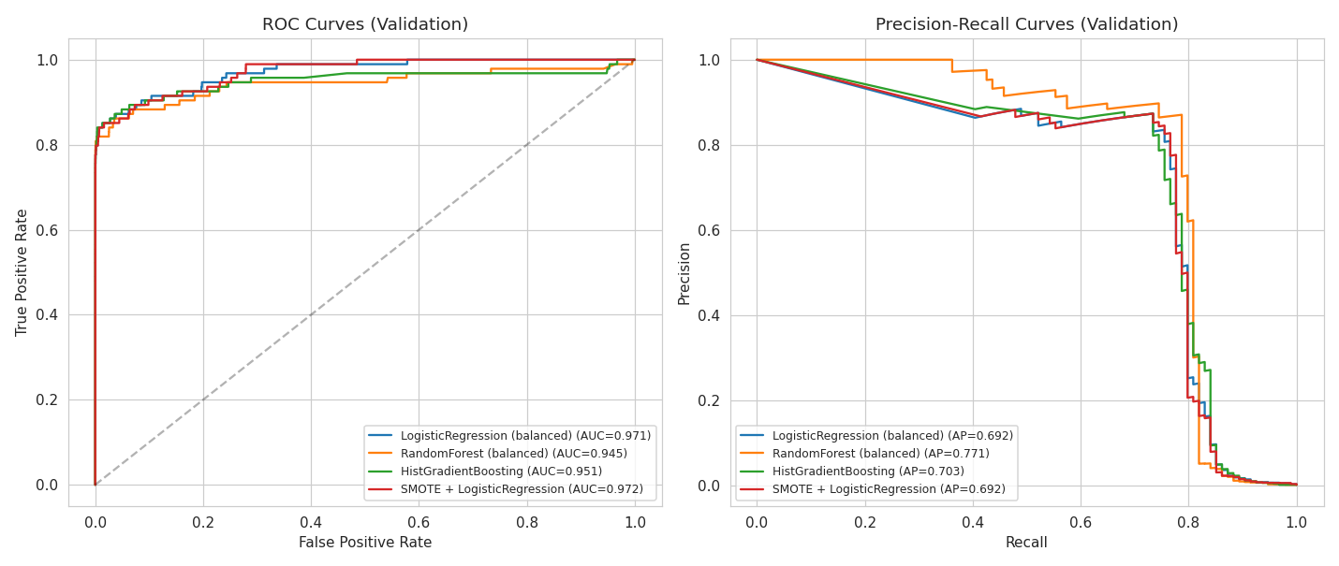
Figure 4. ROC and Precision-Recall curves for all four models on the validation set.
Random Forest was selected as the final model, achieving the highest PR-AUC (0.771) and by far the highest precision at the default threshold. Logistic Regression variants achieve higher raw recall but at a steep precision cost — roughly 15 false alarms for every true fraud caught — illustrating that no single model is unambiguously "best" independent of business context.

Threshold optimization
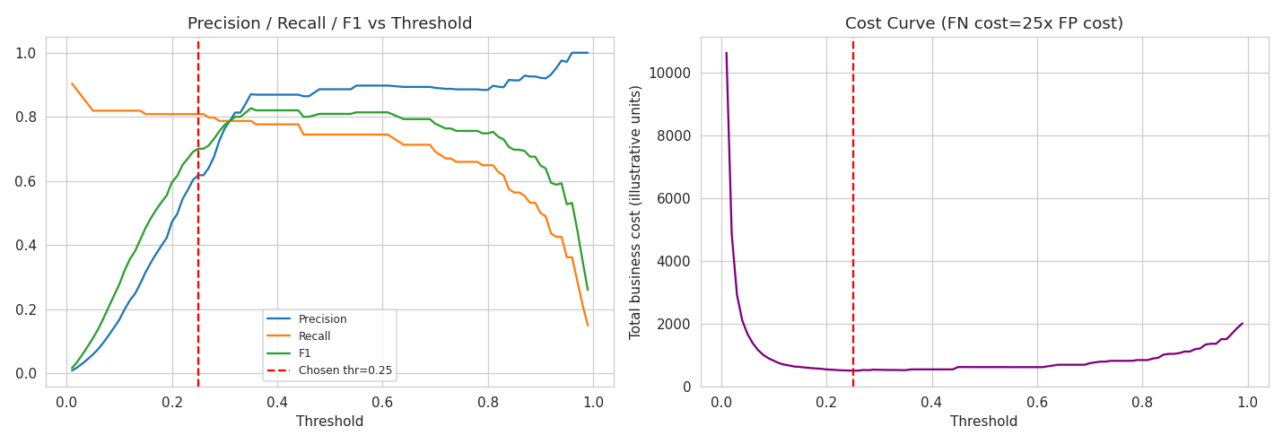
The default 0.5 threshold has no relationship to real-world costs. A cost function was defined as total_cost = 25 x false_negatives + 1 x false_positive, reflecting an illustrative assumption that a missed fraud costs 25 times as much as a false alarm. This ratio is a business input that should, in practice, be supplied by finance/risk stakeholders rather than assumed by the data scientist.

Figure 5. Precision/Recall/F1 versus threshold (left) and total business cost versus threshold (right). The chosen threshold (0.25) minimizes total cost under the stated assumption.
The cost-minimizing threshold was 0.25, compared with an F1-maximizing threshold of 0.35 the cost-based threshold is lower because it weights missed fraud much more heavily, pushing the model toward flagging more transactions (higher recall) at some precision cost.

Final held-out test set performance
Metric | Value
Model | Random Forest (class-weighted)
Threshold | 0.25
Precision | 0.626
Recall | 0.811
F1-score | 0.706
ROC-AUC | 0.973
PR-AUC | 0.822
True Negatives | 56,605
False Positives | 46
False Negatives | 18
True Positives | 77
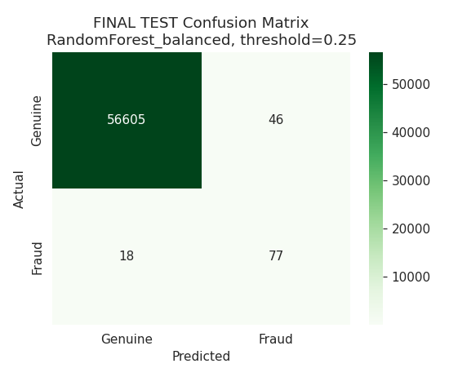

Figure 6. Final test-set confusion matrix at the chosen model and threshold.
Of 95 real fraud cases in the test set, the model correctly identified 77 (81.1% recall) while missing 18. Of 123 transactions flagged, 77 were genuinely fraudulent (62.6% precision), meaning 46 genuine transactions were false alarms. A 3-fold cross-validation of the same model family produced a mean PR-AUC of 0.812 (standard deviation 0.041), confirming the validation-set result was not a lucky split, while also showing meaningful fold-to-fold variance expected given how few fraud examples exist in any single fold.

Feature importance
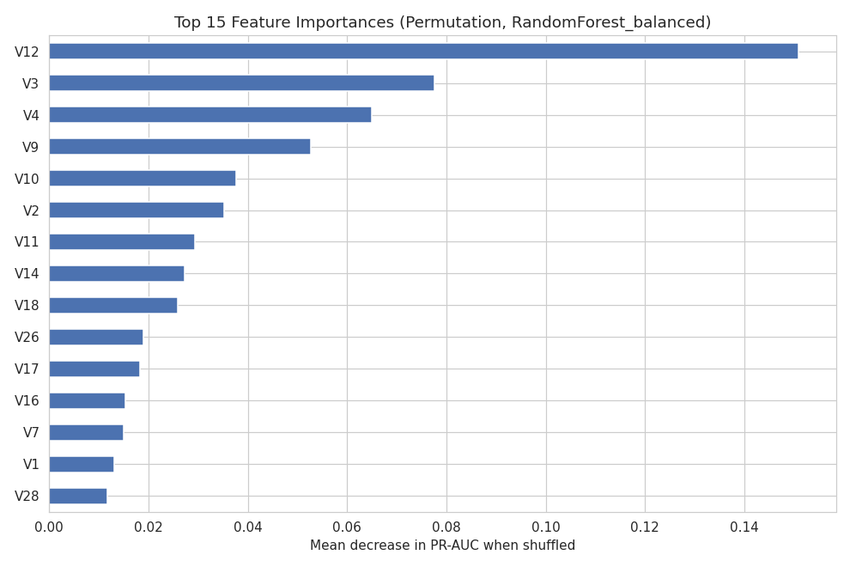

Figure 7. Top 15 features by permutation importance (mean decrease in PR-AUC when a feature is shuffled).
V12, V3, V4, V9, and V10 were the most influential features for the final model. This ranking overlaps with, but is not identical to, the linear correlation ranking from the EDA phase (V17, V14, V12) — expected, since permutation importance captures a feature's contribution to the trained model's actual non-linear, interaction-aware predictions, while correlation only captures linear relationships with the target.

Limitations
- V1-V28 are anonymized PCA components; no business/domain narrative is possible for individual features, only statistical importance.
- The dataset spans only ~48 hours, so genuine time-based train/test validation (training on one period, testing on a later one) was not possible; a production system should use real time-based backtesting instead.
- The 25:1 false-negative-to-false-positive cost ratio used for threshold selection is illustrative and should be replaced with real figures from business stakeholders.
- Cross-validation shows meaningful variance across folds (PR-AUC standard deviation of 0.041), reflecting the small absolute number of fraud examples (492) available for evaluation.
- SMOTE was implemented manually rather than via the imbalanced-learn library, due to a package-availability constraint in the development environment.

Future Scope
- Hyperparameter tuning of the Random Forest (or an alternative gradient-boosted model) via RandomizedSearchCV or Optuna.
- SHAP-based interpretation for individual transaction-level explanations, useful for fraud-analyst review workflows.
- Ensemble/stacking across the four model families evaluated here.
- Real time-based backtesting once multi-month transaction data is available.
- Automated drift monitoring and a defined retraining cadence in production.

Conclusion
This project demonstrates a complete, defensible approach to fraud detection under severe class imbalance: leakage-safe preprocessing, a fair comparison of multiple imbalance-handling strategies, imbalance-appropriate evaluation metrics, and a threshold chosen from an explicit business cost function rather than a statistical default. The final Random Forest model, evaluated honestly on a held-out test set, correctly identifies over 81% of fraudulent transactions while maintaining a manageable false-alarm rate, and is packaged with a documented, reusable prediction function ready for integration into a review workflow or API. The project's explicit treatment of its own limitations — anonymized features, a short time window, and an illustrative cost assumption — reflects the level of rigor and honesty expected of a production-facing data science deliverable.

References
- Chawla, N. V., Bowyer, K. W., Hall, L. O., & Kegelmeyer, W. P. (2002). SMOTE: Synthetic Minority Over-sampling Technique. Journal of Artificial Intelligence Research, 16, 321-357.
- Pedregosa, F., et al. (2011). Scikit-learn: Machine Learning in Python. Journal of Machine Learning Research, 12, 2825-2830.
- Dal Pozzolo, A., Caelen, O., Johnson, R. A., & Bontempi, G. (2015). Calibrating Probability with Undersampling for Unbalanced Classification. IEEE Symposium Series on Computational Intelligence.
- Kaggle. Credit Card Fraud Detection dataset. https://www.kaggle.com/datasets/mlg-ulb/creditcardfraud

