https://kodekloud.com/topic/labs-kubectl/

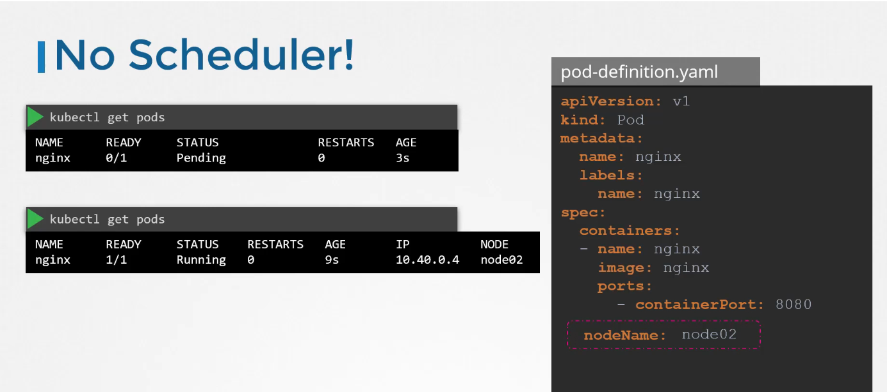
The easyest way to schedule a pod to simply set the node name field into the pod you can specify the node name while creating time
What if pod is already created?
And you want to assing the pod to the node kubernate wan’t allow
then assign the node to the exiting pod to create the binding object and send the post request.
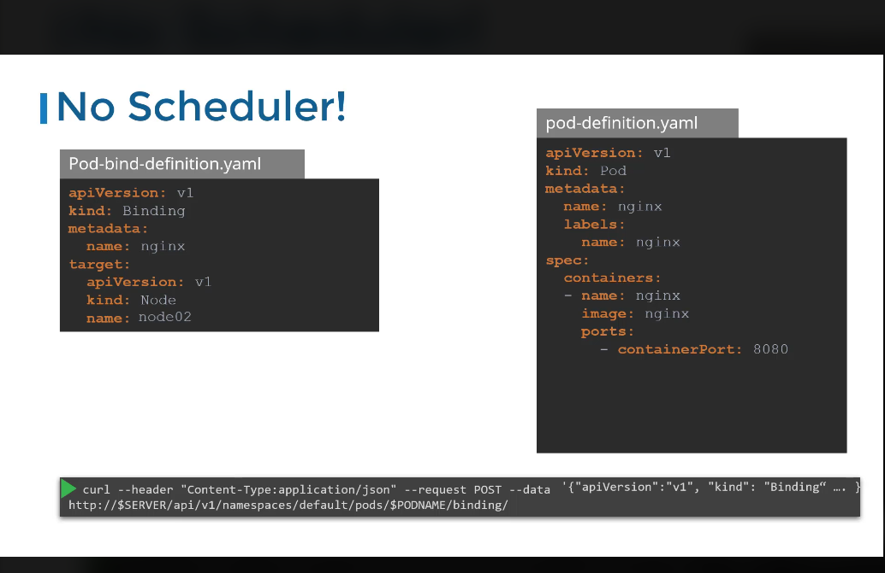
Create the pod
kubectl create -f nginx.yaml
after creatig the pod its in pending state bez no schedular is avalable
Manually schedule the pod on node01.
$ kubectl delete po nginx
To list and know the names of available nodes on the cluster:
$ kubectl get nodes
Add the nodeName field under the spec section in the nginx.yaml file with node01 as the value:

---
apiVersion: v1
kind: Pod
metadata:
name: nginx
spec:
nodeName: node01
containers:
- image: nginx
name: nginx
Then run the command kubectl create -f nginx.yaml to create a pod from the definition file.

To check the status of a nginx pod and to know the node name:

$ kubectl get pods -o wide
