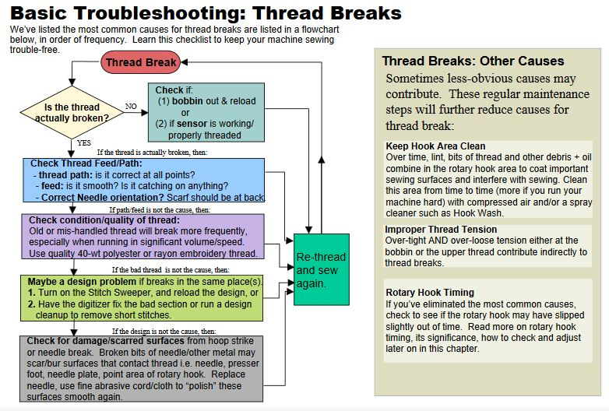

**Basic Troubleshooting: Thread Breaks**

We've listed the most common causes for thread breaks are listed in a flowchart below, in order of frequency. Learn this checklist to keep your machine Sewing

**trouble-free. - (Thread вreas)-**

**Check if is the thread (1) bobbin out & reload ? Of ctually broken (2) if sensoris Working property threaded**

**YES v If the thread is actually broken, then Check Thread FeedPath: -thread path: is it correctatal points? - feed: is it smooth? Is it catching on anything? Correct Needle orientation? Scarf should be at back y If pathfeed is not the cause, then Check condition/quality of thread: Old Ormis-handled thread will break more frequently,**

**especially when running insignificant Volume/speed. 『一 b**

**Use quality 40-Wit polyester or rayon embroidery thread. Re-իrea C If the bad thread is mot the causetben 3 SeW**

**Maybe a design problem if breaks in the same place(s) again**

**1. Turn on the Stitch Sweeper, and reload the design, or 2. Have the digitizer fix the bad section or run a design cleanup to remove short stitches.**

**If the designis mot the cause then Check for damagelscarred surfaces from hoop strike or needle break. Broken bits of needlesother metal may Scarbursurfaces that contact threadi.e. needle, presser foot, needle plate, point area of rotary hook. Replace needle, usefine abrasive cord/cloth to "polish" these - Surfaces Smooth again.**

**Thread Breaks: Other Causes**

Sometimes less-obvious causes may contribute. These regular maintenance steps will further reduce causes for

thread break:

**Keep Hook Area Clean Over time, lint, bits of thread and other debris+ oil combine in the rotary hook area to Coat important sewing surfaces and interfere with sewing. Clean this area from time to time (more if you run your machine hard) with compressed air and/or a spray cleaner such as Hook Wash.**

**improper Thread Tension Over-tight AND Over-loose tension either at the bobbin or the upper thread contribute indirectly to thread breaks**

Rotary Hook Timing If you've eliminated the most common causes, check to see if the rotary hook may have slipped slightly out of time. Read more on rotary hook timing, its significance, how to check and adjust later on in this chapter.