|  |  |  |
| --- | --- | --- |
| **Electrolytic Capacitor** | **Tantalum Capacitor** | **Monolithic Capacitor** |
| Electrolytic Capacitor  These polarity-sensitive capacitors are the easiest to decipher because their value and maximum voltage ratings are listed directly on the metal component "can". The negative side (-) is usually clearly marked with the negative side being the shorter lead and the positive side (+) being the longer lead. | Tantalum Capacitor  These brightly colored "gumdrop" capacitors are polarity-sensitive, where the positive lead (+) is longer than the negative (-). Tantalum capacitors usually have the capacitance value, maximum voltage rating and polarity printed right on the component. | Monolithic Capacitor  These non-polar capacitors have equal length leads that can be installed in either direction and come in many colors. The chart illustrates how to determine their value using the three-number and letter code found on most monolithic capacitors. |

**General Capacitor Codebreaker**

|  |  |  |  |
| --- | --- | --- | --- |
| **Common Capacitor  Code** | **PicoFarad  (pF)** | **NanoFarad  (nF)** | **MicroFarad  (mF/.µF/mfd)** |
| 102 | 1000 | 1 or 1n | 0.001 |
| 152 | 1500 | 1.5 or 1n5 | 0.0015 |
| 222 | 2200 | 2.2 or 2n2 | 0.0022 |
| 332 | 3300 | 3.3 or 3n3 | 0.0033 |
| 472 | 4700 | 4.7 or 4n7 | 0.0047 |
| 682 | 6800 | 6.8 or 6n8 | 0.0068 |
| 103 | 10000 | 10 or 10n | 0.01 |
| 153 | 15000 | 15 or 15n | 0.015 |
| 223 | 22000 | 22 or 22n | 0.022 |
| 333 | 33000 | 33 or 33n | 0.033 |
| 473 | 47000 | 47 or 47n | 0.047 |
| 683 | 68000 | 68 or 68n | 0.068 |
| 104 | 100000 | 100 or 100n | 0.1 |
| 154 | 150000 | 150 or 150n | 0.15 |
| 224 | 220000 | 220 or 220n | 0.22 |
| 334 | 330000 | 330 or 330n | 0.33 |
| 474 | 470000 | 470 or 470n | 0.47 |

**Capacitor Code Chart with Tolerances**

|  |  |  |  |
| --- | --- | --- | --- |
| **Value (First and Second  significant figures)** | **Multiplier** | **Letter** | **Tolerance** |
| 0 | 1 | B | ±0.1pF |
| 1 | 10 | C | ±0.25pF |
| 2 | 102 | D | ±0.5pF |
| 3 | 103 | F | ±1% |
| 4 | 104 | G | ±2% |
| 5 | 105 | H | ±3% |
| 6 | N/A | I | ±5% |
| 7 | N/A | K | ±10% |
| 8 | 0.01 | M | ±20% |
| 9 | 0.1 | Z | ±80% / -20% |

|  |  |
| --- | --- |
|  |  |

|  |  |  |
| --- | --- | --- |
|  |  |  |

**Resistor Color Chart**

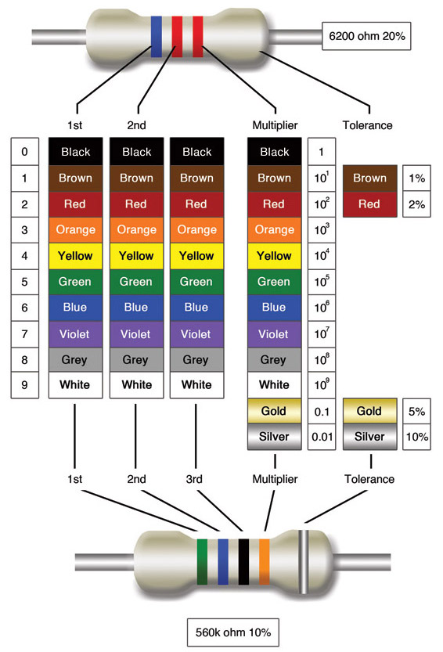

*Note:* The gold and silver band is only for tolerance. The band would be on the right side when reading.