Smokin' Maid

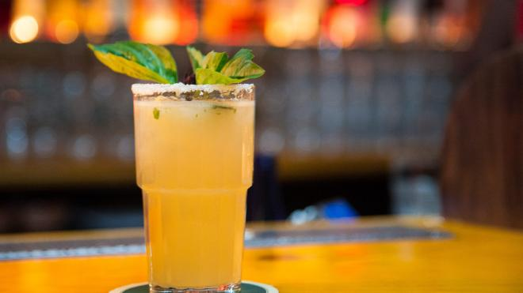

Smoky and spicy, this margarita has it all. (Tijuana Picnic)

1

Spicy, smoky and surprisingly refreshing. You've never had such a sophisticated margarity-- but don't worry, it's easy as squeeze, shake and pour to make.

**INGREDIENTS**

* 1 oz Mezcal
* 1 oz Jalapeño-infused tequila
* 1 oz fresh lime juice
* 3/4 oz cucumber juice
* 1/2 oz agave syrup
* 5-6 mint leaves

**PREPARATION**

Shake and strain into a highball glass with a salt & pepper half rim. Garnish with mint sprig.

Mile High

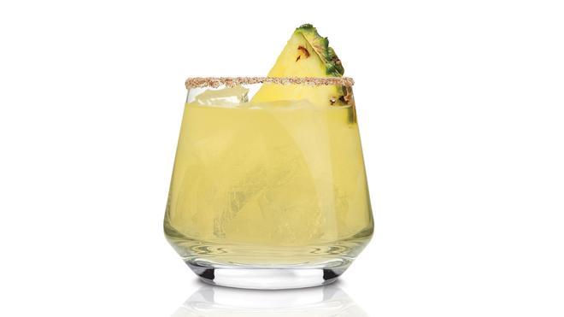

A sassy margarita variation with some fruit and spice. (Tequila Avión )

The Mile High is made with fresh pineapple juice to intensify the natural pineapple flavoring in the tequila and uses jalapeno as an added kick, creating a perfect combination of sweet and spicy.

**INGREDIENTS**

* 2 oz. Tequila Avión Silver
* 1 oz. Pineapple juice
* 1/2 oz. Agave nectar
* 1/2 oz. Fresh lime juice
* 2 Jalapeños wheels
* Pineapple wedge or lime wheel for garnish

**PREPARATION**

Lightly muddle jalapeño wheels and agave nectar in a shaker. Add the remaining ingredients, fill with ice and shake until well chilled. Strain into a large rocks glass that has been rimmed with a mixture of chili powder and salt. Garnish with a lime wheel or pineapple wedge.

# Rosa Mexicano’s Pomegranate Margarita

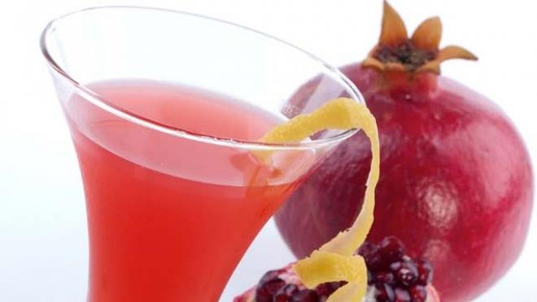

iStock

New York City's Rosa Mexicano restaurant has a 'lucky' way to ring in the New Year.  It combines good fortune and fun with their signature frozen pomegranate margarita, made with silver tequila, pomegranate, fresh lime juice, and triple sec (or substitute a little Grand Marnier if you like to make it just that much more decadent and festive).

### INGREDIENTS

* 2 ounce white tequila
* 1/2 ounce Triple Sec
* 1 ounce fresh lime juice
* 1 Tablespoon fresh pomegranate juice
* 6-8 ounces or one scoop of ice

### PREPARATION

Mix all the ingredients in a blender until smooth and frothy. Garnish with lime wheel or wedge.

Patrón Paloma

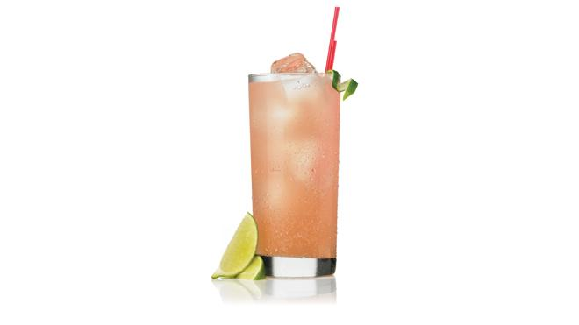

Refreshing alternative to a margarita (Patrón)

This light refreshing cocktail is an easy alternative to the classic margarita.

**INGREDIENTS**

* 1.5 Ounce Patrón Silver
* Grapefruit soda
* Lime wedge

**PREPARATION**

Pour Patrón Silver into a highball glass filled with ice. Add grapefruit soda and top with squeezed lime.

The Double Shot Martini

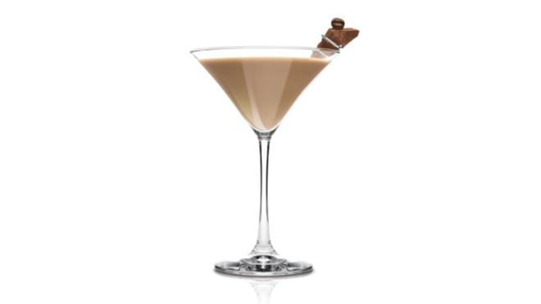

A delicious caffeinated cocktail (Tequila Avión)

This double shot espresso martini will give you the caffeinated kick you're looking for.

**INGREDIENTS**

* 1.5 Part Avión Espresso Tequila
* 1 Part Milk or half & half

**PREPARATION**

Add all ingredients to shaker. Shake and strain into a chilled martini glass. Garnish with 1-3 espresso beans.

Los Feliz's Smoke One Margarita

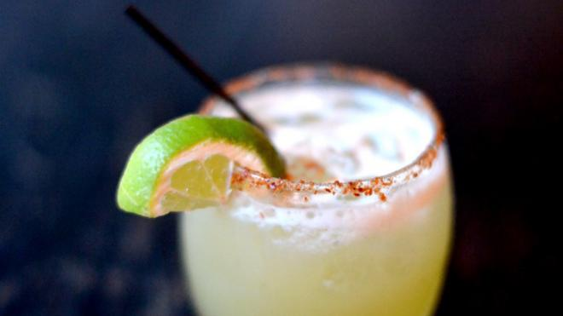

A smokey margarita. (Los Feliz)

Holy smoke. This sweet and sultry sipper from [**Los Feliz Tequileria in New York City**](http://losfeliznyc.com/) uses spicy tequila mixed with smokey mezcal for a unique treat you'll want to drink all night.

**INGREDIENTS**

* 2oz Jalepeno & Habenero infused El Jimador Blanco
* 2 oz home-made sour mix
* Dash of fresh lime juice
* Dash of Pinapple Juice
* Splash of Montelobos Mezcal

**PREPARATION**

Shake all ingredients besides the mezcal with ice in a cocktail shaker.

Topped with Montelobos Mezcal for a smokey flavor and extra kick.

Heart of Gold

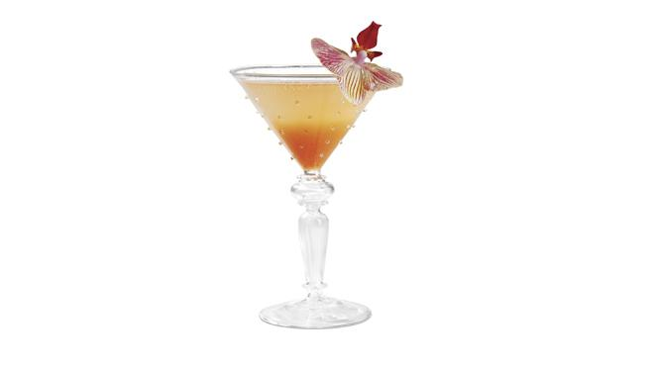

A stunning cocktail for any festive occasion. (Sauza)

This lively cocktail carries the sweet and tart flavors of grapefruit, livened with bubbly effervescence. The herbal and floral notes of the Sauza Blue Silver Tequila are complimented by the aura of the beautiful orchid garnish.

**INGREDIENTS**

* 1 ½ parts Sauza® Blue Silver 100% Agave Tequila
* 1 ½ part club soda
* Juice of 1 fresh grapefruit
* 1 ½ parts raspberry ginger ale soda
* Orchid for garnish

**PREPARATION**

In a shaker filled with ice combine all ingredients. Shake well and pour into glass over ice. Garnish with an orchid.

Tequila Blossom

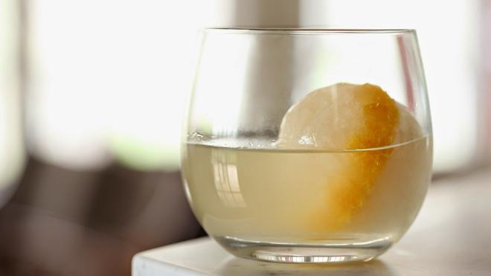

Sweet and sour summer treat (One Twenty One restaurant)

Created by One Twenty One restaurant in Westchester, New York, this tequila cocktail is made with lemon and syrup, creating a refreshing sweet and sour summer treat.

**INGREDIENTS**

* 2 Ounce Reposado tequila
* 1 Ounce Simple syrup
* 1/2 Ounce Lemon juice

**PREPARATION**

Shake all ingredients together then strain over an ice sphere molded ball. Add 4 drops Orange Blossom water. Garnish with orange.

Blood Orange Margarita

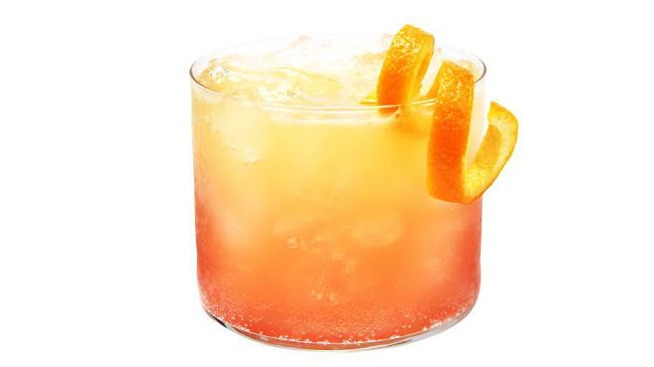

This sweet cocktail brings out tons of bright citrus flavors for a sunny take on a classic margarita.

**INGREDIENTS**

* 1 1/2 parts Tequila Avión
* 3/4 part Cointreau Orange Liqueur
* 1 part Blood Orange Juice
* 1/2 part Fresh Sour Mix

**PREPARATION**

In a cocktail shaker add all ingredients with ice. Shake and strain; best served over fresh ice and garnish with an orange twist.

Border Frappe

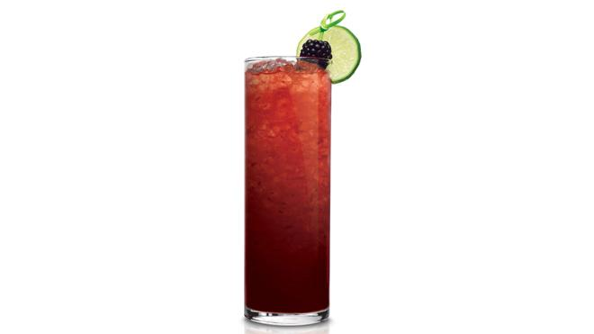

A berry infused tequila sipper. (Tequila Avión)

The Border Frappe’s black currant jam and fresh lime juice pair nicely with the  herbal flavors, complimenting the mint and rosemary.

**INGREDIENTS**

* 2 oz. Tequila Avión Silver
* 3/4 oz. Lime juice
* 1 tbsp. Black currant jam
* Blackberry and lime wheel for garnish

**PREPARATION**

Combine all ingredients in an ice filled shaker, shake vigorously until well chilled. Strain into a Collins or highball glass. Garnish with blackberry and a lime wheel.

Kiwi Margarita

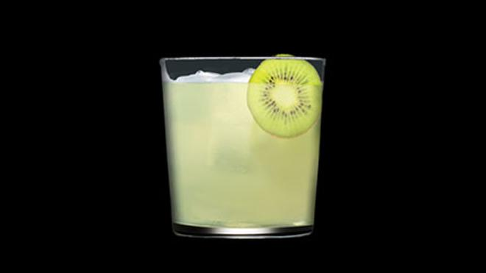

Tangy and sweet. (Tequila Avión)

Light, refreshing and undeniably tropical, the tangy kiwi fruit adds a unique punch to a traditional margarita.

**INGREDIENTS**

* 2 oz. Avión Añejo
* Handful of Fresh Kiwi
* 1 teaspoon Brown Sugar
* 1 oz. Cointreau
* Squeeze Fresh Lemon Juice
* Garnish with Kiwi Wheel

**PREPARATION**

Muddle a handful of fresh kiwi in a pint glass to bring out the juices and flavor. Add one teaspoon brown sugar, a dash of Cointreau and fresh lemon. Then, finish it off with 2 ounces of Avión Añejo. Shake and strain into a rocks glass filled with ice. Garnish with a kiwi wheel.

# Slim and Sparkling Margarita

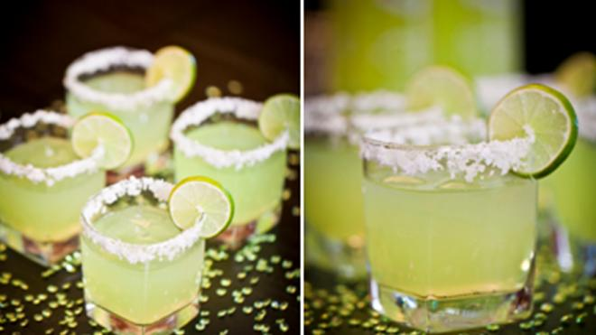

Excite your guests with this slim but tangy cocktail (Sparkling ICE)

This skinny citrus cocktail will get you in the Cinco de Mayo mood.

### INGREDIENTS

* 3 Ounce Lemon Lime Sparkling ICE
* 1 Ounce Silver tequila
* Splash of fresh squeezed orange juice
* Juice from half a lime

### PREPARATION

## Step 1:

Shake tequila with juices from the orange and lime

## Step 2:

Pour into a chilled rocks glass rimmed in salt

## Step 3:

Top with Sparking ICE

## Step 4:

Garnish with lime slices

The Twisted Margarita

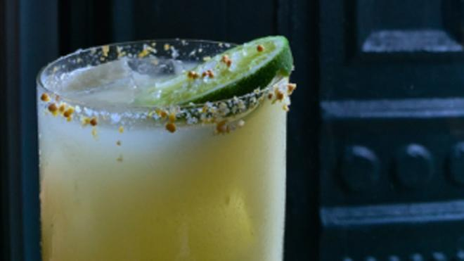

This salty savory drink will satisfy your NYC pretzel craving (Cody Goldstein, Upholstery Store, NYC)

A salty, savory “twist” on May’s most popular cocktail, this margarita pays tribute to that classic NYC snack:

**INGREDIENTS**

* 2 Parts Tres Agaves Blanco Tequila
* 3/4 Parts lime juice
* 1/2 Part triple sec
* 1/2 Part simple syrup
* 1 Teaspoon Mustard powder
* Mustard seed and sea salt rim

Maid to Order

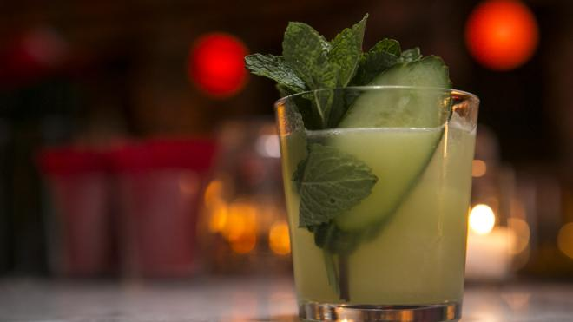

Cool off with this cucumber infused cocktail. (The Happiest Hour)

What's cool as a cucumber and more refreshing than a sprig of mint? This delicious twist on a margarita from master New York City mixologist Jim Kearns.

**INGREDIENTS**

* 2 oz Pueblo Viejo Blanco Tequila
* 3/4 oz lime juice
* 3/4 oz simple syrup
* 3/4 oz cucumber juice
* 5-6 mint leaves
* Cucumber/Mint garnish

**PREPARATION**

Combine all ingredients with chosen spirit and shake. Serve in rocks glass garnished with cucumber and mint.