In order to use AWS built-in tools for custom auto-scaling it requires the following steps:

- Create and publish custom metrics on each EC2 instance
- Create an alarm that responds to the metrics
  - The alarm needs an auto scaling group wich includes network (VPC) and subnet.
    - The group needs an launch configuration
      - Needs an image
- Notify CloudWatch of an event due to the alarm
- Scale up or down based on the alarm

Custom Metrics
https://docs.aws.amazon.com/AmazonCloudWatch/latest/monitoring/publishingMetrics.html

It can be done as one of the two resolutions:

- Standard resolution, with data having a one-minute granularity
- High resolution, with data at a granularity of one second

Metrics produced by AWS services are standard resolution by default. When you publish a custom metric, you can define it as either standard resolution or high resolution. When you publish a high-resolution metric, CloudWatch stores it with a resolution of 1 second, and you can read and retrieve it with a period of 1 second, 5 seconds, 10 seconds, 30 seconds, or any multiple of 60 seconds.
High-resolution metrics can give you more immediate insight into your application's sub-minute activity. Keep in mind that every PutMetricData call for a custom metric is charged, so calling PutMetricData more often on a high-resolution metric can lead to higher charges. For more information about CloudWatch pricing, see Amazon CloudWatch Pricing in the Annex A.
Publishing data to CloudWatch can be done either using the command line tool or one of the AWS SDK. Created an example called cw_metrics.py that show how is done using Python

Creating Alarms
https://docs.aws.amazon.com/AmazonCloudWatch/latest/monitoring/AlarmThatSendsEmail.html

Creating Amazon CloudWatch Alarms
You can create a CloudWatch alarm that watches a single metric. The alarm performs one or more actions based on the value of the metric relative to a threshold over a number of time periods. The action can be an Amazon EC2 action, an Auto Scaling action, or a notification sent to an Amazon SNS topic.
Alarms invoke actions for sustained state changes only. CloudWatch alarms do not invoke actions simply because they are in a particular state, the state must have changed and been maintained for a specified number of periods.
After an alarm invokes an action due to a change in state, its subsequent behavior depends on the type of action that you have associated with the alarm. For Amazon EC2 and Auto Scaling actions, the alarm continues to invoke the action for every period that the alarm remains in the new state. For Amazon SNS notifications, no additional actions are invoked.
Note
CloudWatch doesn't test or validate the actions that you specify, nor does it detect any Auto Scaling or Amazon SNS errors resulting from an attempt to invoke nonexistent actions. Make sure that your actions exist.
You can also add alarms to dashboards. When an alarm is on a dashboard, it turns red when it is in the ALARM state, making it easier for you to monitor its status proactively.

Alarm States
An alarm has the following possible states:
- OK—The metric is within the defined threshold
- ALARM—The metric is outside of the defined threshold
- INSUFFICIENT_DATA—The alarm has just started, the metric is not available, or not enough data is available for the metric to determine the alarm state

Evaluating an Alarm
In the following figure, the alarm threshold is set to three units and the alarm is configured to trigger when all three datapoints in the most recent three consecutive periods are above the threshold. That is, the alarm state changes to ALARM if the oldest of the three periods being evaluated is breaching, and the two subsequent periods are either breaching or missing. In the figure, this happens in the third through fifth time periods. At period six, the value dips below the threshold, and the alarm state changes to OK. During the ninth time period, the threshold is breached again, but for only one period. Consequently, the alarm state remains OK.
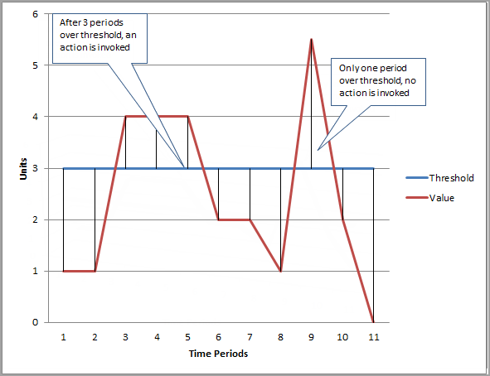

Create or Edit a CloudWatch Alarm
https://docs.aws.amazon.com/AmazonCloudWatch/latest/monitoring/ConsoleAlarms.html

Need to go to the console and select cloudwatch. Once there click on Alarms and “Create Alarm”. Under the Select Metric tab, select CCDPTest as the Metric and then the made up metrics, it should display all the key value pairs we entered. If everything is selected properly then the Next button is enabled. Click on next to go to “Define Alarm”

Set the Action:
If a notification is needed then we need to create a Topic by going to the Simple Notification Service (SNS).

Annexes
Annex A
CloudWatch Prices

Amazon CloudWatch Dashboards
- $3.00 per dashboard per month

Detailed Monitoring for Amazon EC2 Instances
- $2.10 down to $0.14 per instance per month at 1-minute frequency******

Amazon CloudWatch Custom Metrics
- $0.30 per metric per month for the first 10,000 metrics
- $0.10 per metric per month for the next 240,000 metrics
- $0.05 per metric per month for the next 750,000 metrics
- $0.02 per metric per month for metrics over 1,000,000

Amazon CloudWatch Alarms
- $0.10 per alarm per month
- $0.30 per high-resolution alarm per month

Amazon CloudWatch API Requests
- $0.01 per 1,000 GetMetricStatistics, ListMetrics, PutMetricData, GetDashboard, ListDashboards, PutDashboard and DeleteDashboards requests

Amazon CloudWatch Logs
- $0.50 per GB ingested**
- $0.03 per GB archived per month***
- Data Transfer OUT from CloudWatch Logs is priced equivalent to the “Data Transfer OUT from Amazon EC2 To” and “Data Transfer OUT from Amazon EC2 to Internet” tables on the EC2 Pricing Page.

Amazon CloudWatch Vended Logs*******
- $0.50 per GB for the first 10TB of vended log data ingested
- $0.25 per GB for the next 20TB of vended log data ingested
- $0.10 per GB for the next 20TB of vended log data ingested
- $0.05 per GB for vended log data ingested over 50TB

Amazon CloudWatch Events - Custom Events****
- $1.00 per million custom events generated*****

