Ontap自动化运维程序

Ontap Automation
使用说明
V1.1



文档信息
项目名称：Ontap自动化运维程序 – OntapAutomation
版本信息 | 作者 | 行动 | 日期
1.0 |  | 初稿
分发名单
自 | 日期 | 部门 | 职务 | Email | 电话

给 | 部门 | 职务 | 行动* | 截止日期 | Email / 电话
客户负责人 |  |  | 审阅
 |  |  | 审阅
 |  |  | 审阅
项目组 |  | 项目经理 | 抄送
 |  | 售前顾问 | 抄送
 |  | 客户经理 | 抄送
 |  | 技术经理 | 抄送
*行动类别：批准，复审，通知，存档，所需行动，参加会议，其它（请指明）

目 录

1 文档概述 4
2 集群配置文件管理 5
2.1 初次使用 5
2.2 添加集群 6
2.3 显示集群 7
2.4 删除集群 7
3 卷配置文件介绍 8

文档概述
本文主要介绍OntapAutomation程序的使用方法。
OntapAutomation工具旨在完成常见的存储操作，脱离Ontap GUI和CLI完成存储变更，简化运维，结合自动化运维平台调用本工具能极大提高存储运维水平。
OntapAutomation主要特性如下：
- 通过子命令定义操作内容，例如cluster子命令用于维护集群列表，volume子命令用于进行卷的运维管理，等。
- 通过excel配置文件做为相关子命令（volume等）的输入
- 遇到问题或者错误，准确提示信息并返回非0值。
工具帮助如下：
usage: OntapAutomation [-h] [--config <cluster config file>] [--noc] [--seq] [--lic LICENSE] [--key KEY1] [--key2]
{config,cluster,ssh,volume,lun,igroup,policy,policy_rule,cifs_share,cifs_access,snapmirror,snapmirror7,snapshot} ...

positional arguments:
{config,cluster,ssh,volume,lun,igroup,policy,policy_rule,cifs_share,cifs_access,snapmirror,snapmirror7,snapshot}
sub-command help
config config(credentials) related operation, manage cluster config file include 'add', 'delete', 'show'
cluster save configuration by 'getconfig' and manage autosupport/perf-archive by 'autosupport/asup'
ssh run command at remote host via ssh
volume manage ontap flexvol: rename,create,delete,modify,etc
lun manage lun: create,delete,modify,map,unmap,etc
igroup manage igroup: rename,create,delete,modify,etc
policy manage export policy: rename,create,delete,etc
policy_rule manage export policy rule: create,delete,modify,etc
cifs_share manage cifs share: create,delete,modify,etc
cifs_access manage cifs access control(ACL): create,delete,modify,etc
snapmirror manage snapmirror:
show,monitor,create,initialize,abort,quiesce,break,resync,update,resume,modify,delete,release,reverse_resync,etc
snapmirror7 manage snapmirror for 7 mode: show,monitor,initialize,abort,quiesce,break,resync,update,resume,release,etc
snapshot manage snapshot: show,rename,create,delete,protect,restore,etc

optional arguments:
-h, --help show this help message and exit
--config <cluster config file>
the cluster config file path, default: cluster.config in current path, otherwise in app path
--noc no color output, defualt is colored
--seq single thread, execute in the order of input, defualt is multi-threaded
--lic LICENSE full path of license file, default: OntapAutomation.lic in current path, otherwise in app path
--key KEY1 input key to protect cluster config file
--key2 ask for input key to protect cluster config file

集群配置文件管理
OntapAutomation通过命令行完成存储配置，本工具必须管理全部的集群管理凭据。通过config子命令完成，将存储的管理IP，登录用户名和口令全部加密并通过二进制方式存储到配置文件（默认cluster.config）。
集群配置支持show，add和delete。
Add选项用于添加集群，默认验证连通性，可以通过加--no-verify暂不验证。
Delete选项用于删除某集群，通过-i <IP>删除特定记录。
Show选项用于查看加密配置文件的集群清单，通过-v来验证各个集群连通性。

初次使用
OntapAutomation cluster提示帮助
C:\>OntapAutomation config -h
usage: OntapAutomation config [-h] [-i <cluster mgmt ip>] [-u <cluster admin username>] [-p <password>] [--no-verify] [--limit <limit>] [-v]
{show,add,delete,changekey}

positional arguments:
{show,add,delete,changekey}
supported config(credentials) operation

optional arguments:
-h, --help show this help message and exit
-i <cluster mgmt ip>, --ip <cluster mgmt ip>
-u <cluster admin username>, --user <cluster admin username>
-p <password>, --password <password>
--no-verify don't verify password when add, default is verify
--limit <limit> restrict the list of commands that can be executed, separated by comma. default is empty, no limit
-v, --verbose show more information when applicable, default is False
OntapAutomation cluster: error: the following arguments are required: cluster_operation

添加集群
OntapAutomation cluster add 交互式添加集群。
C:\>OntapAutomation config add
IP Address: 10.128.13.6
User: admin
Password:
2021-01-27 21:06:41,283 - INFO - ------------------------------
2021-01-27 21:06:41,283 - INFO - admin@10.128.13.6
2021-01-27 21:06:41,283 - INFO - ------------------------------
2021-01-27 21:06:41,284 - INFO - cluster.config, saved.
OntapAutomation cluster add 自动添加集群。
C:\>OntapAutomation config add -i 10.128.13.6 -u admin -p <password>
2021-04-14 21:05:58,437 - INFO Ontap Automation v1.0 for PS Demo until 20210612, build on 20210414
IP Address: 10.128.13.6
User: admin
Password:
2021-04-14 21:06:06,697 - INFO admin@10.128.13.6,NetApp Release 8.3.2
OntapAutomation cluster add 自动添加集群并验证,上面能显示集群版本，说明连通性和口令都正常。

显示集群
OntapAutomation cluster show -v显示集群并验证连通性
C:\PycharmProjects\NTAPAPI>OntapAutomation config show -v
2021-01-27 21:10:44,925 - INFO - Ontap Automation v1.0 for PS Demo until 20210427, build on 20210127
2021-01-27 21:10:44,933 - INFO - cluster.config, loaded.
2021-01-27 21:10:44,935 - INFO - ------------------------------
2021-01-27 21:10:45,574 - INFO - admin@10.128.13.6,NetApp Release 8.3.2: Wed Feb 24 03:29:11 UTC 2016
2021-01-27 21:10:45,574 - INFO - ------------------------------
也可以通过-i参数只验证特定集群的连通性

删除集群
OntapAutomation config delete -i删除特定集群
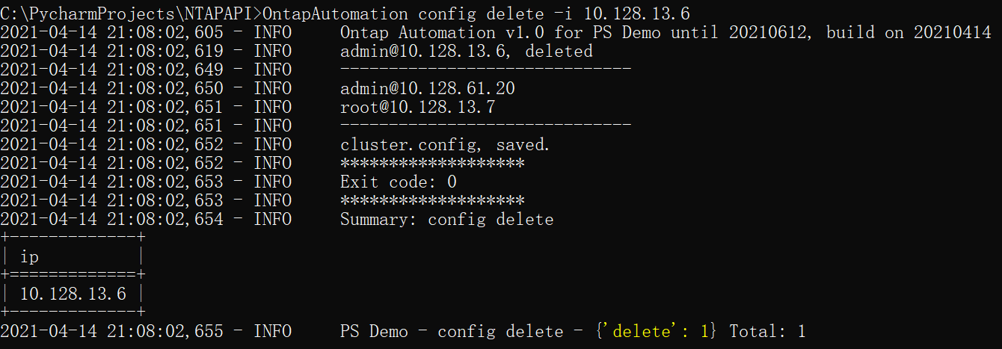

卷配置文件介绍
OntapAutomation通过命令行工具和配置文件一起完成卷操作，操作支持幂等性，即一个配置文件多次执行结果是一样的，工具会检查全部参数，不一样的才执行操作。
OntapAutomation volume plan 完成配置文件检查和提示可能发生的变更。
OntapAutomation volume run正式执行变更，对于有风险的操作，需要加--force参数才会执行。
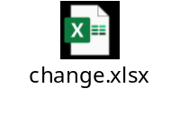
配置文件见附excel，通过配置文件写入需要的卷信息，工具自动到存储检查卷是否存在，如果不存在则新建；存在就是修改，会自动检查全部参数。
C:\PycharmProjects\NTAPAPI>OntapAutomation volume plan
2021-01-27 21:20:49,656 - INFO - Ontap Automation v1.0 for PS Demo until 20210427, build on 20210127
2021-01-27 21:20:49,660 - INFO - cluster.config, loaded.
2021-01-27 21:20:49,706 - INFO - change.xlsx, loaded.
2021-01-27 21:20:49,707 - INFO - 1 input volumes: ['svm_shlab_01:zpw112']
2021-01-27 21:20:50,781 - INFO - svm_shlab_01:zpw112 plan: create volume zpw112: 4 items, {'vserver': 'svm_shlab_01', 'aggr_name': 'aggr1_node01', 'cluster': '10.128.13.6', 'name': 'zpw112'}

C:\PycharmProjects\NTAPAPI>OntapAutomation volume run
2021-01-27 21:20:56,890 - INFO - Ontap Automation v1.0 for PS Demo until 20210427, build on 20210127
2021-01-27 21:20:56,895 - INFO - cluster.config, loaded.
2021-01-27 21:20:56,960 - INFO - change.xlsx, loaded.
2021-01-27 21:20:56,960 - INFO - 1 input volumes: ['svm_shlab_01:zpw112']
2021-01-27 21:20:58,025 - INFO - svm_shlab_01:zpw112 run: create volume zpw112: 4 items, {'aggr_name': 'aggr1_node01', 'cluster': '10.128.13.6', 'name': 'zpw112', 'vserver': 'svm_shlab_01'}
2021-01-27 21:20:59,510 - INFO - svm_shlab_01:zpw112 done: create volume zpw112
2021-01-27 21:20:59,871 - INFO - svm_shlab_01:zpw112 done: modify volume zpw112: 10 items, {'autosize_mode': 'grow', 'nearlyfull_percent': 95, 'snapdelete_commitment': 'try', 'fractional_reserve': 0, 'atime_update': 'true', 'snapdelete_destroylist': 'none', 'snapdir_access': 'false', 'full_percent': 98, 'snap_autodelete': 'false', 'space_mgmt_try_first': 'volume_grow'}

C:\PycharmProjects\NTAPAPI>OntapAutomation volume run
2021-01-27 21:21:05,858 - INFO - Ontap Automation v1.0 for PS Demo until 20210427, build on 20210127
2021-01-27 21:21:05,863 - INFO - cluster.config, loaded.
2021-01-27 21:21:05,918 - INFO - change.xlsx, loaded.
2021-01-27 21:21:05,919 - INFO - 1 input volumes: ['svm_shlab_01:zpw112']
2021-01-27 21:21:07,121 - INFO - svm_shlab_01:zpw112: no action.

C:\PycharmProjects\NTAPAPI>OntapAutomation volume run
2021-01-27 21:21:20,347 - INFO - Ontap Automation v1.0 for PS Demo until 20210427, build on 20210127
2021-01-27 21:21:20,352 - INFO - cluster.config, loaded.
2021-01-27 21:21:20,412 - INFO - change.xlsx, loaded.
2021-01-27 21:21:20,413 - INFO - 1 input volumes: ['svm_shlab_01:zpw112']
2021-01-27 21:21:21,625 - INFO - svm_shlab_01:zpw112 run: delete volume zpw112
2021-01-27 21:21:21,626 - ERROR - svm_shlab_01:zpw112 add --force to run: delete volume zpw112

C:\PycharmProjects\NTAPAPI>OntapAutomation volume run --force
2021-01-27 21:21:26,392 - INFO - Ontap Automation v1.0 for PS Demo until 20210427, build on 20210127
2021-01-27 21:21:26,397 - INFO - cluster.config, loaded.
2021-01-27 21:21:26,452 - INFO - change.xlsx, loaded.
2021-01-27 21:21:26,452 - INFO - 1 input volumes: ['svm_shlab_01:zpw112']
2021-01-27 21:21:27,637 - INFO - svm_shlab_01:zpw112 run: delete volume zpw112
2021-01-27 21:21:31,344 - INFO - svm_shlab_01:zpw112 done: delete volume zpw112

