Results
Over all types of cancers, the TP53 gene had 12 cancer-mutation combinations that occurred in more than 20% of the samples given a cancer type¹. Of these, 8 had a significant proteomic cis effect², and 4 had a significant transcriptomic cis effects³. There were 8 phosphoproteomic sites with significant cis effects⁴.

To analyze trans effects, we restricted our analysis to proteins that shared one of 5 pathways with TP53⁵. For the proteomic trans effects, only 5 out of the 12 cancer-mutations had significant trans effects. However, there were 118 significant trans effects between these combinations⁶. The most common trans effects were with MAP2K, which appeared in 5/5 mutation combinations, and PFAS, which appeared in 4/5 mutation combinations.

We repeated the trans effect analysis with the transcriptomic effects and phosphoproteomic data. Of the 12 cancer-mutation combinations, 9 showed significant transcriptomic trans effects. A total of 265 significant trans effects were divided among these⁷. The most common trans effects were PAFAH1B1 , which appeared in 5/9 combinations, and MAP2K4, which appeared in 4/9 combinations. 4 combinations showed significant phosphoproteomic trans effects, with a total of 103 significant effects⁸. These effects were fairly unique, with only 5 effects appearing in even two cancer-mutation combinations⁹.

Discussion
The tumor samples that had a mutated TP53 gene showed effects that were common across several cancer-mutation combinations. Many combinations showed highly significant cis-effects (p < 0.01 and p < 0.001). In addition, among the combinations that showed significant trans-effects, there was a lot of overlap in which trans effects were significant in each.

¹ BRCA deletion, COAD deletion, HNSCC missense, HNSCC truncation, LSCC deletion, LSCC missense, LUAD deletion, LUAD missense, OV deletion, OV missense, PDAC deletion, PDAC missense
² COAD deletion, HNSCC missense, LSCC missense, LUAD deletion, LUAD missense, OV missense, PDAC deletion, PDAC missense
³ BRCA deletion, COAD deletion, HNSCC truncation, LUAD deletion
⁴ All at site TP53.S315; PDAC deletion, PDAC missense, COAD deletion, HNSCC missense, LSCC missense, LUAD deletion, LUAD missense, OV missense
⁵ MAPK signaling pathway, DNA damage response, Wnt signaling pathway and pluripotency, TP53 network, and G1 to S cell cycle control.
⁶ BRCA deletion, COAD deletion, HNSCC truncation, HNSCC missense, LSCC deletion, LSCC missense, LUAD deletion, LUAD missense, OV deletion, OV missense, PDAC deletion, PDAC missense
⁷ BRCA deletion, COAD deletion, LSCC deletion, LUAD deletion, PDAC deletion,
⁸ COAD deletion, LSCC deletion, PDAC deletion, PDAC missense
⁹PPP3CB.S478, WEE1.S150, WEE1.S165T173, MAPK11.S271, BRCA.S114

Figure 1: Mutations that occurred in more than 20% of samples
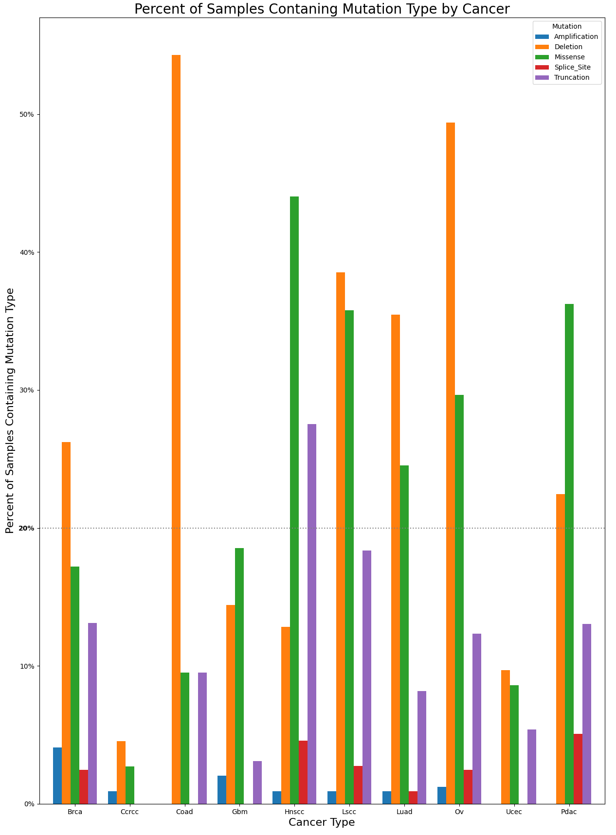

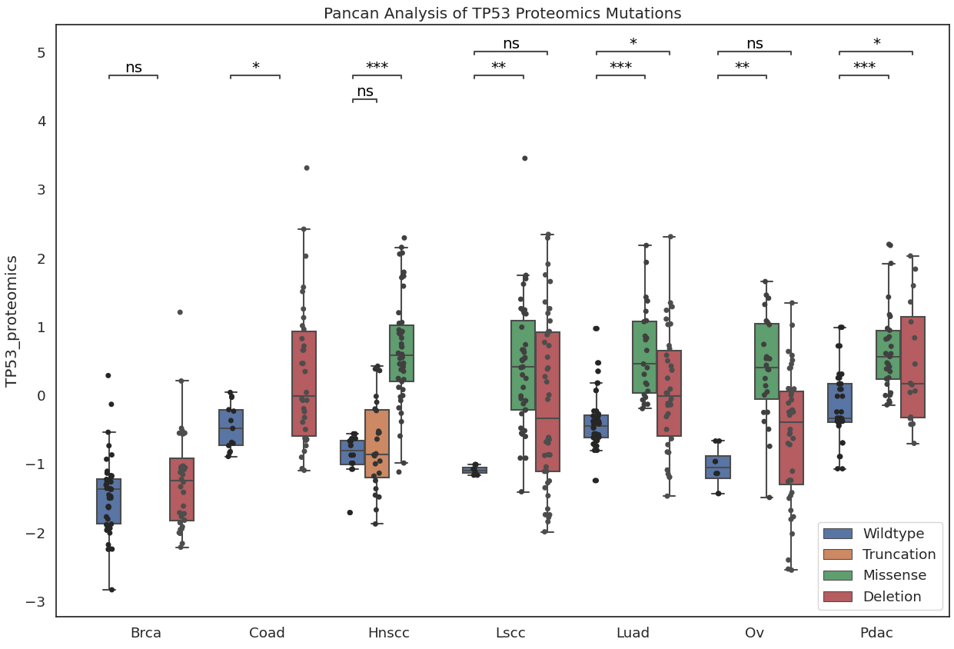
Figure 2: Proteomic cis effects

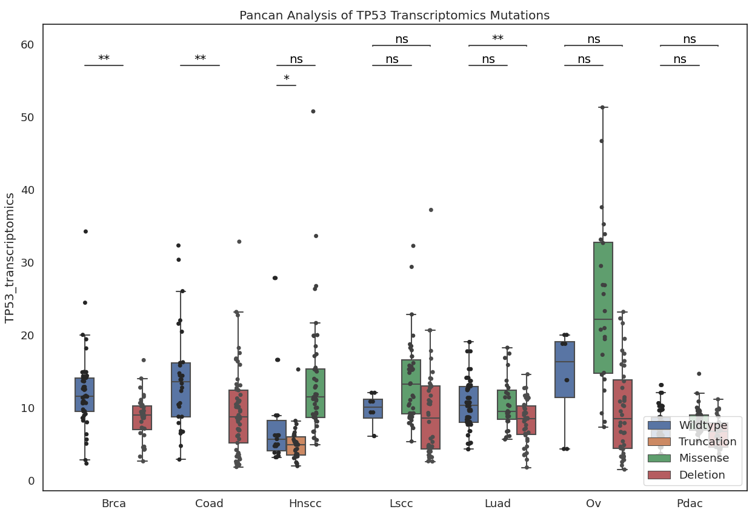
Figure 3: Transcriptomic cis effects

Figure 4: Phosphoproteomic cis effects at site TP53.S315. Two other sites were measured (S314 and S392), but there were no significant effects in either.
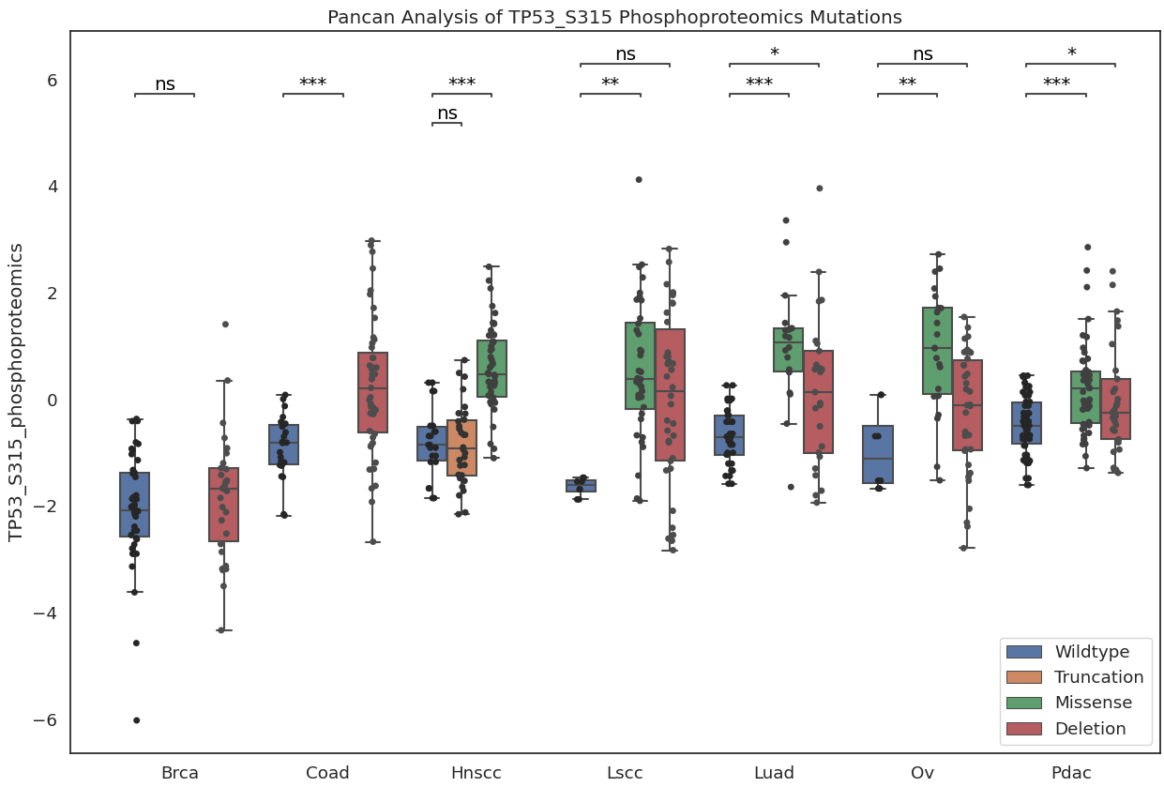

Figure 6: Most common genes with significant proteomic trans effects (p < 0.05) across different cancer-mutation combinations
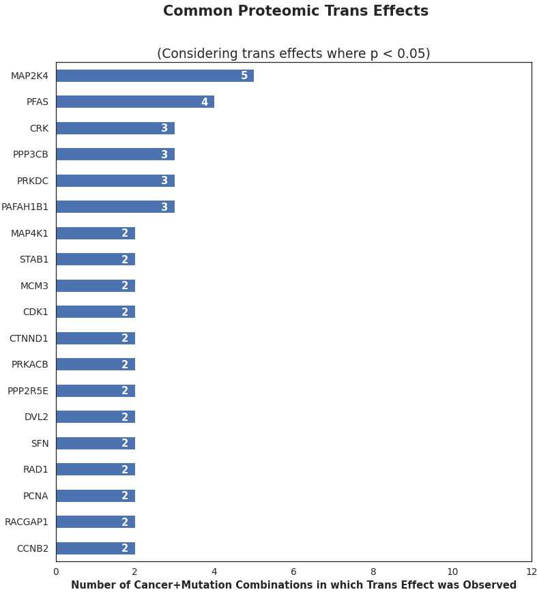

Figure 7: Most common genes with significant transcriptomic trans effects (p < 0.05) across different cancer-mutation combinations
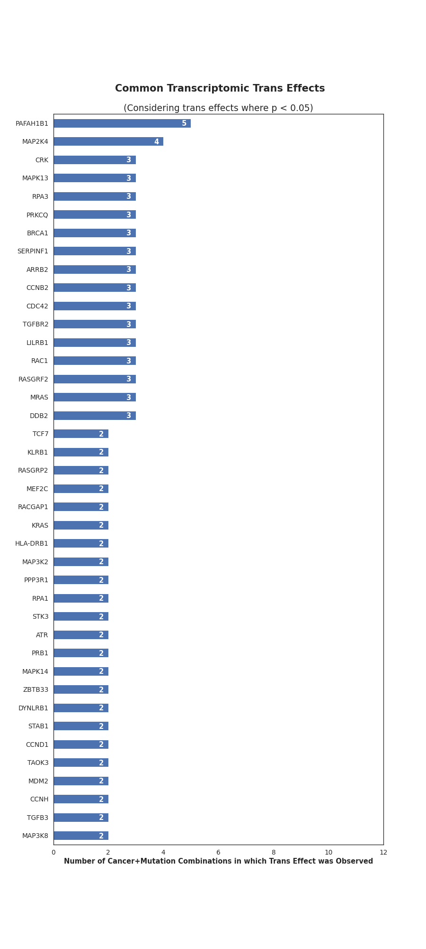

Figure 8: Most common genes with significant phosphoproteomic trans effects (p < 0.05) across different cancer-mutation combinations

