Results
Over all types of cancers, the EGFR gene had 8 cancer-mutation combinations that occurred in more than 20% of the samples given a cancer type¹. Of these, 7 had a significant proteomic cis effect², and 7 had a significant transcriptomic cis effects³. There were 42 phosphoproteomic sites measured, which shared a total of 89 significant cis effects between them⁴.

To analyze trans effects, we first restricted our analysis to proteins were part of the EGF/EGFR pathway. All 8 cancer-mutation combinations showed significant proteomic trans effects, with a total of 76 trans effects divided between them⁵. The most common trans effects were with RALA and GRB2, which appeared in 4/8 mutation combinations⁶. We then broadened the scope to include all measured genes. This resulted in 2,217 significant proteomic trans effects between all 8 combinations. The most common trans effect was with PURB, which appeared in 6/8 cancer-mutation combinations, and 4 other genes which appeared in 5/8 combinations⁷.

We repeated the trans effect analysis with the transcriptomic and phosphoproteomic data. All combinations showed significant transcriptomic trans effects, and had a total of 65 effects between all combinations. The most common trans effects were JAK1 , which appeared in 4/8 combinations, and BRAF, RAC1, and RALA, which appeared in 3/8 combinations⁸. After broadening the scope, there was a total of 2,282 significant trans effects between all combinations. The most common trans effects were AVL9 and URGCP, which appeared in 6/8 cancer-mutation combinations⁹.

5/8 combinations showed significant phosphoproteomic trans effects, with a total of 34 significant effects. With so few phosphoproteomic effects, only one site—ARHGEF1.S384S388—appeared in more than one combination. Although broadening the scope yielded 537 significant trans effects, no phosphoylation site appeared in more than two combinations¹⁰.

Discussion
The tumor samples that had a mutated EGFR genes showed many significant proteomic and transcriptomic cis and trans effects, and showed commonalities across many types of cancers and mutations. Both the quantity of significant effects and the number of commonalities increased when all proteins were considered. This indicates that a mutation in EGFR is correlated with very consistent effects regardless of the cancer and mutation type. In addition, the number of significant effects was much higher than for the other genes, indicating that mutating EGFR produces wide-ranging proteomic and transcriptomic effects across the genome.

The phosphoproteomic data did not show such clear results. Mutating EGFR seemed to have clear cis effects on many of its own phosphosites. However, despite many genes having more than one phosphosite, there were far fewer significant phosphoproteomic trans effects than proteomic or transcriptomic. Of these, there were hardly any common trans effects between the cancer-mutation combinations. This may indicate that a mutated EGFR does not exert as clear of an influence on other genes’ phosphoproteomics as it does their proteomics and transcriptomics. However, our approach with phosphoproteomic data was fairly naive, considering each phosphosite independently. Perhaps a more sophisticated analysis of phosphoproteomic data would yield more significant results.

¹ CCRCC Amplification, COAD Amplification, GBM Missense, GBM Amplification, HNSCC Amplification, LSCC Amplification, LUAD Missense, LUAD Amplification
² CCRCC Amplification, GBM Missense, GBM Amplification, HNSCC Amplification, LSCC Amplification, LUAD Missense, LUAD Amplification
³ CCRCC Amplification, GBM Missense, GBM Amplification, HNSCC Amplification, LSCC Amplification, LUAD Missense, LUAD Amplification
⁴ Sites S1026, S1037, S1039, S1039S1042, S1039S1042S1045, S1039T1041, S1039T1041S1042, S1042, S1042S1045, S1045, S1057, S1064, S1071, S1071T1085, S1081, S1096, S1104, S1153, S1162S1166, S1166, S1166Y1172, S1204, S1205, S315, S695, S991, S991S995, S991T993, S995, T1041, T1041S1042, T1041S1042S1045, T1145, T693, T693S695, Y1016, Y1069, Y1069Y1092, Y1092, Y1110, Y1172, Y1197
⁷ NUDCD3, NIPSNAP2, GGCT, LANCL2

Figure 1: Mutations hat occurred in >20% of each cancer sample group
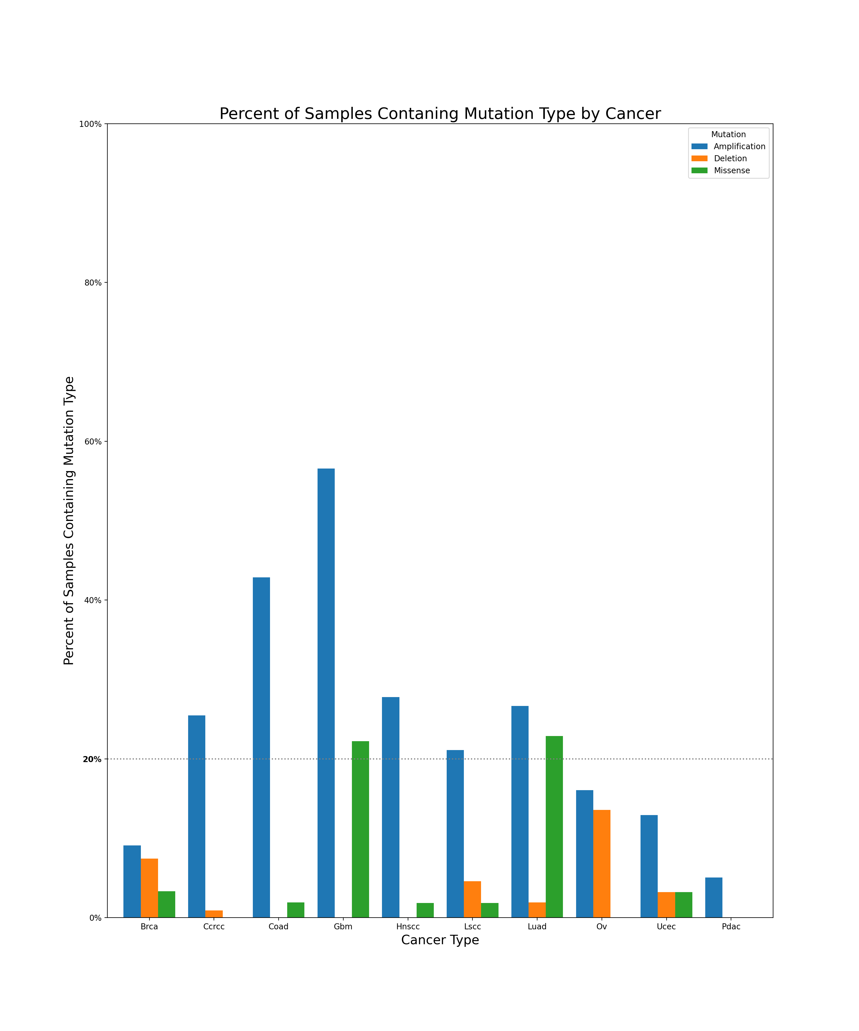

Figure 2: Significant proteomic cis effects (p < 0.05)
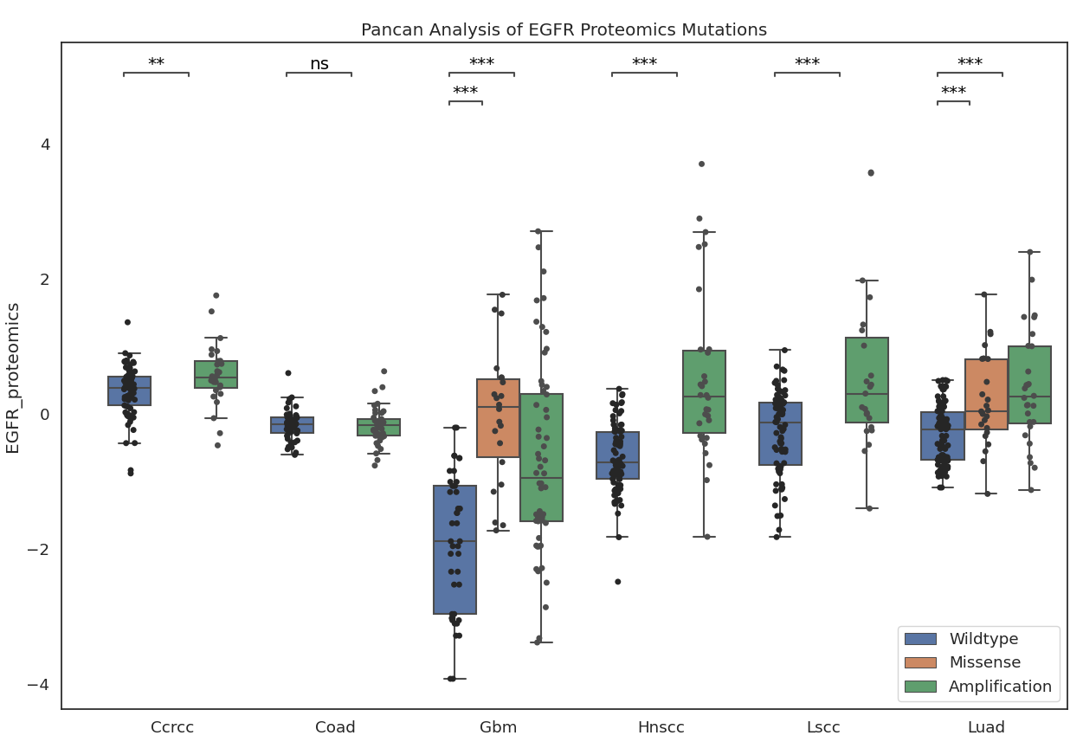
Figure 3: Significant transcriptomic cis effects (p < 0.05)
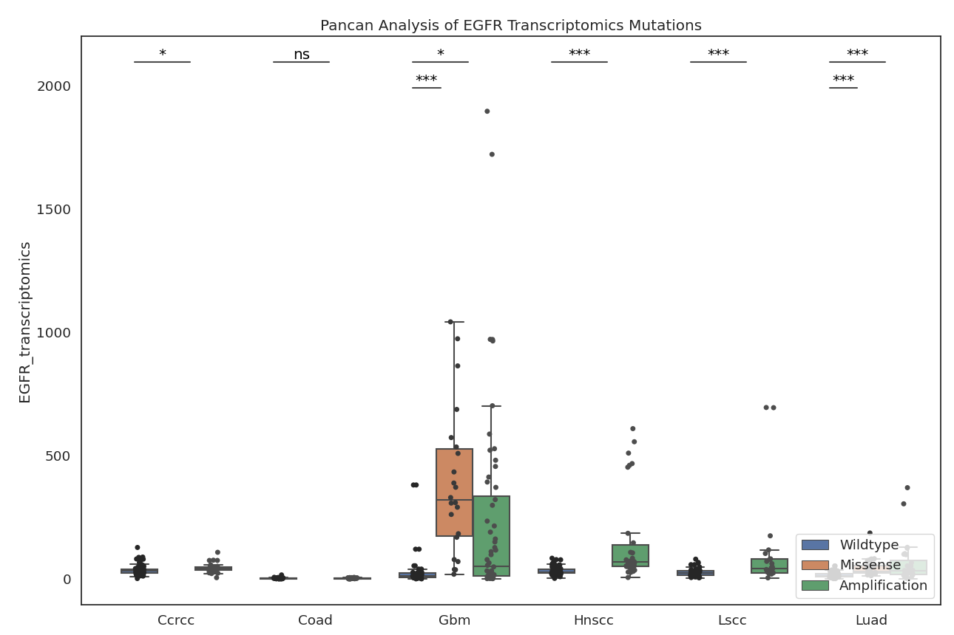

Figure 4: Significant phosphoproteomic cis effects (p < 0.05). Only two phosphosites are shown here; all 42 are included in attached documents.
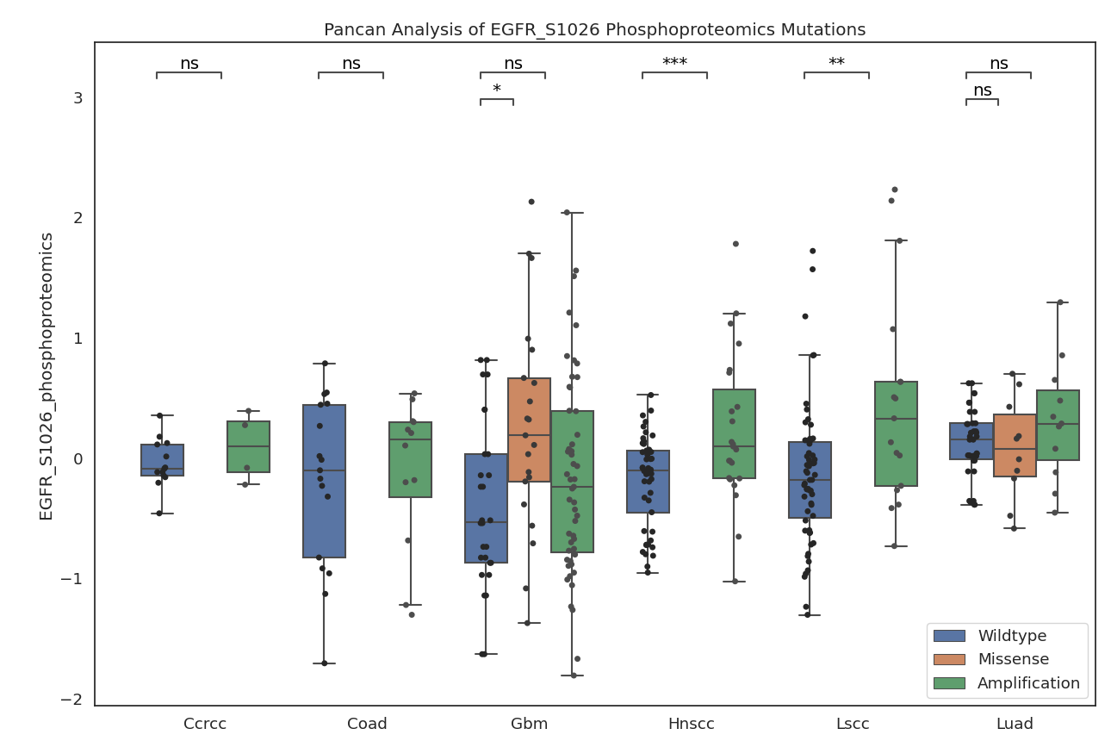

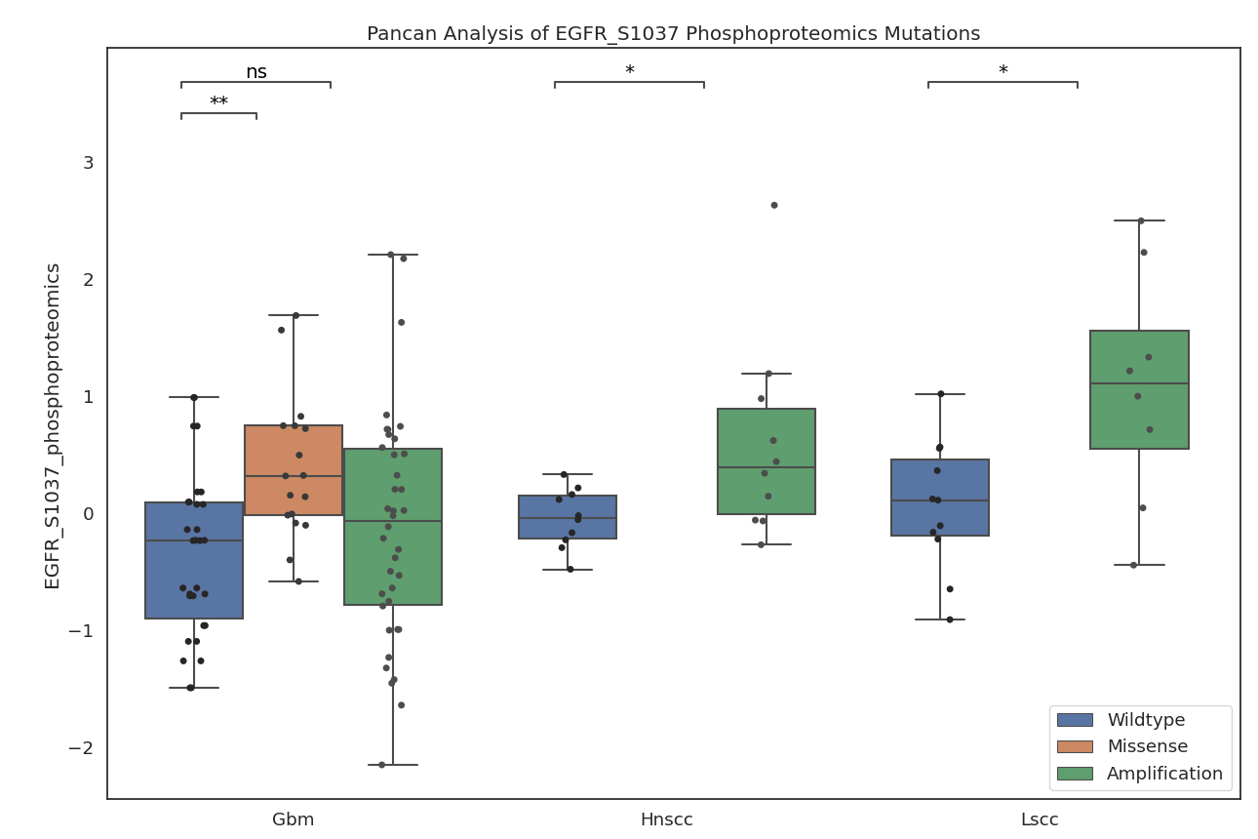

Figure 6: Significant proteomic effects (p < 0.05) common across all cancer-mutation combinations, considering proteins in the EGF/EGFR signaling pathway.
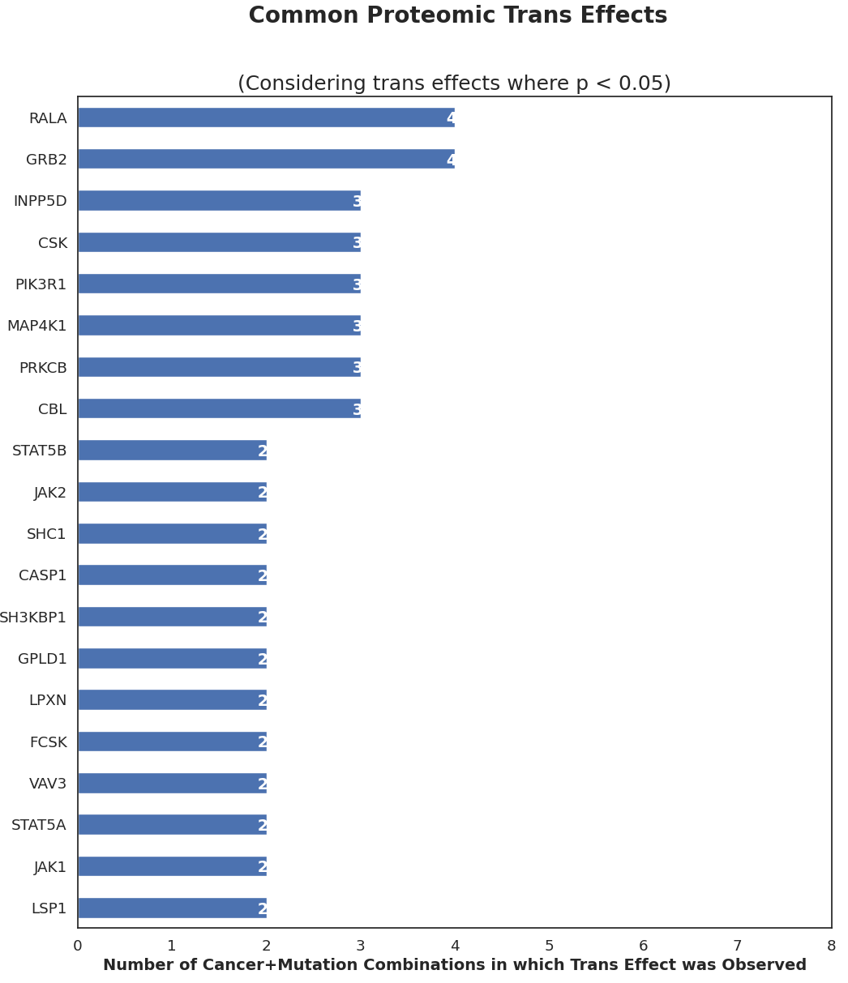

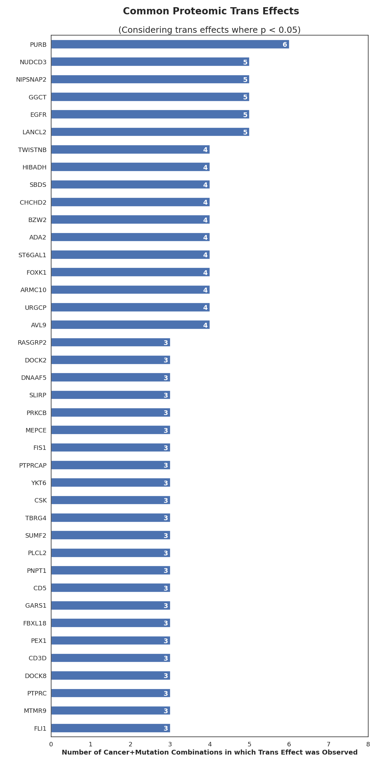
Figure 7: Significant proteomic effects (p < 0.05) common across all cancer-mutation combinations, considering all measured proteins.

Figure 8: Significant transcriptomic effects (p < 0.05) common across all cancer-mutation combinations, considering proteins in the EGF/EGFR signaling pathway.
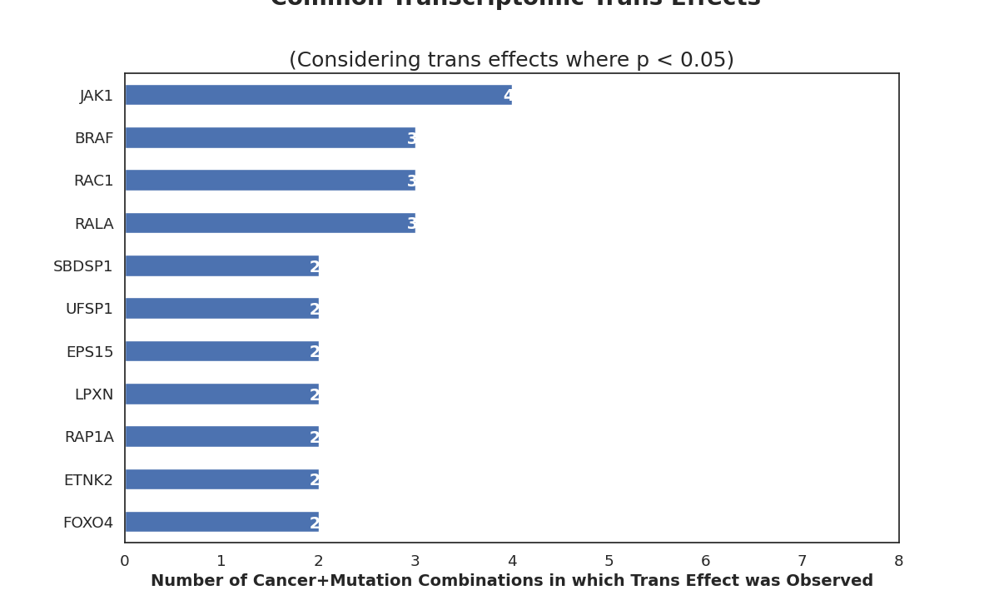

Figure 9: Significant transcriptomic effects (p < 0.05) common across all cancer-mutation combinations, considering all measured proteins.
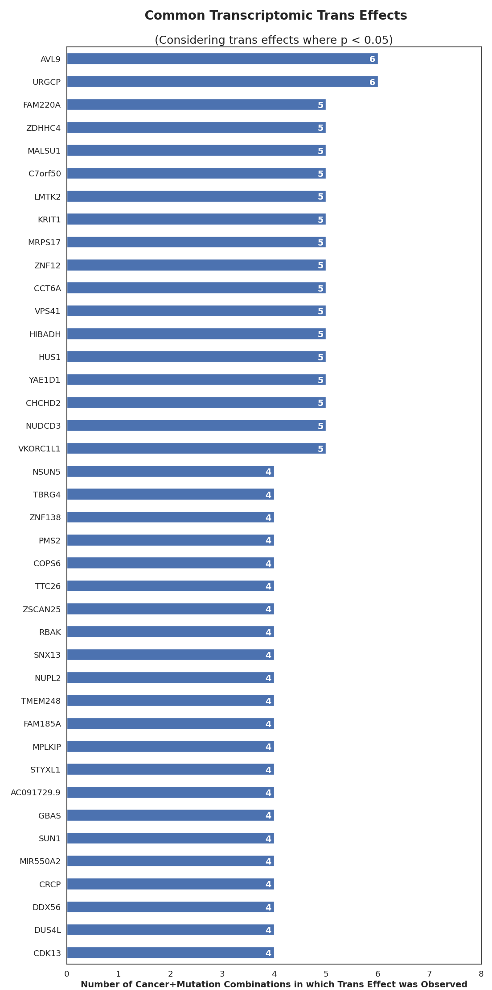

Figure 10: Significant transcriptomic effects (p < 0.05) common across all cancer-mutation combinations, considering all measured proteins.
