Results
Over all types of cancers, the KRAS gene had 6 cancer-mutation combinations that occurred in more than 20% of the samples given a cancer type¹. Of these, 5 had a significant proteomic cis effect², and 4 had a significant transcriptomic cis effects³. There was not enough phosphoproteomic data for KRAS in any of the cancer-mutation combinations, so phosphoproteomic data was not considered for KRAS.

To analyze trans effects, we restricted our analysis to proteins that shared the MAPK signaling pathway with KRAS. For the proteomic data there were only 4 significant trans effects (p < 0.05)⁴. We then broadened the scope to include all measured genes. This resulted in 195 significant trans effects across all 6 combinations. Despite this, increase, the effects were fairly unique with only 9 occurring in more than one combination⁵.

For the transcriptomic data there were only 11 significant trans effects (p < 0.05)⁶. We then broadened the scope to include all measured genes. This resulted in 2,290 significant trans effects across all 6 combinations. Interestingly, 95% of these (2,186) came from PDAC missense. As such, there were only 3 significant trans effects (p < 0.05) that occurred in more than one combination—IPO8, CDCA3, and GAPDH.

Discussion
The tumor samples that had a mutated KRAS gene showed very few common effects across cancers and mutations. Even when considering all measured proteomic and transcriptomic genes, which yielded a sizable number of significant trans effects, very few were shared between even two cancer-mutation combinations. This suggests that KRAS is highly variable in its expression between cancers and mutations.

Although the other genes we studied had sufficient phosphoproteomic data consider it as well, the data we used had large numbers of missing values for KRAS phosphoproteomic data. Perhaps more complete phosphoproteomic data would give new insights.

¹ COAD missense, LSCC amplification, LUAD missense, OV amplification, PDAC missense, UCEC missense
² COAD missense, LSCC amplification, LUAD missense, OV amplification, UCEC missense
³ COAD missense, LSCC amplification, LUAD missense, OV amplification
⁴ LSCC amplification at PRKACB, LSCC amplification at STAB1, LUAD missense at SERPINF1, UCEC missense at MAP3K6
⁵ PHB, MLFW, INTS13, GAPDH, FKBP4, CCDC91, CMAS, TPI1, LDHB.
⁶ LUAD missense at CHUK, LUAD missense at PPP3CB, UCEC missense at DUSP6, UCEC missense at FAS, UCEC missense at PFAS, PDAC missense at BATF2, PDAC missense at ARRB2, PDAC missense at RAC3, PDAC missense at GRB2, PDAC missense at STMN1, PDAC missense at MAPK11

Figure 1: Mutations that occurred in more than 20% of each cancer sample group
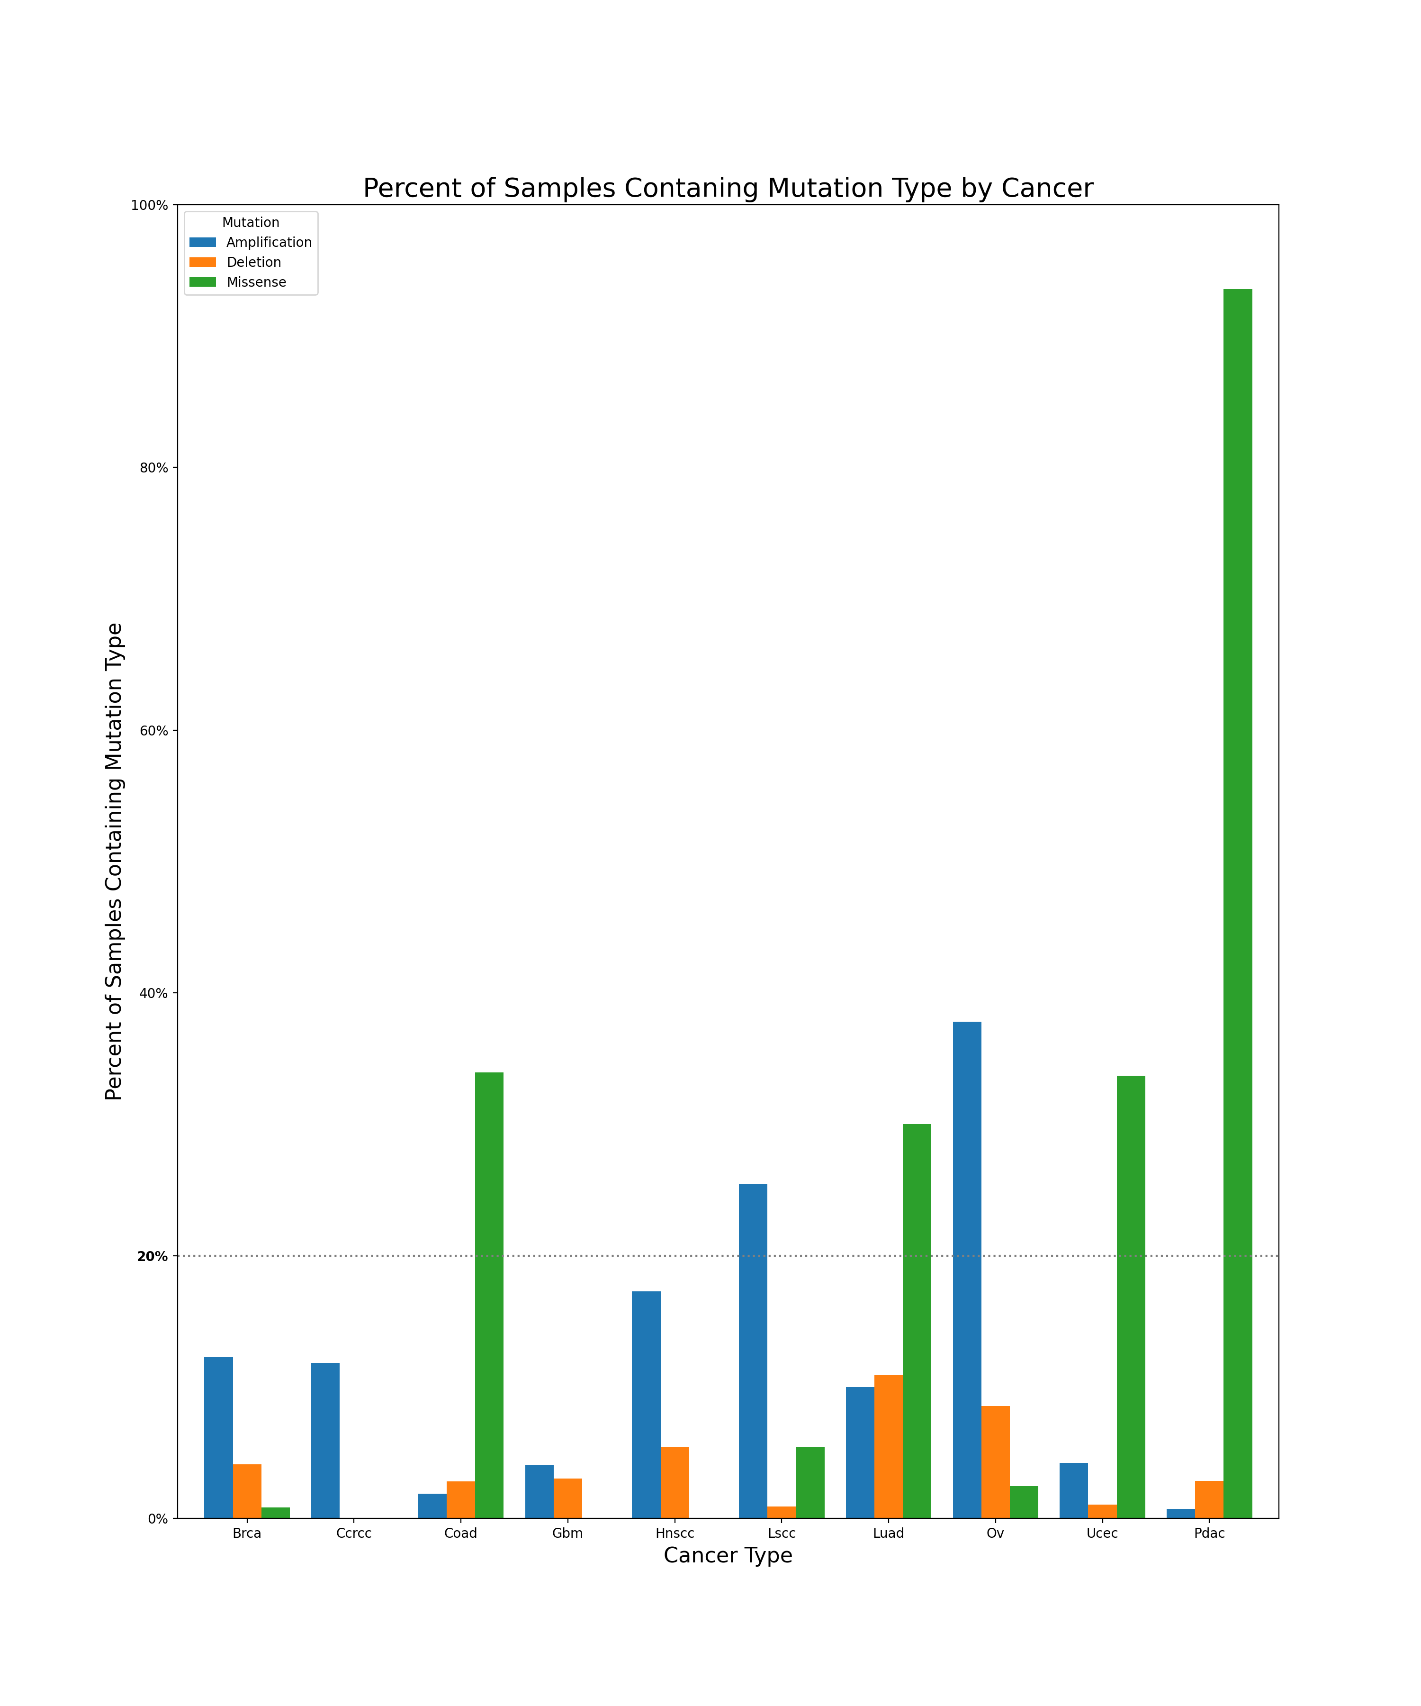

Figure 2: Significant proteomic cis effects (p < 0.05)
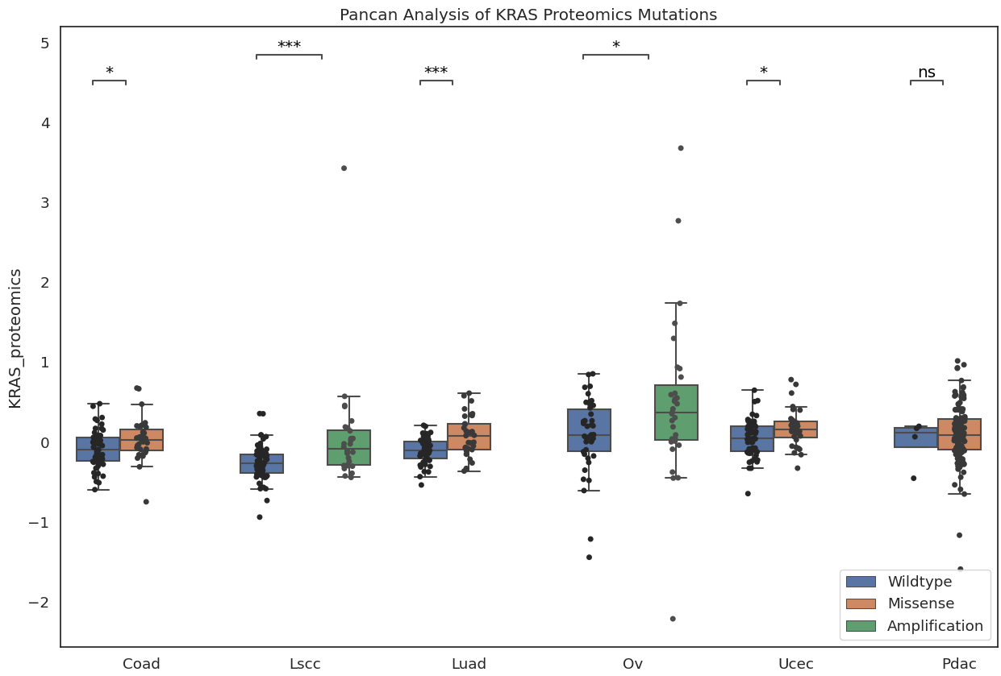
Figure 3: Significant transcriptomic cis effects (p < 0.05)
