Results
Over all types of cancers, the PTEN gene had 5 cancer-mutation combinations that occurred in more than 20% of the samples given a cancer type¹. Of these, 4 had a significant proteomic cis effect², and 4 had a significant transcriptomic cis effects³. There were also 3 phosphoproteomic sites with significant cis effects⁴.

To analyze trans effects, we restricted our analysis to proteins that shared the Pik3-Akt signaling pathway. For the proteomic trans effects, only 3 out of the 5 cancer-mutations had significant trans effects. There were 30 significant trans effects (p < 0.05) between these combinations⁵. Because of the limited number of these trans effects, only one gene appeared in multiple combinations—CDK2. We repeated this analysis looking at the top 25% most significant trans effects (p < .241). The most common trans effects were in HSP90AB1, which occurred in 5/5 cancer-mutation combinations, and MAPK3, JAK2, PIK3R1, THBS3, and STK11, which occurred in 4/5 cancer-mutation combinations⁶.

We repeated the trans effect analysis with the transcriptomic effects and phosphoproteomic data. Of the 5 cancer-mutation combinations, 3 showed significant transcriptomic trans effects⁷. A total of 56 significant trans effects were divided among these. Only 3 genes—PPP2R2D, PIK3R6, and CHUK—appeared in multiple combinations. Similarly, there were only 2 combinations with significant phosphoproteomic trans effects⁸, with a total of 5 effects divided between them. As with the proteomic data, we re-ran our analysis with the top 25% most significant effects. For the transcriptomic data (p < 0.263), the 4 most common trans effects occurred in 4/5 combinations⁹. For the phosphoproteomic data, taking the top 25% most significant trans effects resulted in p < 0.991, indicating that there was no significant overlap in phospho sites.

Discussion
Using this data, tumor cells with a mutated PTEN gene did not show many common effects between the different cancer-mutation combinations. The only consistency in the cis mutations was that all Deletion mutations had significant proteomic and transcriptomic cis effects. There were very few trans effects in samples with a mutated PTEN gene. Though this may be attributable to a physiologic cause, it is largely because of a lack of data. In the CPTAC samples, PTEN had very low mutation rates except in a few cancers. Further sampling would be needed to conclusively determine significant commonalities.

¹ GBM deletion, LSCC deletion, OV deletion, UCEC truncation, UCEC missense
² GBM deletion, LSCC deletion, OV deletion, UCEC truncation
³ GBM deletion, LSCC deletion, OV deletion, UCEC missense
⁴ OV deletion at S294, and UCEC truncations at S294 and S385
⁵ GBM deletion, LSCC deletion, UCEC truncation
⁷ GBM deletion, LSCC deletion, UCEC truncation
⁸ LSCC deletion, OV deletion

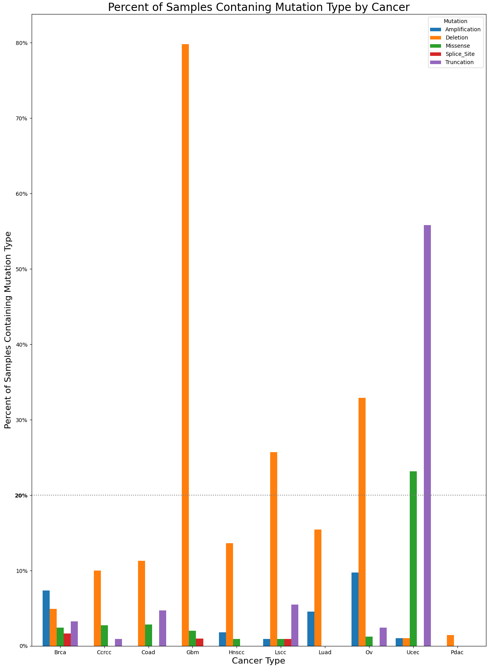
Figure 1: Mutations hat occurred in >20% of each cancer sample group

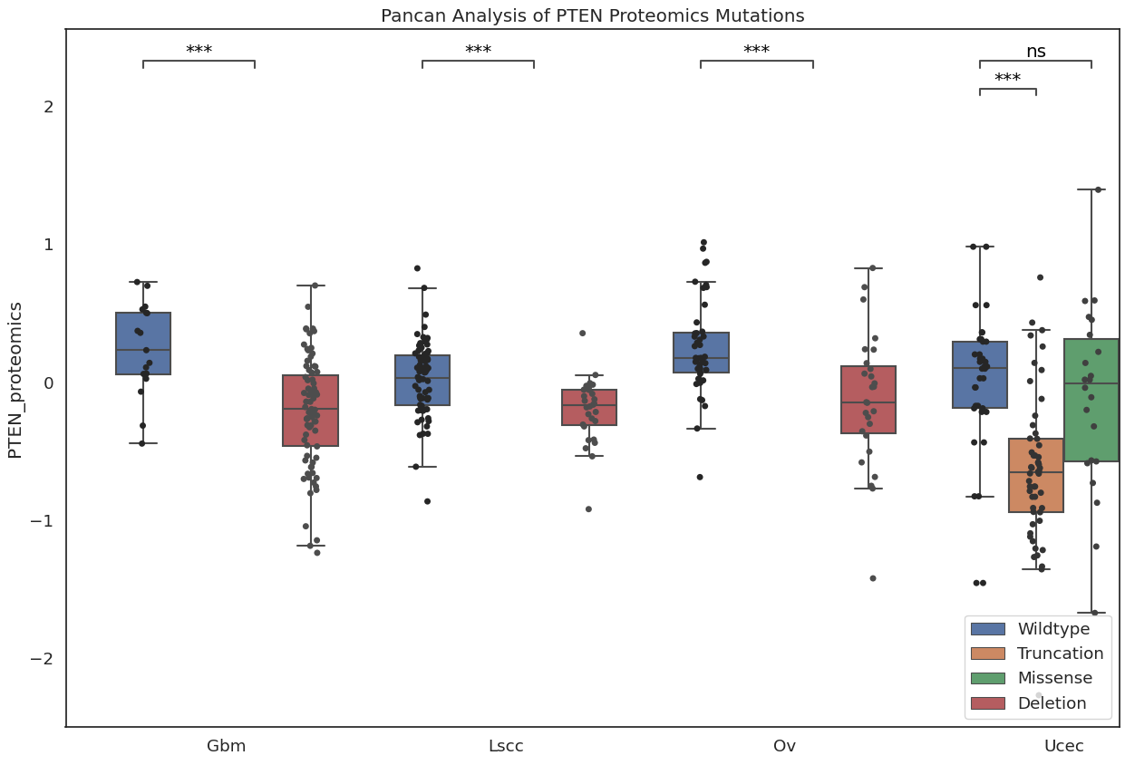
Figure 2: Significant proteomic cis effects (p < 0.05)

Figure 3: Significant transcriptomic cis effects (p < 0.05)
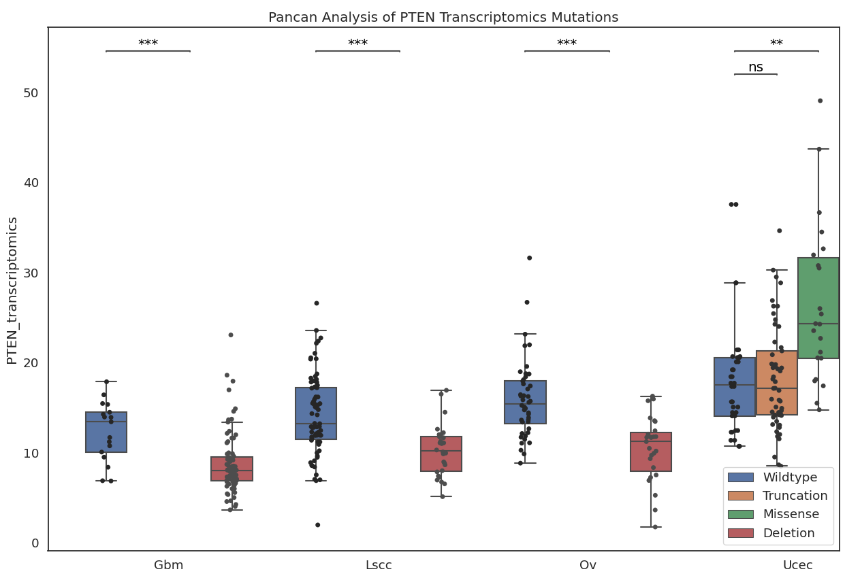

Figure 4: Significant phosphoproteomic cis effects (p < 0.05) at sites S294, S370, and S385
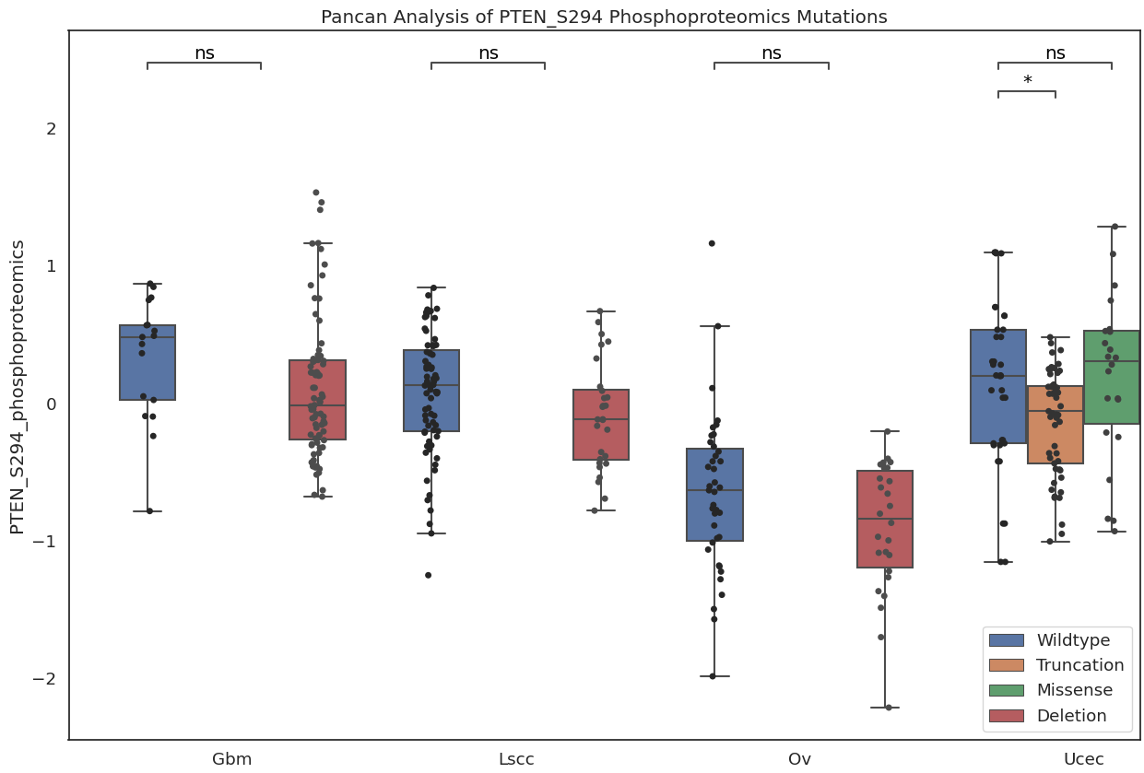
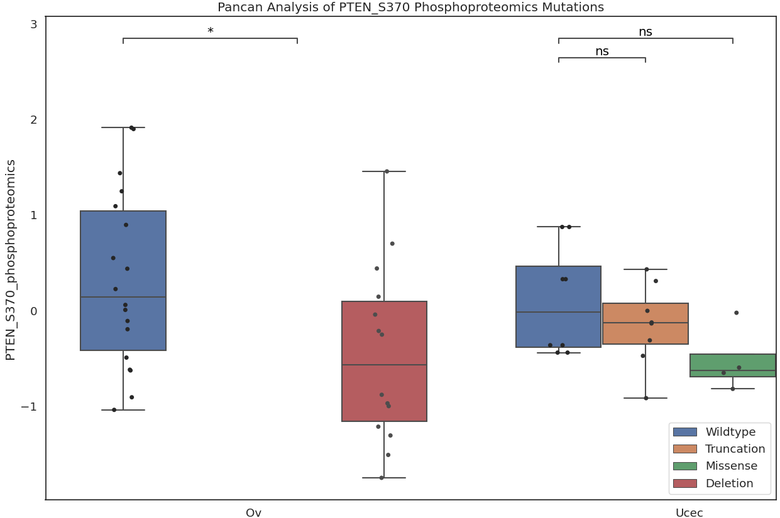

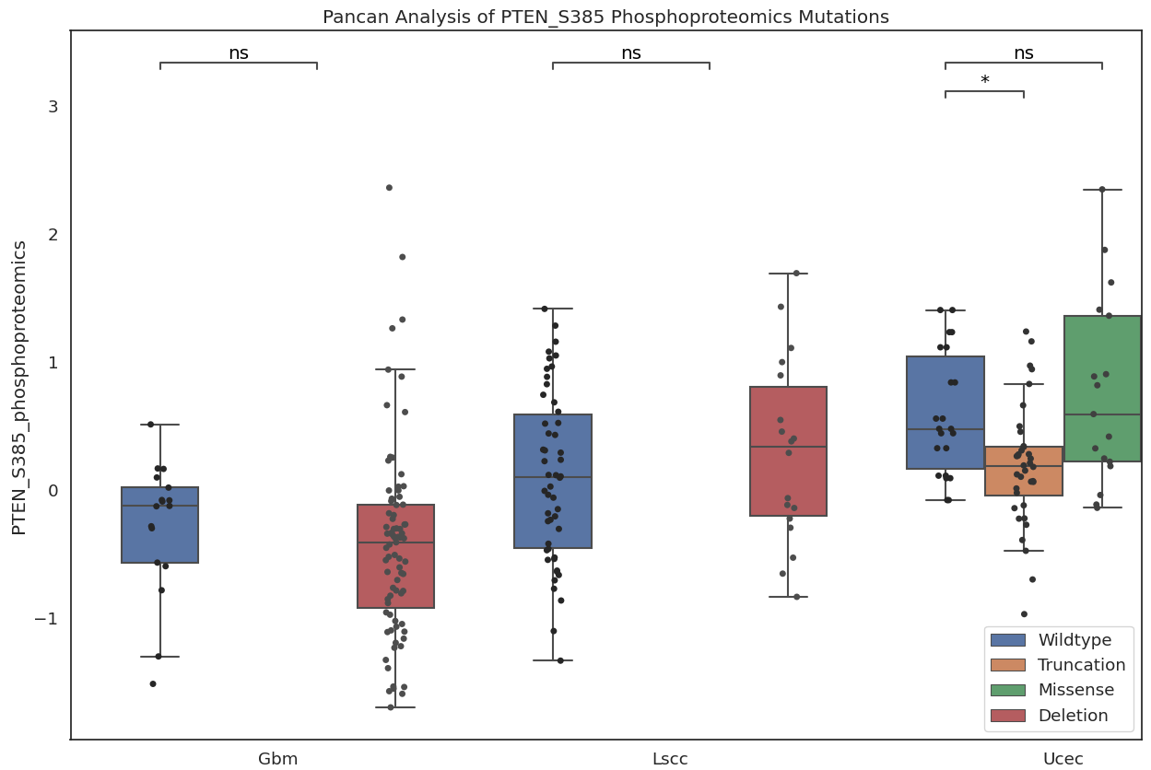

Figure 6: Most common genes with significant proteomic trans effects (top 25% most significant effects, or p < 0.241) across different cancer-mutation combinations
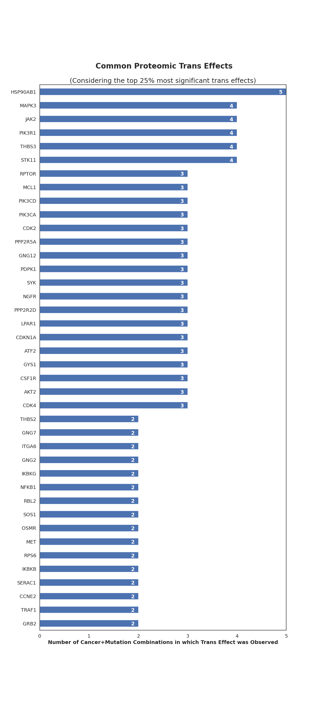

Figure 9: Most common genes with significant transcriptomic trans effects (p < ???) across different cancer-mutation combinations

