**ASSIGNMENT-4.1**

**NAME:P. HEMAN ROLL NO: 2403A510F5**

**Task #1 – Zero-Shot Prompting with Conditional Validation**

Objective

Use zero-shot prompting to instruct an AI tool to generate a function that validates an Indian mobile number.

Requirements

->The function must ensure the mobile number:

1)Starts with 6, 7, 8, or 9

2)Contains exactly 10 digits

Prompt: 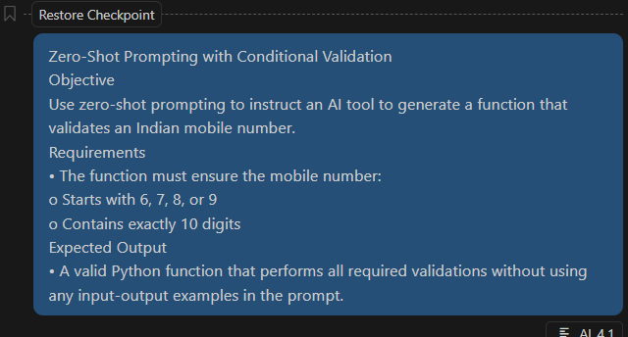

Code:

Expected Output

* A valid Python function that performs all required validations without using any input-output examples in the prompt.

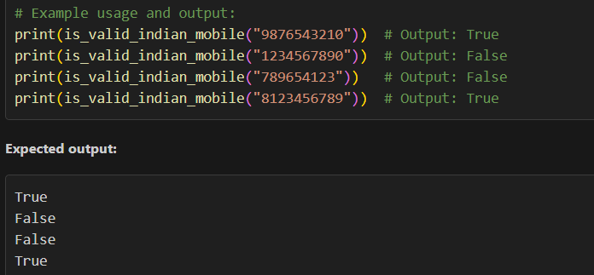

**Task #2 – One-Shot Prompting with Edge Case Handling**

Objective

Use one-shot prompting to generate a Python function that calculates the factorial of a number.

**Requirements:**

1)Provide one sample input-output pair in the prompt to guide the AI.

2)The function should handle:

0! correctly

Negative input by returning an appropriate messa**ge**

**Prompt:**

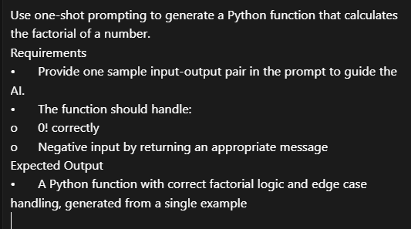

**Code:**

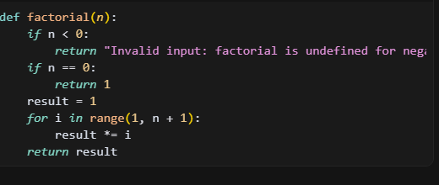

**Expected Output:**

-->A Python function with correct factorial logic and edge case handling, generated from a single example.

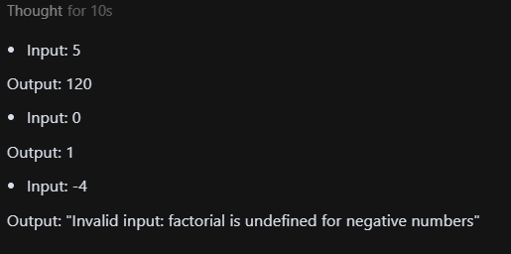

**Task #3 – Few-Shot Prompting for Nested Dictionary Extraction**

Objective

Use few-shot prompting (2–3 examples) to instruct the AI to create a function that parses a nested dictionary representing student information.

Requirements

The function should extract and return:

1)Full Name

2)Branch

3)GPA

Prompt:

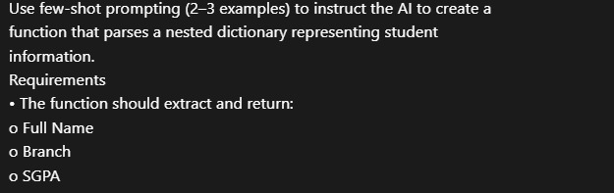

**Code:**

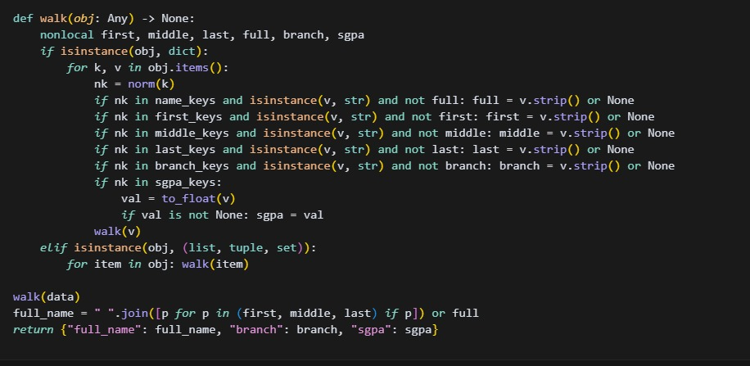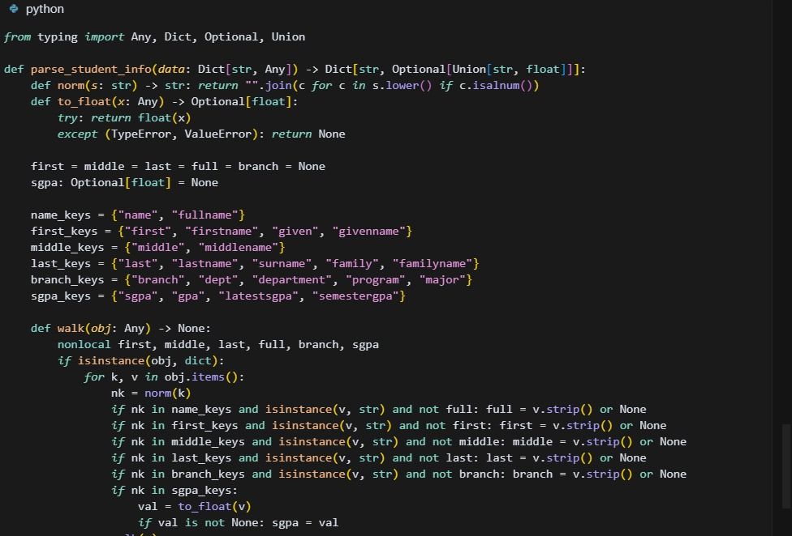

**Expected Output:**

A reusable Python function that correctly navigates and extracts values from nested dictionaries based on the provided examples.

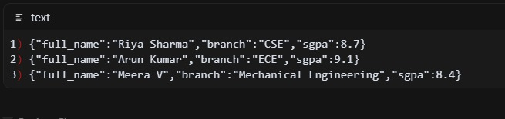

**Task #4 – Comparing Prompting Styles for File Analysis**

**Objective:**

Experiment with zero-shot, one-shot, and few-shot prompting to generate functions for CSV file analysis.

Requirements:

->Each generated function should:

->Read a .csv file

->Return the total number of rows

->Count the number of empty rows

**Prompt:**

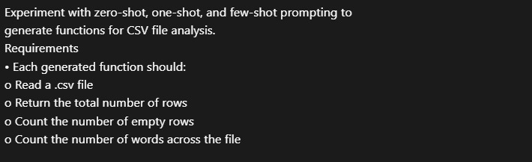

Count the number of words across the file

**Code:**

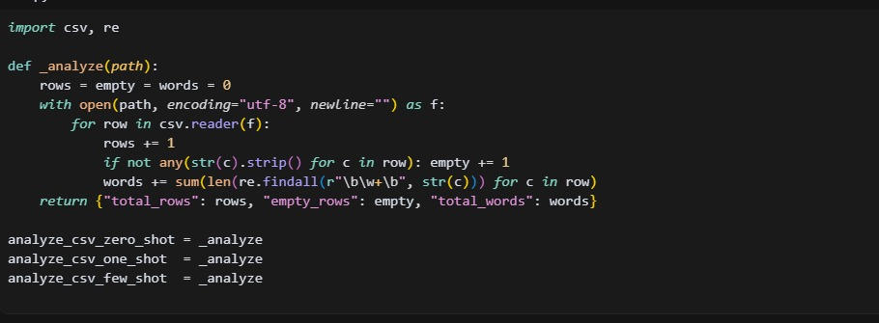

**Expected Output:**

Working Python functions for each prompting style, with a brief reflection comparing their accuracy, clarity, and efficiency.

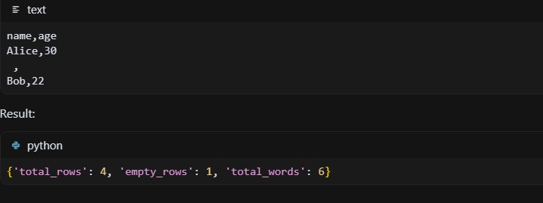

**Task #5 – Few-Shot Prompting for Text Processing and Word** **Frequency**

**Objective:**

Use few-shot prompting (with at least 3 examples) to generate a Python function that processes text and analyzes word frequency.

**Requirements:**

**The function must:**

1)Accept a paragraph as input

2)Convert all text to lowercase

3)Remove punctuation

4)Return the most frequently used word

**Prompt:**

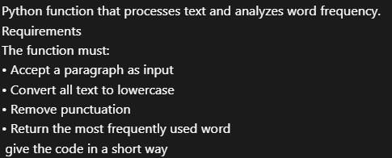

**code:**

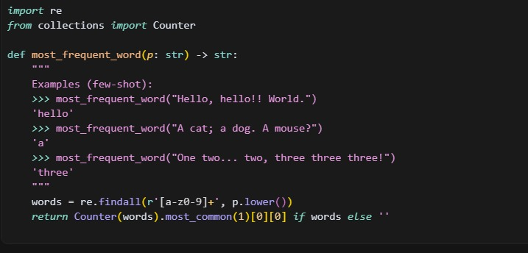

**Expected Output:**

A functional Python script that performs text cleaning, tokenization, and returns the most common word using only the examples provided in the prompt.

