**ASSIGNMENT-4.3**

**NAME: P. HEMAN ROLL NO: 2403A510F5**

**TASK 1:**

**PROMPT:**



**CODE:**

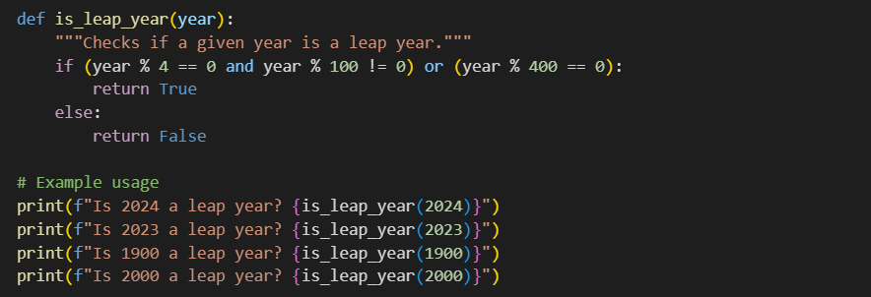

**OUTPUT:**

**OBSERVATION:**The AI understood the task without any example and generated the correct leap year checking logic.

**TASK 2:**

**PROMPT:**

**CODE:**

**OUTPUT:**



**OBSERVATION:**With one input-output example, the AI learned the conversion formula and applied it correctly for general use.

**TASK 3:**

**PROMPT:**



**CODE:**

**OUTPUT:**



**OBSERVATION:**The AI used multiple examples to clearly identify the pattern and produced a consistent function that works for different **names.**

Example 1: Input: "John Doe" Output: "Doe, John"

Example 2: Input: "Alice Wonderland" Output: "Wonderland, Alice"

Example 3: Input: "Peter Pan" Output: "Pan, Peter"

These examples show how a full name with a first and last name should be formatted as "Last, First".

**TASK 4:**

**PROMPT:**



**CODE:**

**OUTPUT:**



**OBSERVATION:**

**TASK 5:**

**PROMPT:**



**OUTPUT:**



**OBSERVATION:**

