Departments of Library:
This module is used to manage different library departments. The librarian can add, update, and view department details. It helps organize library resources efficiently.
Output:
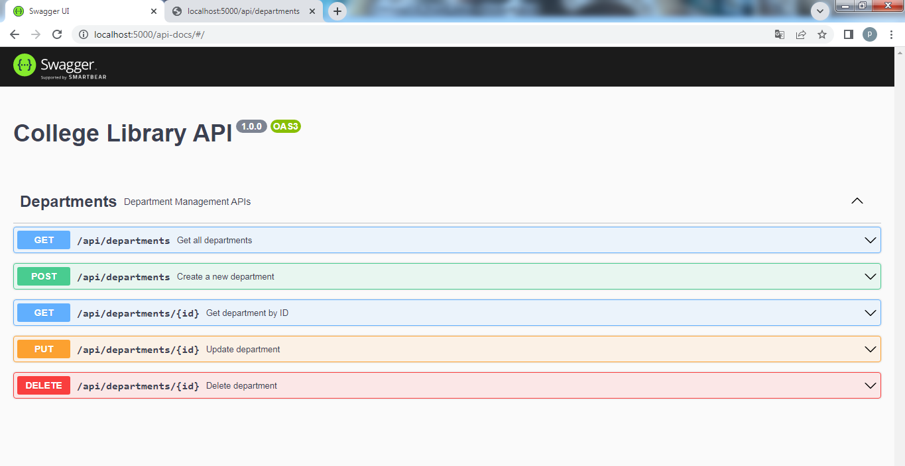

Creating new Department:
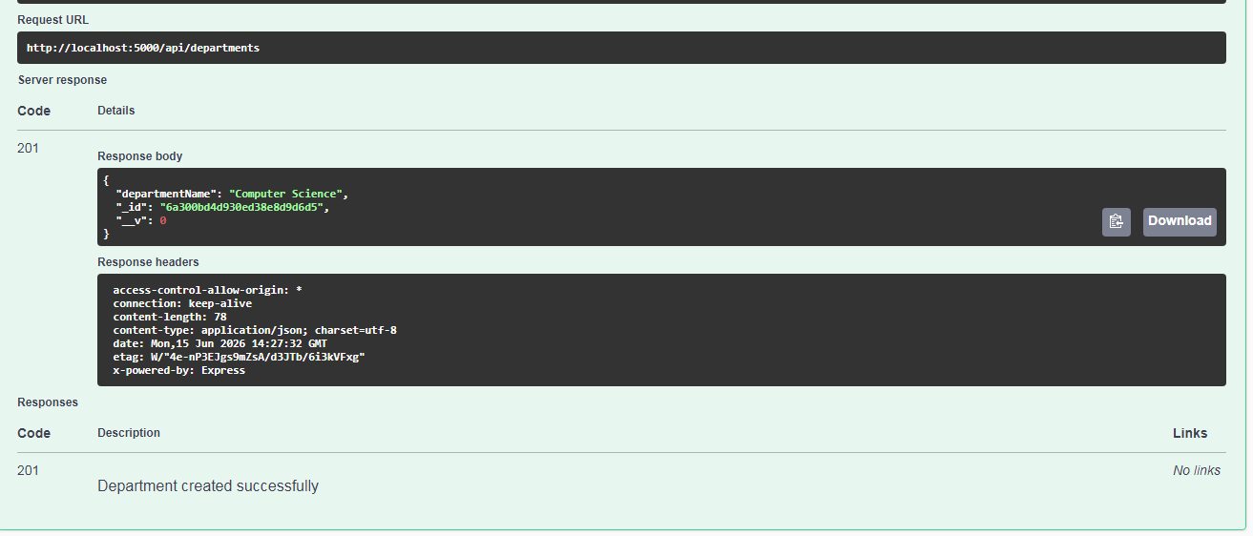
Output:
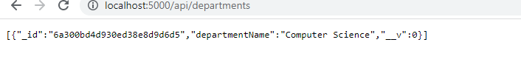

Getting all departments:
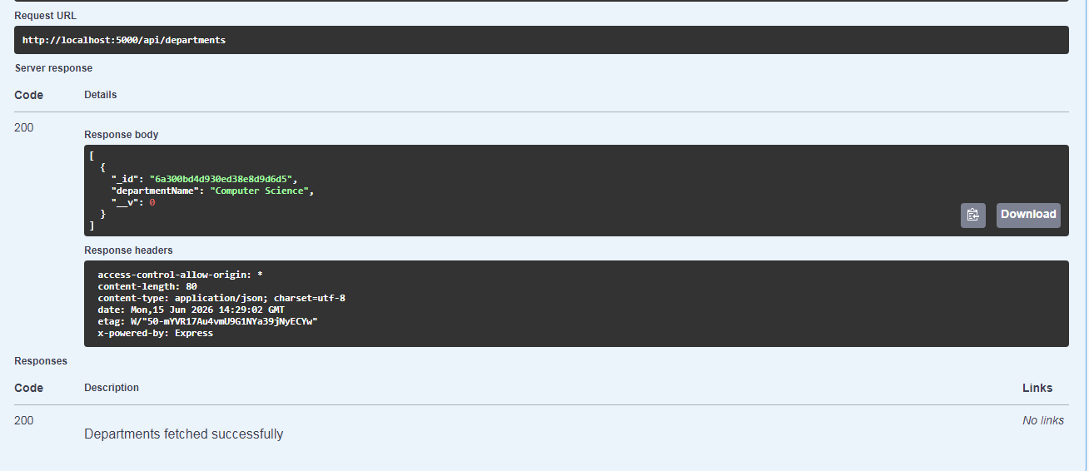
Deleting Some Department by id:
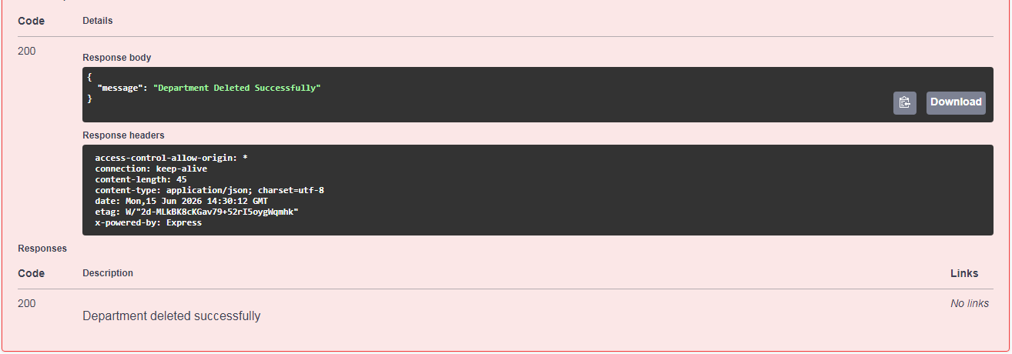
Note:
Further I am Adding Student and Faculty.This module allows the librarian to register students and faculty members. User details are stored and managed in the system. It helps maintain accurate library member records.

