Create Data Directories:
mkdir C:\data\config
mkdir C:\data\shard1
mkdir C:\data\shard2
Starting Config Server:
Command:
mongod --configsvr --replSet configReplSet --dbpath C:\data\config --port 27019

Connecting port 27019 Connection.Then initiate,
Command:
rs.initiate({
_id: "configReplSet",
configsvr: true,
members: [
{ _id: 0, host: "localhost:27019" }
]
})

Starting Shard 1:
Command:
mongod --shardsvr --replSet shard1ReplSet --dbpath C:\data\shard1 --port 27011
Connecting port 27011 Connection.Then initiate,
Command:
rs.initiate({
_id: "shard1ReplSet",
members: [
{ _id: 0, host: "localhost:27011" }
]
})

Starting Shard2:
Command:
mongod --shardsvr --replSet shard2ReplSet --dbpath C:\data\shard2 --port 27012
Connecting port 27012 Connection.Then initiate,

Command:
rs.initiate({
_id: "shard2ReplSet",
members: [
{ _id: 0, host: "localhost:27012" }
]
})
Strating mongos router:
Command:
mongos --configdb configReplSet/localhost:27019 --port 27017
Connecting port 27017 Connection.
Adding Shard 1:
Command:
sh.addShard("shard1ReplSet/localhost:27011")
Adding Shard 2:
Command:
sh.addShard("shard2ReplSet/localhost:27012")

Enabling Sharding:
sh.enableSharding(“eCommerceDB”)
Then Adding some orders collection to Database then Sharding.
db.orders.createIndex({_id:"hashed"})
sh.shardCollection(
"eCommerceDB.orders",
{_id:"hashed"}
)
Verifying Sharding:
Command:
sh.status()
Output:
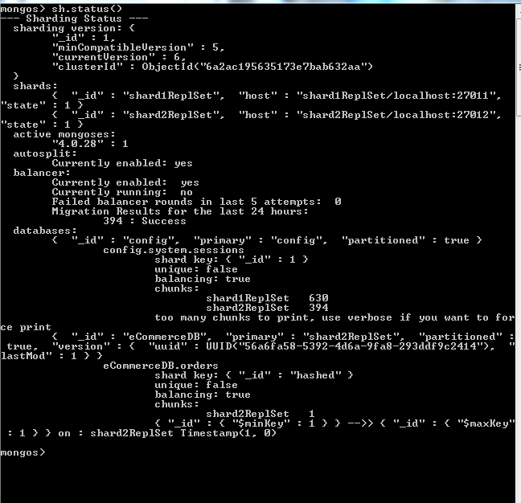
Command:
db.orders.getShardDistribution()
Output:
