

Ministry of Education and Science of Russian Federation

National Research Tomsk Polytechnic University

Final Paper

Black Friday Sale Data Analysis

Course Participant ___________ _____ P.A. Zyabletsev
(signature) (date) (name)

Course Participant | ___________ | _____ | N.I. Zhurbich
 | (signature) | (date) | (name)
Institute | _____________ | 8PM8I | SCSR_________
 |  | (group) | (name)
Scientific Consultant | _____________ | _______ | I.A. Zaikin
 | (signature) | (date) | (name)

Tomsk – 2018

Content
Content 2
Introduction 3
1. Analysis of dataset 4
1.1. Data input 4
1.2. Data preparation 5
2. Exploratory data analysis 9
2.1. Gender 9
2.2. Married or single 11
2.3. Occupation 12
2.4. Age 13
2.5. Purchase 14
2.6. City 15
2.7. Stay in current city years 16
2.8. Products 17
2.9. Correlation 19
Conclusion 20
References 21

Introduction
Black Friday - the day after the US holiday of Thanksgiving, regarded as the first day of the Christmas shopping season, on which retailers make many special offers.
Goal of the research a study of sales through consumer behaviors.
Objectives of the research:
- Analyze and prepare data for analysis;
- Conduct data analysis.
Python programming language was chosen for the research.
Follow tools were used:
1. NumPy is the fundamental package for scientific computing with Python. Besides its obvious scientific uses, NumPy can also be used as an efficient multi-dimensional container of generic data. Arbitrary data-types can be defined.
2. Pandas is a high-level data manipulation tool for Python. It is built on the Numpy package and its key data structure is called the DataFrame. DataFrames allow you to store and manipulate tabular data in rows of observations and columns of variables.
3. Seaborn is a Python data visualization library based on matplotlib. It provides a high-level interface for drawing attractive and informative statistical graphics.

Analysis of dataset

Data input
For this research was selected dataset «Black Friday». Dataset of 550 000 observations about the black Friday in a retail store, it contains different kinds of variables either numerical or categorical. It also contains missing values. You can see columns of this dataset and brief description of every column.
Columns:
- User_ID: Unique identifier of shopper.
- Product_ID: Unique identifier of product. (No key given)
- Gender: Sex of shopper.
- Age: Age of shopper split into bins.
- Occupation: Occupation of shopper. (No key given)
- City_Category: Residence location of shopper. (No key given)
- Stay_In_Current_City_Years: Number of years stay in current city.
- Marital_Status: Marital status of shopper.
- Product_Category_1: Product category of purchase.
- Product_Category_2: Product may belong to other category.
- Product_Category_3: Product may belong to other category.
- Purchase: Purchase amount in dollars.

Data preparation
First of all, we need to prepare dataset for next analysis. To do that, we need to understand that dataset have missing and null values. Our purpose is to change values in dataset if it is possible. It is very important stage of analysis data, because if it have bad «garbage» data on enter, we will have bad results in the end.
Therefore, we start to look at our dataset, you can see in picture 1, which columns have missing values or null values.
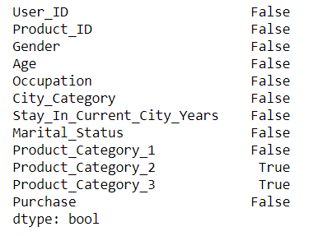
Picture 1. Attributes in dataset
As you can see on the picture above, there is null values in columns «Product_Category_1» and «Product_Category_2».
Then, we need to understand what type of data we have and what type we need. On the picture 2, after reading csv file, we will check data by using info() method of dataframe , we can see column names and types .
If we execute command, we will see there are 537577 entries in file.
For Product_Category_1 column, 164278 of 537577 are non-null and that means rest are null.
For Product_Category_2 column, 370591 of 537577 are non-null and that means rest are null.
Other columns are all full and there is no empty data.

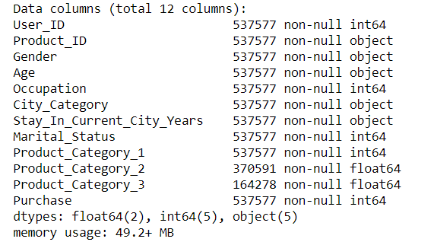
Picture 2. Types of attributes
Therefore, in picture 3 looks like Product_Category_2 and Product_Category_3 have some null values. We believe that the NaN values for Product_Category_2 and Product_Categrory_3 would mean that the concerned person did not buy the products from these categories. Hence, we believe that it would be safe to replace them with 0.
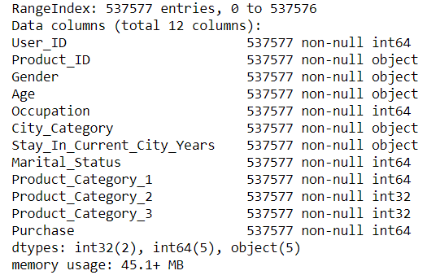
Picture 3. Type of attributes
After the replacement, in Figure 4 you can see that after checking all the data is complete.
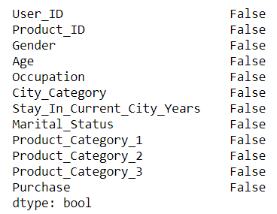
Picture 4. Attributes in dataset

After having a look at the data columns, we began to think what could be the use cases.
1) Who spends the most money on Black Friday?
- Women or men
- Married or unmarried
- Young, middle-aged or elderly
2) What type of product is most popular for sales?
3) What type of products is most popular among men, women at the sale?
4) How much does the customer spend depending on the region?
5) How much does the customer spend depending on the work (occupation)?

Exploratory data analysis

Gender
First of all, out first task was to determine, which gender attend to the sale more. Looking at the picture 5, looks like very less number of females attended the black Friday sale. However, it could also mean less number of females paid for the products and may be their husband paid for them.
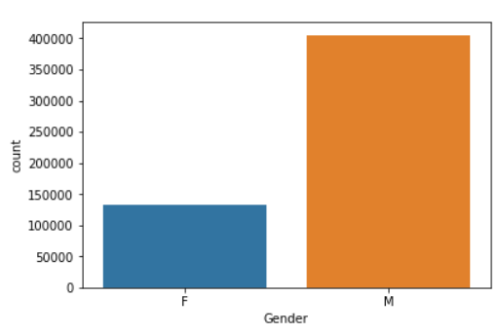
Picture 5. Number of purchases of female and male
In table 1, you can see the main parameters to analysis of this case.
Table 1. Parameters
Total purchases: | 537577
Female | 132197
Male | 405380
Total customers: | 5891
Female | 1666
Male | 4225
Average total purchases for female | 79.3499399
Average total purchases for male | 95.9479289

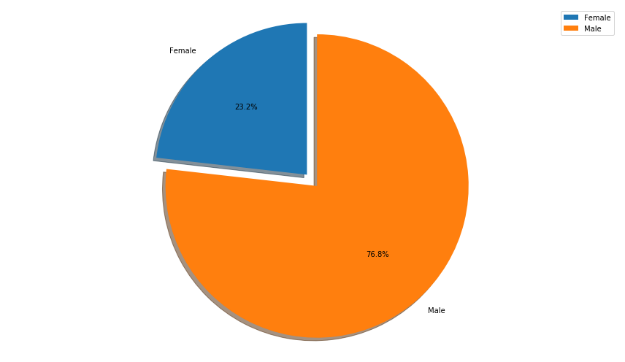
Picture 6. Percentage of purchase for male and female
Based on this graph, we can say that men's purchasing power is greater than women's purchasing power, even in normal circumstances. But there has been a high turnout of men in the store. About 75% of the customers have made sales of men of all ages, we have probably made sales worth more than 4 billion in men and more than 1 billion in ladies.

Married or single
In this case, we will test this theory: is it true that single men buy more than single women do.
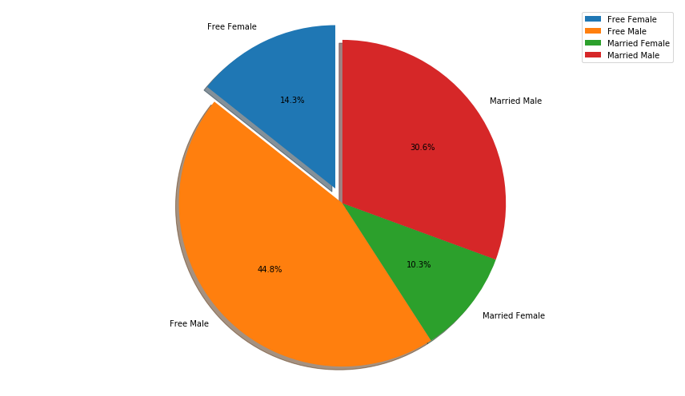
Picture 7. Numbers of purchase for single and married person
As you can see on picture above, single men have more percent of purchases than woman does. However, married female buying less than free female.

Occupation
In this case, we will check whether the occupation affects to purchasing power.
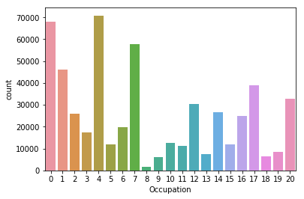
Picture 8. Occupation distribution
We can suggest, that people who has occupation number 0, 4 and 7 have more purchasing power, than another. It can also be assumed that people with higher purchasing power occupy a higher position.

Age
In this case, we will consider a target group of people to whom a retail company should direct its influence.
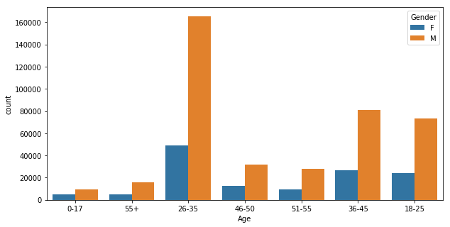
Picture 9. Age distribution
Obviously, we can consider that the target age group of retail stores is the age group of 26-35 years.

Purchase
Now, on plotting a count plot for age seems like the majority of the population in the ages group 26-35 attended the sale. Further, we could also check among the age groups, which gender was a majority. In addition, as seen below, more males spent in the sale than females.

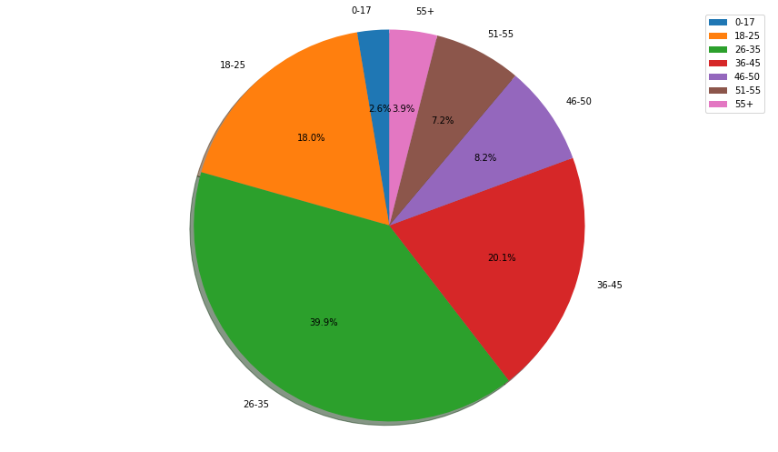
Picture 10. Percentage of purchase for age
Obviously, we can consider that the target age group of retail stores is the age group of 26-35 years.
As we see in picture 10, there are no bars for the married in the 0-17 range, which makes sense. Then if we look at the 46 and above groups, females are very less. On the other hand, married males paying in range 46-55 are also comparatively more than married females. Therefore, it could also imply that though women do shop a lot, their husbands are possibly paying for it and hence data reflects that men shopped more.

City
In this case, we consider the distribution of purchases among cities. Using these results, we can assume that city B is larger than all the rest.
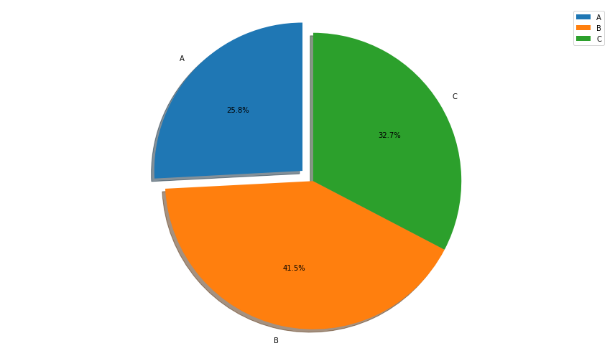
Picture 11. Percentage of purchase for city

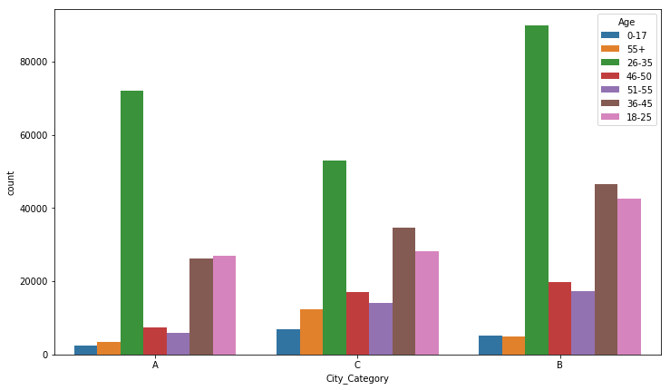
Picture 12. Numbers of purchase for age (in each city)
Unexpectedly, the highest sales do not come in the number of purchases, people from Area B have a greater purchasing power than others, and greater sales gained from people from Areas A and C.

Stay in current city years
As you can see on picture 13, this retail company have almost gained about 1.75 billion new city residents only.
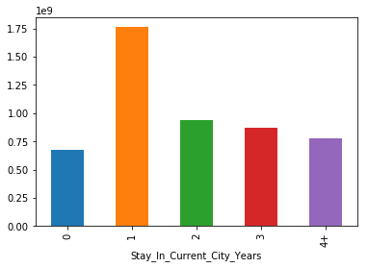
Picture 13. Stay in current city years
Retail company achieved a large percentage of sales from the new population of cities in past 2 years, but these figures indicate that the older city citizens have less passion for this products.
Based on these results, we can assume that people who stays in the city for first year buy goods necessary for arranging their lives. We can also say that people who have lived in this city for more than 3 years do not purchase goods in large quantities, since they already have them. It can be assumed that such goods are outerwear, furniture and household appliances.

Products

Here we explore the products themselves. This is important, as we do not have labeled items in this dataset. Theoretically, a customer could be spending $5,000 on 4 new TVs, or 10,000 pens. This difference matters for stores, as their profits are affected. Since we do not know what the items are, let us explore the categories of the items.
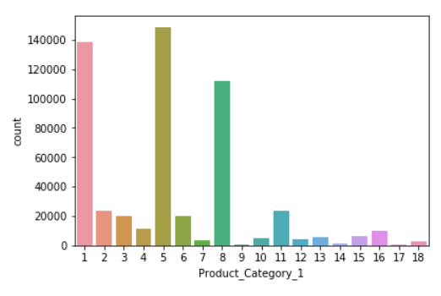
Picture 14. Products from Сategory 1
Clearly the most popular products are the ones falling into 1, 5 and 8 categories. In addition it seems as categories 12-18 (especially 14-16) are somewhat secondary (meantioned in either Product_Category_2 or Product_Category_3).
After that, we can understand which categories of products each of women and men buys.
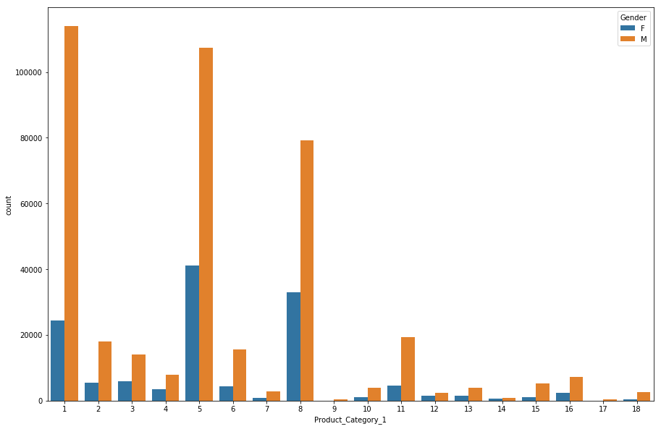
Picture 15. Product category
In picture above, the most popular products are the ones in 1, 5 and 8 categories for both (female and male).
After that, we must calculate the average value of the cost of each product from the category
Code:
MeanCatPrice=df[df.Product_Category_2==0].groupby(['Product_Category_1'])['Purchase'].mean()
print(MeanCatPrice)
MeanCatPrice.plot(kind='bar')
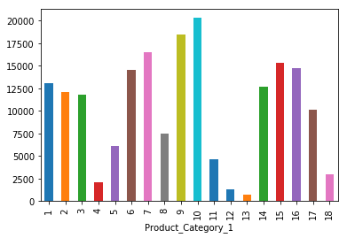
Picture 16. Mean cost of each product category
Then,
Code:
MeanCatPrice=df[df.Product_Category_2==0].groupby(['Product_Category_1'])['Purchase'].count()
print(MeanCatPrice)
MeanCatPrice.plot(kind='bar')

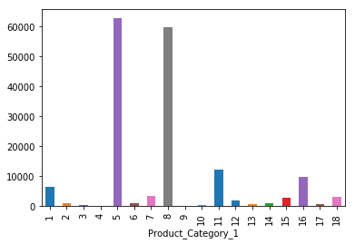
Picture 17.

Correlation
In the broadest sense, correlation is any statistical association, though in common usage it most often refers to how close two variables are to having a linear relationship with each other.
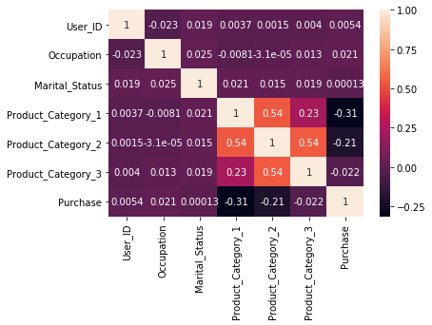
Picture 17. Correlation of attributes
Based on the picture above, we can say that nothing is highly correlated with the Purchase variable.
Although a few conclusions can be drawn:
- Product_Category_1 has a negative correlation with Purchase.
- Product_Category_3 has a strong correlation with Purchase. Maybe the products in this category were cheap.

Conclusion
In the process of exploratory data analysis, we came to the following conclusions:
- Male shopped more than Female;
- Customers who has resided in their city for 1 year shopped the most;
- Product_category_1 #1,5,8 were the most selling;
- Product_category_1 #1 made the most profit.
- Customers around the age of 26-35 generally shop a lot during Black Friday.
- City B tops the sales followed by city C and then A.
- There are clearly several occupations (possibly high earning jobs) of the customers that affect the sales.
- Lastly, customers who are single seem to shop more during Black Friday, than married customers.
These relationships between different features can be investigated further to set the new marketing strategies to maximize the profit of the retail store (possibly for the future black Fridays). For example, the retail store may consider doing more advertisements targeting their unmarried male customers in City B on product_category_1 #1.
In addition, The result of the work can be found on GitHub [4].

References

- Black Friday - A study of sales through consumer behaviours (dataset).URL: https://www.kaggle.com/mehdidag/black-friday
- Breazley, D. Python Cookbook, Third Edition / D. Breasley, B. K. Jones. – USA: O’Reilly Media, 2013. – 688 p.
- McKinney, W. Python for Data Analysis. – USA: O’Reilly Media, 2013. – 453 p.
- Paz4/PythonAnalyzeOfBlackFriday–URL:https://github.com/Paz4/PythonAnalyzeOfBlackFriday (Date of the application: 15.12.2018).

