**Brooklyn, Where New York City Begins!**

By Kelsie Rivera

* **Brief Description**: This article provides some background information about one of New York City’s most recognized monuments; The Brooklyn Bridge. It briefly discusses its history as well as provides detailed travel information to tourist about how to access the bridge.

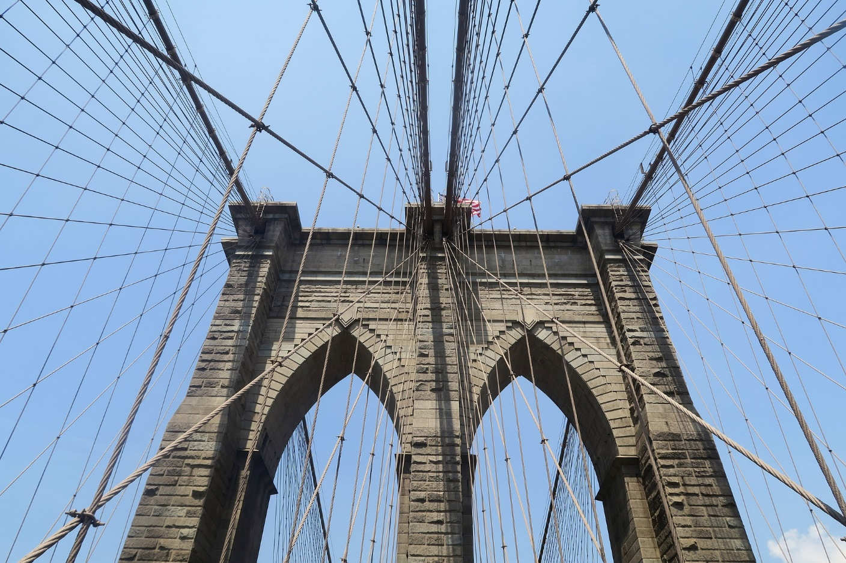

* (Photo by Adrien Pincemin) <https://pixabay.com/en/new-york-brooklyn-bridge-2149532/>

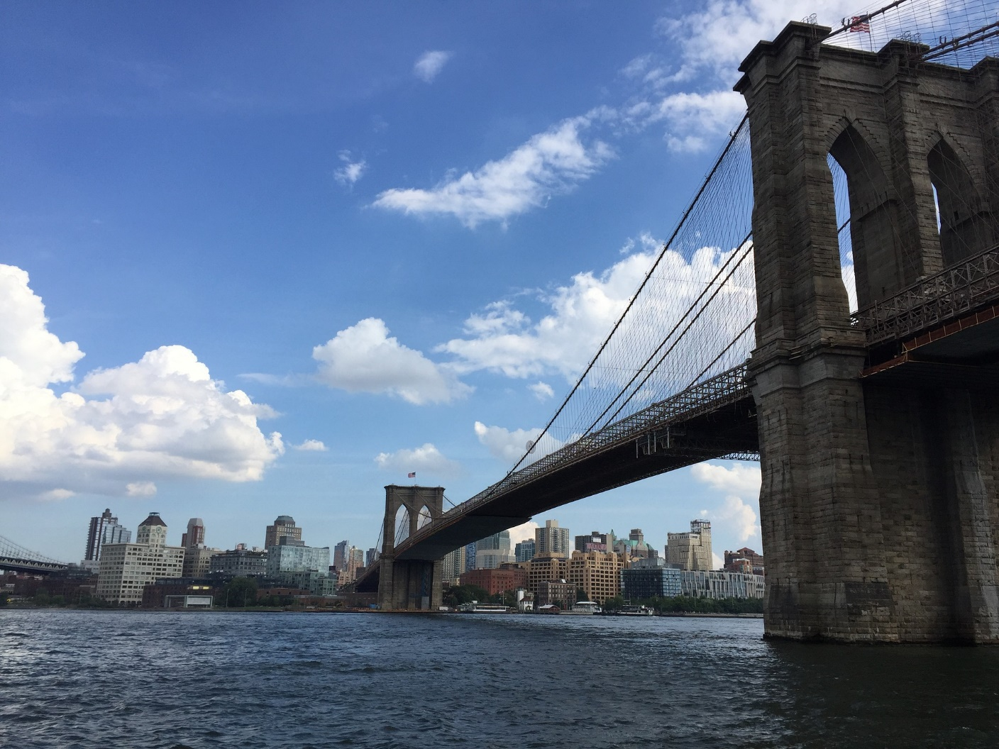

* (Photo by Jet Wolffs) <https://pixabay.com/en/bridge-brooklyn-bridge-new-york-3670287/>

The Brooklyn Bridge is one of the most iconic monuments not only in New York but in the world. The Brooklyn bridge has been connecting Manhattan and Brooklyn together since 1883. The bridge took over 12 years to complete, cost over $13 million and over 600 people worked on the bridge. It was designed by John A. Roebling who was an immigrant from Prussia. Over 5,000 people cross the bridge on a daily basis. It has been designated as a National Historic Landmark by the National Park Service and designated as a New York city Landmark by the Landmarks Preservative Commission. The bridge spans nearly 1600 feet across the East River and remains one of New York city’s most recognized symbols.

Upon the completion of the Brooklyn Bridge, it cost 1 penny to walk across and even went up to 5 pennies. Luckily that fee was waived, and you no longer have to pay to access the bridge. You can walk across the bridge which is only 1 mile long, 24 hours a day, completely free of charge. Also, there is no toll fee for driving on the Brooklyn Bridge. As one of New York City’s most iconic attractions it is highly encouraged for all who can to experience it and take advantage of the amazing views that it gives access to such as The Statue of Liberty! That’s right, you can see the beautiful Statue of Liberty from the Brooklyn Bridge. It is important to note that there are two paths and the one on the right is for pedestrians and the path on the left is for bicycles. The Brooklyn Bridge can be accessed from Brooklyn and Manhattan, see information below on how to get there.

**Arriving by subway (from the Manhattan side)**

* Take the **4, 5, or 6** trains to **Brooklyn Bridge/City Hall** Stop or the **J or Z** trains to **Chambers St.** Stop.
* The bridge will be right across the street from the subway station.
* You could also take the **2 or 3** train to Park Place, the **N or R** train to City Hall, or the **A or C** train to Fulton Street.

**Arriving by subway (from the Brooklyn side)**

You can get take these subways whose stops will be within walking distance of the entrance to the walkway leading to the bridge. The pedestrian stairs on the Brooklyn side are located on Washington Street and Prospect Street, right at the northeast corner of Cadman Plaza.

* **A, C or F** to **Jay Street/MetroTech Station**
* **N, R** to **Court Street Station**
* **2/3 or 4/5** to **Borough Hall Station**

**Fun Fact:** On May 17, 1884, circus owner P.T. Barnum led 21 elephants over the Brooklyn Bridge to prove that it has a stable structure.