Contents

SYNOPSIS 1

REQUIREMENTS 1

HARDWARE 2

Memory capacity (RAM) 2

Disk free space 2

SOFTWARE 2

Exyte BIM360 Integration APP (CURRENTLY SUSPENDED FOR DOWNLOADING FILES FROM ACC) 2

Autodesk Navisworks 2

NETWORK 2

\\a1300564\D\S13_BIM-VDC 2

USAGE (IN PROGRESS) 3

SCRIPT WORKFLOW (WHAT IT DOES) 3

AUTHOR 5

# SYNOPSIS

Builds the Models of the project S96029 (Pelican):

* Design Models
* Construction Models
* Existing Models
* Federated Models (all the three above combined)

# REQUIREMENTS

Below list is what is required to run the script properly.

## HARDWARE

### Memory capacity (RAM)

**Minimum**: 32GB

**Recommended**: 128GB

With less than the recommended value, updating/creating big models (e.g., PG-FM models) may not be possible.

### Disk free space

**Minimum**: 20GB

**Recommended**: 50GB

**NOTE:** Automatically checked once you run the script.

With less than the recommended value, updating/creating big models (e.g., PG-FM models) may not be possible.

## SOFTWARE

### Exyte BIM360 Integration APP (CURRENTLY SUSPENDED FOR DOWNLOADING FILES FROM ACC)

**For**: Automatic synchronization between BIM 360 and Exyte server

The Exyte BIM360 Integration App is an external tool (not installed on your machine) that must be running with the proper configuration.

Notes: Currently only being used to automatically upload all the Federated Models (daily at 4.00am). Downloading NWCs files still done manually with saved searches.

### Autodesk Navisworks

**For**: Model Builds

**Tested versions**: Manage 2021, Manage 2022, Manage 2023 (Not properly working), Manage 2024

## NETWORK

### \\a1300564\D\S13_BIM-VDC

**For**: Building the models

Network path must be accessible.

# USAGE (IN PROGRESS)

Before running the script follow this steps:

1. Go to ACC ([Pelican - ACC](https://acc.autodesk.eu/docs/files/projects/0a335d80-7511-4cf3-9ca2-1f2647378a26))
2. Click Search and filter > Saved searches > (Under Private or Shared) There are 6 saved searches

3

2

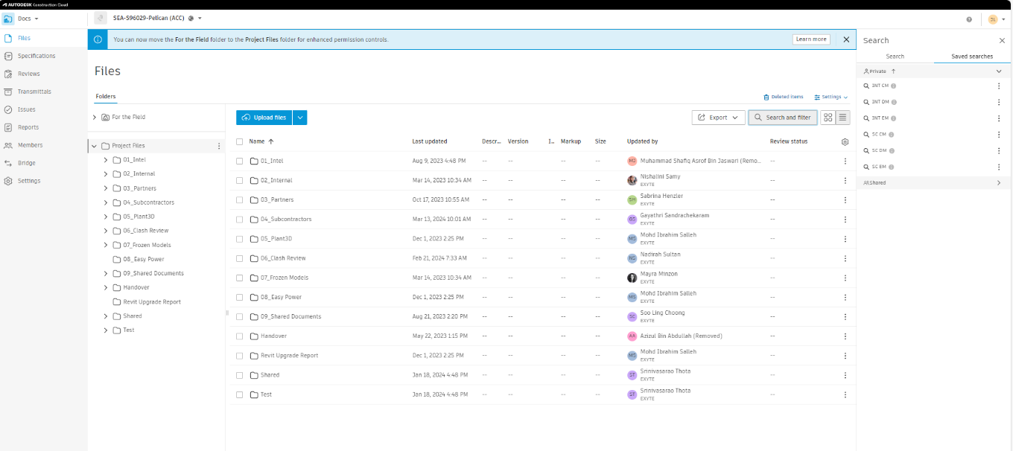

1

To start the Pelican Federated Model build automation, run the script **Pelican_build_latest_federated_model.bat**.

Other useful scripts:

* To force rebuild all Federated Models for maintenance use and when the script has not been run for more than two days, use **Pelican_force_build_all_nwf_and_models.bat**. It will take around 6-8hrs average.
* To generate text files to reflect the content of each NWF/NWD files, run **Pelican_generate_latest_nwf_textfile.bat** (all the text files are in C:\test-temp-all\20-Federated-Model\204-NWDs\_Data Files - Batch Utility)
* To start the model build without console output, run **Pelican_build_latest_federated_model_no_console_output.bat.** The console output will instead be written into a file in the script log folder.

# SCRIPT WORKFLOW (WHAT IT DOES)

**All the steps below are done automatically** when you run the script**.** They are only detailed description of its workflow.

1. Extract the downloaded Zip files

* Read Zip file name by date and only extract the zip file with the date the script run
* All files will be extracted in the Download folder temporarily

1. Backup previous NWC models

* Check if Archived folder exist. If not, the script will create the folder

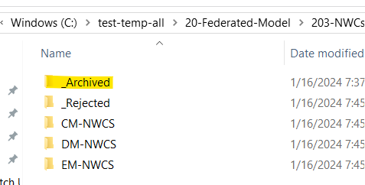

- Create folder with the date the script running as the folder name

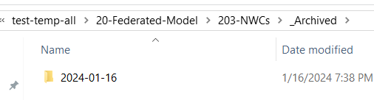

- Backup all the NWC models into this folder

1. Copy latest NWC files

* Check if Incorrect folder exist. If not, the script will create it
* Copy the extracted files from Download folder into DM, CM, EM folder

1. Move models with wrong naming convention

* Check if Rejected folder exist. If not, the script will create one
* Move all the models

1. Move models uploaded at wrong folder on ACC

* Check if Incorrect folder exist. If not, the script will create one
* Move all the models

1. Compare Test-Temp folder and BIM Machine folder to get the list of New and Retired models

* Models are considered Retired if file exist in Test-Temp but not in BIM Machine
* Models are considered New if file exist in BIM Machine but not in Test-Temp

1. Generate NWF files

* Only appends a file if it is following the naming convention
* Only generates a building model (NWF) if really needed (e.g., at least one of the below is true):
  + Retired model exist for that specific NWF file
  + New model exist for that specific NWF file

Example : If there is new/retired model for F26_APB1-1YA-CM, it will rebuild F26_APB1-1YA-CM.nwf and F26_APB1-CM.nwf. It also rebuild the building model (F26_APB1-CM.nwf) just in case there is changes to the level naming for level building.

* FM NWF file will be rebuilt if there is at least one new/retired EM model and will be rebuilt in sequence. This is done to ensure future EM model included in the model automatically.

Example : rebuild F26_APB1-1YA-EM.nwf > F26_APB1-EM.nwf > F26_APB1-FM.nwf

* Update Viewpoints and Search sets for newly all generated NWFs

1. Generate Federated Model (NWD)

* Export all list of federated models to be rebuild into text files
* Read generated text files from previous step.
* Rebuild all models in the list.

Notes : Only modified NWFs files will be converted into NWDs. Other up to date NWDs will not be rebuilt.

1. Copy all newly generated federated models into BIM Machine

(\\A1300564\D\S13_BIM-VDC \20-Federated-Model\204-NWDs)

1. Copy all files from DM, CM, EM, Rejected, Incorrect folder into BIM Machine.

(\\A1300564\D\S13_BIM-VDC \20-Federated-Model\203-NWCs)

1. Send an email to the list of receivers if there is any error during the model build.
2. Copy Daily Federated Model Build log file into BIM Machine

(\\A1300564\D\S13_BIM-VDC\20-Federated-Model\204-NWDs\_Logs)

1. Exyte B360 Integration App will automatically upload the latest Federated Models daily at 4.00am
2. Federated Model Tracker \\A1300564\D\S13_BIM-VDC\20-Federated-Model\204-NWDs\_Logs\PG_FM.xlsm)

# AUTHOR

Lawrenerno Jinkim ([lawrenerno.jinkim@exyte.net](mailto:lawrenerno.jinkim@exyte.net))

Janet Jasintha Lopez ([janetjasintha.lopez@exyte.net](mailto:janetjasintha.lopez@exyte.net))