Contents

SYNOPSIS 1

REQUIREMENTS 1

HARDWARE 1

Memory capacity (RAM) 1

Disk free space 2

SOFTWARE 2

Exyte BIM360 Integration APP (CURRENTLY SUSPENDED) 2

Autodesk Navisworks 2

NETWORK 3

\\\a1300564\D\S13_BIM-VDC 3

DOCUMENT 3

MASTER MODEL TRACKER 3

USAGE 3

SCRIPT WORKFLOW (WHAT IT DOES) 4

AUTHOR 5

# SYNOPSIS

Builds the Models of the project S96029 (Pelican):

* Design Models
* Construction Models
* Existing Models
* Federated Models (all the three above combined)

# REQUIREMENTS

Below list is what is required to run the script properly.  
**NOTE:** All requirements, except **Exyte BIM360 Integration App**, are automatically checked by the script once you run it.

## HARDWARE

### Memory capacity (RAM)

**Minimum**: 32GB

**Recommended**: 128GB

With less than the recommended value, updating/creating big models (e.g., PG-FM models) may not be possible.

### Disk free space

**Minimum**: 20GB

**NOTE:** Automatically checked once you run the script.

With less than the recommended value, updating/creating big models (e.g., PG-FM models) may not be possible.

## SOFTWARE

### Exyte BIM360 Integration APP (CURRENTLY SUSPENDED)

**For**: Automatic synchronization between BIM 360 and Exyte server

The Exyte BIM360 Integration App is an external tool (not installed on your machine) that must be running with the proper configuration.

### Autodesk Navisworks

**For**: Model Builds

**Tested versions**: Manage 2021, Manage 2022, Manage 2023 (Not properly working), Manage 2024

**NOTE:** Automatically checked once you run the script.

## NETWORK

### \\\a1300564\D\S13_BIM-VDC

**For**: Building the models

**NOTE:** Automatically checked once you run the script.

Network path must be accessible.

## DOCUMENT

### MASTER MODEL TRACKER

**For**: Checking new and retired model files

Spreadsheet must be available and accessible at the link [TEMPORARY NAME FOR JANET’S MODEL TRACKER](https://project-emea.mwgroup.net/sites/1906000975/pp/0504_Design/Master_Drawing+Document_Register_BB+LOD/46090_23310_MasterDrawing+DocumentRegister_210112_DOn.xlsm)

# USAGE

To start the Pelican Federated Model build automation, run the script **Pelican_build_latest_federated_model.bat**.

Other useful scripts:

* More conservative script **Pelican_build_latest_federated_model_conservative.bat** will rebuild affected NWF and NWD for modified and retired model. It will take around 5-7hrs average.
* To force rebuild all Federated Models for maintenance use **Pelican_force_build_all_nwf_and_models.bat**. It will take around 6-8hrs average.
* 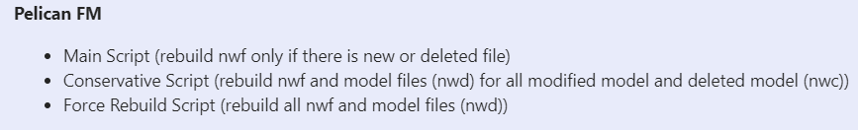To generate text files to reflect the content of each NWF/NWD files, run **Pelican_generate_latest_nwf_textfile.bat**

# SCRIPT WORKFLOW (WHAT IT DOES)

**All the steps below are done automatically** when you run the script**.** They are only a detailed description of its workflow.

1. Backup previous NWC models

- Check if Archived folder exist. If not, the script will create the folder

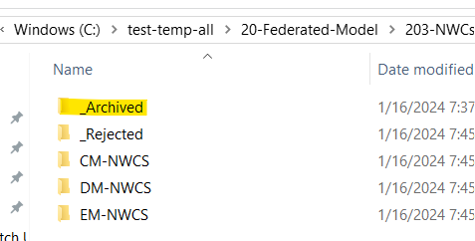

- Create folder with the date the script running as the folder name

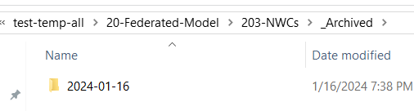

- Backup all the NWC models into this folder

1. Copy new and updated NWC models

- Check if there is new updated NWC models in BIM Machine

- Copy NWC models into the temporary build folder

1. Move models with wrong naming convention

- Check if Rejected folder exist. If not, the script will create one

- Move all the models

1. Generate NWF files

- Only appends a file if it is following the naming convention  
- Only generates a building model (NWF) if really needed (e.g., at least one of the below is true):  
There is a new version of a file previously appended  
A file previously appended does not exist anymore  
A file new file is available to be appended (not part of previous build)  
- Update viewpoints and Search sets for newly generated NWF

1. Generate Federated Model (NWD)

- Export all list of federated models to be rebuild into text files

- Read generated text files from previous step.

- Generate all federated model in the list.

# AUTHOR

Janet Jasintha Lopez ([janetjasintha.lopez@exyte.net](mailto:janetjasintha.lopez@exyte.net))

Lawrenerno Jinkim ([lawrenerno.jinkim@exyte.net](mailto:lawrenerno.jinkim@exyte.net))