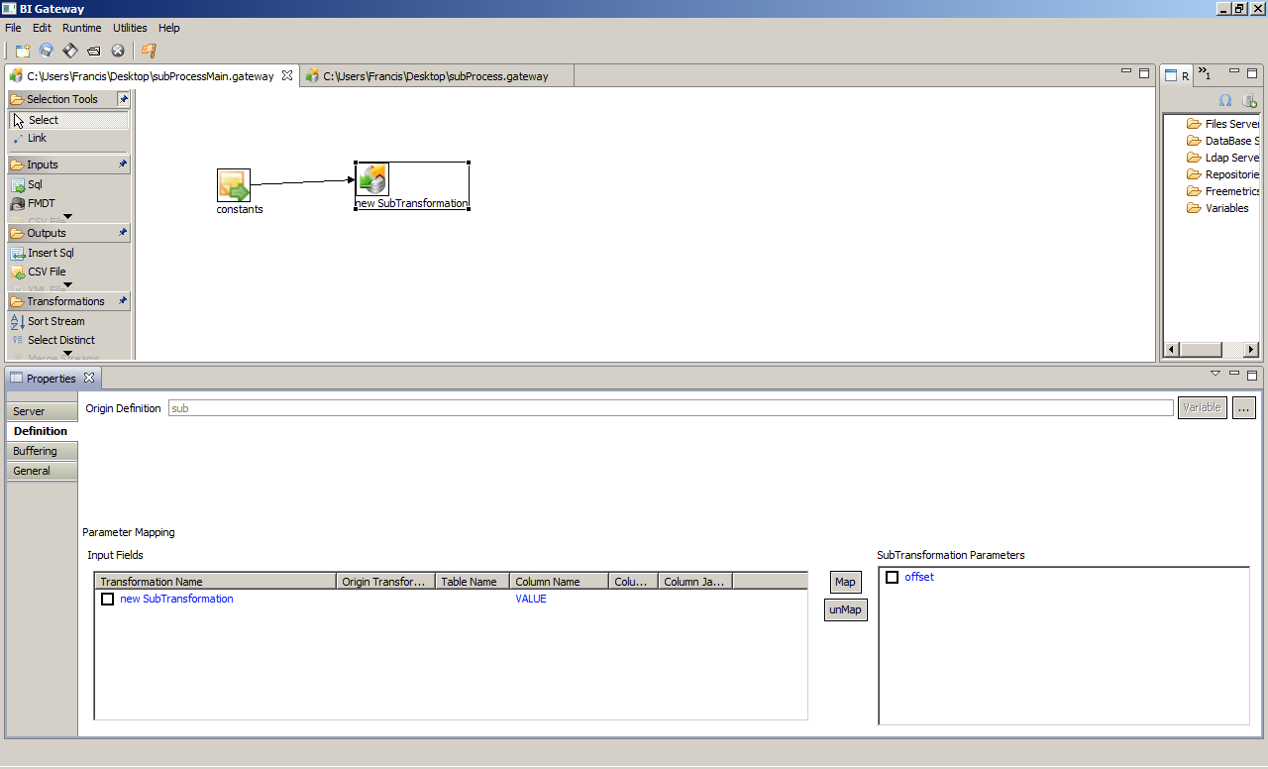

How To Use : SubProcess :

- First you have to select a sever which will provide the GTW model (only RepositoryServer or FileSystemServer are supported now).

- Select the Orgin Definition with the brows button(you can use a variable only for FileSystemServer provider).

- Once this is done, you just have to define which field will be mapped to which SubProcess parameter.

- Each Row will launch the subProcess with its own values

