- Do not edit/delete any heading or section with red text.
- Type /paste you answers in relevant sections (below Final Answer (in all questions , Approach (wherever required ) and Charts & tables (wherever required)) of the solution
- Link to submission guidelines
- Please note that submission not following the guidelines will not be accepted

OBJECTIVE QUESTIONS

Question 1: What is the total no. of attributes present in the data?

Solution:
Final Answer (if any):
The total no. of attributes present in the dataset is: - 17
But Agent Name Column in Tickets Sheet is NULL.
- Tickets sheet= 11 attributes (Adding Agent Name Column)
- IT Agents sheet= 6 attributes

Approach (if any):
-I manually counted the column headers (attributes) in both sheets, namely Tickets and IT Agents, to calculate the total number of attributes.

Charts & Tables (if any):
-No charts and tables were used. Only column headers from both the sheets were counted manually.

Question 2: Which columns have inconsistent or missing values, and what is the count of such values?

Solution:
Final Answer (if any):
The columns with inconsistent and missing values are:
  - Tickets Sheet: -
1. Agent Name(column): Missing values (entire column appear blank).
2. Severity(column): Inconsistent spelling such as “Unclasified” and “Mayor”.
3. Priority(column): Inconsistent spelling such as “Unassiged”.
  - IT Agents Sheet: -
1.Full Name(column): Contains Formatting issues such missing space, incomplete name.

Approach (if any):
- I manually reviewed both sheets to identify missing values, spacing issues, spelling errors, and formatting issues.

Charts & Tables (if any):
- No charts were used. Only the summary table was used.

Question 3: What is the average daily ticket volume over time?

Solution:

Final Answer (if any):
53.365

Approach (if any):
I calculated the average daily ticket volume by dividing the total number of IT tickets by the number of unique dates in the dataset. For this, I used the ID Ticket and Fecha columns from the Cleaned Data sheet.
Using Formula:-
=COUNTA('Cleaned Data'!A2:A97499)/COUNT(UNIQUE('Cleaned Data'!B2:B97499))
But my Excel version does not support the UNIQUE() function.
So, I used Pivot table.

Charts & Tables (if any):
I Used a Pivot Table.

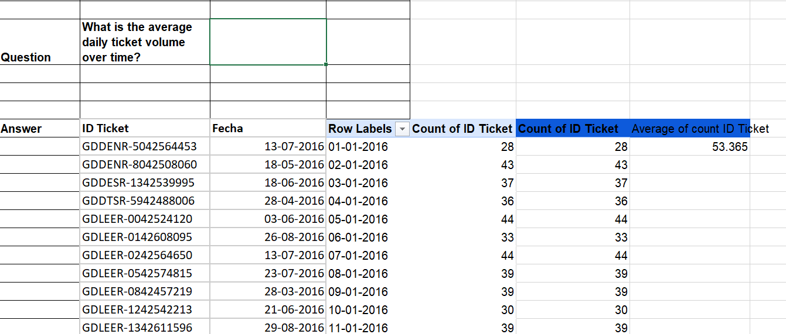

Question 4: What is the distribution of ticket categories (e.g., Login Access, System, Software)?

Solution:
Final Answer (if any):
The majority of IT tickets belong to the System Category, accounting for 40% of all tickets. This is followed by Login Access with 29.94%, Software with 20.07%, and Hardware with 9.98%. Therefore, System-related issues are the most common type of requests raised by users, while Hardware issues are the least common.
- Hardware: - 9733 Tickets (9.98%)
- Login Access: -29193 Tickets (29.94%)
- Software: -19570 Tickets (20.07%)
- System: -39002 Tickets (40.00%)

Approach (if any):
I selected the entire dataset and created a Pivot Table. In the Pivot Table, I placed Request Category in the Rows, ID Ticket in the Values and again ID Tickets placed in values for percentage of ID Tickets and summarized by count.

Charts & Tables (if any):
I Used a Pivot Table and chart to visualize ticket category distribution.

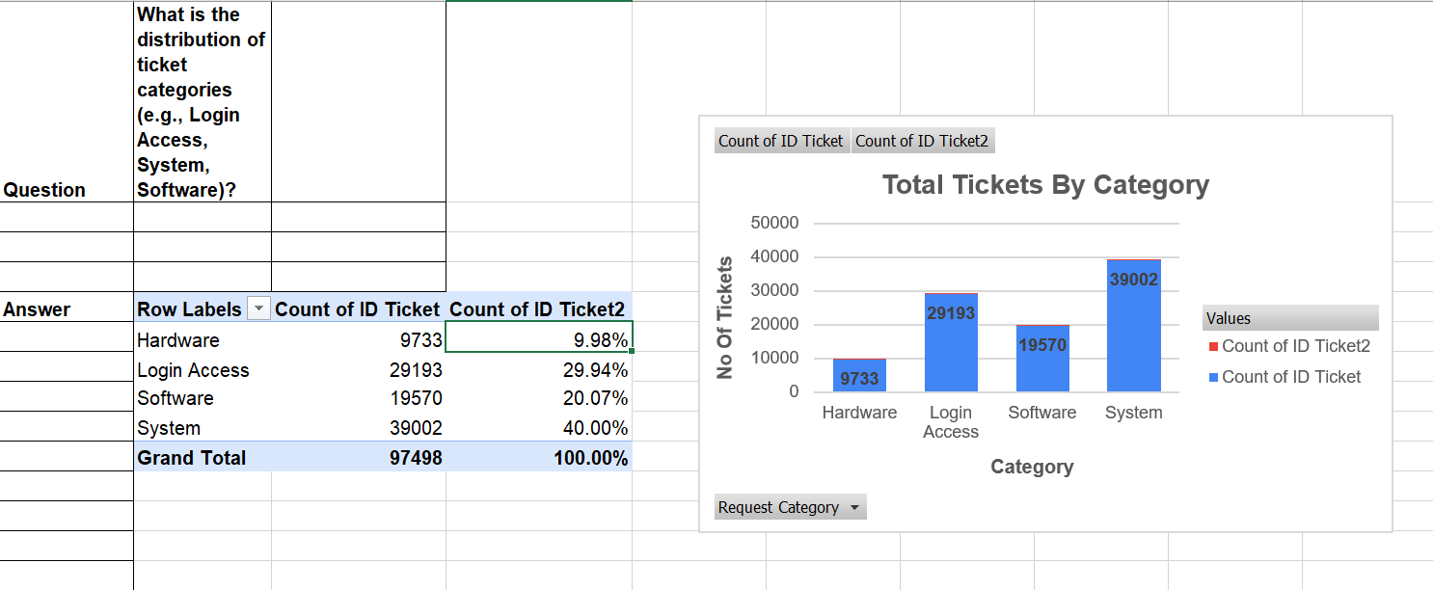

Question 5: How many tickets has each agent handled?

Solution:
Final Answer (if any):
Each agent handled around 1856-2027 tickets. Agent 48 handled the most tickets (2027), while Agent 13 handled the fewest (1856).

Approach (if any):
-I Used the COUNTIF () function to count the number of tickets handled by each agent based on Agent ID.

Charts & Tables (if any):
- No charts were used. Only the summary table was used.

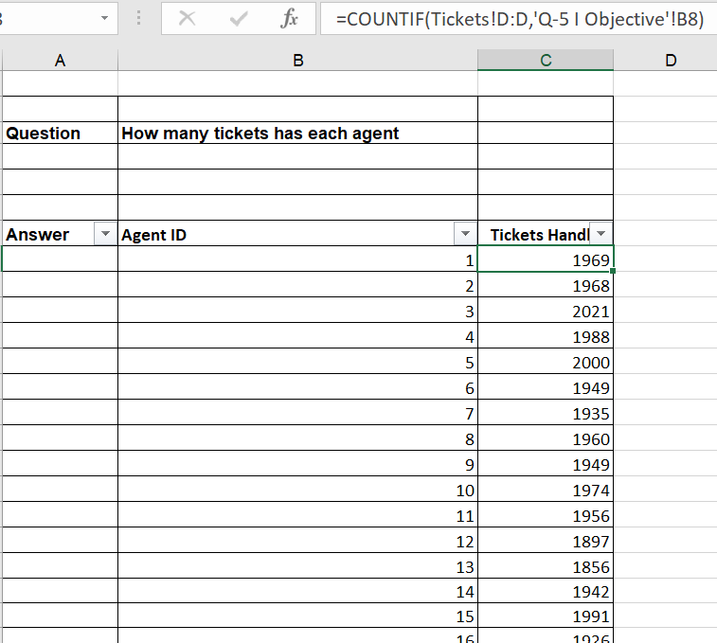

Question 6: How can you extract the domain from the email addresses in the IT Agents sheet?

Solution:
Final Answer (if any):
- Used an Excel formula to extract the email domain from email addresses by taking the text after @. The formula uses the RIGHT(), LEN(), and FIND() functions.
Formula: =LEFT(RIGHT(B9,LEN(B9)-FIND("@",B9)),FIND(".",RIGHT(B9,LEN(B9)-FIND("@",B9)))-1)

Approach (if any):
-Used an Excel formula to extract the email domain from email addresses by taking the text after @. The formula uses the RIGHT(), LEN(), and FIND() functions.

Charts & Tables (if any):
- No charts were used. Only the IT Agents sheet was used.

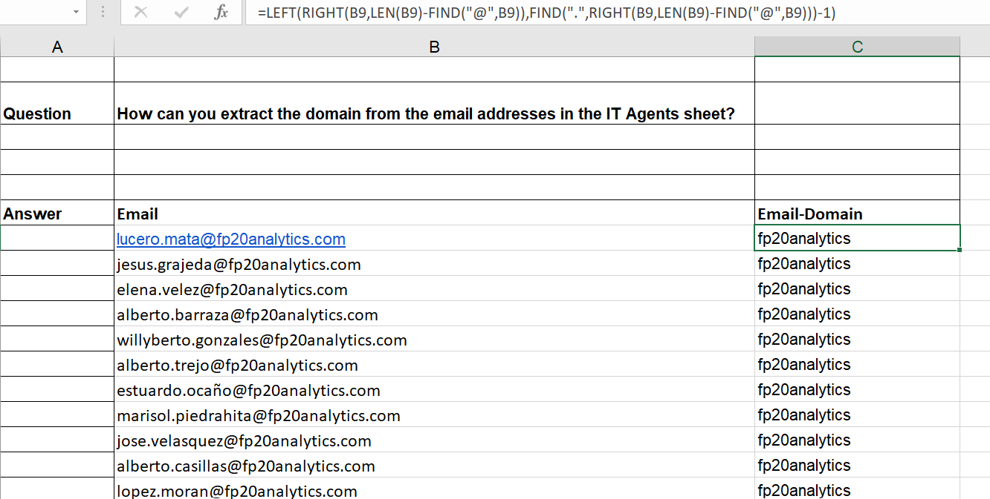

Question 7: How can you find the full name of an agent given their Agent ID?

Solution:

Final Answer (if any):
- Used a lookup formula to find the full name of an agent based on Agent ID.
Formula: - =VLOOKUP(D2,'IT Agents'!$A$2:$B$51,2,FALSE)

Approach (if any):
- Used a lookup formula VLOOKUP to find the full name of an agent based on Agent ID.

Charts & Tables (if any):
-Both Sheet was used. i.e. Tickets sheet and IT Agent Sheet.

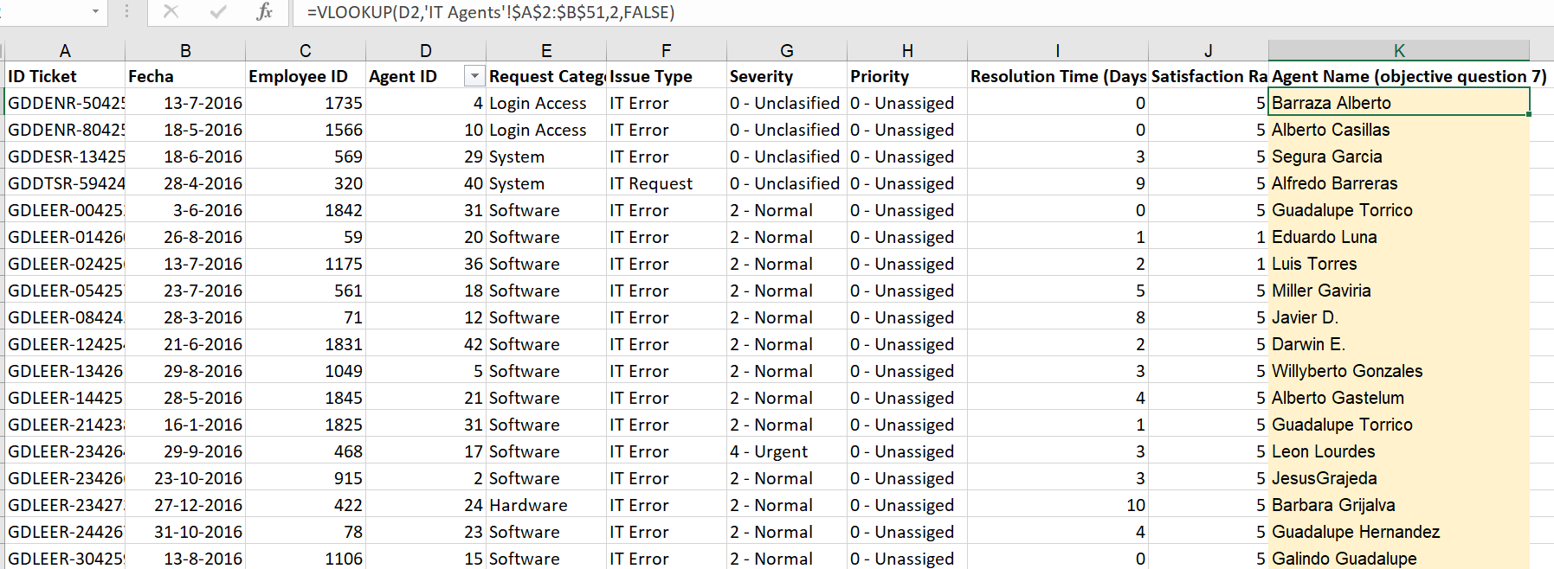

Question 8: What is the count of each issue type (e.g., IT Error, IT Request)?

Solution:

Final Answer (if any):
- IT Error: - 24278
- IT Request: - 73220

Approach (if any):
-I Used a Pivot Table to count the number of tickets for each Issue Type.

Charts & Tables (if any):
-I Used a Pivot Table and pie chart to visualize issue type distribution.

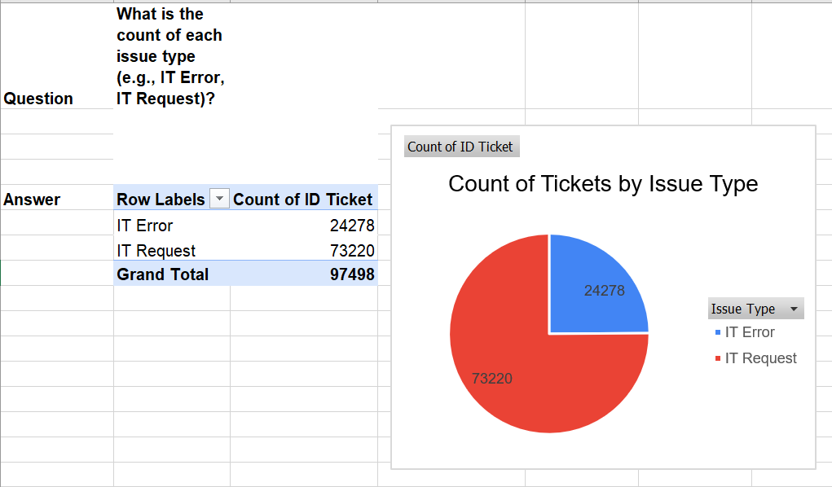

Question 9: What is the average resolution time for tickets?

Solution:

Final Answer (if any):
-Ans1. Only Calculate the average resolution time for tickets is 4.55 days.
-Ans2. I also Calculate the daily average because in the Data Sheet the ques like What is the daily average resolution time for tickets?

Approach (if any):
-Ans1.
- Used the Resolution Time (Days) column from the Tickets Sheet.
- Used Excel ‘Average’ Formula to calculate the average resolution time for tickets.
- Formula:- =ROUND(AVERAGE(B8:B97505),2)
-Ans2.
- I used a Pivot Table to calculate the Daily Average in pivot table add Fecha column in rows and resolution time(days) column in values take the average of this.

Charts & Tables (if any):
- No charts were used. Only the Tickets sheet was used.

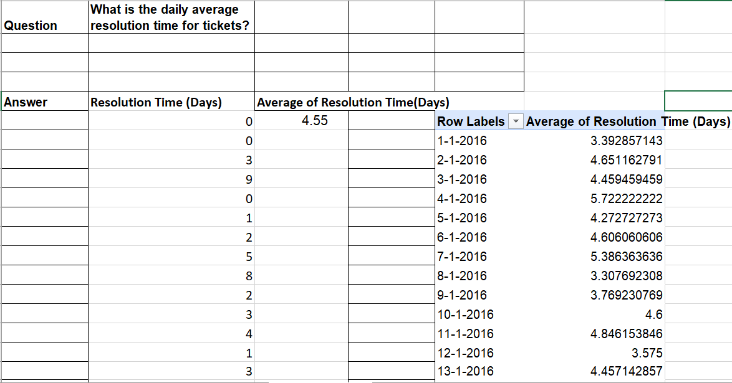

Question 10: How has the volume of tickets changed over time?

Solution:

Final Answer (if any):
The number of tickets increased over time, with a major rise in 2020.

Approach (if any):
-Used a Pivot Table to count tickets by month and year using the Fecha column, and a Line Chart to visualize ticket volume trends over time.

Charts & Tables (if any):
- Pivot Table showing monthly ticket counts by year.
- Line Chart visualizing ticket volume trend over time.

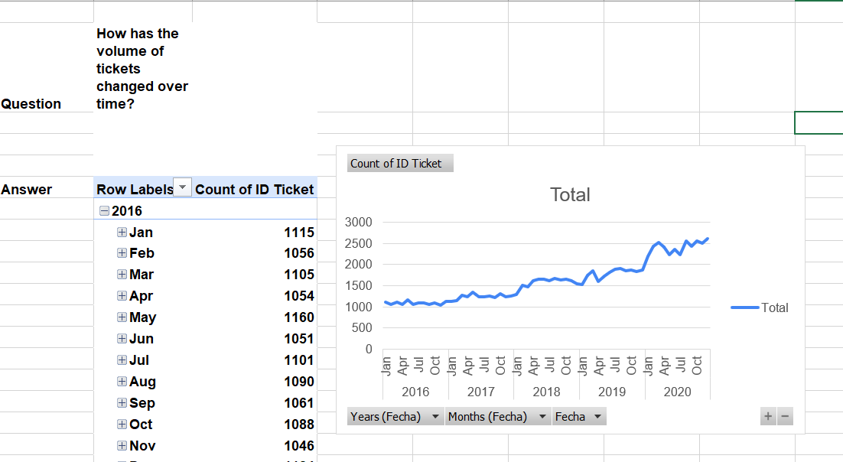

Question 11: What is the average age of the IT agents?

Solution:

Final Answer (if any):
-Average age of the IT agents is: - 40.98 years.
-Since age shows a whole number that’s why I used round() function.
-Therefore, approximate average age of IT agents is 41 years.

Approach (if any):
- First, I calculated the Full DOB using the DATE(year, month, day) function
from the IT Agents sheet columns: Year of Birth, Month of Birth,
and Day of Birth.
Formula: =DATE(B8,C8,D8)
- Second, after finding the Full DOB,
I calculated the Age of Agent using the DATEDIF function.
Formula: =DATEDIF(E8,TODAY(),"Y")
- Finally, I calculated the Average Age of Agents using the AVERAGE function
and rounded it using ROUND.
Formula: =ROUND(AVERAGE(F8:F57),0)

Charts & Tables (if any):
- No charts were used. Only the IT Agent sheet was used.

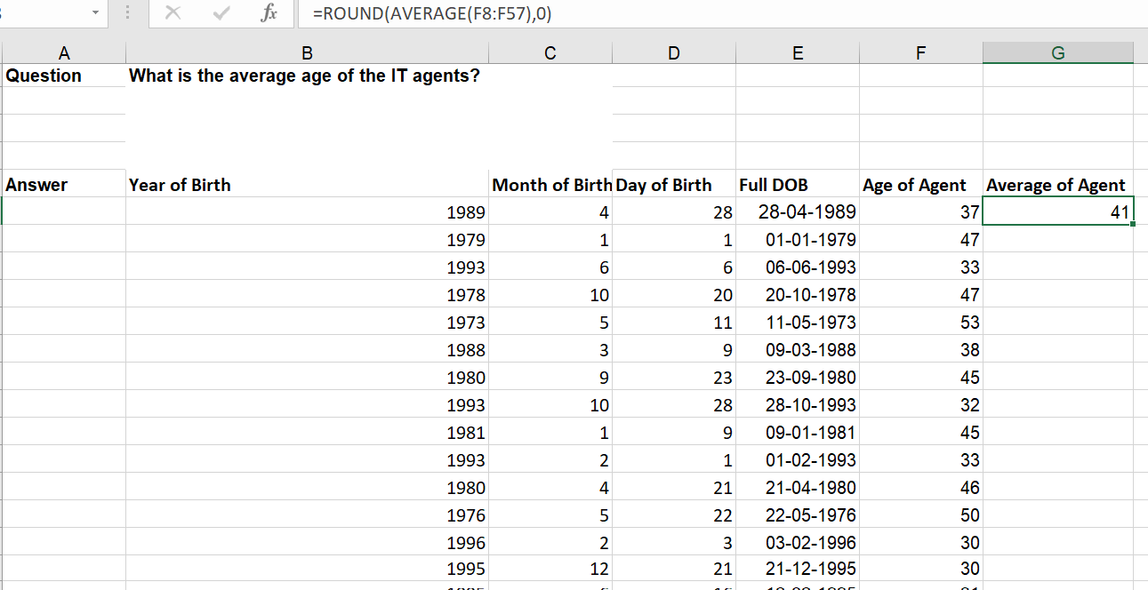

Question 12: Is there a correlation between the severity of issues and the resolution time?

Solution:

Final Answer (if any):
-I used CORREL function and Pivot Table to analyse the relationship between severity and resolution time.
-Formula: =CORREL('Cleaned Data'!K:K,'Cleaned Data'!I:I)
-Correlation value = -0.04054
-This value is close to 0, so there is no strong correlation.
Approach (if any):
- I used a Pivot Table to calculate the average resolution time for each severity level.
- Then, I used a Bar Chart to compare resolution time across severity categories.
Charts & Tables (if any):
-I Used a Pivot Table for showing average resolution time by severity
And Bar Chart visualizing resolution time by severity.

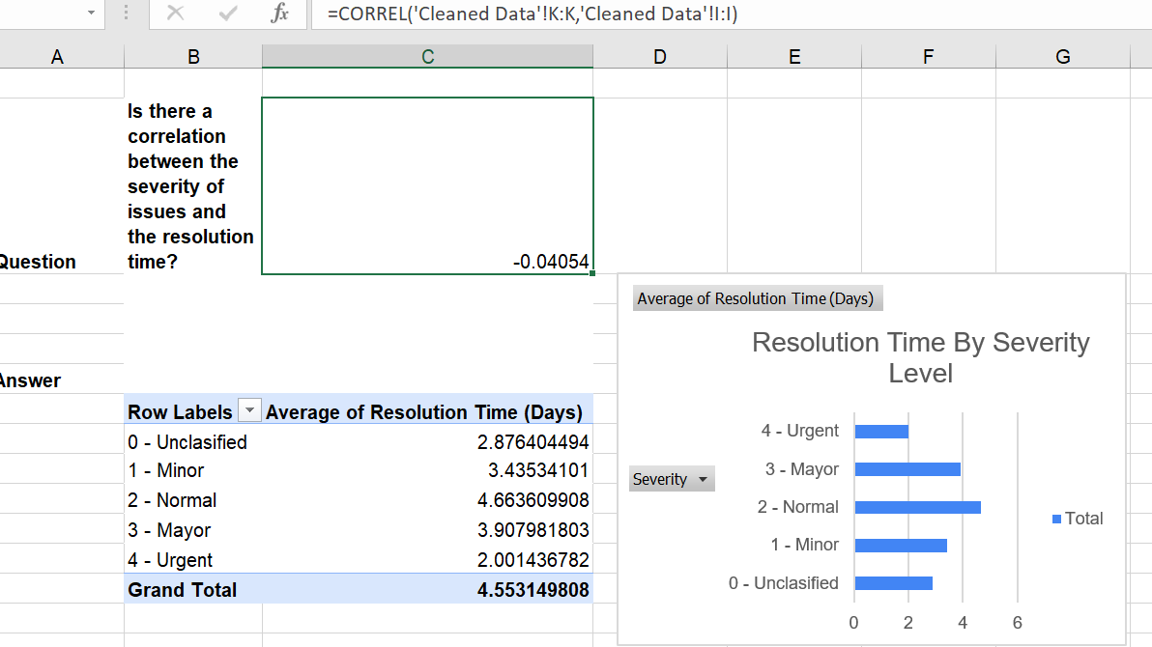

Question 13: How many categorical columns are there in the data? [Search about categorical and continuous data, and try to answer this question]

Solution:

Final Answer (if any):
There are 13 categorical columns across both the sheets.

Approach (if any):
I reviewed all the columns from both sheets and classified them as categorical or continuous data. Columns containing labels, IDs, and text values were considered categorical, while columns containing measurable numerical values were considered continuous. Then, I calculated the total number of categorical columns.

Charts & Tables (if any):
- No charts only table were used.

SUBJECTIVE QUESTIONS

Question 1: If there is an investment, should it be used to hire more IT agents, improve training programs, or upgrade ticket management software?

Analysis: Perform a cost-benefit analysis using ticket resolution and satisfaction metrics.

Solution:

Approach:
  - Selected the required columns: Agent ID, ID Ticket, Resolution Time (Days), and Satisfaction Rate.
  - Then Created 4 Pivot Tables:
1.Pivot Table 1: Added Agent ID in Rows and Count of ID Ticket, Average of Resolution Time (Days), and Average of Satisfaction Rate in Values.
  - Calculated overall averages:
Resolution Time = 4.55 days
Satisfaction Rate = 4.10
  - Compared each agent’s performance with overall averages to classify them as Good Agent or Weak Agent.
Using Excel If Formula: =IF(AND(H8>=$F$8,I8<=$G$8),"Weak Agent","Good Agent")
2. Pivot Table 2: Added Status in Rows and Count of Status in Values to count Good and Weak Agents.
3. Pivot Table 3: Added Priority in Rows and Count of ID Ticket, Average of Resolution Time (Days), and Average of Satisfaction Rate in Values.
4. Pivot Table 4: Added Severity in Rows and Count of ID Ticket, Average of Resolution Time (Days), and Average of Satisfaction Rate in Values.
  - Compared agent performance, ticket priority, and severity to identify areas for improvement and recommend the best investment option.

Charts & Tables:
  - I Used Pivot Table, Summary Table and Charts.

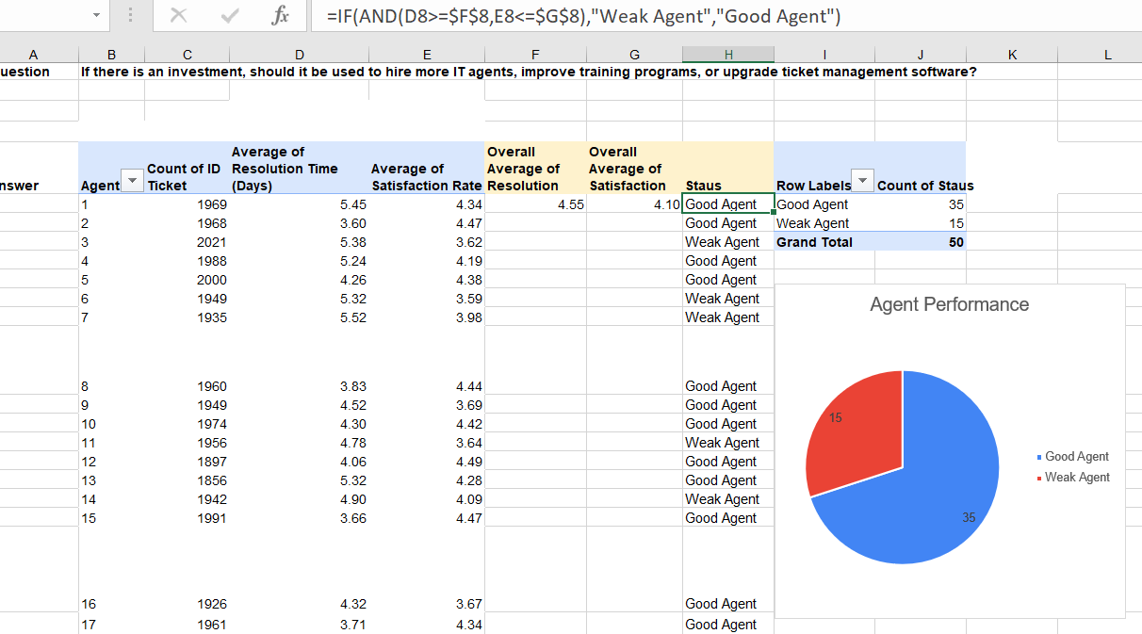

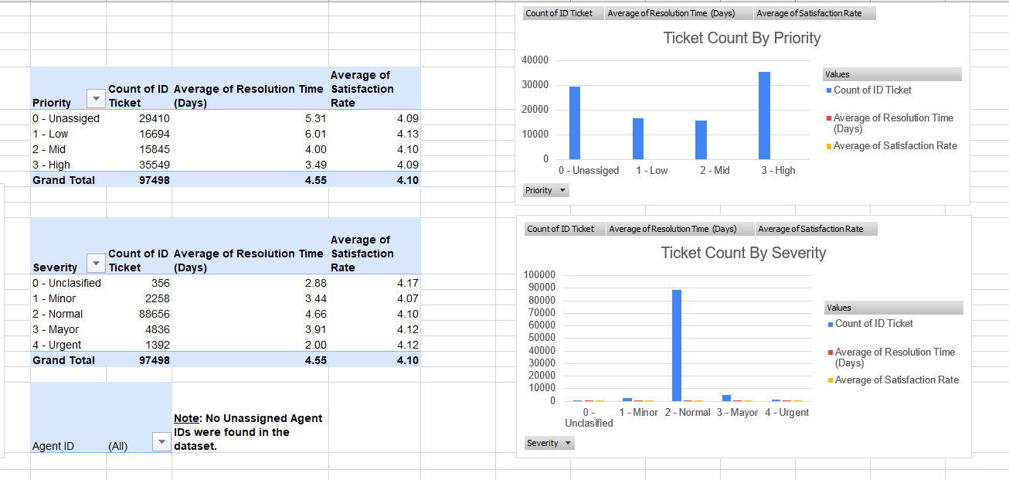

Insights:
  - 35 agents are performing well, while 15 agents need improvement.
  - High Priority tickets have the highest number of tickets (35,549).
  - Low Priority tickets take the longest to resolve (6.01 days).
  - Most tickets are Normal Severity (88,656), so improving their handling can reduce overall resolution time.
  - No unassigned Agent IDs were found in the dataset.

Recommendations:
- Provide training to the 15 weak agents to improve their performance.
- Upgrade the ticket management software to improve ticket routing and reduce resolution time.
- Continue monitoring priority and severity to handle important tickets more efficiently.
- No need to hire more IT agents, as all tickets are already assigned and the main improvement is in training and process efficiency.

Question 2: Which agents need additional training based on their performance metrics?

Analysis: Identify agents with the lowest satisfaction ratings and longest resolution times.

Solution:

Approach:
- Selected the required columns: Agent ID, Resolution Time (Days) and Satisfaction Rate.
- Then I Created a Pivot Tables.
1.Pivot Table- In Row add Agent ID and In Values add Average of Resolution Time (Days) and Average of Satisfaction Rate.
- Calculated overall averages:
Resolution Time = 4.55 days
Satisfaction Rate = 4.10
- Compared each agent’s performance with overall averages to identify agents needing training.
Using Excel If Formula: =IF(AND(H8>$F$8,G8<$E$8),"Yes","No").
- 2.Pivot Table- In Row add Training Needed column and In Values add Count of Training Needed and Counted the number of agents requiring training and agents not requiring training.

Charts & Tables:
- Pivot Table for agent-wise performance analysis
- Summary table for Training Needed (Yes/No)

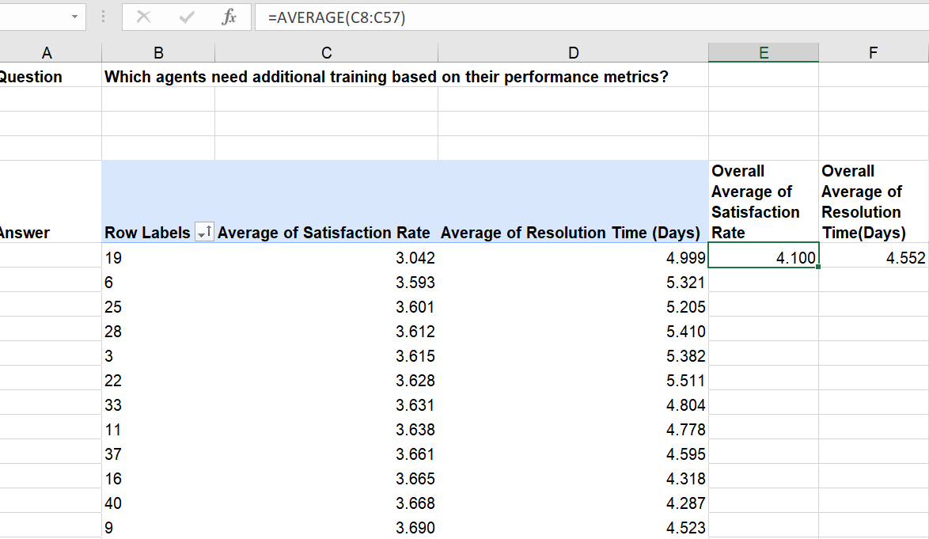

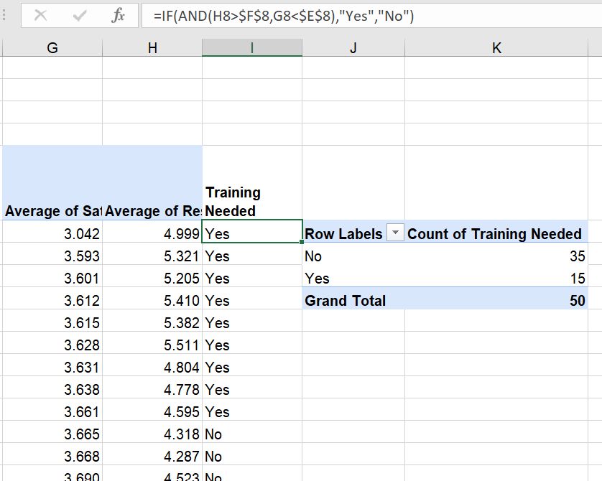

Insights:
- Overall average satisfaction rate = 4.10
- Overall average resolution time = 4.55 days
- 15 agents need additional training.
- 35 agents are performing well.

Recommendations:
- The 15 identified agents should receive additional training to improve ticket resolution speed and customer satisfaction.

Question 3: Do certain categories of requests have longer resolution times?

Analysis: Analyze the resolution times by request category.

Solution:

Approach:
- Selected the required columns: Request Category and Resolution Time (Days).
- Then created a Pivot Table.
- Pivot Table
- In Rows: Added Request Category
- In Values: Added Average of Resolution Time (Days)
- Calculated the average resolution time for each request category to compare performance across categories.
- Compared the average resolution time of each category to find which category takes more time.

Charts & Tables:
- I Used Pivot Table, Summary Table and Create Column Chart.

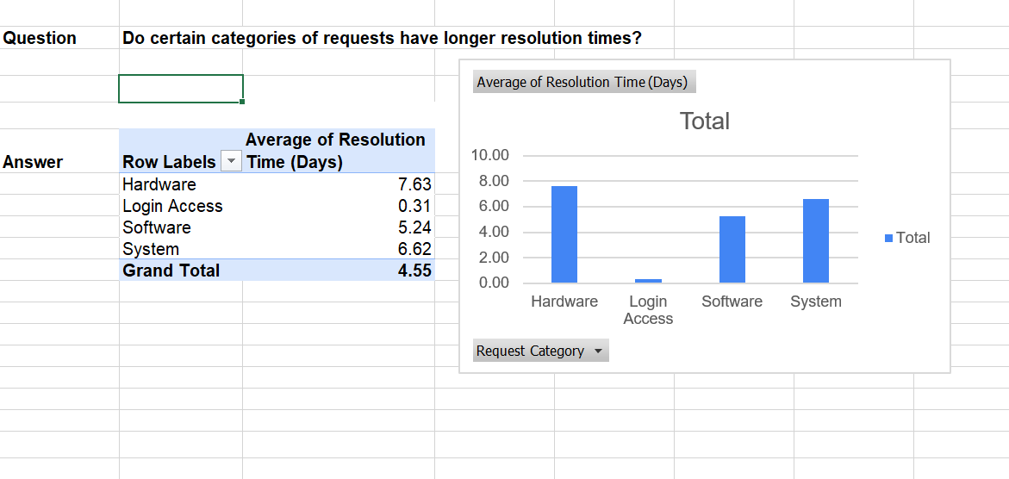

Insights:
- Hardware Category has the highest average resolution time, meaning it takes the longest to resolve.
- Login Access Category has the lowest average resolution time, meaning it is resolved the fastest.
- Resolution time is different for each Request Category.

Recommendations:
- Give more attention to Hardware and System requests.
- Try to reduce time for requests that take longer.

Question 4: How effective are the current software tools in managing IT tickets?

Analysis: Evaluate performance metrics before and after the implementation of new tools.

Solution:

Approach:
- Selected the required columns: Request Category, Resolution Time (Days), ID Ticket, and Satisfaction Rate.
- Created a Pivot Table.
- Added Request Category in Rows.
- Added Average of Resolution Time, Count of ID Ticket, and Average of Satisfaction Rate in Values.
- Used these metrics to evaluate software performance in managing IT tickets.

Charts & Tables:
- I Used Pivot Table and Summary Table.

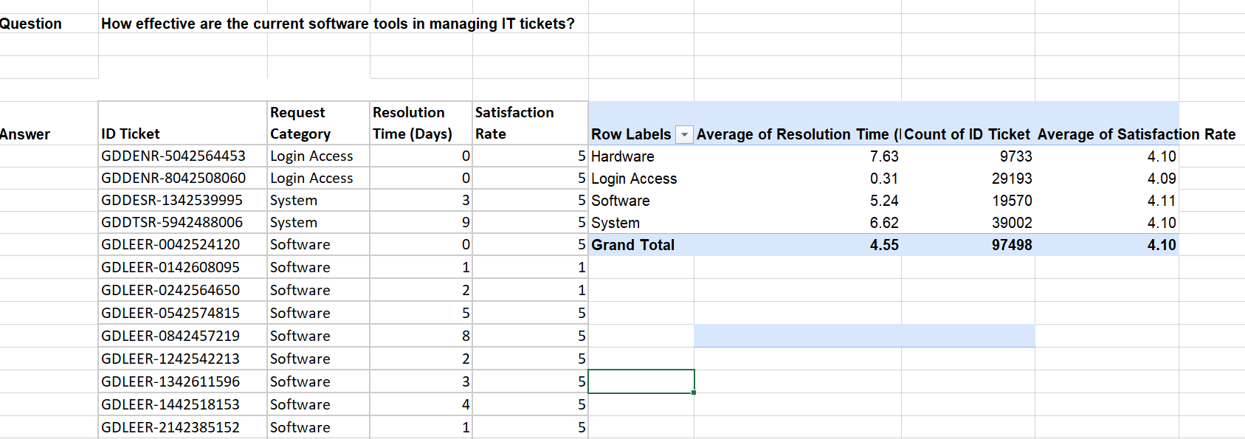

Insights:
- The software handled 97,498 tickets.
- The overall average resolution time was 4.55 days.
- The overall average satisfaction rate was 4.10, showing good customer satisfaction.
- Login Access tickets had the fastest resolution time (0.31 days).
- Hardware tickets took the longest to resolve (7.63 days).
- The software tools perform well for simple issues but take more time for complex issues.

Recommendations:
- Improve Hardware and Software systems.
- Focus more on categories taking more time.
- Use better technology for faster ticket resolution

Question 5: How has the performance of the IT support team changed over time (e.g., monthly or quarterly)?

Analysis: Trend analysis using time series charts.

Solution:

Approach:
- Selected the required columns: Date, Resolution Time (Days), and Satisfaction Rate.
Then I created a Pivot Table.
- Pivot Table:
In Row added Month.
In Values added Average of Resolution Time (Days) and Average of Satisfaction Rate.
- Compared monthly Resolution Time and Satisfaction Rate to analyse how IT team performance changed over time.
- Finally, I created a Line Chart for better Visualization.

Charts & Tables:
- I Used Pivot Table, Summary Table and Create a Line Chart

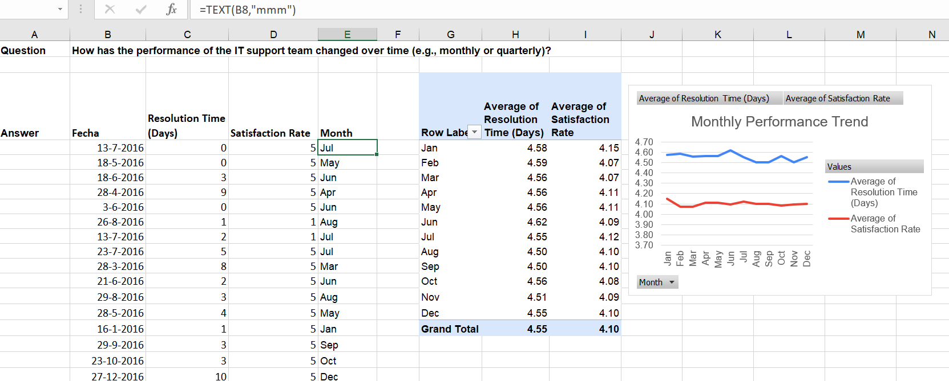

Insights:
- IT team performance was almost the same throughout the year.
- Resolution time was a little higher in June but improved in August and September.
- Satisfaction rate stayed almost the same in all months.

Recommendations:
- Continue the same performance.
- Improve the resolution time where needed.
- Check performance Regularly.

Question 6: If we invest more on tech (Hardware, software, etc), do you think it will improve the ticket resolution times and employee satisfaction?

Analysis: Use historical data to project potential improvements.

Solution:

Approach:
- Selected Request Category, Resolution Time (Days), and Satisfaction Rate columns.
Created a Pivot Table:
- Pivot Table:
In Rows added Request Category.
In Values added Average of Resolution Time (Days) and Average of Satisfaction Rate.
- I analysed that which categories have higher resolution time and lower satisfaction.

Charts & Tables:
- I Used Pivot Table, Summary Table.

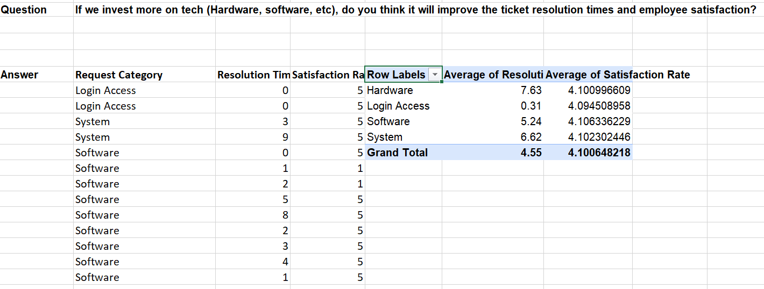

Insights:
- Hardware, System and Software requests take more time to solved.
- Login Access requests are solved quickly.
- Satisfaction rate is almost same in all categories.

Recommendations:
- Improve Hardware and Software systems.
- Focus more on categories taking more time.
- Use better technology for faster ticket resolution

Question 7: What are the key performance metrics for IT agents, and how can they be improved, do we need to fire any agents?

Analysis: Define and analyze metrics such as average handling time, satisfaction scores, and number of tickets resolved.

Solution:

Approach:
- Selected Request Category, ID Ticket, Resolution Time (Days), and Satisfaction Rate from the Ticket sheet.
- Created a Pivot Table.
- Added Request Category in Rows.
- Added Count of ID Ticket, Average of Resolution Time (Days), and Average of Satisfaction Rate in Values.
- Compared the average resolution time and satisfaction rate for each request category.
- Identified which request categories take longer to resolve and need improvement Using IF() Formula: =IF(AND(E8>$E$12,D8<$D$12),"Need Improvements","Good").
- Used the analysis to decide whether agents need training or process improvements instead of firing them.

Charts & Tables:
- I Used Pivot Table, Summary Table and Chart.
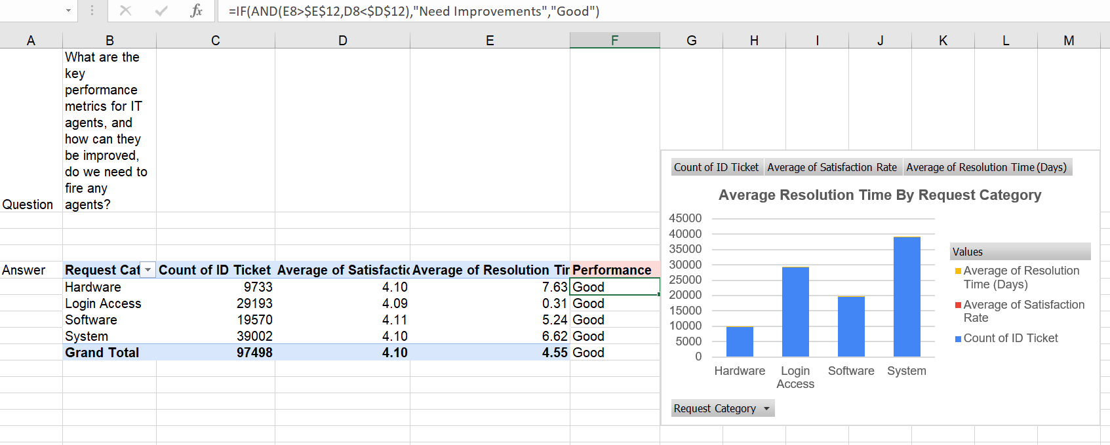

Insights:
  - System requests have the highest number of tickets (39,002).
  - Hardware requests take the longest to resolve (7.63 days), followed by System (6.62 days) and Software (5.24 days).
  - Login Access requests are solved the fastest (0.31 days).
  - Customer satisfaction is good (around 4.10) across all request categories.
  - Hardware and System requests need improvement because they take more time to resolve.
Recommendations:
- There is no need to fire any agents because customer satisfaction is good.
- Provide training for agents handling Hardware and System requests.
- Improve the ticket management process to reduce resolution time.
- Continue the current process for Login Access requests, as it is working well.

Question 8: How do employee demographics (e.g., department, seniority) impact satisfaction and ticket outcomes?

Analysis: Segment analysis using filters and pivot tables.

Solution:

Approach:
- Selected Age Group, ID Ticket, and Satisfaction Rate Column from the IT Agent Sheet.
- Created a Pivot Table.
- Added Age Group in Rows.
- Added Count of ID Ticket and Average of Satisfaction Rate in Values.
- Created a chart to compare ticket volume and satisfaction across age groups.
- Analysed the results to identify how employee demographics impact satisfaction and ticket outcomes.

Charts & Tables:
I Used Pivot table, Summary Table and Chart.
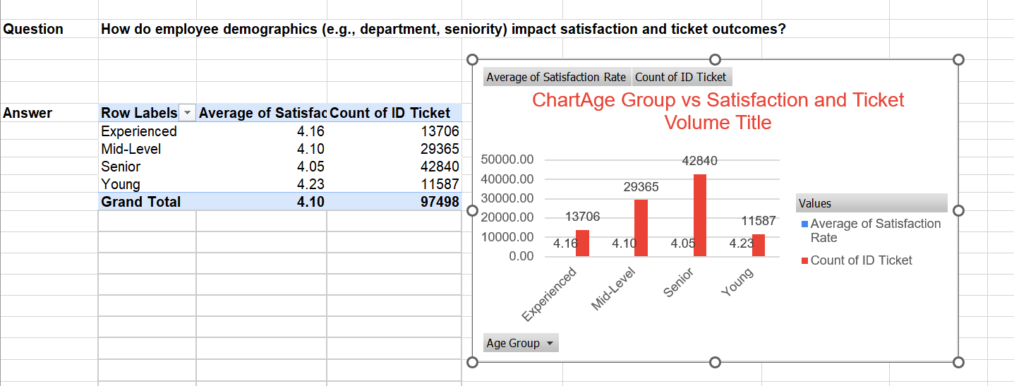

Insights:
- Young employees have the highest satisfaction rate (4.23) but handle the lowest ticket volume (11,587).
- Senior employees handle the highest ticket volume (42,840) but show the lowest satisfaction rate (4.05).
- Mid-level employees have moderate satisfaction (4.10) and ticket volume is (29365).
- Experienced employees maintain relatively good satisfaction (4.16) with lower ticket volume (13,706).
Recommendations:
- Give proper support and training to employees handling more tickets.
- Avoid giving too many tickets to senior employees to reduce workload and improve satisfaction.
- Check employee satisfaction regularly.

Question 9: Identify the trends for IT support operations based on ticket volumes and satisfaction, and mention the peak and stable times?

Analysis: Use pivot tables and charts to identify peak and off-peak hours.

Solution:

Approach:
- Selected Fecha, ID Ticket, and Satisfaction Rate from the Ticket sheet.
- Created three Pivot Tables.
- Added Year in Rows and Count of ID Ticket in Values (Ticket Volume).
- Added Year in Rows and Average of Satisfaction Rate in Values (Satisfaction Trend).
- Added Year and Month in Rows and Count of ID Ticket in Values (Monthly Ticket Trend).
- Created charts to compare ticket volume and satisfaction trends.
- Analysed the data to identify peak and stable (off-peak) periods.

Charts & Tables:
- I Used Pivot Table, summary table and charts.

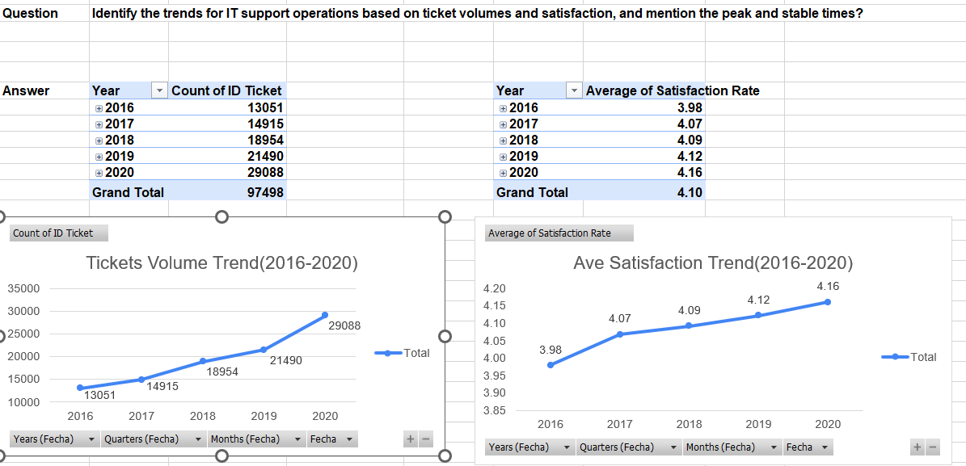

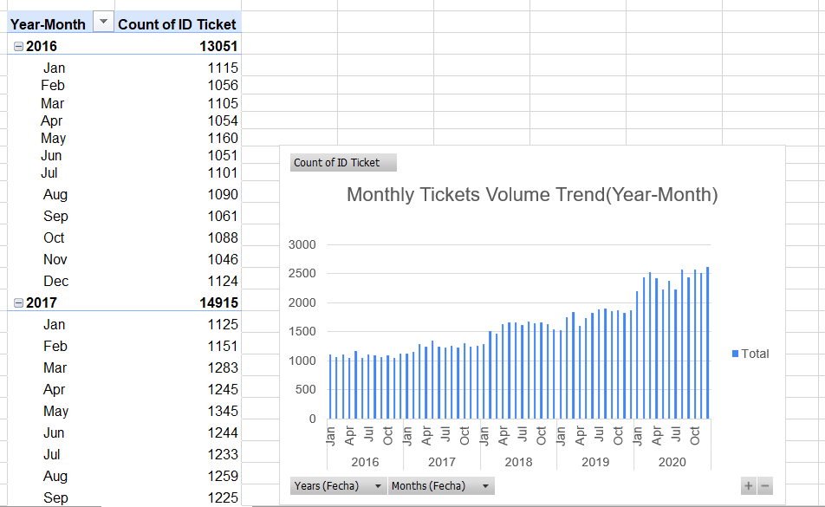

Insights:
- Ticket volume gradually increased from 2016 to 2020.
- June–July and October–December show higher ticket volumes (peak months).
- Peak performance was observed in 2020.
- January–March have lower ticket volumes (stable/off-peak months).
- Stable growth was seen from 2017 to 2019.

Recommendations:
- Increase IT support resources during peak months (Jun–Jul and Oct–Dec).
- Add more staff when tickets are high.
- Plan training and maintenance during off-peak months (Jan–Mar).
- Monitor peak/off-peak patterns and schedule agents accordingly.

Question 10: What metrics should be included in the final dashboard to provide a comprehensive view of call center performance and guide investment decisions?

Solution:

Approach:
- Data Collection: Collected ticket and agent data from the dataset.
- Data Cleaning: Checked missing values, duplicates, and corrected data format.
- Data Preparation: Created new fields such as Age Group and Severity Score, etc.
- Data Analysis: Analysed ticket volume, resolution time, and satisfaction rate.
- Dashboard Creation: Built an interactive dashboard to visualize key metrics.
- Insights & Recommendations: Generated insights and suggested improvements.

Charts & Tables:
- I Created Dashboard

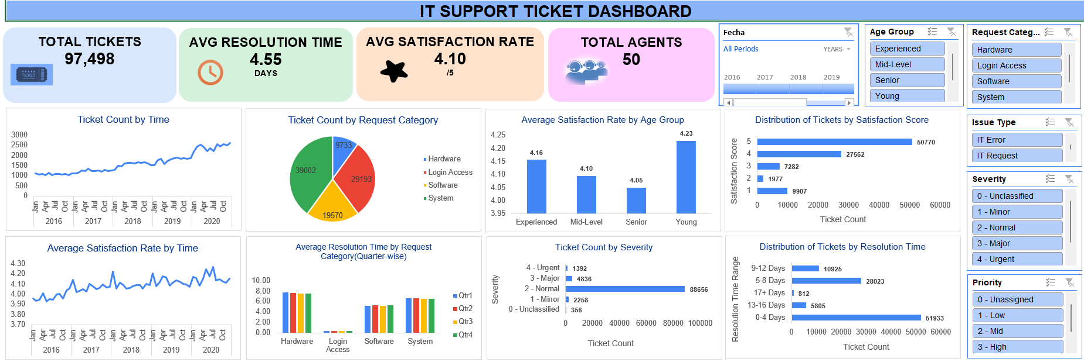

Insights:
- The IT support team handled a high volume of 97,498 tickets efficiently.
- The System category generated the highest number of tickets, making it the major workload area.
- IT Requests were more frequent than IT Errors.
- Most tickets were classified as Normal severity, while urgent tickets were minimal.
- The average resolution time was 4.55 days, indicating moderate support efficiency.
- Hardware-related issues took the longest time to resolve.
- The average customer satisfaction rate was 4.10/5, showing overall good service quality.
- System and hardware-related requests need more focus for better performance.

Recommendations:
- Increase staff during peak hours: High ticket volume during busy periods can delay issue resolution. Adding more support staff can reduce workload and improve response time.
- Improve hardware support service: Hardware-related tickets take longer to resolve. Improving hardware support processes can help reduce delays.
- Automate common login issues: Many login/access issues are repetitive. Automation can solve these quickly and reduce manual effort.
- Resolve system issues faster: System-related tickets are the highest in volume. Faster resolution can improve overall support efficiency.
- Monitor unassigned tickets regularly: Unassigned tickets may lead to delays. Regular monitoring ensures all tickets are addressed on time.

