--1st

select * from books where author like '%er'

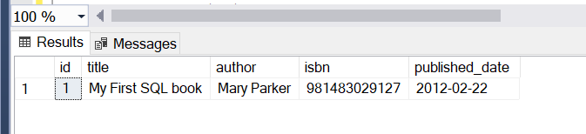

--2

select * from reviewss

select books.title, books.author,reviewss.reviewer_name from books

inner join reviewss on books.author=reviewss.reviewer_name;

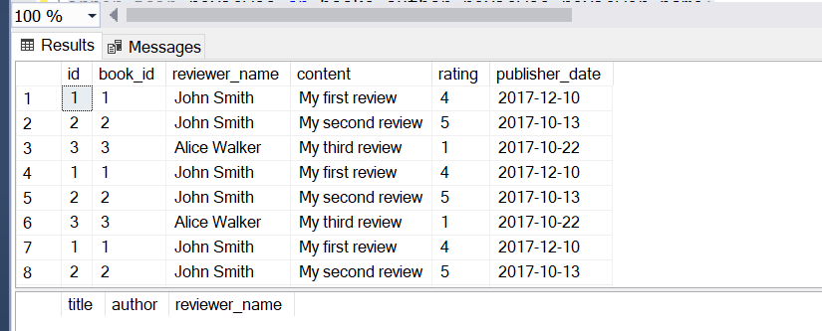

--3

select * from reviewss where rating>1

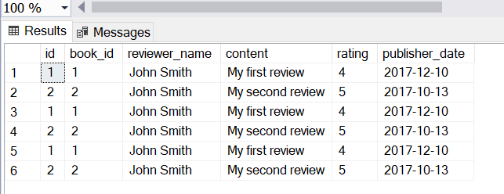

--4.same address

select * from customer where address like '%o%';

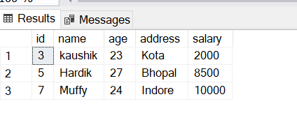

--5.samedate

select odate, count(DISTINCT customer_id) as total_customers from orders group by odate

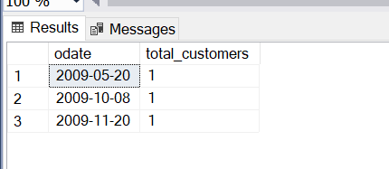

--6.salary null

select lower(name) as LowercaseName from employee

where salary is null;

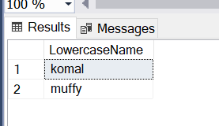

--7.gender count

select gender as Gender,

count(*) as c

from studentdetails

group by gender;

