Trader Performance vs. Bitcoin Market Sentiment
An Analysis of Hyperliquid Trading Data Against the Fear & Greed Index
Prepared for: Primetrade.ai Data Science Assignment
Dataset period: May 2023 – May 2025 | 211,218 trades across 32 accounts and 246 assets

1. Executive Summary
This report merges 211,218 individual trades from Hyperliquid (32 accounts, 246 assets, May 2023 – May 2025) with the daily Bitcoin Fear & Greed Index to test a simple question: does crowd sentiment predict how well traders actually perform? The data says yes — but not in the way most people assume.
- Traders were most profitable during “Fear” days ($3.36M total closed PnL, 29% of all trades) and least profitable during “Extreme Fear” ($0.74M, only 10% of trades) — profitability is not linear across the sentiment spectrum.
- Win rate was highest in Extreme Greed (89.2%) and Fear (87.3%), and lowest in Extreme Fear (76.2%) — panic conditions are where trades go wrong most often.
- Trading activity is inversely correlated with sentiment value (correlation ≈ −0.25): traders transact more often and in larger size when the market is fearful, not greedy — a contrarian, “buy the fear” behavior pattern.
- Average position size peaks during Fear ($7,816) and is smallest during Extreme Greed ($3,112), suggesting traders scale up conviction into weakness rather than euphoria.
The strategic implication: sentiment-aware position sizing — leaning in during moderate Fear and de-risking during Extreme Fear and Extreme Greed — lines up with where this trader cohort actually made its money.

2. Data & Methodology

2.1 Datasets
Dataset | Rows | Key Fields | Coverage
Fear & Greed Index | 2,644 | date, value (0–100), classification | Feb 2018 – May 2025
Hyperliquid Trades | 211,224 | account, coin, execution price, size, side, direction, closed PnL, fee, timestamp | May 2023 – May 2025

2.2 Processing steps
- Parsed the IST trade timestamp into a calendar date and left-joined each trade to that day's Fear & Greed classification (only 6 of 211,224 trades, <0.01%, had no matching sentiment day and were dropped).
- Treated rows with a non-zero Closed PnL as “closing” trades (104,402 of 211,218) since Hyperliquid records 0 PnL for trades that open or add to a position; win rate and average PnL are computed on this closing subset, while volume and activity metrics use all trades.
- Aggregated by sentiment class (Extreme Fear, Fear, Neutral, Greed, Extreme Greed) and, separately, by calendar day for time-series and correlation analysis.

3. Key Findings

3.1 Profitability by sentiment
Total realized profit across the entire dataset was $10.25M. Broken out by sentiment regime, profit is concentrated disproportionately in “Fear” days:
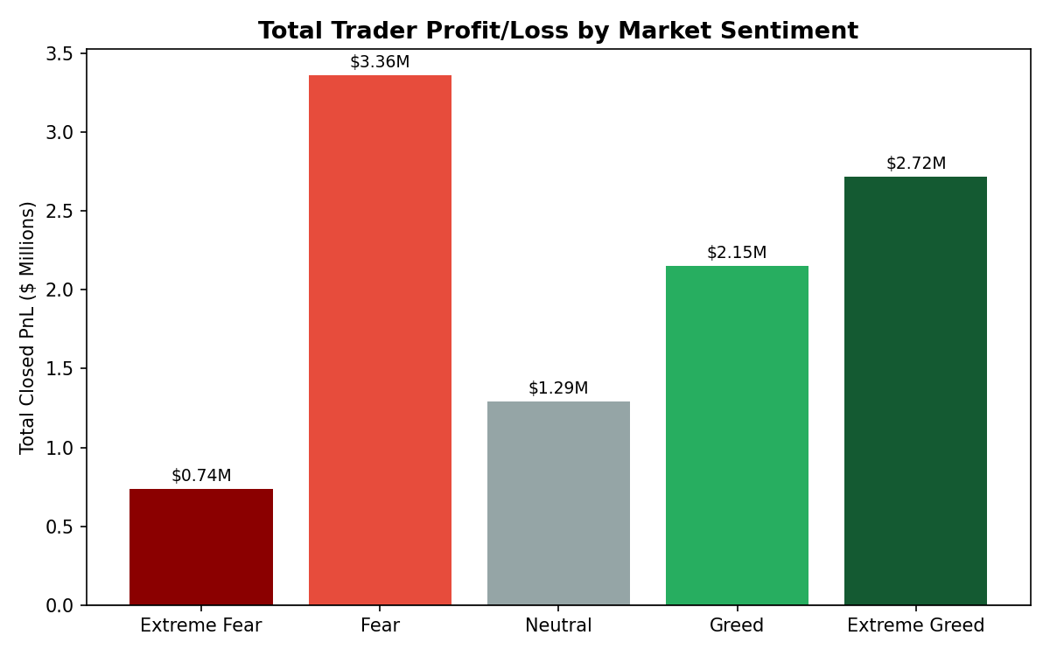
Figure 1. Total closed PnL by market sentiment classification.
Sentiment | % of Trades | Total Closed PnL | Avg Closed PnL / Trade
Extreme Fear | 10.1% | $0.74M | $34.54
Fear | 29.3% | $3.36M | $54.29
Neutral | 17.8% | $1.29M | $34.31
Greed | 23.8% | $2.15M | $42.74
Extreme Greed | 18.9% | $2.72M | $67.89

Fear (not Extreme Fear) is the single most profitable regime in absolute terms, generating a third of all profit despite being less than a third of trades. Extreme Fear is the weakest regime on every measure — lowest per-trade PnL, lowest win rate — suggesting that panic-driven trades are the cohort's worst decisions, while moderate fear is where genuine opportunity is captured.

3.2 Win rate by sentiment
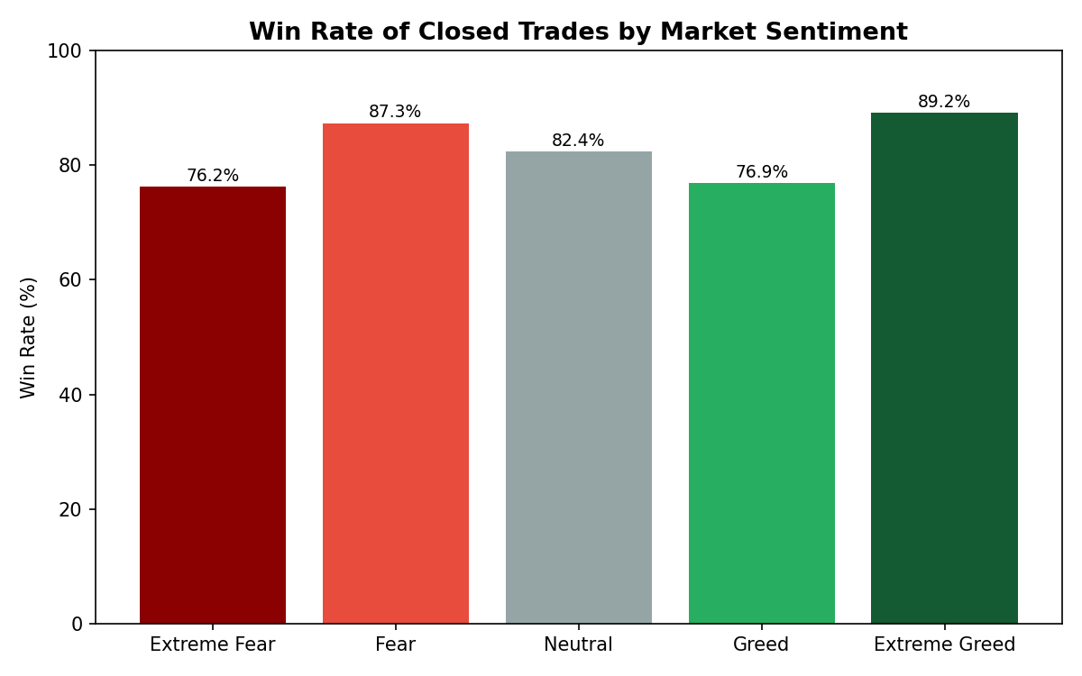
Figure 2. Share of closing trades that ended in profit, by sentiment.
Win rate follows a U-shape rather than a straight line: it is highest at Extreme Greed (89.2%) and Fear (87.3%), dips in Greed (76.9%) and is lowest in Extreme Fear (76.2%). This implies the crowd is a fairly reliable coincident indicator only at the extremes of euphoria, and a fairly unreliable one during outright panic — the two “extreme” states behave very differently from each other, which is easy to miss if Fear/Greed is treated as one linear scale.

3.3 Trading activity vs. sentiment
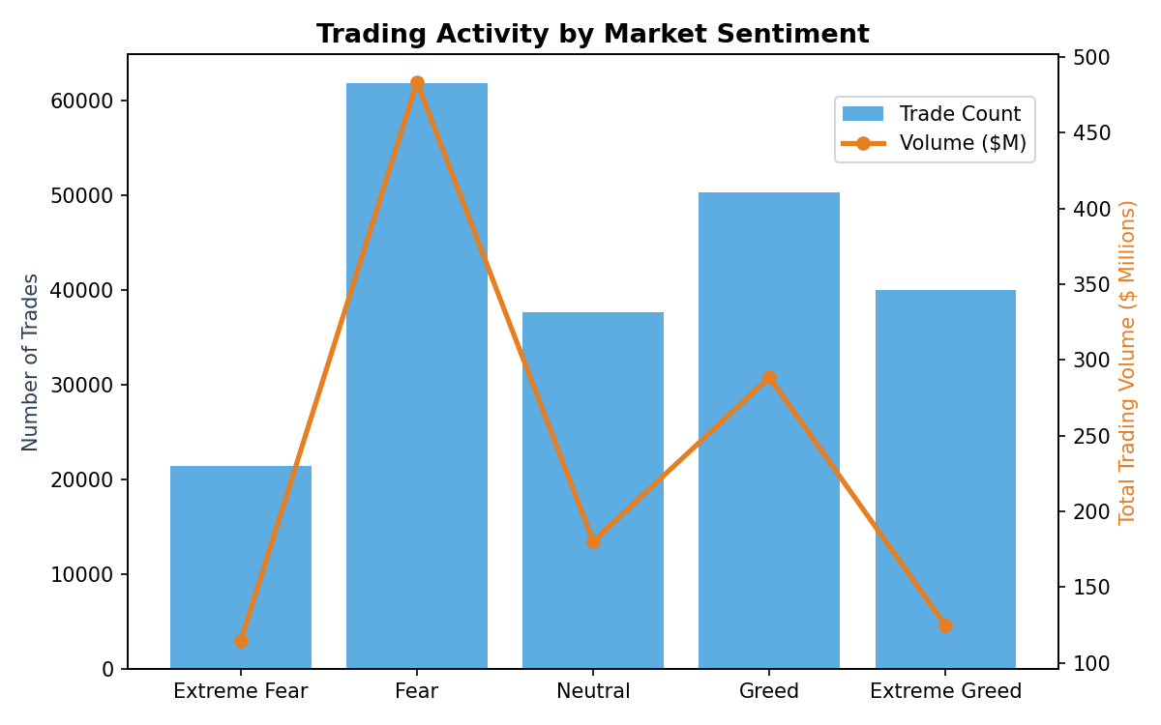
Figure 3. Number of trades (bars) and total volume (line) by sentiment.
Both trade count and dollar volume peak during “Fear” and are lowest during “Extreme Fear” and “Extreme Greed.” At the daily level, the correlation between the Fear & Greed index value and daily trade count is −0.25, and with daily volume is −0.26 — modest but consistent negative relationships. In plain terms: this cohort trades more, not less, as the market gets more fearful (up to a point), which is a contrarian “buy-the-dip” posture rather than a momentum-chasing one.

3.4 Position sizing by sentiment
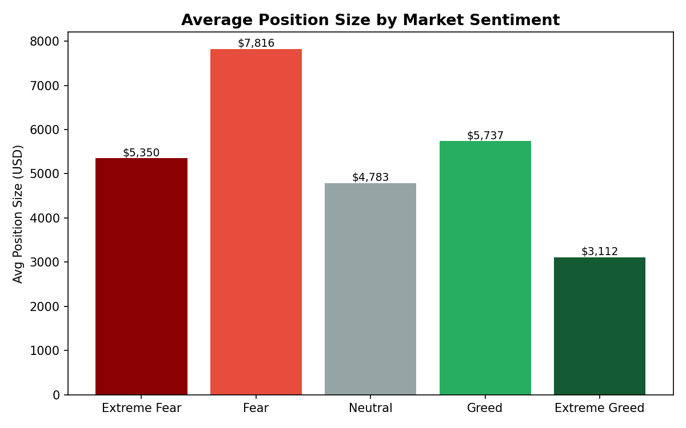
Figure 4. Average position size (USD) by sentiment.
Average position size is largest during Fear ($7,816) and smallest during Extreme Greed ($3,112) — more than double. Traders appear to add size into fear and de-risk into euphoric tops, which is consistent with the higher win rates and PnL seen in the Fear regime.

3.5 Sentiment sensitivity by asset
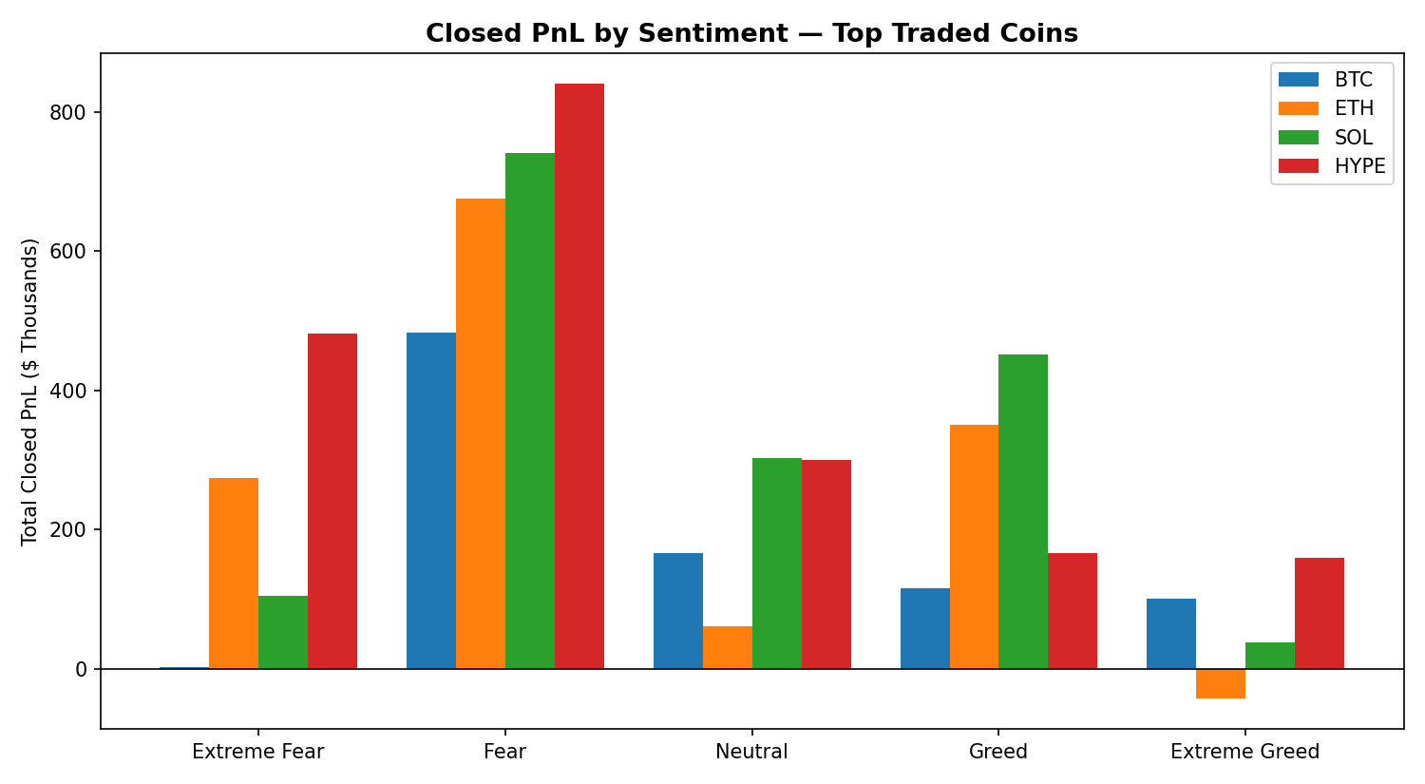
Figure 5. Closed PnL by sentiment for the four most-traded assets.
The sentiment effect is not uniform across assets. BTC and HYPE profits are heavily concentrated in “Fear” conditions. ETH is the only major asset that lost money overall during “Extreme Greed” (−$42K), hinting at late-cycle long positions being caught in reversals. SOL's profit is also weighted toward Fear and Greed, with much smaller contributions from the extremes. This suggests sentiment-based strategies should be tuned per-asset rather than applied as a blanket rule.

3.6 PnL and sentiment over time
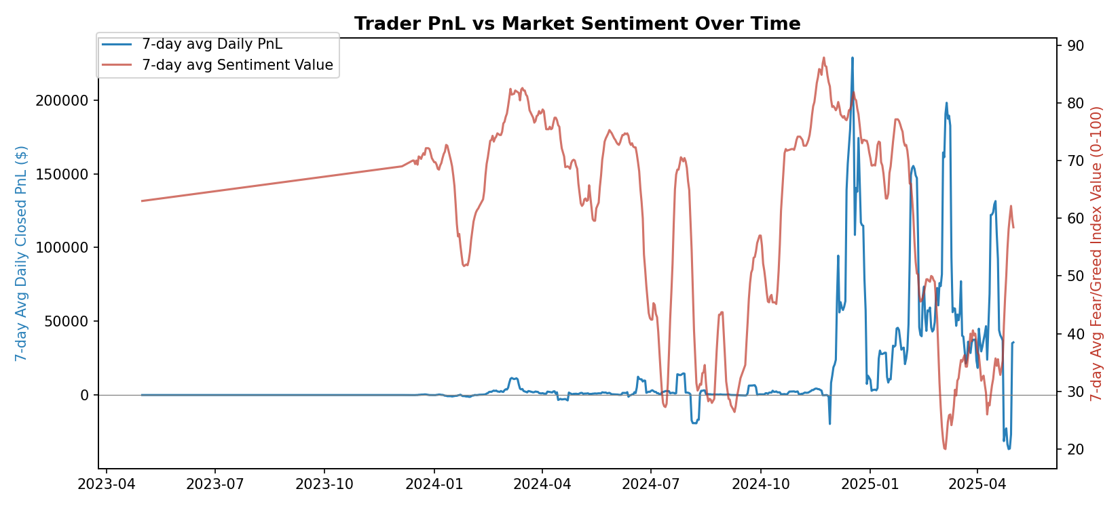
Figure 6. 7-day rolling average of daily PnL (blue, left axis) vs. 7-day rolling Fear & Greed value (red, right axis).
Visually, spikes in trader profitability cluster around periods when the sentiment index is moving off its lows rather than at sustained euphoric highs — consistent with the correlation figures above and reinforcing that this trader cohort profits from re-entering during and just after fear, rather than chasing greed.

4. Strategic Implications
- Lean in during moderate Fear: historically the highest-profit, high-activity, high-win-rate regime for this cohort — a candidate for modestly larger sizing rules.
- De-risk in Extreme Fear: despite being an intuitive “buy low” signal, this is the weakest regime by win rate and per-trade PnL — tighter risk limits or smaller size are warranted here specifically, not across all “fear” days.
- Treat Extreme Greed cautiously per-asset: while win rate is high in aggregate, ETH specifically lost money here — a reminder to monitor asset-level exposure rather than portfolio-level sentiment alone.
- Use sentiment as an activity signal, not just a directional one: the strongest relationship in the data is between sentiment and how much traders trade, which itself interacts with realized PnL — sentiment-scaled position limits may add more value than sentiment-based directional bets.

5. Limitations & Next Steps
- Closed PnL reflects realized gains only; unrealized (open) positions at the end of the dataset are not captured, which can understate or overstate true performance in any single regime.
- No leverage/margin field was present in the trade data, so position sizing is proxied by notional USD size only — true risk-adjusted returns could not be computed.
- Only 32 accounts are represented; results may be concentrated in a small number of high-volume traders (the top 10 accounts account for a large share of total PnL) and may not generalize to the broader Hyperliquid trader base.
- Recommended next step: repeat this analysis with account-level leverage/margin data and out-of-sample validation (e.g., a holdout period) before committing capital to any sentiment-based sizing rule.

