Tracking Fishing Hours and Fish Migration

By: Philip Blumin, Paul Cucchiara, Amy Leong

**TABLE OF CONTENTS**

Page Section

2 Introduction

3 Datasets & Region of Interest

4 Research

7 Results & Analysis

15 Conclusion

16 Future work

17 Sources

18 Appendix

# **Introduction**

The vast ocean is home to many different kinds of wildlife, yet in the North East Atlantic and nearby seas, 39% of fish stocks are classified as overfished. Today, each person eats on average 19.2kg of fish a year – around twice as much as 50 years ago[1]. With heightened demands from an increase in human population as well as the reliance of fishermen to feed their families through their catches, overfishing serves to be a growing issue around the globe. When vessels are catching fish quicker than when stocks can replenish, it becomes imperative for humanity to take action to ensure that the ocean’s ecosystem is not destroyed.

It is our part to determine how our excessive influence from fishing impacts ocean wildlife. We must understand the effects of our actions to be able to fix this issue. Without a way to easily detect all of the fish in the ocean and their migration patterns, it becomes difficult to analyze the extent to which humans play a role in tampering with the ocean. This is where remote sensing becomes useful. Satellites have the ability to detect certain features about the ocean and have been doing this for years. Using data about our ocean, we try to determine a correlation between fishing and our influence on fish. In effect, we try to learn as much as we can about the ocean.

# 

# **Datasets & Region of Interest**

The datasets that are analyzed come from The Hybrid Coordinate Ocean Model (HYCOM), a data-assimilative hybrid isopycnal-sigma-pressure (generalized) coordinate ocean model. This dataset comes from the National Ocean Partnership Program ([NOPP](https://www.hycom.org/component/weblinks/44/7)), as part of the U.S. Global Ocean Data Assimilation Experiment ([GODAE](https://www.hycom.org/component/weblinks/44/8)), and contains information about the temperature, salinity, velocity, and elevation of our oceans. Aside from the elevation, the data was taken at different depths, providing us with a more clear picture of which fishing types might be affected by these changes. The data has been interpolated to a uniform 0.08 degree lat/long grid between 80.48°S and 80.48°N. The salinity, temperature, and velocity variables have been interpolated to 40 standard z-levels. The data was accessed through Google Earth Engine’s large directory of data.

The other main source of datasets comes from the Global Fishing Watch (GFW), an organization that promotes ocean sustainability through greater transparency. They use cutting-edge technology to visualize, track and share data about global fishing activity in near real-time. The data in this dataset is in hours per square km and has 6 bands: Drifting Longines, Fixed Gear, Other Fishing, Purse Seines, Squid Jigger, and Trawlers.

The region of interest that was chosen for this project is the mid Atlantic ocean and the timeframe chosen was January 2014 - December 2016.

# 

# **Prior Research in the Field**

**Previous Work in Field**

This project is very interesting because surprisingly, there is not much known about fish migration and population. Since there are so many fish at different depths in the sea it is pretty much impossible to get an exact number. Scientists have speculated that the number is over 3.5 trillion. Fortunately, there is a lot more data out there on fishing hours and websites such as globalfishingwatch.org have been able to keep track of fishing hours throughout the world. Regarding fish migration there are several theories surrounding things like temperature change that will be discussed in greater detail later on in this report.

**Ocean Depths and Characteristics Effects on Fish**

The ocean’s sea surface temperature can be influenced by sunlight and global warming since the ocean naturally traps heat. However, this leads to an increase in water temperature, which is bad for fish because fish are unable to regulate their body temperature. Because of this, they are very much influenced by the surrounding water temperatures and are forced to migrate. When the water temperature increases to a level that can be dangerous for fishes, there are less regions in the ocean where certain species of fish can survive, which can lead to a decline in those fish populations.

Another known stressor from the increased water temperature is the dissolved oxygen levels in the water. As the temperature increases, the solubility of oxygen decreases[2]. In other words, if the water temperature gets too high, fishes may have trouble breathing in certain regions depending on the species because of oxygen depletion. This process of oxygen depletion typically begins in late spring, increases in summer, and ends in the fall.[3] Additionally, salinity has an effect on the dissolved oxygen levels. As salinity increases, the dissolved oxygen level decreases. This is because salt ions attract water molecules, which leaves fewer hydrogen and oxygen ions to capture and disassociate gas molecules.[4]

A factor that might influence fish migration is the Gulf Stream ocean current. The Gulf Stream ocean current moves north along the coast of Florida and then turns eastward off of North Carolina, flowing northeast across the Atlantic.[5] This can have an effect on the direction that the fish travels.

Aside from dissolved oxygen, salinity levels are pretty important for fish as their livelihood depends on the contents of the water they reside in. Certain fish are suited to live in freshwater(low salinity) while other fish are suited to live in saltwater (higher salinity). Some fish can even live in both as salinity levels do not affect them as much. Mainly the salinity impacts the fish’s stress level as it is harder for fish to regulate the amount of salt that is taken in through their gills.[6]

Understanding sea velocity is much more difficult and unpredictable than temperature and salinity. There are many things that impact the ocean’s currents, such as the earth’s rotation, the sun and moon’s gravitational impact, as well as the surface level wind. On a larger scale, temperature gradients in the ocean cause the ocean water in the north to travel southward. In another sense, the ocean is pushed by the coriolis effect, a force that veers all currents in the northern hemisphere to the right. This creates a clockwise motion in the ocean, forming one of the world’s eight gyres.

The ocean’s elevation is mainly dependent on its temperature. The water exhibits thermal expansion, which is the water's ability to expand as it warms. The particles of water in the ocean are more separated as the water gets warmer, thus resulting in the water taking up more space. The only place for the water to go is upward, resulting in different elevations. Because of the correlation in elevation and temperature, this may lead to fish migrating to places of certain elevation.

**Fishing Types and Hours**

The fishing hours dataset that was used for the project included several different types of fishing methods. The first method is known as **Drifting Longlines**, which is when a longline that has a bunch of baited hooks attached to it is suspended horizontally in the water. The hooks all go to different depths and are held up by surface floats as well. This method of fishing is common in the middle of the ocean and takes place near the surface, usually 50-150m but sometimes used at depths up to 1000m. The target fish of this method are tuna, swordfish, and billfish.

Another method in the dataset was **Fixed Gear** fishing, which includes rod & reel, and means trapping or potting, and gillnetting, where the catching implement is set, soaked and later retrieved. This method is more popular near the coast rather than in the middle of the ocean. Fixed Gear fishing usually takes place between 0 and 225m and targets sablefish and rockfish.

Another common fishing method is **Purse Seines**, which is basically when there is a large wall of netting deployed around an entire area of school of fish. This method is not very popular in the mid-atlantic ocean but usually takes place in the middle of the ocean up to 200m. The target fish are tuna and mackerel.

The final method of fishing that will be mentioned in the paper is **Trawlers.** A Trawler is a fishing net that is pulled along the bottom of the sea or in midwater at a specific depth by a commercial fishing vessel. This method of fishing is the deepest method compared to the others discussed and can go up to 600 meters. The target fish are cod, flounder and shrimp (only for bottom trawling).

In addition to fishing methods, research was also done into the amount of fishing hours in the mid-Atlantic ocean. A website was found that did a very good job illustrating the global fishing hours at any custom set timeframe[7]. Looking at the region of interest between and including 2014 and 2016, a few interesting patterns could be visualized from the website. The fishing hours could be broken up into 3 sections: near the coast, on the shelf, and in the middle of the ocean. Looking at the hours near the coast the fishing hours increase during the summer time (June - August) and seem to move a bit away from the coast. During the other months the fishing takes place a bit closer to the coast and there is much less of it. Near the shelf the hours seem to be pretty much consistent throughout the year. In the middle of the ocean is where the most interesting pattern can be seen. At the start of the year most of the fishing takes place in the southwest corner of the region of interest, but as the months go on the fishing hours shift northeast up till July. Then from July to December the fishing hours shift back southwest. This is a very important insight and will be discussed and compared to the results later in the report.

# 

# **Analysis & Results**

## **Procedure**

The Temperature and Salinity HYCOM datasets were analyzed first with histogram plots depicting the mean values of all pixels in a given month from all three years per depth. The histograms for the velocity and elevation datasets show the range of mean values for each month of data. Each dataset was then visualized with folium diagrams denoting each band as a different depth. Lastly, gifs were compiled highlighting the change in each pixel. This was done with each dataset from HYCOM.

The GFW datasets followed a similar procedure. The histograms made for GFW show the range of values that were observed for the entire month. Similar to HYCOM, the folium visualization was developed for the dataset from GFW.

## **Temperature**

Ocean temperatures have been something that people have looked at closely for some time now, so the expectation is quite clear of what should be found. Due to water’s high specific heat, it takes much more energy to be able to heat or cool the temperature of water. Thus, we should expect the temperature of the water to be a bit out of phase with the air above it. Also, sunlight has a much easier time reaching the surface as opposed to the depths of the ocean, so there should be a trend of cooler temperatures at lower depths.

As we can see from Figure 1, the graph peaks around August and September, which coincides with what was predicted. These trends hold for the next few recorded depths of 4m, 10m, and 20m as shown in Figures 2-5. Once we get to 80m of depth (Figure 6), we start to see the peak be pushed back to October/November. This makes intuitive sense because as the water above it gets warmer, it will take time for the heat to warm all the water below it. Once we start looking at the depths around 250m (Figure 9), we lose a clear sense of peak temperature and it seems more like a constant temperature range.

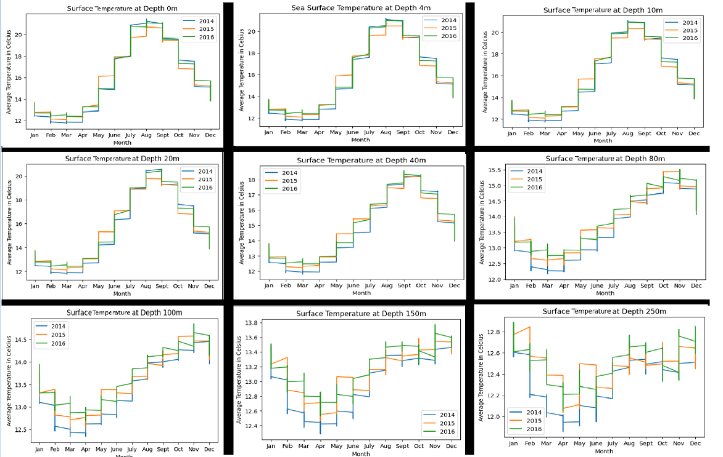**Figure 1-9:** Temperature By Depth

From the Folium view in Figure 10, it is much easier to see the temperature change than in the histograms. The red indicates the warmer regions, which show that the deeper we look, the less warm the water gets. The water closer to the equator is the warmer water, so our results make sense.

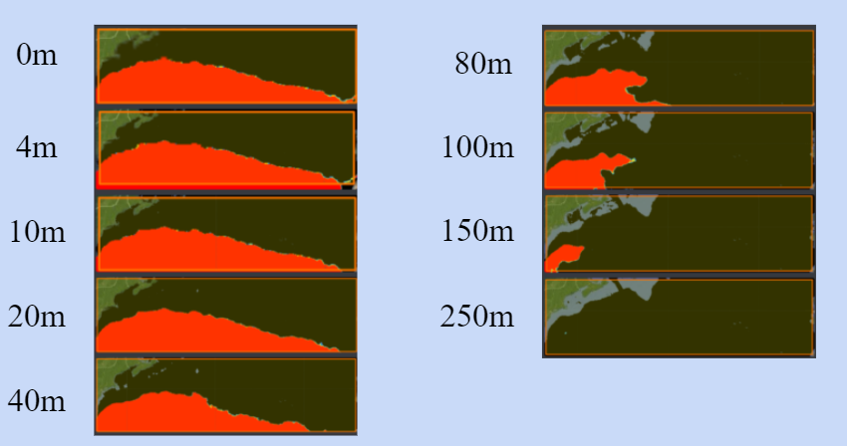

**Figure 10:** Folium view of Temperature per depth (colorband/values)

## **Salinity**

Our expectations of ocean salinity were not quite as certain as the entire region is composed of salt water. Analyzing salinity at different depths seems like it could show some results, but from prior research, salinity does not change drastically from area to area.

Figures 12-20 show the mean salinity throughout the year at different depths over the course of the three year period. Just as expected, the mean salinity does not change enough to attract different kinds of fish. The range for saltwater fish is generally 1.020-1.028sg in psu, which encapsulates the entire region. The folium visualization proves that the salinity does not change too much between depths. It is interesting that contrary to our assertions on salinity, the range of values does not really look greatest at the surface depths as time frame seems to be the bigger factor in salinity change.

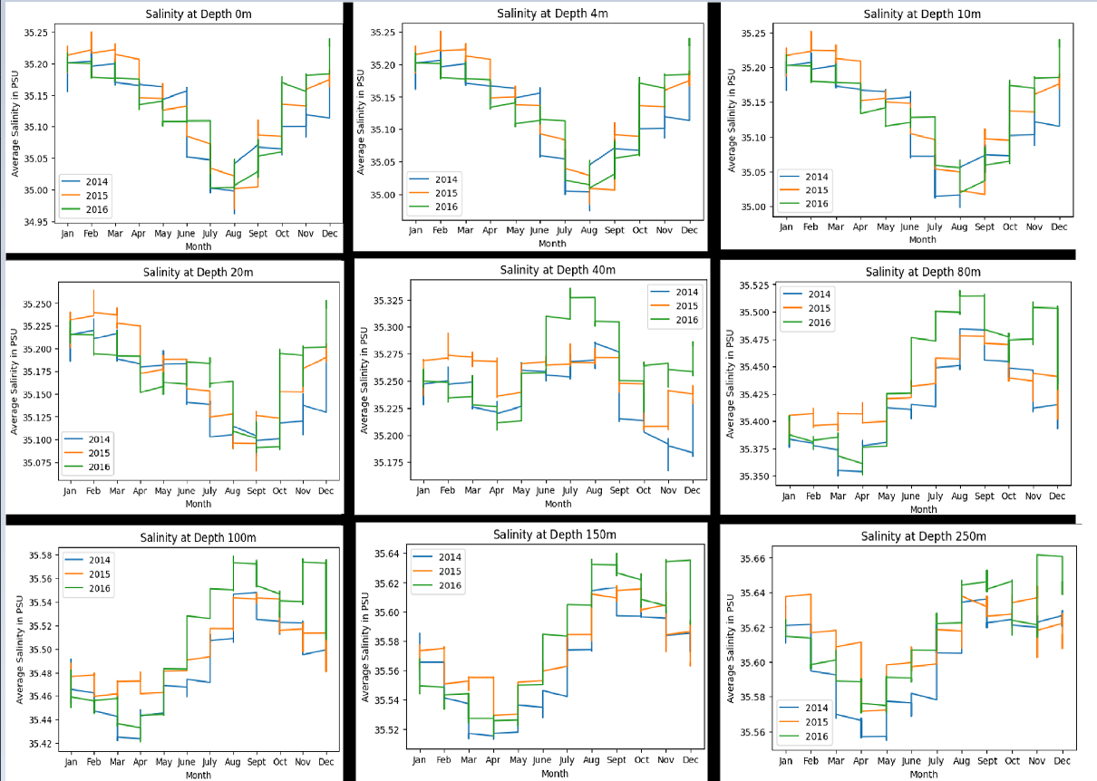

**Figure 11-19:** Salinity by Depth

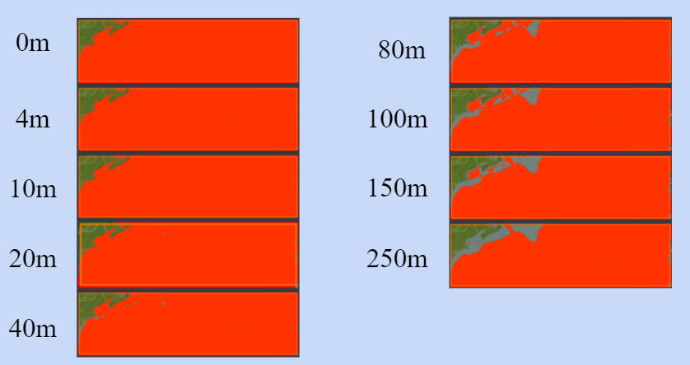

**Figure 20:**  Folium view of Salinity per depth

## **Velocity (Both Northward and Eastward)**

In our data, we see the effect of the gyre rotating the water in a clockwise manner by the graphs showing that the water moves both to the north and south from Figures 21-29 and primarily to the west in Figures 30-38. It is worth noting that these gyres operate at a much deeper level under the sea than the region that we are looking at, but these results show up nonetheless.

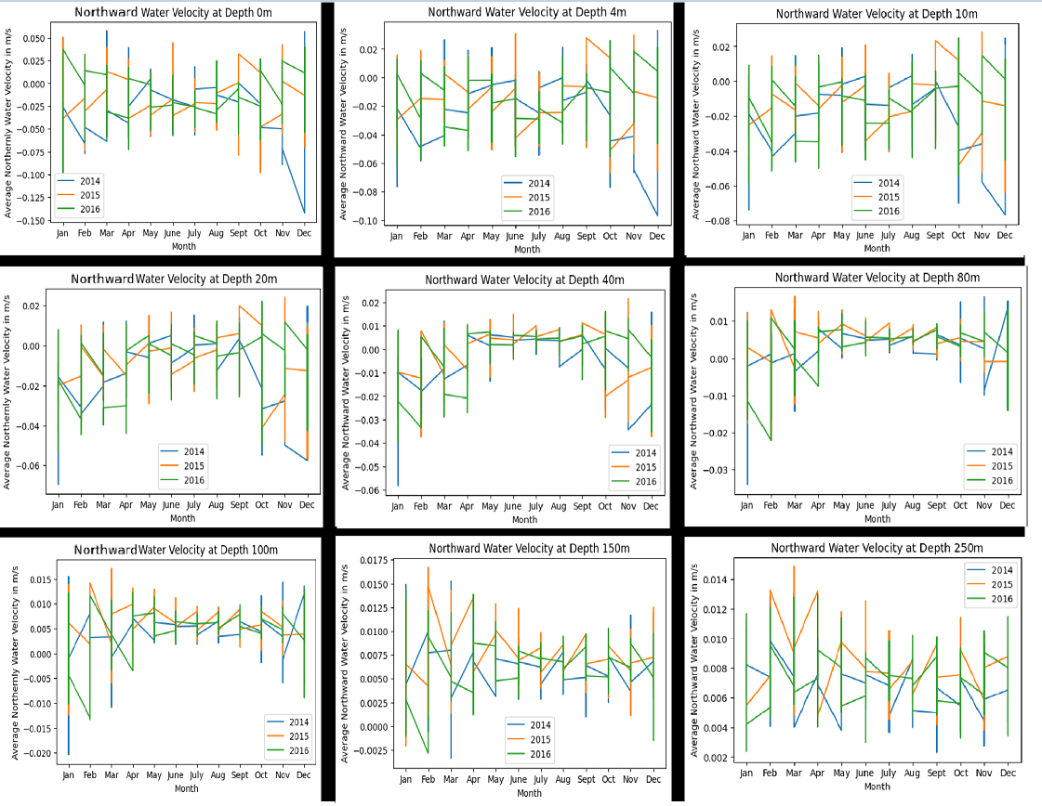

**Figure 21-29:** Northward Velocity by depth

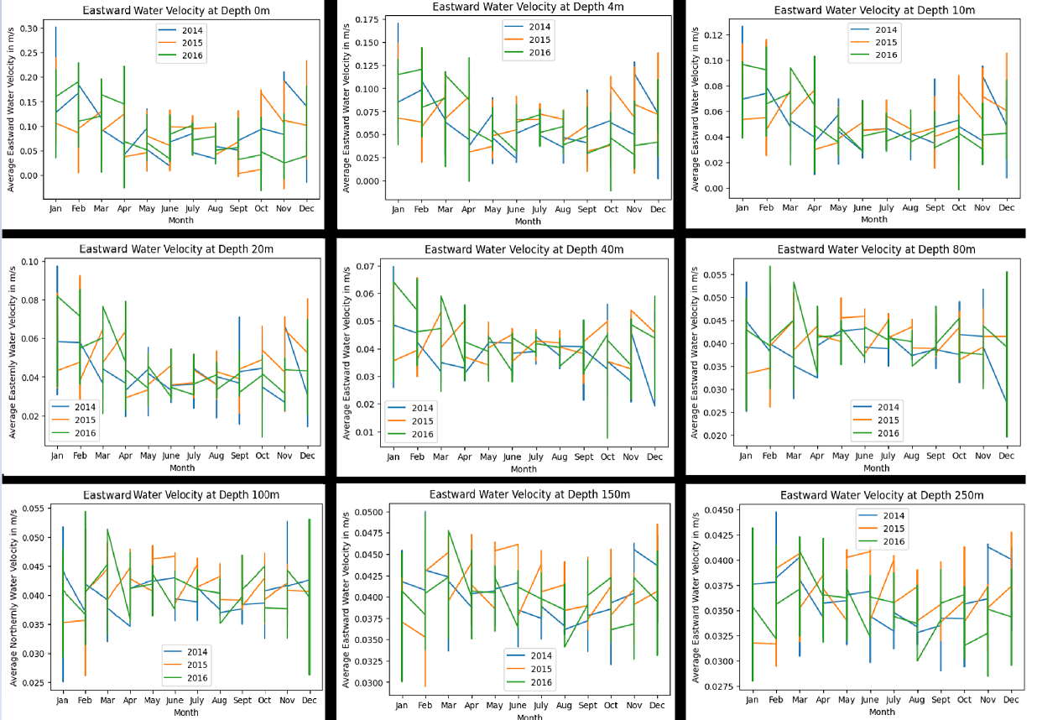

**Figure 30-38:** Eastward Velocity by depth

## **Elevation**

As shown in Figure 39, The sea elevation is highest in the months where the temperature was greatest. The fact that the results are negative are interesting because they indicate that the ocean’s non-uniformity is not too much of a factor here. Certain places in the ocean are going to be higher than other places, but because the range of values are not too drastic in Figure 39, we can see that the results make sense.

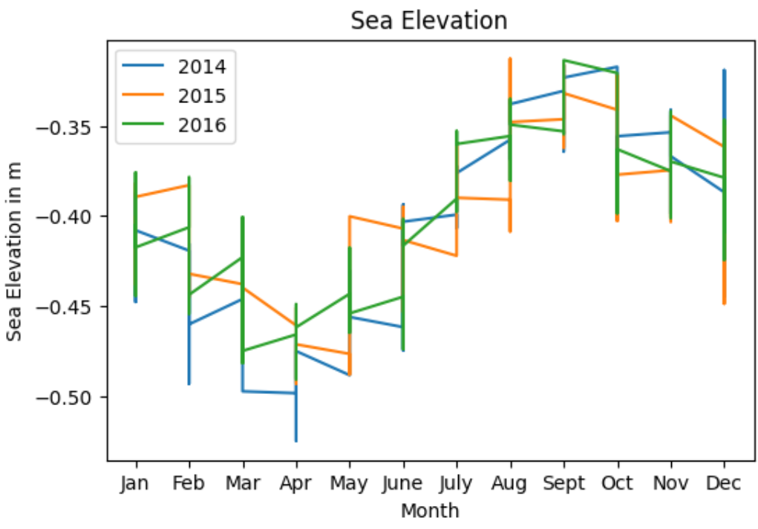

**Figure 39:** Sea Elevation

## **Fishing Data**

## The fishing dataset was pretty difficult to deal with because of how large the dataset was. There were many computational timeouts so the data needed to be cut down a lot. Because of this, the graphs seen in Figure 40 are taken from 2 days a week throughout the year (Wednesday and Sunday). All of the graphs below are also the max per day, as taking the mean would be pretty useless since most of the region will not have any fishing going on so the mean would be basically 0. As seen from Figure 40, squid jiggler fishing does not occur at all in the ROI so there was no point in looking further into this method. Drifting Longlines, Fixed, Gear, and Trawlers all seem to happen the most consistently throughout the year at around 25-30 hours/sq*km. Purse Seines occurs only in a few months but has the highest hours per sq*km of all the fishing methods.

# 

**Figure 40:** Max Fishing Hours by Type

In addition to the above graphs, folium maps for each fishing type were made separated by months. These can be found in the Appendix of this paper, but it is pretty difficult to see them from just a screenshot. It is a lot easier to see some of the patterns that will be discussed when looking at the folium on the Google Colab notebook.

When looking at the drifting longlines folium map, it is clear that most of the fishing is going on in the middle of the ocean and on the mid Atlantic Continental Shelf (top leftish area). Throughout the year, there is a shift from the southwest to northeast and back is visible. On the shelf the amount of fishing increases around July. This shift was quite interesting to see and agrees with the shift that was seen when looking at the global fishing hours in the prior research. Some possible explanations and conclusions from this shift will be discussed in greater detail later on.

# The next folium maps to look at are fixed gear, trawlers, and other fishing. These 3 methods are grouped together because they all exhibit similar patterns in the same areas of the ocean. As seen from the folium maps there is a lot more fishing going on during the summertime and the fishing seems to move closer to the coast. Meanwhile, during the colder months fishing moves a bit away from the coast. This pattern is best visible for the trawler folium map.

# The final folium map is purse seines and there is not much to tell from this as it seems during most months barely any fishing is going on. Below is a chart that summarizes the locations of each of the fishing types seen in the folium map as well as the depths.

# **Figure 41:** Folium Map Observations

# **Conclusion**

Overall, the ocean feature datasets were consistent with what was expected for the temperature, velocity, and elevation in our region of interest between and including 2014 and 2016. Our data for the temperature shows that the temperature decreases as the depth increases, which makes sense because less sunlight travels the deeper the depth. Our dataset for northward and eastward velocity was also consistent with what was predicted. Since there are many factors for the movement of the water such as the earth’s rotation, the sun and moon’s gravitational impact, and the surface level wind, it is hard to predict just one trend. However, it is found that there is a southwest to northeast movement, which is consistent with the gulf stream ocean current. Our dataset for elevation was consistent with what was predicted. Factors like thermal expansion cause the water to expand when temperatures increase. As found in the dataset, the elevation was highest around the summertime.

There was a dataset for the ocean features that was not consistent with what was expected. The salinity dataset had salinity levels that were relatively consistent. However, it was predicted that the salinity levels were expected to be the greatest at surface level.

For the fish dataset there was a clear trend that could be seen in the middle of the ocean and near the coast. Drifting Longlines demonstrated a shift from southwest to northeast and back throughout the year. There was increased fishing activity for Fixed Gear, Trawlers, and Other Fishing during the summer time. Also there was a shift towards the coast during the summer time. During the other months of the year these types of fishing had increased hours a bit farther away from the coast. Overall observations for each of the types are consistent with the hours seen on the global fishing hours website.

Since the datasets were examined through a 3 year period time frame from January 2014 to December 2016, it might be worth looking into a bigger time frame to see more change. Additionally, there are other factors in the Mid Atlantic Ocean region that were not taken into consideration, which will be discussed further in the Future Work section.

# 

# **Future Work**

# Although ocean characteristics such as temperature, salinity, velocity, and elevation were examined, there are other factors that may indicate the direction of fish migration. Natural disasters impact marine life in many ways that are not always so apparent to people. In our region of focus, hurricanes are the most common form of disaster. These mighty forces are known to devastate thousands of peoples, but for ocean creatures it is different. The rough waves of the ocean during a hurricane only affect the region close to the surface as many marine animals can swim deeper to avoid the havoc. With that said, certain types of oceanic creatures tend to stay close to the shore. Many of their homes would be destroyed and many more would be cast onto shore. The ones that do survive have to endure the high amounts of incoming debris from shore. This is one of the alleged factors that wiped an estimated 9.4 million saltwater fish in Hurricane Andrew from 1992, which hit lower in the Atlantic Ocean. The debris also prevents sunlight from reaching the depths it used to before the disaster, impacting the food supply of algae for these fish. Some of the other things that could be hazardous for fish would be the mixing of water of different temperature, salinity, and other properties.

Other things that might be significant would be the relationships between different marine creatures and how they might influence migration patterns. We noticed that the fish tended to stay outside of the warmest region, and a possible reason could be that sharks have a stronger presence in these warmer areas.

Furthermore, different fish species have different preferences for temperature and salinity. Certain types of salmon can survive in both freshwater and saltwater, but other kinds of fish are more strict with the kind of environment it can survive in.

Lastly, it would have been interesting to combine all of the data that was found into one dataset and train a model with machine learning to predict which areas would be best for fishing at certain time periods. However, there would be a few challenges with the learning aspect as most of the data would have no fishing (~95%) since the region is huge. This would cause the model to most likely predict that there is no fish activity. It still might have been insightful to try to build a model with all the datasets and predict the best fishing spots in the mid Atlantic region and compare it to the global fishing hours dataset from Google Earth Engine.

**Sources**

**Research:**

* <https://www.open.edu/openlearn/science-maths-technology/the-oceans/content-section-3.5>
* <https://oceanservice.noaa.gov/facts/coldocean.html#:~:text=Water%20gets%20colder%20with%20depth,warmer%20water%20near%20the%20surface.&text=While%20this%20geothermal%20energy%20is,it's%20immeasurable%20by%20direct%20means>.
* <https://oceanservice.noaa.gov/facts/gulfstreamspeed.html>
* <https://www.noaa.gov/education/resource-collections/ocean-coasts/ocean-currents>
* <https://ocean.si.edu/through-time/ancient-seas/sea-level-rise#:~:text=As%20the%20planet%20gets%20warmer,of%20water%20in%20the%20sea>
* <https://globalfishingwatch.org/map/>
* <https://en.wikipedia.org/wiki/Longline_fishing>
* <https://seacoastspecialty.com/vessels/commercial-fishing/>
* <https://en.wikipedia.org/wiki/Fishing_trawler>
* <https://www.msc.org/what-we-are-doing/our-approach/fishing-methods-and-gear-types/purse-seine>
* <https://oceanservice.noaa.gov/facts/gulfstreamspeed.html#:~:text=The%20Gulf%20Stream%20is%20an,flowing%20northeast%20across%20the%20Atlantic>
* <https://www.ospo.noaa.gov/Products/ocean/sst/contour/>
* <https://www.open.edu/openlearn/science-maths-technology/the-oceans/content-section-3.5>
* <https://www.sciencemag.org/news/2004/04/volcanoes-favorite-time-year>
* <https://www.sciencekids.co.nz/sciencefacts/earth/oceans.html#:~:text=Around%2070%25%20of%20the%20Earth's,(621%20miles)%20in%20length>.
* <https://www.worldwildlife.org/threats/overfishing>
* <https://www.fishforward.eu/en/topics/facts-figures/#:~:text=Over%20just%2040%20years%20there,stocks%20are%20fully%20fished%20%5B7%5D>
* https://www.businessinsider.com/what-happens-fish-dolphins-sea-animals-hurricane-2018-10#:~:text=Hurricanes%20can%20be%20just%20as,or%20far%20out%20at%20sea.&text=Far%20out%20at%20sea%2C%20fish,and%20swim%20to%20calmer%20seas.

**Datasets:**

* <https://developers.google.com/earth-engine/datasets/catalog/GFW_GFF_V1_fishing_hours>
* <https://developers.google.com/earth-engine/datasets/catalog/HYCOM_sea_water_velocity>
* <https://developers.google.com/earth-engine/datasets/catalog/HYCOM_sea_surface_elevation>
* [https://developers.google.com/earth-engine/datasets/catalog/HYCOM_sea_temp_salinity](https://developers.google.com/earth-engine/datasets/catalog/HYCOM_sea_temp_salinity#description)

# **Appendix**

## **Fishing Folium Maps**

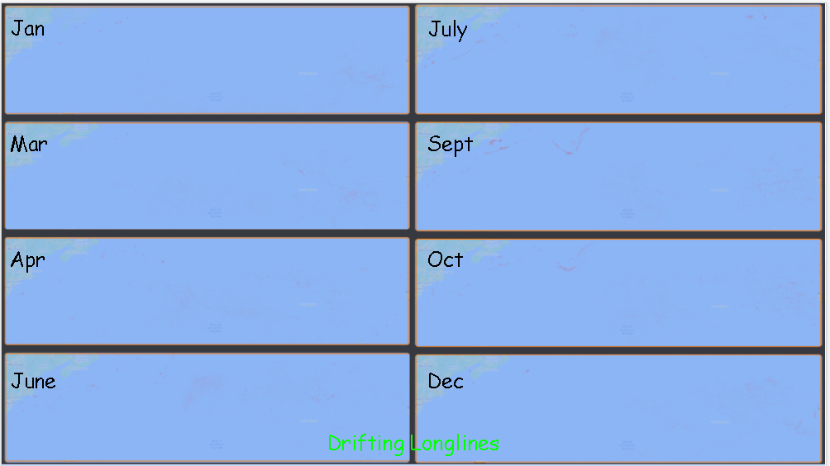

**Figure 42:** Drifting Longlines Folium Map by Month

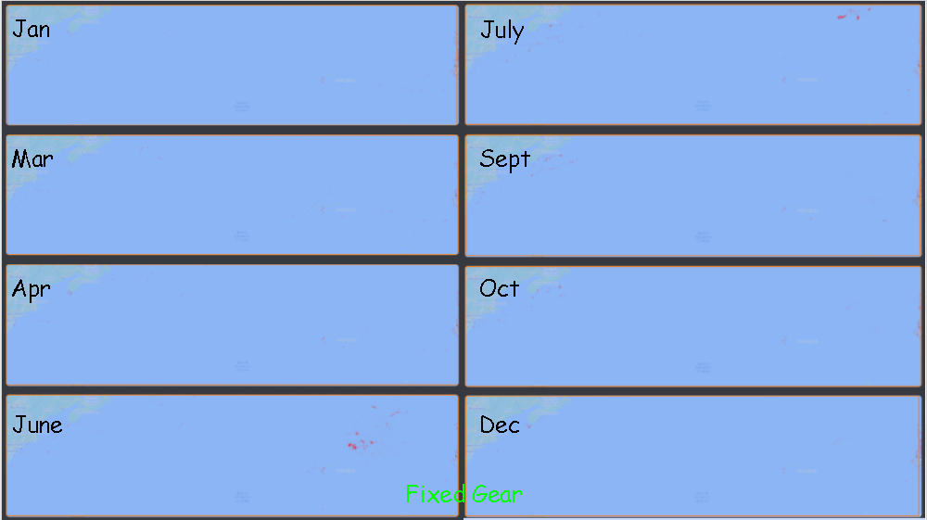

**Figure 43:** Fixed Folium Map by Month

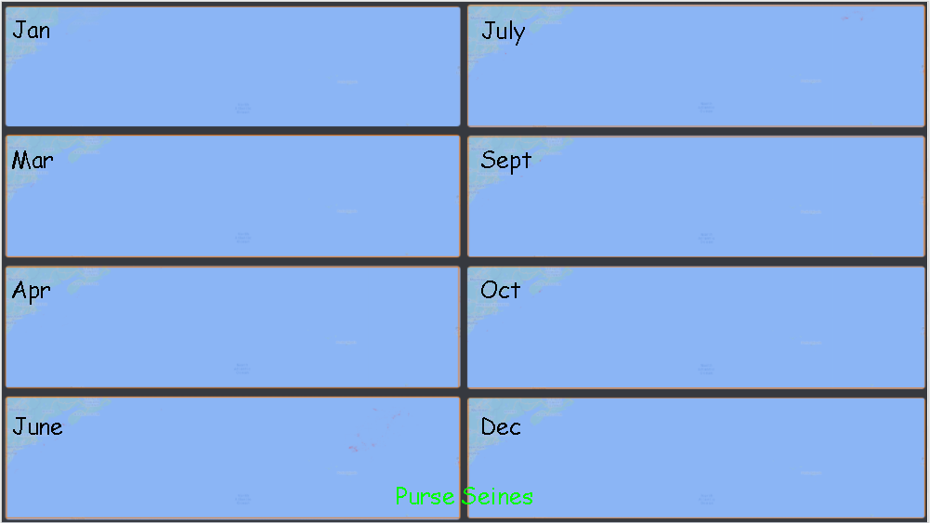

**Figure 44:** Purse Seines Folium Map by Month

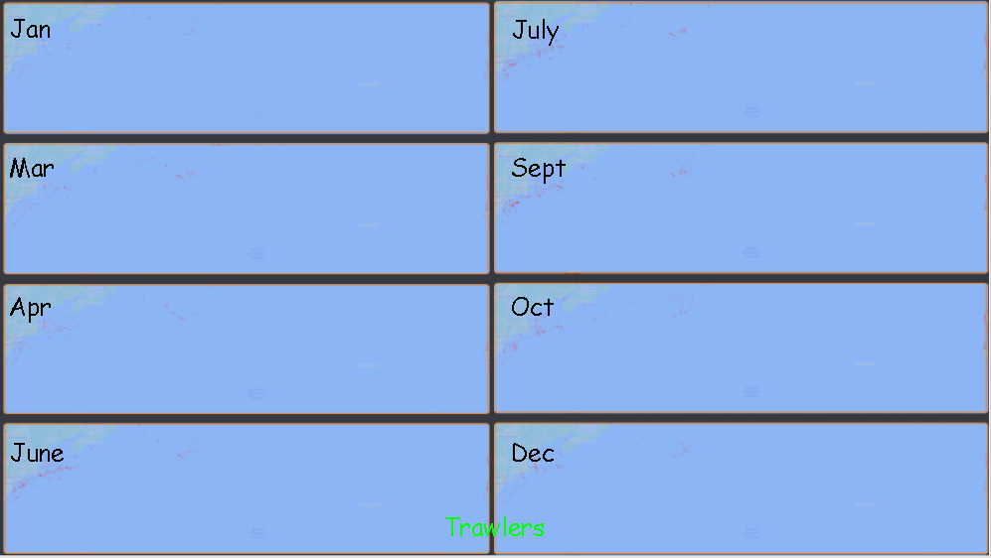

**Figure 45:** Trawlers Folium Map by Month

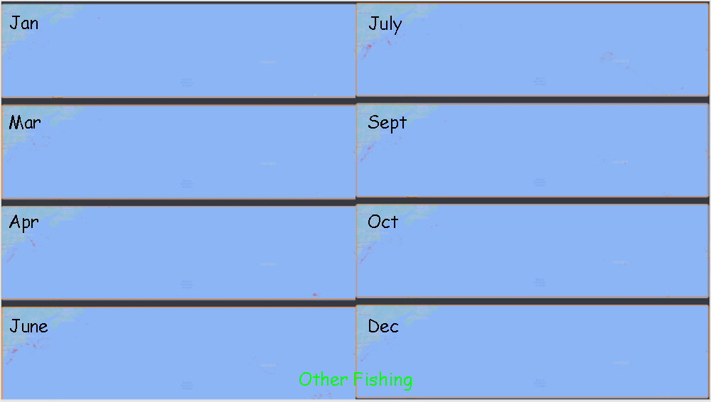

**Figure 46:** Other Fishing Folium Map by Month

## **Gifs**

Temperature: <https://photos.app.goo.gl/tbmGxjYuYWi6MTeM6>

Elevation: <https://photos.app.goo.gl/NusJgCqu1JBkUJbw6>

Northward Velocity: <https://photos.app.goo.gl/KTktukRqDA2PvWin9>

Eastward Velocity: <https://photos.app.goo.gl/gu4LXabcUY1HEr8v9>

1. <https://www.fishforward.eu/en/topics/facts-figures/>
2. <https://www.fondriest.com/environmental-measurements/parameters/water-quality/dissolved-oxygen/>
3. <https://www.usgs.gov/special-topic/water-science-school/science/dissolved-oxygen-and-water?qt-science_center_objects=0#qt-science_center_objects>
4. <https://sciencing.com/info-10024026-salinity-affect-solubility-oxygen-water.html>
5. <https://oceanservice.noaa.gov/facts/gulfstreamspeed.html>
6. <https://www.scientificamerican.com/article/why-do-some-fish-normally/>
7. <https://globalfishingwatch.org/map/>