Task 1 Activity B – Design Documentation
Activity B is worth 34 marks and requires you to produce four separate design documents for your digital solution. These must be detailed enough for a third-party developer to implement your proposed solution.
Overview of Activity B
You must produce:
- Visual/Interface Design (6 marks)
- Algorithm Design (4 marks)
- Data Requirements (6 marks)
- Test Strategy (6 marks)
Plus Design Documentation Quality (6 marks) – assessed across all documents for clarity, technical language, and audience suitability.
1. VISUAL/INTERFACE DESIGN
What This Means
This is the user-facing design of your application. It shows how the website or app looks and feels to customers. You're explaining the layout, visual hierarchy, design conventions, and user experience features.
Key Design Principles
- Layout and White Space
What This Means: How you organise information on the screen. Good layout uses "white space" (empty space) strategically to help users focus and reduce cognitive overload.

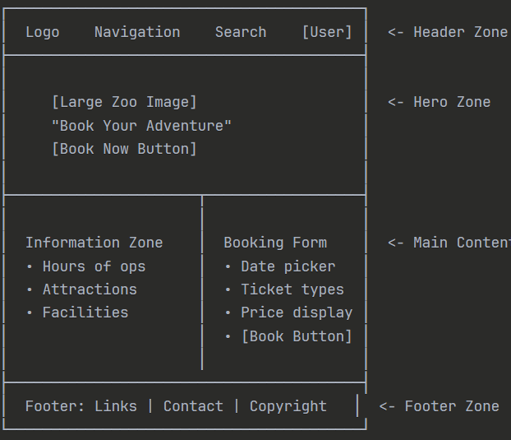
Responsive Layout for Different Devices:
Your design must work on mobile, tablet, and desktop. Explain how layouts adapt:
Desktop View (1200px+ width):
Tablet View (768-1024px width):
Mobile View (320-480px width):
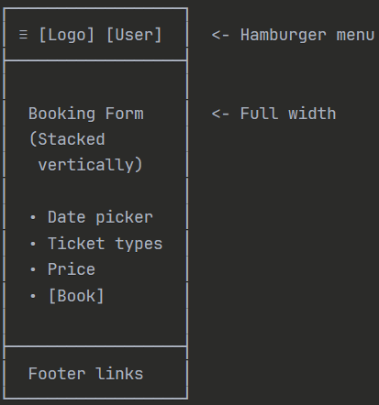
- Visual Hierarchy
What This Means: Using size, colour, and placement to guide users' attention. Important elements should stand out; less important elements should be subtle.
Example (Size Hierarchy, Colour Hierarchy, Placement Hierarchy)

2. ALGORITHM DESIGN
What This Means
Algorithms are step-by-step procedures to solve specific problems. You explain the logic of how your system handles key processes using flowcharts, pseudocode, and data flow diagrams.
Key Problems to Decompose
The marking scheme suggests up to 5 complex problems representing different types. Here are examples for RZA:
- User Authentication – Password validation and session management
- User Registration – Registers new users
- Booking Availability Check – Prevent overbooking in real-time
- Hotel Reservation – Users reserve a room if there is availability.
- Safari Ticket Booking – Users book a safari ticket
- Loyalty Points Calculation – Calculate and award points from transactions
- Payment Processing – Secure payment transaction flow
- Educational Content Recommendation – Suggest materials based on user age

Problem 1: User Login/Authentication
Decomposition:
Inputs:
- User email address (string)
- User password (string)
Processes:
- Check if email exists in the database
- Retrieve stored password hash
- Hash the entered password
- Compare hashes
- Create a session if a match
- Record login attempt
Outputs:
- Success: User logged in, session token created
- Failure: Error message ("Email not found" or "Incorrect password"), login attempt logged

Problem 2: Check Booking Availability (Prevent Overbooking)
Decomposition:
Inputs:
- Visit date (date)
- Ticket type (string: "Adult", "Child", "Senior")
- Number of tickets required (integer)
- Daily capacity limit (integer, e.g., 500)
Processes:
- Query database for tickets already booked on this date
- Calculate remaining capacity
- Compare requested tickets to remaining capacity
- If available, reserve the tickets
- Update inventory
Outputs:
- Success: "X tickets reserved. Total cost: £Y"
- Failure: "Only N tickets available. Would you like X instead?"

Problem 3: Calculate Loyalty Points
Decomposition:
Inputs:
- User ID (integer)
- Transaction amount (decimal, e.g., £89.50)
- Transaction type (string: "ticket_purchase", "hotel_booking")
- Existing loyalty points balance (integer)
Processes:
- Calculate points earned (amount × 0.1, i.e., 1 point per £1)
- Check for multipliers (e.g., hotels give 2x points)
- Add to user's total points
- Record transaction in loyalty ledger
Outputs:
- Points earned: N points
- New total balance: M points
- Message: "Congratulations! You earned X points. New balance: Y points."

3. DATA REQUIREMENTS
Overview
The data design ensures that all components of the Riget Zoo Adventures (RZA) solution can store, retrieve, and process information efficiently.
What This Means: This is the database design explaining how data is organised, structured, and validated. You show the tables, fields, data types, and rules that govern data.
It includes:
- Entities and Relationships - Visual representation of tables and relationships
- Data Dictionary - Table-by-table explanation
- Validation Rules - Rules for cleaning/validating input
- Error Handling - How invalid data is managed

Explanation:
- USER: Stores account details, preferences, and accessibility settings.
- BOOKING: Links users to ticket and hotel reservations.
- HOTEL: Stores room details, availability, and pricing.
- LOYALTY_ACCOUNT: Tracks points earned and redeemed.

Data Dictionary
Entity | Attribute | Type | Validation Rules/Constraints | Description
User | user_id | INT (PK) | Auto-increment, unique | Unique user identification number
 | name | VARCHAR(50) | Not null, letters only | User name
 | email | VARCHAR(100) | Must match regex: ^[^@]+@[^@]+\.[^@]+$ | User email
 | password_hash | CHAR(60) | Generated using bcrypt | User password (hashed)
Booking | booking_id | INT (PK) | Auto-increment | Booking id
 | user_id | INT (FK) | Must exist in User | User id
 | visit_date | DATE | Must be >= CURRENT_DATE | Date of the safari visit
 | ticket_type | ENUM | {Adult, Child, Senior, AnnualPass} | Ticket type
 | quantity | INT | 1–50 | Number of tickets
 | status | ENUM | {pending_payment, confirmed, cancelled} | Payment status
Hotel | room_id | INT (PK) | Auto-increment | Hotel room id
 | room_type | ENUM | {Standard, Deluxe, Suite} | Hotel room type
 | price_per_night | DECIMAL(6,2) | > 0 | Price of a room per night
 | availability | BOOLEAN | TRUE/FALSE | Room availability
Loyalty | loyalty_id | INT (PK) | Auto-increment | Loyalty id
 | user_id | INT (FK) | Must exist in User | User id
 | points_balance | INT | >= 0 | Points accumulated

Projected Data Requirements
Variable names | Function | Data Type | Reason
$username | To store username when users register on the application. | String | To validate username and then  store it in database
$dateOfBirth | To store user date of  birth when they  register | DateTime | To validate date of  birth to ensure that  the user is legal age  and if they need to  assign their  account to their  parent account and  then store it in  database.
$emailAddress | To store user email  address when they  register | String | To validate email  address and store  it within the  database and  ensure that the
Add more

Error Handling Procedures
- Email Validation: Reject invalid formats; display error:
“Invalid email address. Please use format: name@example.com.”
- Password Strength: Minimum 12 characters, mix of letters and numbers.
- Date Validation: Prevent past dates for bookings.
- Quantity Validation: Reject >50 tickets; suggest alternative.
- SQL Injection Prevention: Use prepared statements and sanitisation.

4. TEST STRATEGY
Testing Approach
Testing will follow a structured order:
- Unit Testing – Individual modules (e.g., login, booking form).
- Integration Testing – Interaction between front-end and back-end.
- System Testing – Full workflow (account creation, booking, payment).
- Acceptance Testing – Validate against KPIs and user acceptance criteria.
Example
Project Testing
Software must be tested before it is deployed to ensure that the software is
secure and that it functions as required, and so it will improve user experience and reduce
costs in the long term. By implementing various testing methodologies, we aim to identify and
resolve potential errors, validate data integrity, improve efficiency, and improve usability.
Testing Methodologies
We will carry out various testing methods, where each focuses on different parts of the
software and the scale of the system, and so is required to ensure that the software is fully
functional.
Some of the testing methodologies we will be using include:
• Unit Testing – This is the testing where we test each function (method in OOP),
classes in JavaScript and PHP code, on its own.
• Integration Testing – In this testing methodology, we will test if any bugs or errors
are created when different functions and classes are integrated.

Continue……

Component Interrelation
- Login Module: feeds Session Management - required for Booking Module.
- Booking Module: interacts with Payment Gateway and Database.
- Loyalty Module: updates after successful payment.

Types of Tests
- Functional Tests: Verify booking form calculates correct price.
- Non-functional Tests: Load testing for 500 concurrent users.
- Black-box Tests: Validate outputs without checking internal code.
- White-box Tests: Check algorithm logic for loyalty points calculation.

Example Test Cases
Test ID | Component | Test Type | Input | Expected Output
TC01 | Login | Functional | Email: valid, Password: valid | Redirect to dashboard
TC02 | Login | Functional | Email: invalid format | Error: “Invalid email address”
TC03 | Booking | Boundary | Quantity: 0 | Error: “Quantity must be at least 1”
TC04 | Booking | Boundary | Quantity: 51 | Error: “Maximum 50 tickets allowed”
TC05 | Payment | Functional | Card details valid | Confirmation message + booking status = confirmed
TC06 | Accessibility | Non-functional | Enable high-contrast mode | UI switches to high-contrast theme

Test Data Categories
- Normal Data: Valid email, date, quantity.
- Erroneous Data: Invalid email, negative quantity.
- Boundary Data: Quantity = 0, Quantity = 50.
- Absent Data: Empty fields in booking form.
- Wrong Format: Date entered as text instead of DD/MM/YYYY.

Testing Sequence Diagram
[Unit Test] → [Integration Test] → [System Test] → [Acceptance Test]

