**EXERCISE 2**

**DIGITAL ELEVATION MODEL (DEM) – INTERPOLATING AND VISUALISING**

CHUKWU CHINYERE PRECIOUS

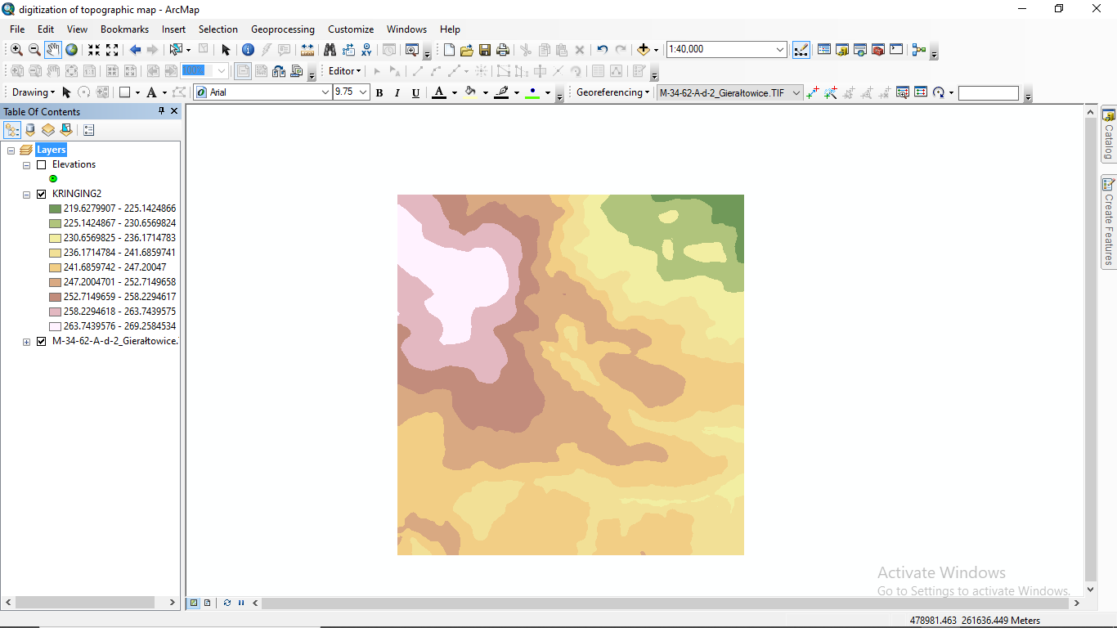**KRINGING – CLASSIFIED**

**KRIGING - STRETCHED**

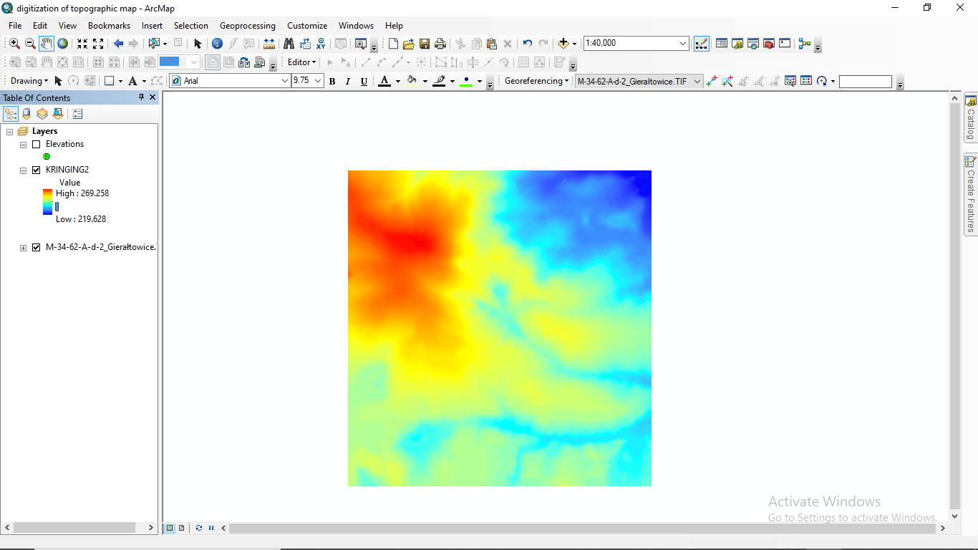

**IDW - CLASSIFIED**

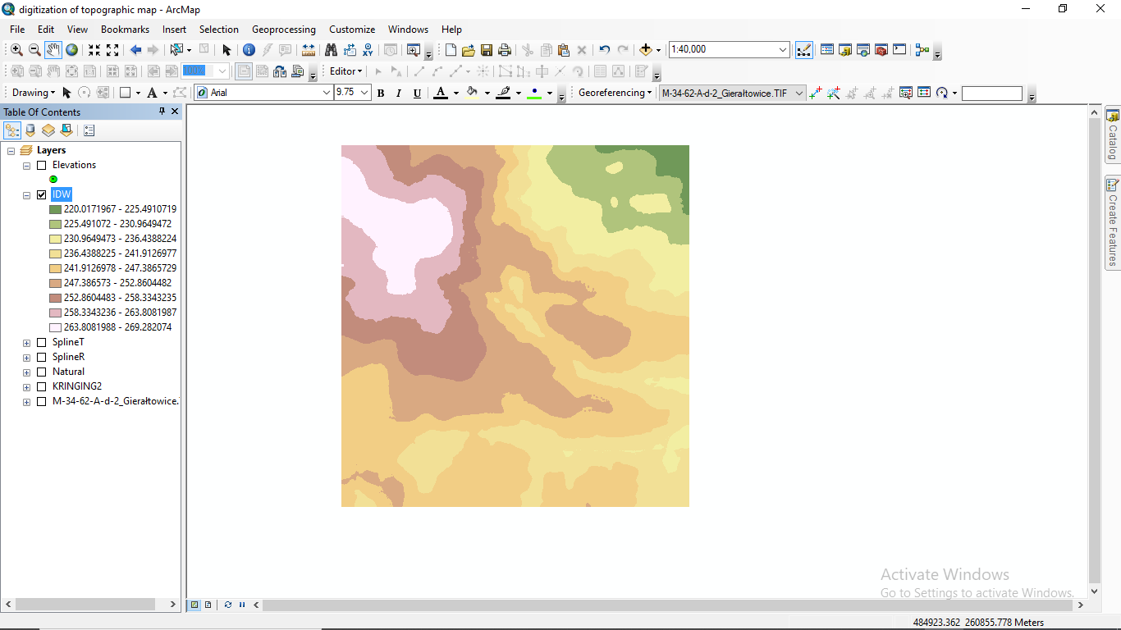

**IDW - STRETCHED**

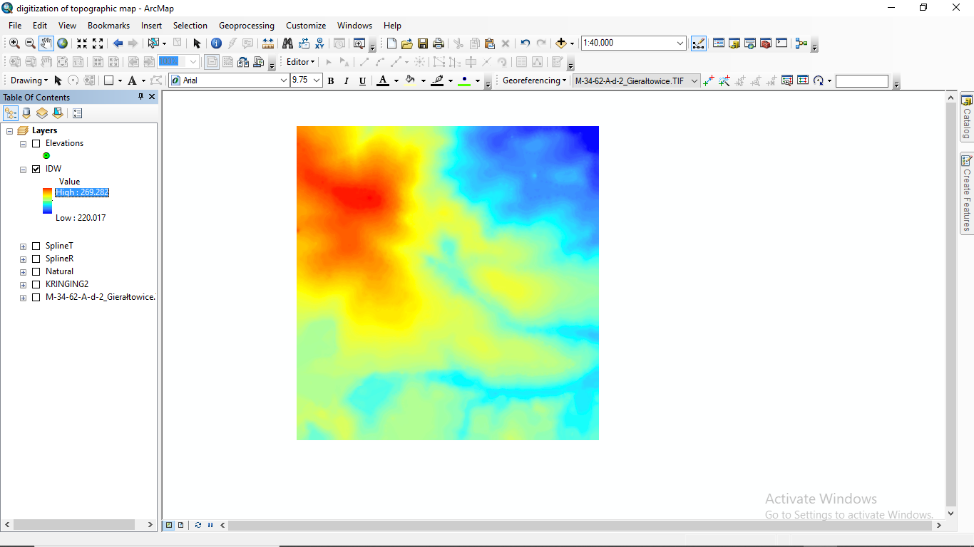

**NATURAL NEIGHBOR - CLASSIFIED**

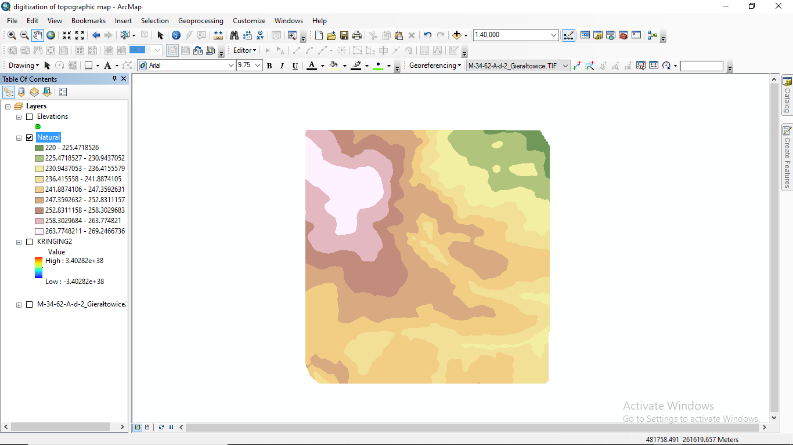

**NATURAL NEIGHBOR - STRETCHED**

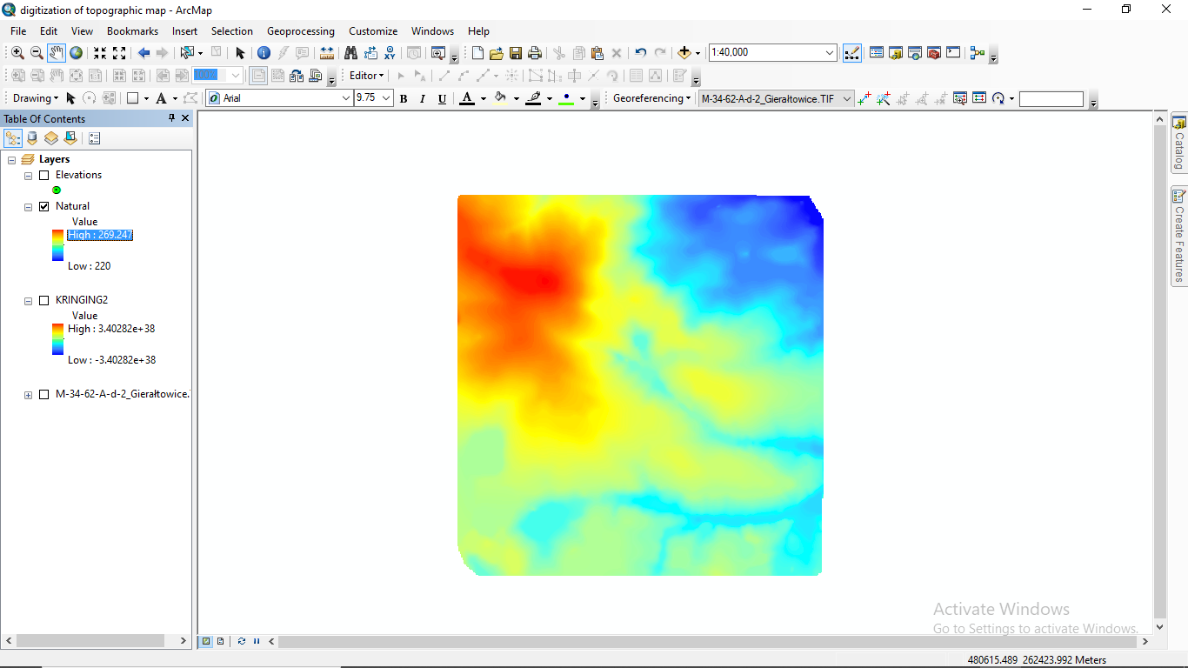

**SPLINE (REGULARIZED)- CLASSIFIED**

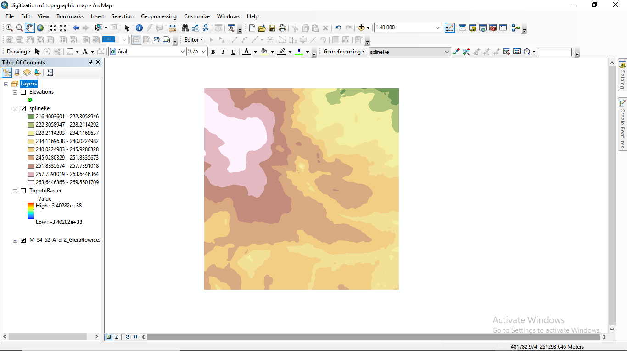

**SPLINE (REGULARIZED) – STRETCHED**

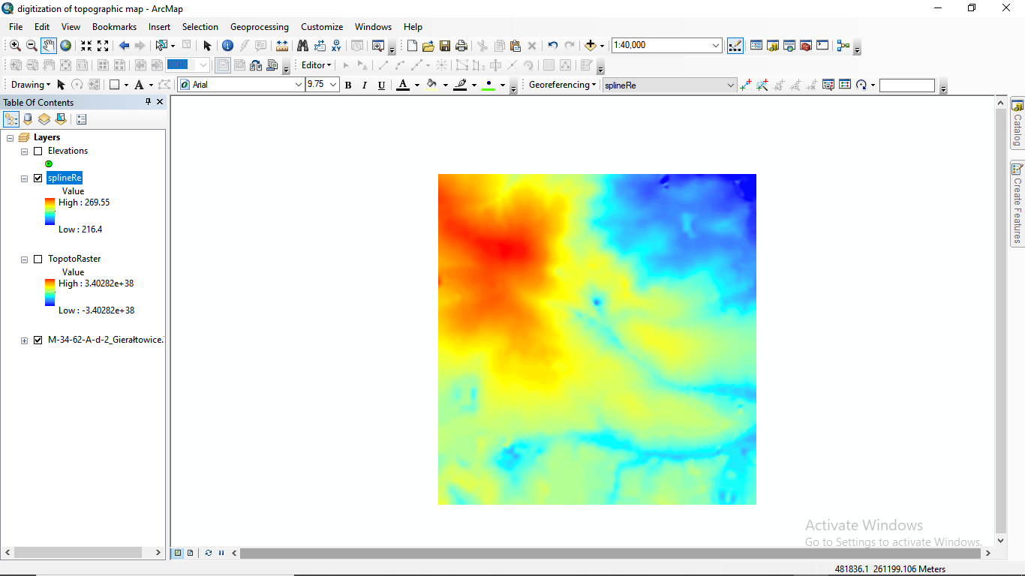

**SPLINE (TENSION) - CLASSIFIED**

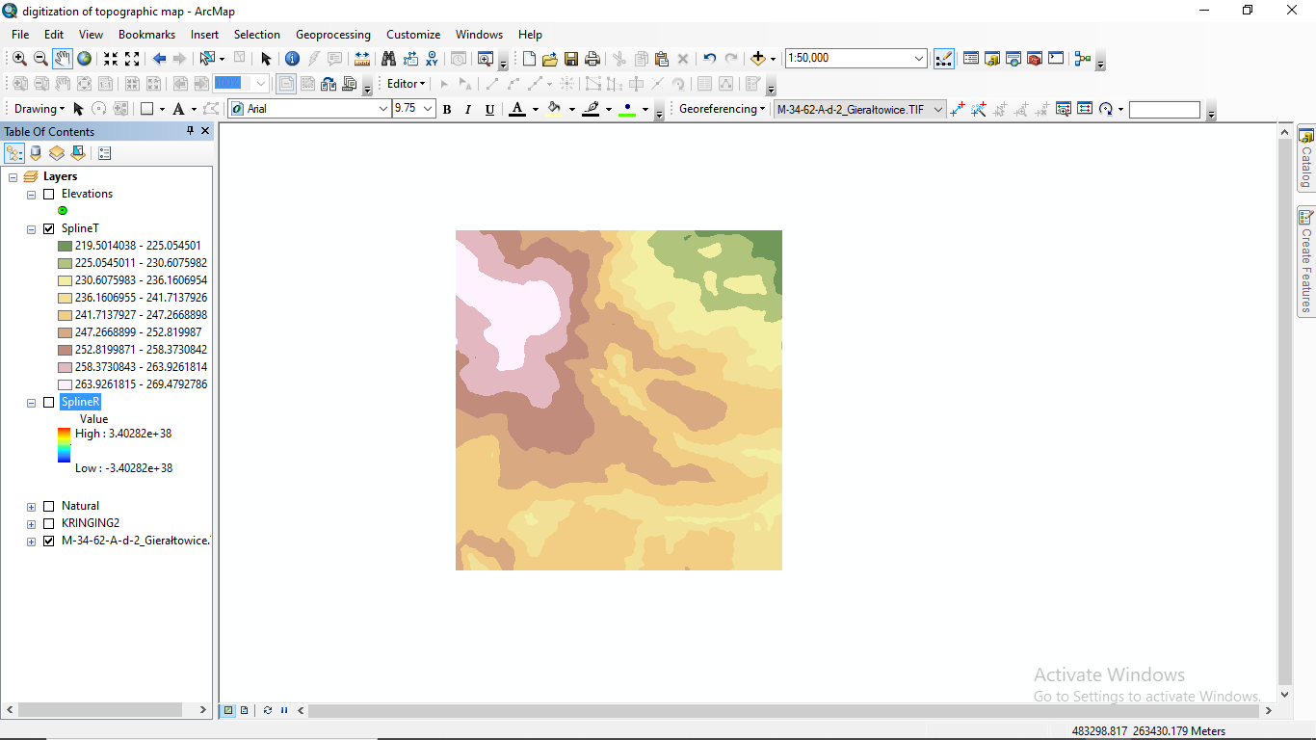

**SPLINE (TENSION) - STRETCHED**

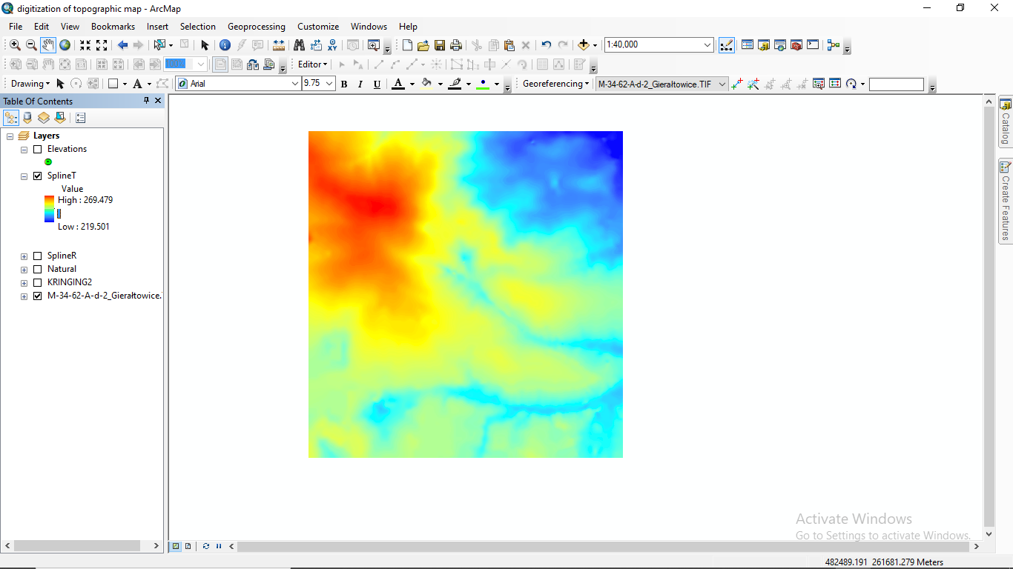

**TOPO TO RASTER - CLASSIFIED**

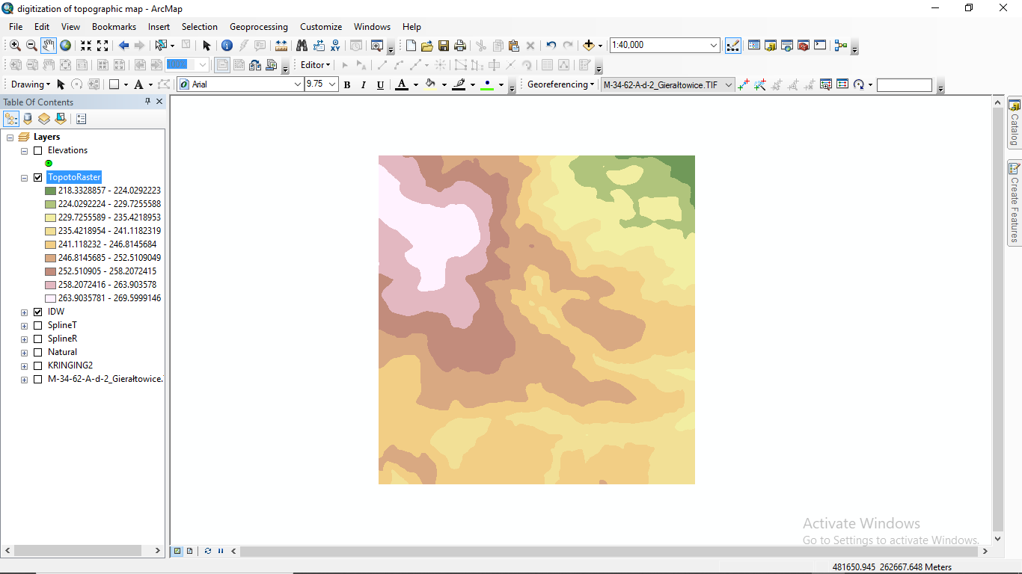

**TOPO TO RASTER - STRETCHED**

