**EXERCISE 5**

**DIGITAL ELEVATION MODEL (DEM) –BASIC ANALYSIS**

**CHUKWU CHINYERE PRECIOUS**

SLOPE_CLASSES

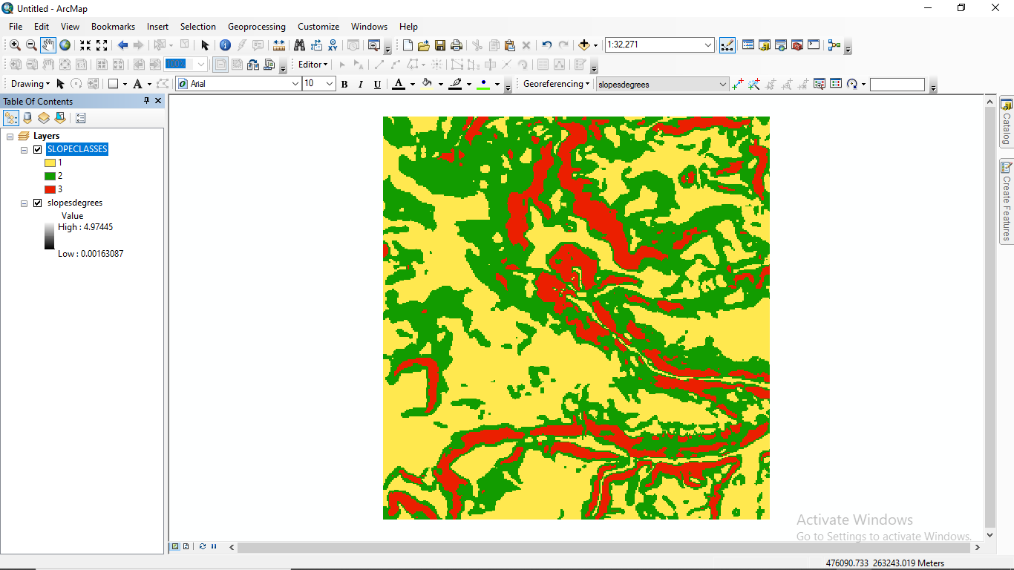

ASPECTS

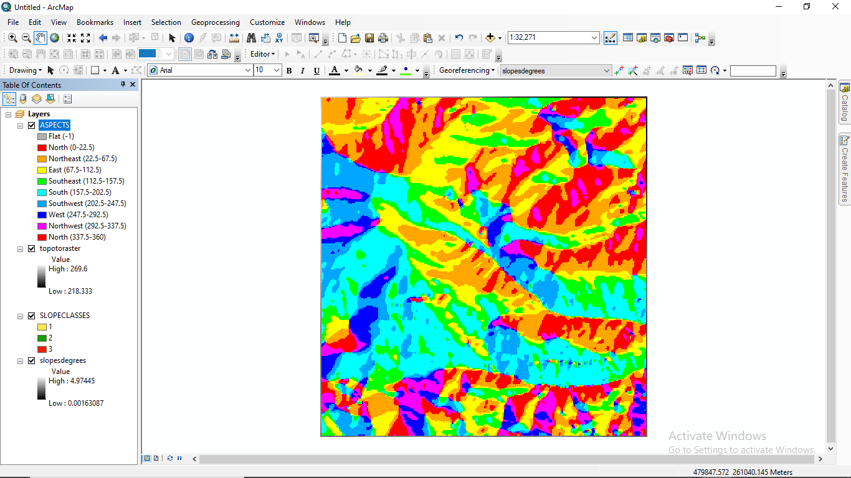

ASPECT_2

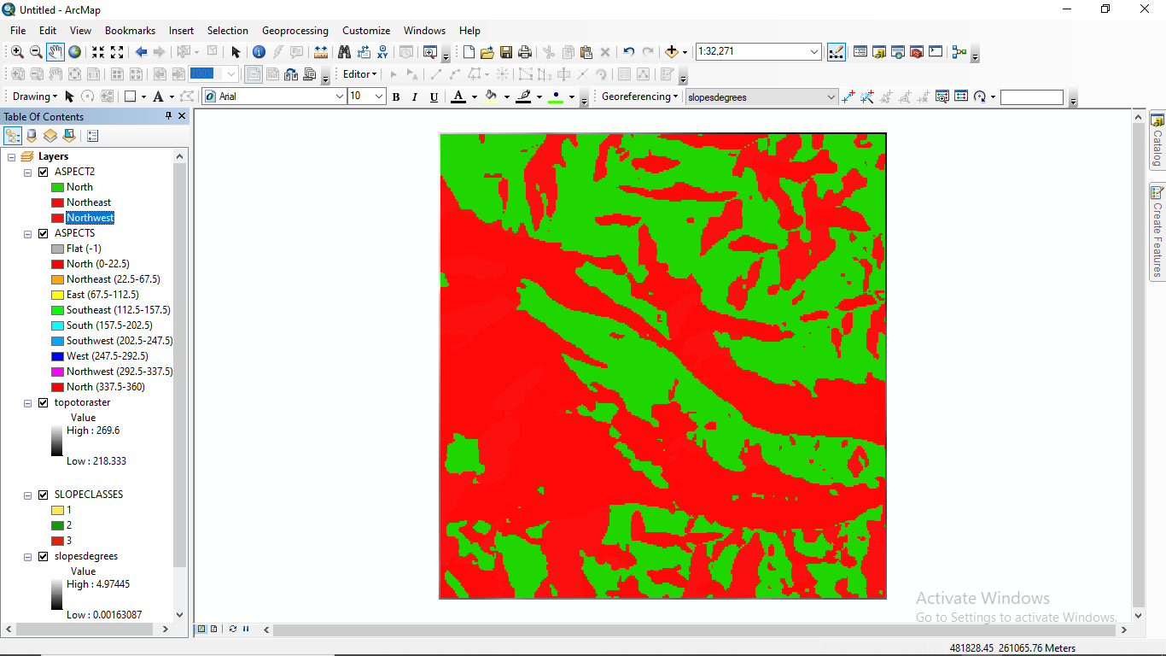

CONTOURS_1

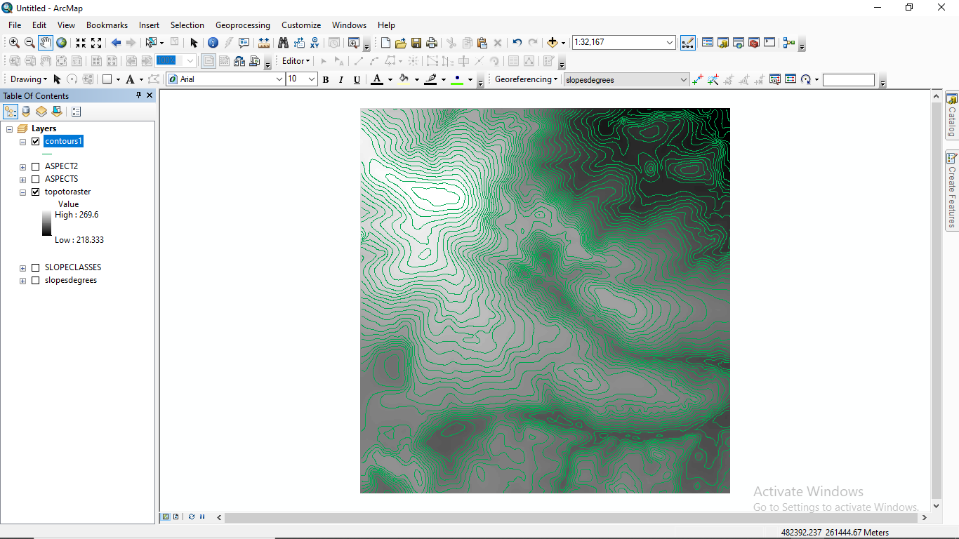

CONTOURS_10

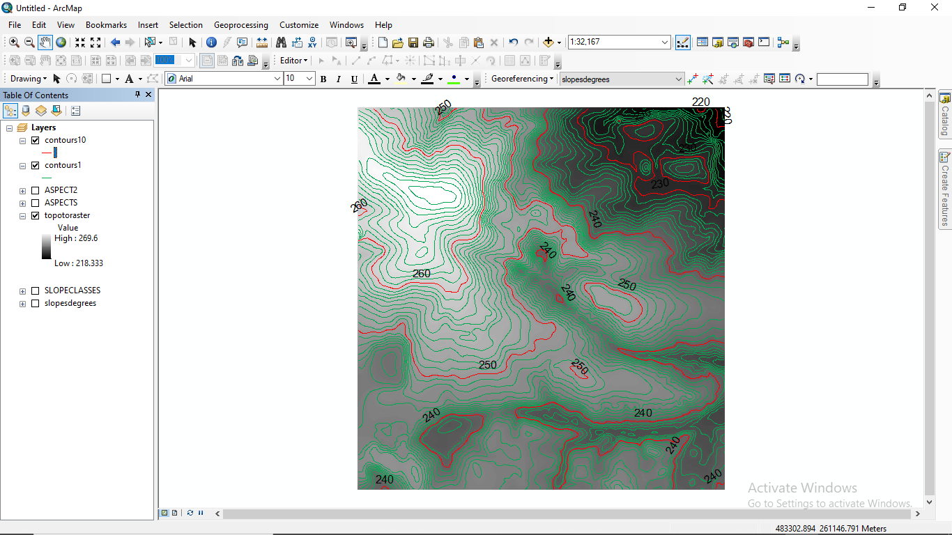

EVERY 1m CONTOUR

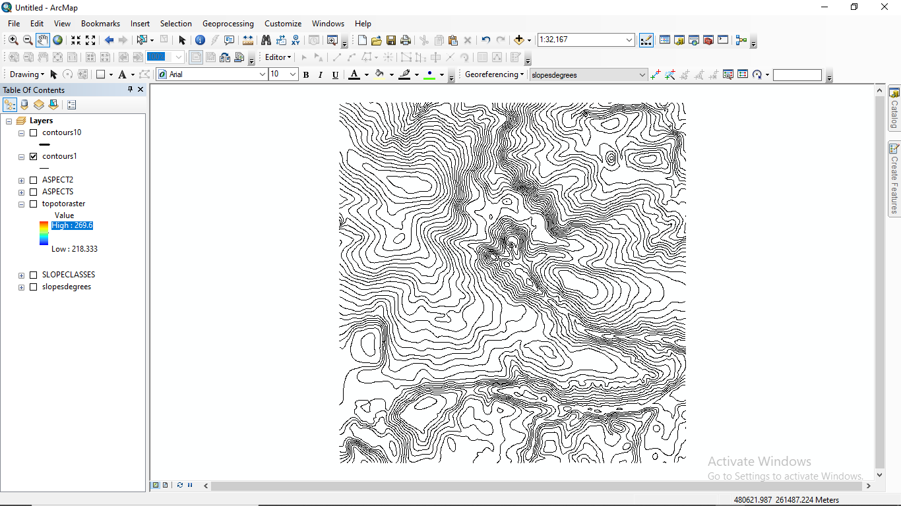

EVERY 10m CONTOUR

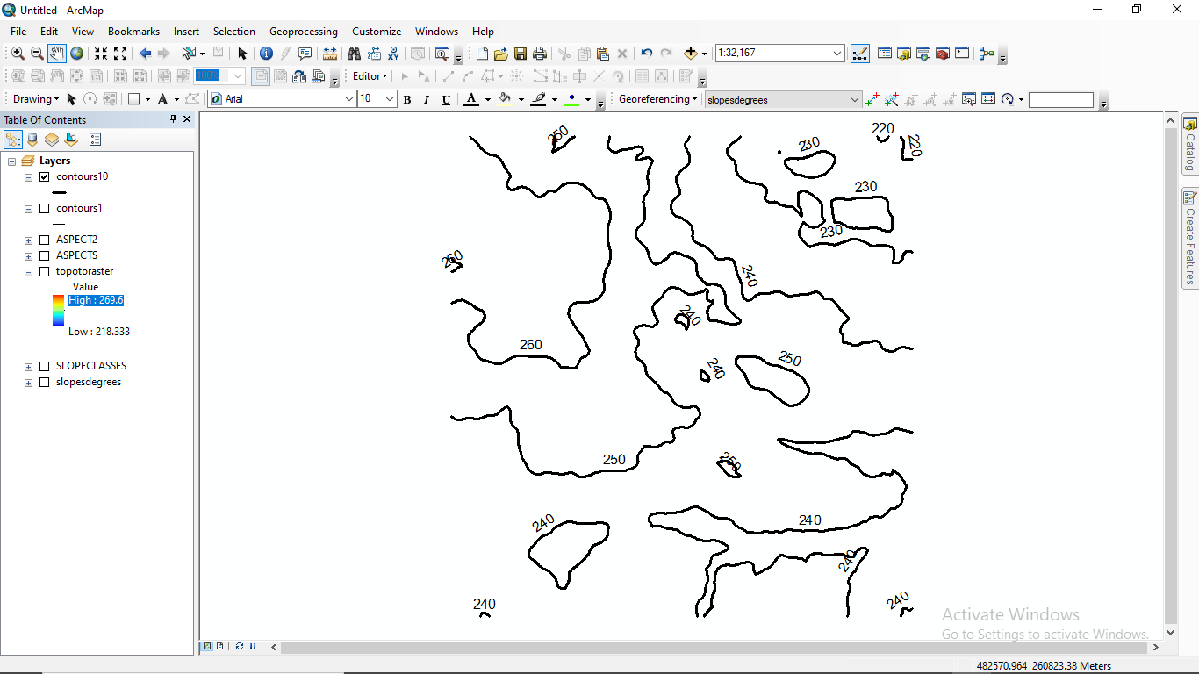

CONTOURS WITH (TOPOTORASTER) DEM

