**EXERCISE 6**

**DIGITAL ELEVATION MODEL (DEM) –BASIC ANALYSIS**

**CHUKWU CHINYERE PRECIOUS**

VISIBILITY (POINT 1) –OBSERVER ON THE GROUND

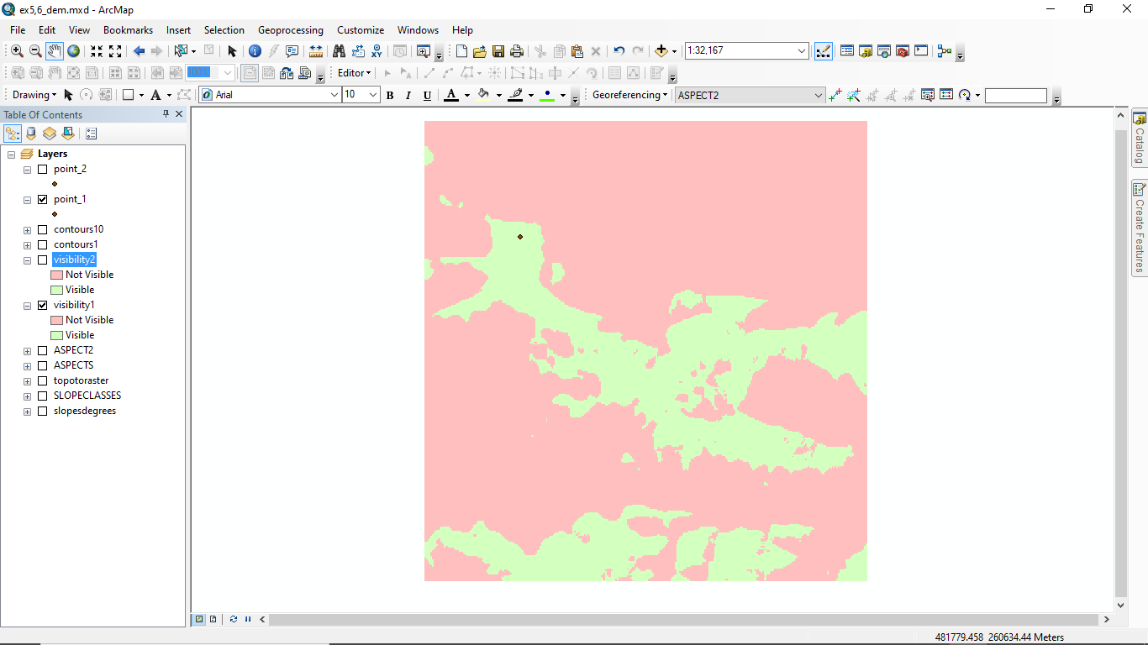

VISIBILITY (POINT 1) –OBSERVER 5M ABOVE THE GROUND

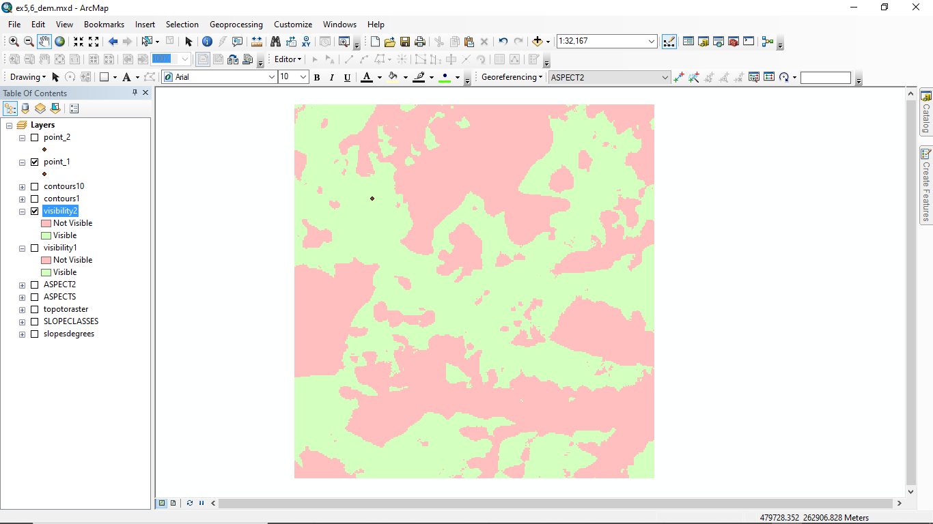

VISIBILITY (POINT 2) –OBSERVER ON THE GROUND

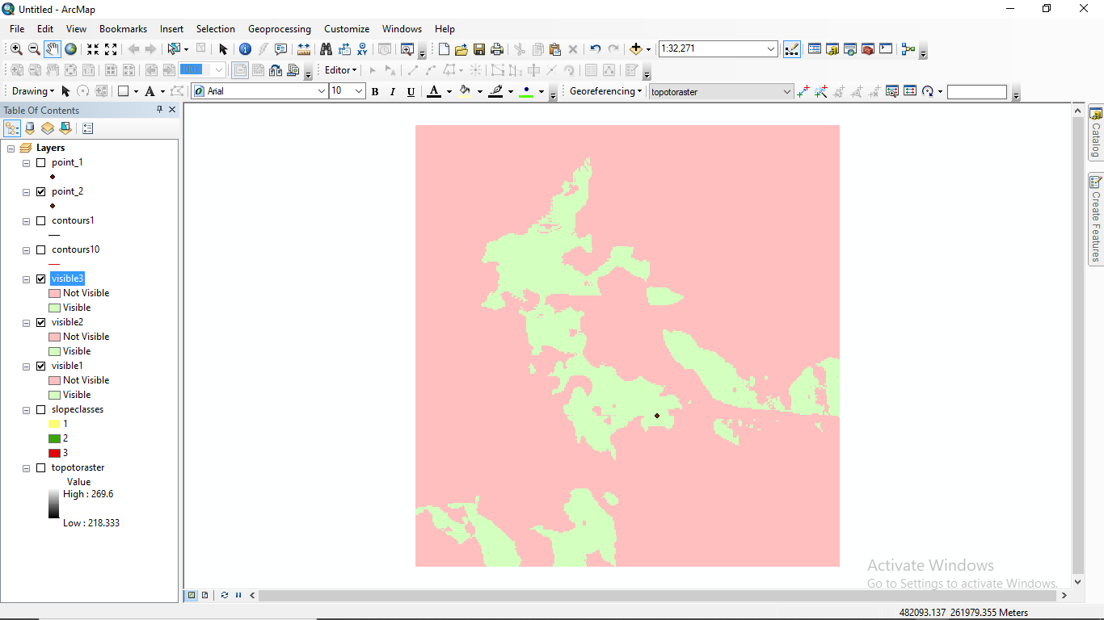

VISIBILITY (POINT 2) – OBSERVER 5 M ABOVE THE GROUND

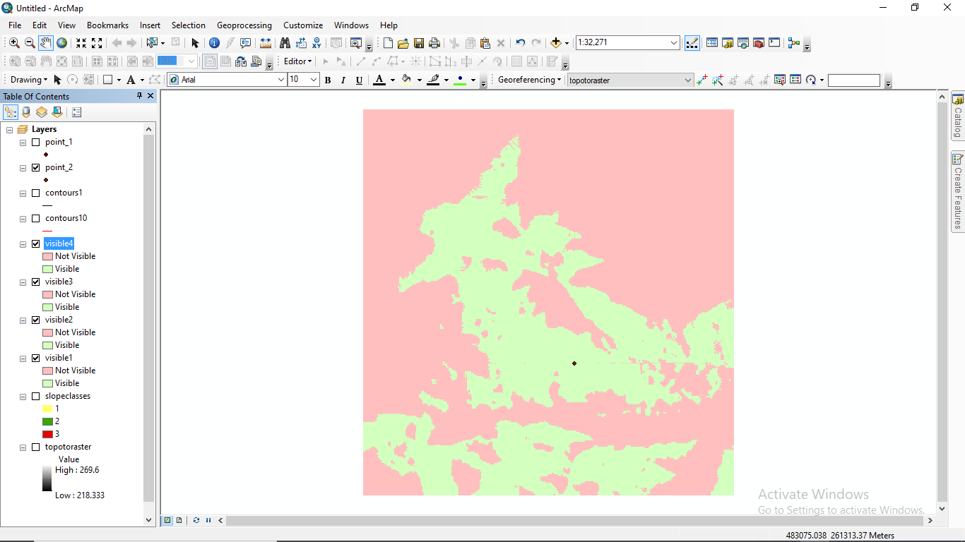

PROFILE LINE

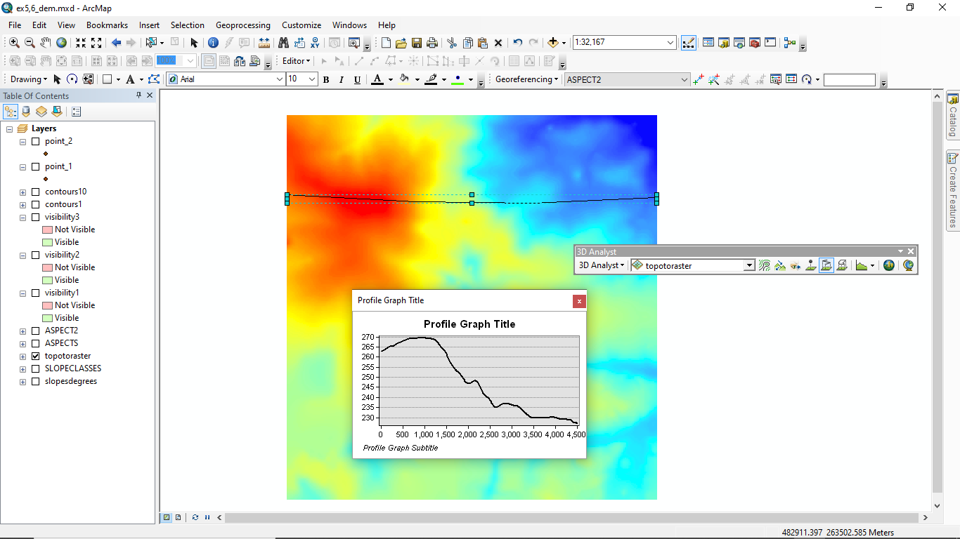

PROFILE LINE OF SIGHT

