VR369
Assignment 1
Pan Chongdan
27 Oct 2018
Examine of conflict between EU and Italy.
On Oct. 23, EU send back Italy new draft budget for rework because Italy government broke promise and intended to keep increasing spending even when its accumulated debt is more than 120% of its GDP, which is twice of the limit in EU’s rules. However, Italy government refused to change and one of Italian senator even stepped on EU’s document in public meeting.
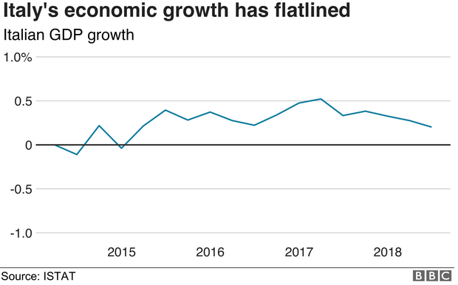
In my opinion, EU have to compromise instead of punishing Italy because of two reason. First, domestically, the government’s motivation is to boost economy to get the debt burden down, which can’t be achieved without money. Unfortunately, it seems the only way to save Italy’s debt is to use loose monetary policy and increase liquidity to boost the economy. Second, from EU’s side, if the country is out of EU, it can solve debt problem by printing more money simply, but Euro is issued only by European Central Bank so Italy government have to solve it through another way.
According to Italy government, the new policy’s motivation is to make GDP rise higher so debt as a percentage of GDP declines. They want to achieve this by spending more money on infrastructure and welfare. Actually, Italy’s biggest problem is persistently weak growth because deficits are less than in 2000s. As economists from the International Monetary Fund have noted, old persistent belt-tightening creates pent-up demand for tax cuts or public spending to alleviate social discontent. Financial support for low-income families, for instance, could be particularly effective, because the money would go to the people most likely to spend it. If EU impose an economic sanction on Italy, it’ll do nothing but aggravate Italy financial burden, so the government need more time or more new debt to pay for the old debt.
In addition to simply spending more money, maybe Italy government should take more actions to boost its economy. As far as I know, Italy already has the lowest interest rate in Europe while their economy isn’t boosted. In reality, more Italian spend money to buy real estate to avoid inflation. In the end, the currency amount in the market is not increased. Maybe Italy should learn from China to carry out purchase limitation policy on real estate, so more money can go to the market and increase GDP.
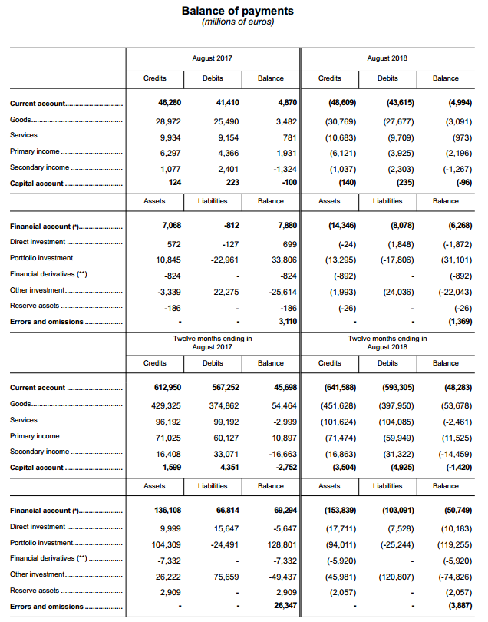
On the other hand, EU rejected Italy’s draft budget because they’re worried about debt crisis happen again after Greece. However, as European Stability Mechanism chief said, comparing Italy debt concerns to Greece is ‘not quite fair’. Even though Italy has dramatic deficit, it’s still smaller than Greece’s, not to mention Italy has a current account surplus and high private sector saving. From the above balance of payment table, we can see the current account is positive and the error is smaller than last year, which means Italy financial status is relatively healthier than last year. EU should have more confidence in Italy government.
Normally, we always hear debt crisis in member of EU, which is definitely in relation with Euros. Every country has its own economic status, so their currency needs to be adaptable and changeable, but Euros can’t do that because many countries are using it and it has a welfare effect on many countries. To avoid such large debt, EU should make a more strict and detailed economic regulation because they can’t solve such problem through Euros. Maybe they should reject Italy draft budget more than twenty years ago.

Reference
BBC. “What's behind Italy's economic turbulence?
https://www.bbc.com/news/business-45751416
Bloomberg Opinion. “Italy’s Budget Isn’t as Crazy as It Seems”
https://www.bloomberg.com/opinion/articles/2018-10-26/italy-s-budget-isn-t-as-crazy-as-it-seems?srnd=opinion-economics
CNBC. “Comparing Italy debt concerns to Greece is 'not quite fair': European Stability Mechanism chief.”
https://www.cnbc.com/2018/10/11/comparing-italys-debt-concerns-to-greece-is-unfair-esm-chief-says.html
Bank of Italy. “Balance of Payments and International Investment Position”
https://www.bancaditalia.it/pubblicazioni/bilancia-pagamenti/index.html?com.dotmarketing.htmlpage.language=1

