VR369
Assignment 2
Pan Chongdan
3 Dec 2018
Examine of Qatar’s WTO Dispute over Saudi Arabia
On Nov. 19, Qatar has escalated a dispute against Saudi Arabia at the World Trade Organization, a WTO filing showed on Monday, with a request for adjudication of its complaint that Saudi Arabia had violated its intellectual property rights. However, Saudi Arabia had refused to meet Qatari officials to try to resolve the dispute, as required by WTO rules.
During the World Cup, Saudi Arabia blocked a broadcasting company called “beIN” and refused to take effective action against the piracy of beIN content by a sophisticated pirate operation called "beoutQ", which was broadcasting the game of the World Cup. As a result of Saudi Arabia’s illegal actions, beIN lost 40% percent. Even FIFA has intervened and intended to reach an agreement so that Saudi Arabia’s resident can watch the World Cup legally through beoutQ, but it also failed.
This problem is about trade-related aspects of intellectual property, which is the subject covered from Uruguay Round. Actually, it’s very difficult to settle the dispute because there are more political conflicts behind the dispute, which is not covered by WTO and the political conflicts are potential motivation for Qatar and Saudi’s dispute.
About one year ago, Riyadh and Arab allies severed diplomatic and trade ties with Qatar, over its alleged support of terrorism but they don’t have any unambiguous evidence. In my opinion, WTO dispute is more like a battlefield of interest and politics. In Qatar’s case, there are three motivations behind Qatar and Saudi Arabia’s conflict.
First, Qatar wants to settle Islamic world problem by teaming up with Iran while Saudi Arabia wants Qatar to cut ties with Iran because they’re from two opposed camps.
Second, Qatar’s tv station called Al Jazeera Network always break scandals of Saudi Arabia’s royal family even though they are neutral. Saudi Arabia is afraid of Qatar’s media company will badly affect its sovereignty at east Asia.
Third, Qatar is cooperating with Iran to exploit an oil filed around the Persian Gulf together, which is the core of Qatar and Saudi Arabia’s conflict. Qatar’s cooperation with Saudi Arabia has seriously affect the Saudi Arabia’s interest of economy and politics.
Therefore, Saudi Arabia decided to bring other Asia countries, cut ties with Qatar and set trade ban against Qatar. In this case, the dispute is more like to the cross ambition of interest damaged countries.
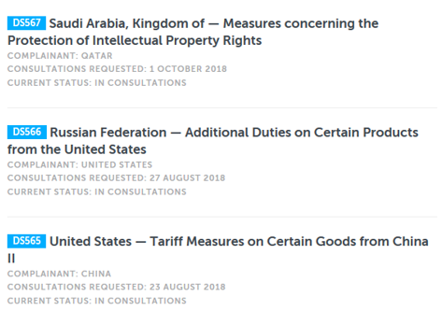

From the chronological list from WTO website, we can see that most of countries which have disputes against each other also have conflict of interest or politics. I think WTO should improve itself to prevent such things from happening because, so it won’t become a weapon utilized by countries. For example, the time required for WTO procedure for settlement should be cut down significantly so it won’t be utilized by government for short-term interest.
In conclusion, Qatar’s dispute against Saudi Arabia is a typical trade conflict originating from conflict of interest and politics. WTO should find some ways to settle the problem from its at root instead of wasting a long time to implement the procedure.

Reference
Reuters.” Qatar escalates WTO Dispute over Alleged Saudi IP Violation.”
https://www.nytimes.com/reuters/2018/11/19/world/middleeast/19reuters-saudi-qatar-wto.html
WTO. “Saudi Arabia — Measures concerning the Protection of Intellectual Property Rights.”
https://www.wto.org/english/tratop_e/dispu_e/cases_e/ds567_e.htm
Wikipedia.” Qatar-Saudi Arabia diplomatic conflict.”
https://en.wikipedia.org/wiki/Qatar%E2%80%93Saudi_Arabia_diplomatic_conflict
The Atlantic.” What’s the problem with Al Jazeera?”
https://www.theatlantic.com/international/archive/2017/06/al-jazeera-qatar-saudi-arabia-muslim-brotherhood/531471/

