**HW5 Report**

**Q1.**

**Verilog Code:**

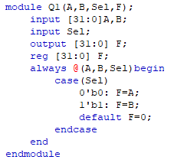

**Stimulation Result:**

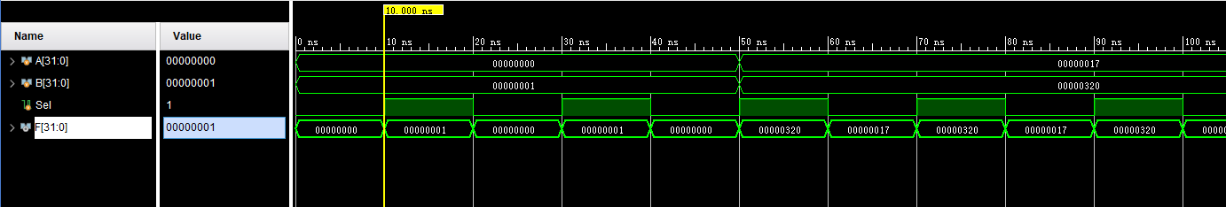

**Q2.**

**Verilog Code:**

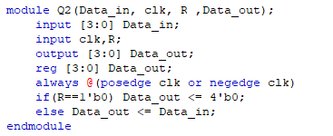

**Stimulation Result:**

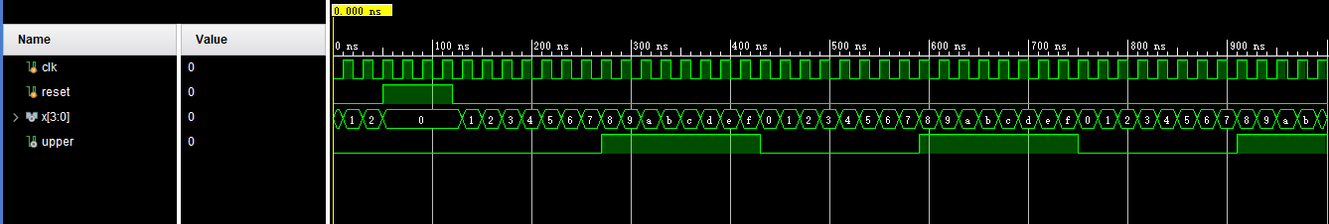

**Q3.**

**Verilog Code:**

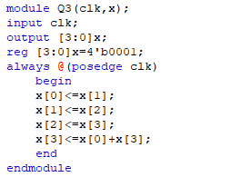

**Stimulation Result:**

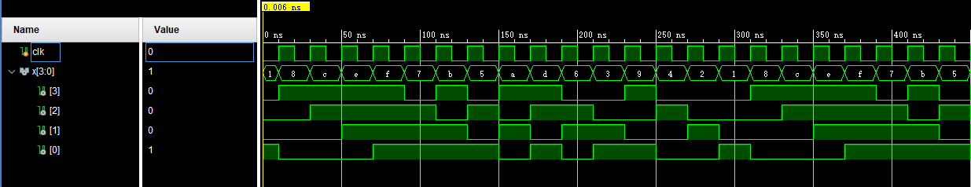

**Q4.**

**Verilog Code:**

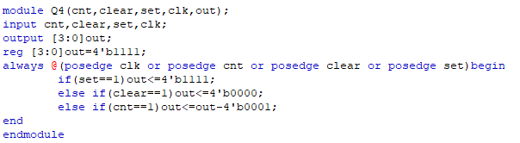

**Stimulation Result:**

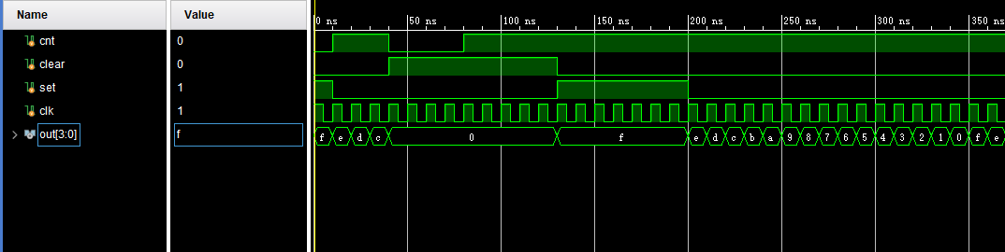

**Q5.**

**Verilog Code:**

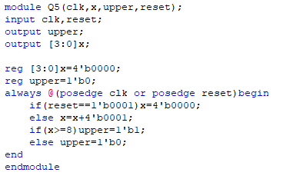

**Stimulation Result:**

