**HW6 Report**

**Q6**

**Verilog Code:**

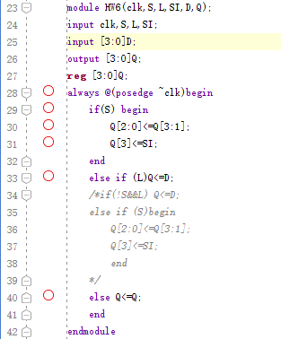

**Stimulation Result:** 