**Ve270 Introduction to Logic Design Homework 10**

**Assigned: July 26, 2018**

**Due: August 2, 2018, 2:00pm.**

**The homework should be submitted in hard copies.**

1. Problem 5.19 (30 points)

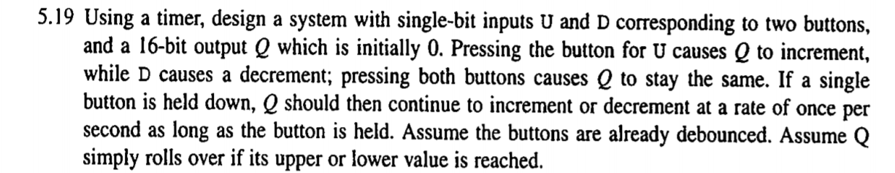

1. Problem 5.26 (10+5+5 points)

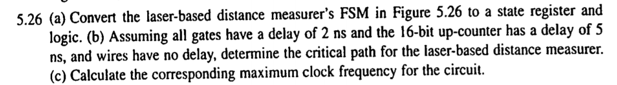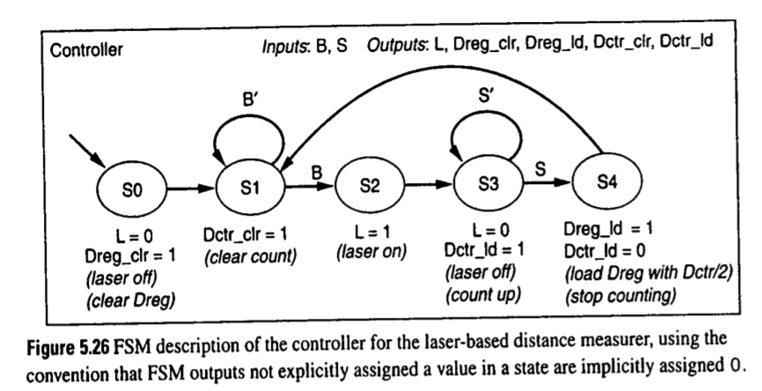

1. Given an SRAM block,

32

32

data

addr

r

w

en

SRAM

If the memory is byte addressable (each byte has an address), how many **bits** in maximum can the SRAM block have? (10 points)

1. Problem 5.43 (30 points)

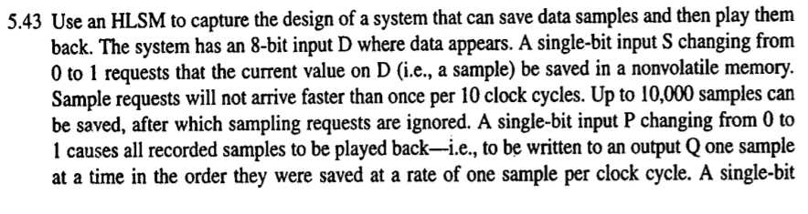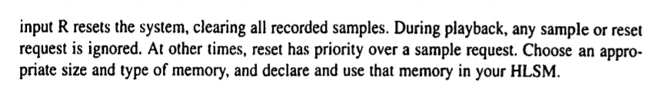

1. Problem 6.27 (10 points)

