**Ve270 Introduction to Logic Design Homework 1**

**Assigned: May 17, 2018**

**Due: May 24, 2018, 2:00pm.**

**The homework should be submitted in hard copies.**

1. Fill out the blank spaces. Show steps to earn partial credits. (10 points)

1110101.1012 = ________________10 = ___________________16

98.3710 = __________________2 = ___________________8 = ____________________3

1. Perform the following arithmetic operations step by step, assuming unsigned numbers: (15 points)

(6FE58C + 3ADD) 16 =

(11100 – 10001111) 2 =

(545 – 267) 8 =

1. Problem 2.13 (Boolean equation = logic equation) (4 points)

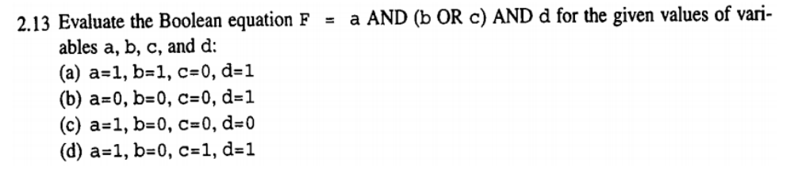

1. Problem 2.16 (10 points)

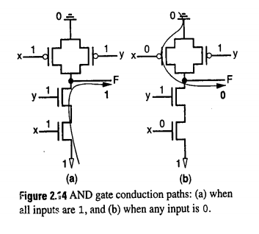

1. Problem 2.19 (c) (10 points)

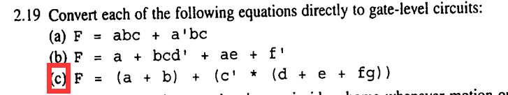

1. Problem 2.21 (15 points)

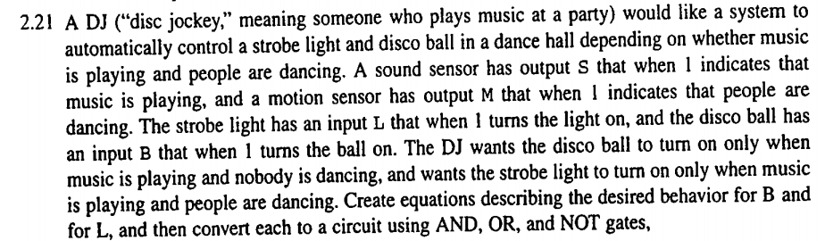

1. Problem 2.33 (6 points)

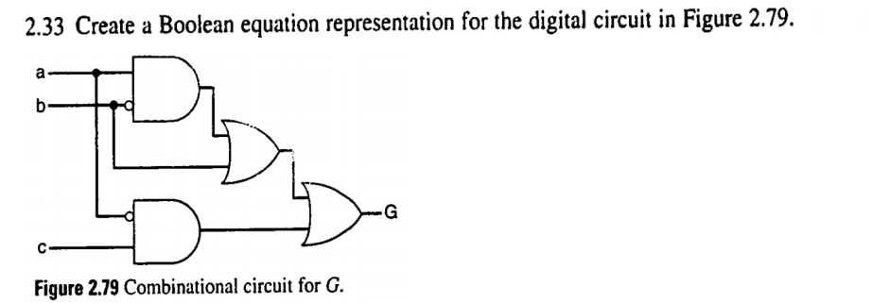

1. Problem 2.35 (b) (c) (10 points)

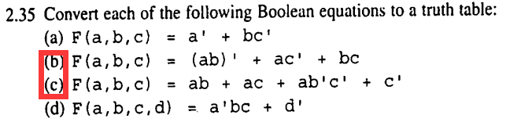

1. Build a truth table for the following circuit. (10 points)

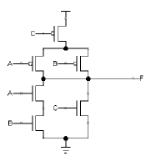

Vdd

1. Given a logic equation F = a’c’ + b’c + ab, draw an output waveform for F based on the given input waveforms. (10 points)



a

F

c

b